**The Rust Electrical Handbook**

THIS IS ONCE AGAIN A WORK IN PROGRESS

**On April 4th 2024, FacePunch released a significant update to the game transforming electricity. This update marks the separation of PC and Console functionality. This handbook is specifically tailored for PC users.**

**We encourage you to make comments or suggestions to help keep this guide accurate and up-to-date.**

This handbook was created and is maintained by **SwiftCoyote** on Discord, with the valuable contributions from the **Rustricity Workshop** community.

[**Discord Invite**](https://discord.rustrician.io/)

Make your own circuits on[Rustrician.io](https://www.rustrician.io/)

As of **April 10th 2025**, I have reviewed and updated the entirety of the Components Details section. Please forgive me if I have missed something and please correct me if something is wrong.

**Google Doc Dark Mode** 

Component Details

# Tools

## Wire Tool

**Item ID:** -144417939  
**Description:** A tool used to create electrical connections between components. E*ssential for wiring* electrical circuits in Rust.

**Crafting Details**

* **Crafting Recipe:** 2 High Quality Metal
* **Research Table Cost:** 10 Scrap
* **Stack Size:** 1
* **Despawn Time:** 5 minutes

**Functionality**

* The Wire Tool allows players to connect electrical components only.
* To create a wire connection, left-click on the input/output (IO) of one component, then left-click again on the input/output (IO) of another component.
* Using multiple Wire Tools in your hot bar, you can run multiple wires at the same time.
* It can be stored in a Tool Cupboard.
* 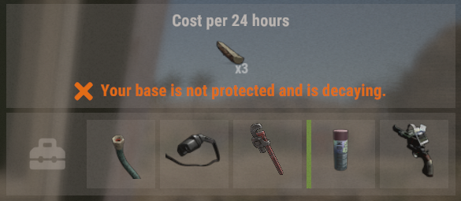

**Wire Mechanics**

* **Wire Length:** Approximately 30 meters (10 building foundations) before needing to be reconnected to a component.
* **Wire Anchors:** A single wire can be attached or anchored to building block up to 16 times before it needs to be connected to another component.
* **Color Coding:** Players can cycle through different wire colors by holding Reload(R) before placing a wire. After a wire is placed, recolor the wire by selecting the color and tapping Reload(R) on an IO connection.
* 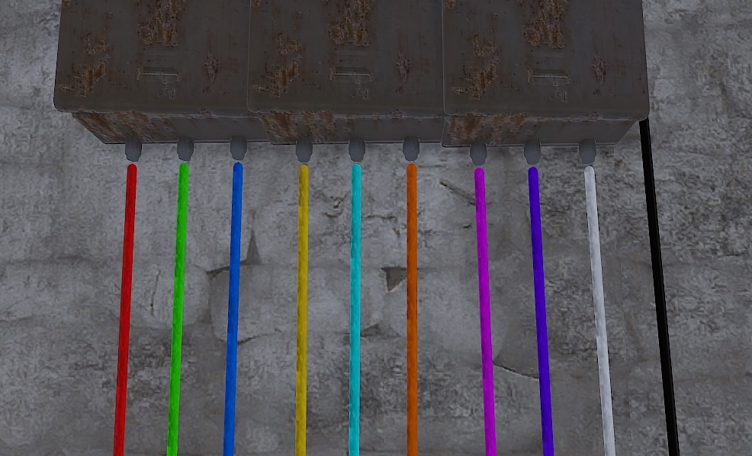
* **Removing Wires:** To remove a wire, look at the IO connection and tap Right-Click once to pick up the wire. Holding Right-Click will delete the entire wire.
* **Undoing Placement:** If a mistake is made, tap Right-Click and it will undo the last placement or anchor point.
* **Wire Slack:** To adjust wire slack, hold Sprint(Left Shift) and scroll the mouse wheel. The amount of slack isnot reset after use.
* **Wire Snapping:** Hold Sprint (Left Shift) to snap wires at 90 degree angles.
* **IO Port Snapping:** By default, the wire will want to snap to IO ports. Hold Head Look(Left Alt) to stop the snap when placing wires near IO ports.
* **Component Snapping:** Holding Sprint(Left Shift) allows you to snap electrical components in line with each other. This works on the top/bottom or sides of electrical components.
* **Wire Tracing:** To trace an existing wire, left-click the IO connection point. This action will prompt a wire animation for the selected connection only. Note: You need to have TC Auth to trace wires.

**Notes**

* Does not work on water or industrial connections.
* Some water and industrial components require power, but their networks are connected using Hose Tool, Pipe Tool, or just placed without needing a connection.
* The Wire Tool is not consumed on use, meaning it can be used indefinitely once crafted.
* When wires are placed on walls and the wall is destroyed, the wires will remain in place.
* Wear Diving Fins to get cleaner and straighter wire placement. They force the player to move slower, allowing for better accuracy when strafing left and right.
* To increase or decrease the range of the auto snap when getting close to an IO connection, in the F1 console, change **client.lookatradius from 0.2 to 0.05.** This lets anchor points be placed closer to IO connections.

### Hose Tool

**Item ID:** 363163265  
**Description:** A tool used to create water connections between components. Essential for moving water in Rust.

**Crafting Details**

* **Crafting Recipe:** 2 High-Quality Metal
* **Research Table Cost:** 10 Scrap
* **Stack Size:** 1
* **Despawn Time:** 5 minutes

**Functionality**

* The Hose Tool allows players to connect water components only.
* To create a hose connection, left-click on the input/output (IO) of one component, then left-click again on the input/output (IO) of another component.
* Using multiple Hose Tools in your hot bar, you can run multiple hoses at the same time.
* It can be stored in a Tool Cupboard.
* 

**Hose Mechanics**

* **Hose Length:** Approximately 30 meters (10 building foundations) before needing to be reconnected to a component.
* **Hose Anchors:** A single hose can be attached or anchored to building block up to 16 times before it needs to be connected to another component.
* **Color Coding:** Players can cycle through different hose colors by holding Reload(R) before placing a hose. After a hose is placed, you can recolor it by selecting the color and tapping Reload(R) on an IO connection.
* 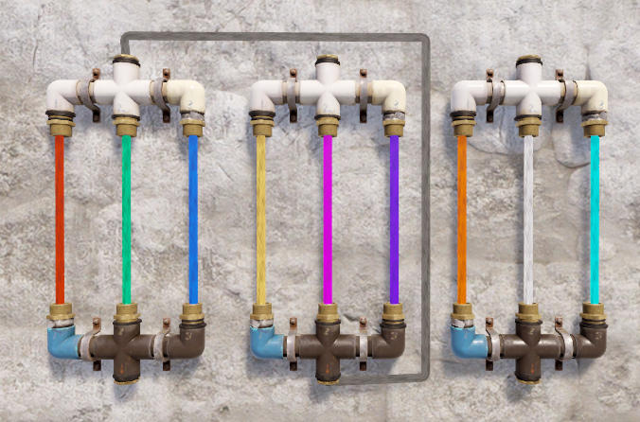
* **Removing Hoses:** To remove a hose, look at the IO connection and tap Right-Click once to pick up the hose. Holding Right-Click will delete the entire hose.
* **Undoing Placement:** If a mistake is made, tap Right-Click and it will undo the last placement or anchor point.
* **Hose Slack:** To adjust hose slack, hold Sprint(Left Shift) and scroll the mouse wheel. The amount of slack is not reset after use.
* **Hose Snapping:** Hold Sprint (Left Shift) to snap hoses at 90 degree angles.
* **IO Port Snapping:** By default, the hose will want to snap to IO ports. Hold Head Look(Left Alt) to stop the snap when placing hoses near IO ports.
* **Component Snapping:** Holding Sprint(Left Shift) allows you to snap water components in line with each other. This works on the top/bottom or sides of components.
* **Hose Tracing:** To trace an existing hose, left-click the connection point. This action will prompt a hose animation for the selected connection only.

**Notes**

* Does not work on electrical or industrial connections.
* The Hose Tool is not consumed on use, meaning it can be used indefinitely once crafted.
* When hoses are placed on walls and the wall is destroyed, the hoses will remain in place.
* Wear Diving Fins to get cleaner and straighter hose placement. They force the player to move slower, allowing for better accuracy when strafing left and right.
* To increase or decrease the range of the auto snap when getting close to an IO connection, in the F1 console, change **client.lookatradius from 0.2 to 0.05.** This lets anchor points be placed closer to IO connections.

### Pipe Tool

**Item ID:** -144513264  
**Description:** A tool used to create industrial connections between components, allowing for automated item transfer in Rust.

**Crafting Details**

* **Crafting Recipe:** 2 High-Quality Metal
* **Research Table Cost:** 10 Scrap
* **Stack Size:** 1
* **Despawn Time:** 5 minutes

**Functionality**

* The Pipe Tool allows players to connect industrial components only.
* To create a pipe connection, left-click on the input/output (IO) of one component, then left-click again on the input/output (IO) of another component.
* Using multiple Pipe Tools in your hot bar, you can run multiple pipes at the same time.
* It can be stored in a Tool Cupboard.
* 

**Pipe Mechanics**

* **Pipe Routing:** Pipes cannot pass through player built structures, like walls and floors. They must pass through openings, like doors, hatches, windows, prison cells and chainlink. They cannot pass through rocks but they can pass through the ground.
* **Pipe Anchors:** 
  + A single pipe can be attached or anchored to building block up to 16 times before it needs to be connected to another component.
  + Holding Head Look(Left Alt) allows placement of anchor points on deployed entities like boxes or chairs.
* **Pipe Length:** Approximately 30 meters (10 building foundations) before needing to be reconnected to a component.
* **Color Coding:** Players can cycle through different pipe colors by holding Reload(R) before placing a pipe. After a pipe is placed, you can recolor it by selecting the color and tapping Reload(R) on an IO connection.
* 
* **Removing Pipes:** To remove a pipe, look at the IO connection and tap Right-Click once to pick up the pipe. Holding Right-Click will delete the entire pipe.
* **Undoing Placement:** If a mistake is made, tap Right-Click and it will undo the last placement or anchor point.
* **Pipe Snapping:** Hold Sprint (Left Shift) to snap pipes at 90 degree angles.
* **IO Port Snapping:** By default, the pipe will want to snap to IO ports. Hold Head Look(Left Alt) to stop the snap when placing pipes near IO ports.
* Pipes break if the surface they are attached to is destroyed. Sometimes pipes have been known to break when altering the surface it is attached to (e.g., upgrading a wall).

**Notes**

* Does not work on electrical or water connections.
* The Pipe Tool is not consumed on use, meaning it can be used indefinitely once crafted.
* Wear Diving Fins to get cleaner and straighter pipe placement. They force the player to move slower, allowing for better accuracy when strafing left and right.
* To increase or decrease the range of the auto snap when getting close to an IO connection, in the F1 console, change **client.lookatradius from 0.2 to 0.05.** This lets anchor points be placed closer to IO connections.

### Hammer

**Item ID:** 200773292  
**Description:** A tool used to repair, upgrade, and pick up deployable items and building structures in Rust. Essential for base maintenance and modifications.

**Crafting Details**

* **Crafting Recipe:** 100 Wood
* **Research Table Cost:** 10 Scrap
* **Stack Size:** 1
* **Despawn Time:** 5 minutes

**Functionality**

* The Hammer allows players to repair damaged structures and deployables using the required materials from their inventory.
* It can be used to upgrade building pieces to stronger materials if the player has the necessary resources. Hold Right-Click to bring up the radial menu when looking at a building surface.
* To pick up components, with TC authorization and a hammer in hand, look at the component then press and hold Use(E).
* Can be stored in a Tool Cupboard.
* 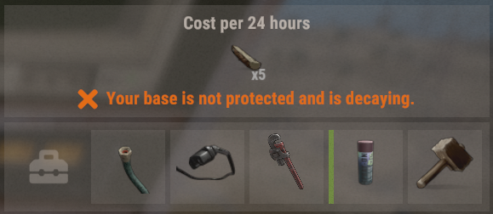

**Hammer Mechanics**

* **Repairing:** Left-click on a damaged structure or deployable to repair it using available materials.
* **Upgrading:** Hold Right-click to open the upgrade menu and select the desired building tier (Wood, Stone, Metal, or Armored).
* **Picking Up Items:**
  + To pick up components, gain tool cupboard authorization and with a hammer in hand, look at the component then press and hold Use(E).
  + All components can be picked up except for the Windmill.
  + Most components take no damage when picked up. However, the following items take damage when picked up: Laser Light, Sound Light, Connected Speaker, Snow Machine, Fogger-3000, Spooky Speaker, Strobe Light, Fridge, Auto Turret, SAM Site, Small Generator, and Batteries.
  + **Be cautious** when holding the hammer, as accidental pickups can and will happen.

**Notes**

* Essential for base building, upkeep, and modifications.
* When upgrading structures, all existing attachments (like doors and locks) remain intact.

### Garry’s Mod Tool Gun

**Item ID:** 1803831286

**Description:** A tool similar to the Hammer but with extended range, used for repairing, upgrading, and picking up deployable items and building structures in Rust.

**Crafting Details**

* **Crafting Recipe:** 100 Wood, 20 Metal Fragments
* **Research Table Cost:** Blueprints cannot be created
* **Stack Size:** 1
* **Despawn Time:** 5 minutes

**Functionality**

* Requires owning and playing Garry’s Mod for 30 minutes before use.
* Functions identically to the Hammer, allowing players to repair, upgrade, and pick up deployables and structures.
* Features an extended range of up to 2 meters, making it easier to interact with structures from a distance.
* Displays the name of the item it is pointed at using a small LCD screen.
* Can be stored in a Tool Cupboard.
* 

**Tool Gun Mechanics**

* **Repairing:** Left-click on a damaged structure or deployable to repair it using available materials.
* **Upgrading:** Hold Right-click to open the upgrade menu and select the desired building tier (Wood, Stone, Metal, or Armored).
* **Picking Up Items:**
  + To pick up components, with TC authorization and the Tool Gun in hand, look at the component then press and hold Use(E).
  + All components can be picked up except for the Windmill.
  + Most components take no damage when picked up. However, the following items take damage when picked up: Laser Light, Sound Light, Connected Speaker, Snow Machine, Fogger-3000, Spooky Speaker, Strobe Light, Fridge, Auto Turret, SAM Site, Small Generator, and Batteries.
  + **Be cautious** when holding the gun, as accidental pickups can and will happen.

**Notes**

* Works exactly like the Hammer but with a slightly longer range.
* When upgrading structures, all existing attachments (like doors and locks) remain intact.
* The F1 console command **"toolgun.classiceffects true"** or **"toolgun.classiceffects false"** will change the color of the beam. **False** is the default **orange** color but **True** is **blue** like it is in Gmod.

### Spray Can

**Item ID:** -596876839

**Description:** A tool used to change the appearance of certain deployable items and components in *Rust*.

**Crafting Details**

* **Crafting Recipe:** 100 Metal Fragments
* **Research Table Cost:** 10 Scrap
* **Stack Size:** 1
* **Despawn Time:** 5 minutes

**Functionality**

* Anyone can craft and use the Spray Can.
* Allows players to reskin Industrial Lights, Reactive Targets, Fridges, and certain deployables.
* Allows players to spray tags or free draw with different colors.
* **Comes with 1 default tag and the ability to reskin items.**
* **Players need to purchase the Graffiti DLC to unlock 8 additional tags and the ability to free spray.**
* Can be stored in a Tool Cupboard.

**Spray Can Mechanics**

* **Skinning Items:**
  + Aim at a compatible item.
  + Right-click to open the skin selection window.
  + Select a skin by left-clicking it to apply.
  + 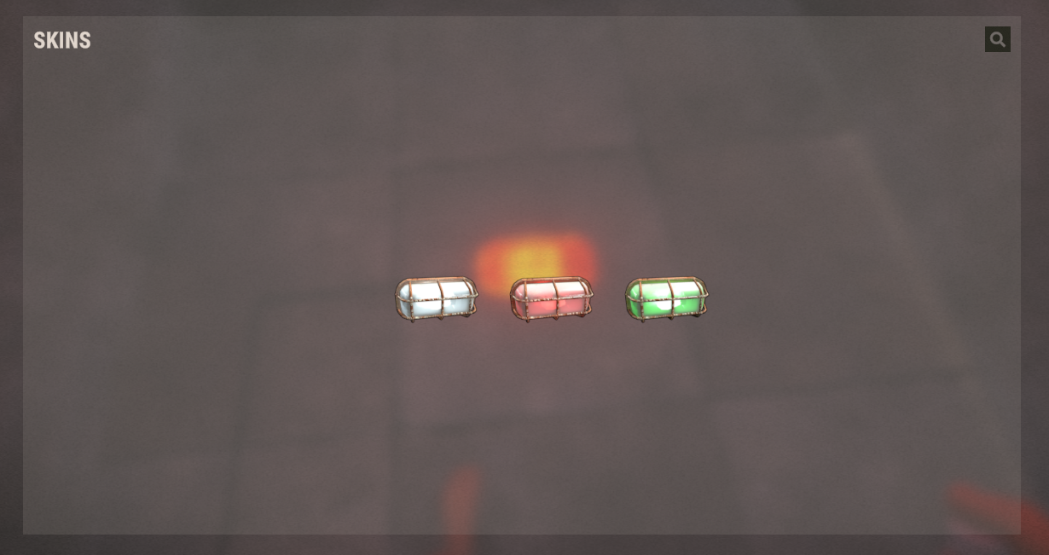
* **Spray Tagging Mechanics:**
  + Hold Reload(R) to access the radial menu to select a tag or Free Spray.
  + There are 9 tags to choose from.
  + 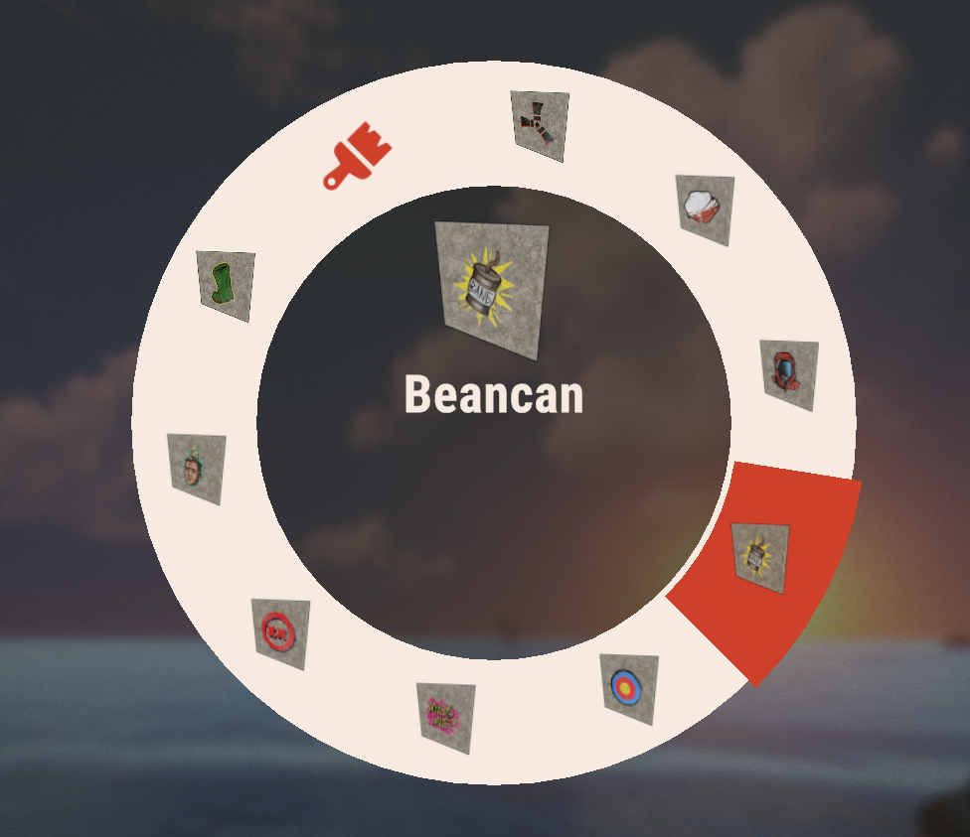
  + 25 tags can be sprayed before the first one is removed.
  + 1 Spray Can will tag 40 times before it breaks.
  + Free Sprays have a max length of roughly 150 meters or 50 square foundations before the start of the spray starts to disappear.
  + There are 5 colors to choose from.
  + 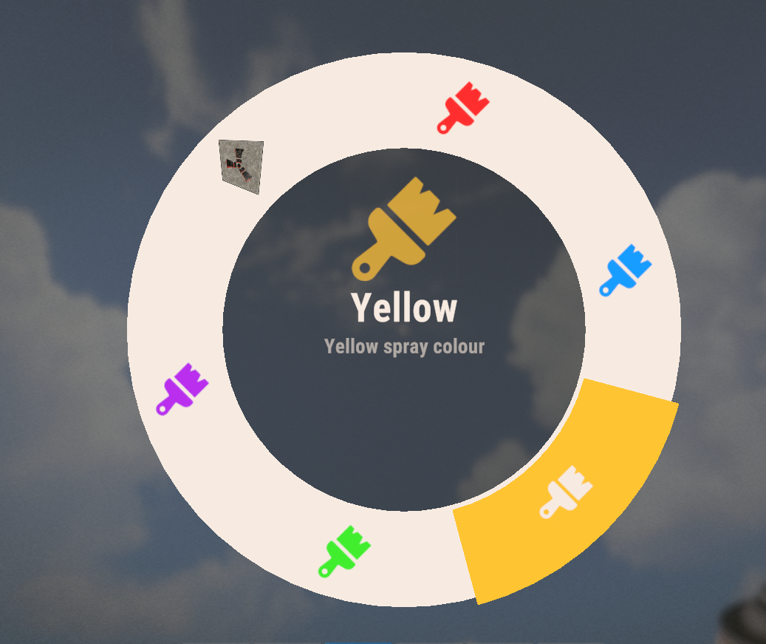
  + Paint can be removed by holding a Water Gun, looking at the spray and pressing Use(E) to wash it away. Spraying or splashing water will also remove the paint.

**Notes**

* Consumes durability with each spray.
* Cannot be repaired even though it is consumed.
* Cannot be used on electrical wiring, hoses, or pipes.
* Useful for customizing base aesthetics and distinguishing different areas.

## Power Sources

There is no way around this. If electrical circuits are going to function, power must be generated somehow. These are the components that produce power. For a more in depth explanation, have a look at Power Generation in the Concepts section.

### Test Generator (NOT CRAFTABLE)

**Item ID:** -295829489

**Description:** Consistent and reliable power source for testing purposes

**Crafting Details**

* **Crafting Recipe:** Not craftable (only available in creative mode or via admin commands)
* **Stack Size:** 1
* **Research Table Cost:** Cannot be researched
* **Hit Points:** 750
* **Despawn Time:** 20 minutes
* **Decay Time:** Does not decay

**Functionality**

* Only available to admins or creative mode users
* Can be damaged and destroyed

**Power Output Mechanics**

* **Power Connections:**
  + **Outputs:** Power Output 1, Power Output 2, Power Output 3
  + **Power Output:** 100rW per output
* Unlike other power sources, it does not require fuel, elevation, or specific placement conditions.

**Placement Considerations**

* Can be placed on any flat surface and the ground
* Cannot be placed underwater
* Can be picked up once placed
* Can be rotated with Reload(R)

# Wind Turbine

**Item ID:** -1819763926

**Description:** A deployable power source that generates electricity based on elevation above buildable ground. Higher placement results in increased power output.

**Crafting Details**

* **Crafting Recipe:** 500 Wood, 10 High Quality Metal, 3 Gears, 3 Sheet Metal
* **Stack Size:** 1
* **Workbench Required:** Level 2
* **Research Table Cost:** 125 Scrap
* **Where To Buy:** Bandit Camp for 500 Scrap
* **Hit Points:** 250
* **Despawn Time:** 40 minutes
* **Decay Time:** 8 hours

**Functionality**

* The Wind Turbine generates power based on its elevation above buildable ground.
* Placement at higher elevations increases power output, while lower elevations reduce efficiency.
* Power output fluctuates due to wind variability, making output inconsistent over time.
* Holding a hammer while looking at the turbine will show its health.
* Will auto-repair over time using resources from the Tool Cupboard.
* Vulnerable to explosives.
* A small area at the base of the turbine, on some sheet metal, allows placement of components.
* 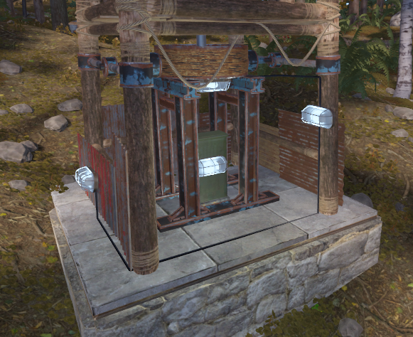

**Power Output Mechanics**

* Power Connections:
  + **Outputs:** Power Out
* Operates during both day and night.
* **Power Output:** Varies between 0 and 150rW, depending on elevation and wind conditions.
* **Wind Speed & Elevation:**
  + Wind speed becomes more consistent and powerful the higher the turbine is built above the buildable ground.
  + Structures built on beaches, mountaintops or icebergs experience the same wind behavior.
* **Optimal Height:** While placing a Wind Turbine at maximum build height provides the highest power output, it significantly increases building upkeep costs due to the required support structure. A mid-range height (8–12 floors above terrain) may offer a better balance between power efficiency and resource consumption.
* **Fluctuations:** Power generation is not constant and will change over time.

**Placement Considerations**

* **Obstructions** (trees, rock formations, walls, player-built objects) affect power generation.
* Requires a minimum of 15 meters (5 foundations) distance between turbines or other obstructions to prevent wind blockage.
* Can only be placed on foundations or floors. Requires a single square or 2 triangles to be placed on.
* Cannot be placed in water or within caves.
* Can be rotated with Reload (R) before placing.
* Cannot be picked up but can be destroyed by hammer within 10 minutes of placement. No resources are refunded.

**Notes**

* The largest renewable power source in Rust, but inconsistent.
* Works well with Large Batteries to store fluctuating power for stable output.
* Does not require fuel or upkeep once placed.
* Multiple turbines can be used with Root Combiners to centralize the power supplies.
* Wind speed fluctuates and is not constant.

# Large Solar Panel

**Item ID:** 2090395347

**Description:** Generates electricity from the Sun.

**Crafting Details**

* **Crafting Recipe:** 5 High Quality Metal, 1 Tech Trash
* **Stack Size:** 3
* **Workbench Required:** Level 1
* **Research Table Cost:** 75 Scrap
* **Where To Buy:** Outpost for 75 Scrap
* **Hit Points:** 100
* **Despawn Time:** 20 minutes
* **Decay Time:** 8 hours

**Power Output Mechanics**

* **Power Connections:**
  + **Outputs:** Power Out
* **Power Output:** 0-20rW

**Placement Considerations**

* Can be placed on the ground or flat building structures.
* Can be rotated with Reload(R).
* Large Solar Panels output electricity only during the day when the face of the panel can see the Sun.
* They will produce less power if they are damaged or the Sun is not making it to the entire panel's face.
* The ground, cliffs, trees and building blocks can all block the Sun.
* Deployables do not appear to block the Sun.

**Solar Cycle Mechanics**

* 24 hours in-game is 1 hour in real time.
* 1 in-game year is roughly 15 real days.
* The Sun will change locations in the sky throughout an in-game year.
* There is a summer and winter solstice, and there are roughly 7.5 real days between solstices.
* The Sun will start in the North at the beginning of the wipe. It will move a little further North before it starts to make its way South. It will make it to its more Southern point in roughly 8 real days before heading North again.

**Additional Notes**

* Holding a hammer while looking at the panel will show its health.
* It will auto repair over time with resources from the Tool Cupboard.

# Small Generator

**Item ID:** 1849887541

**Description:** Generates electricity from Low Grade Fuel.

**Crafting Details**

* **Crafting Recipe:** 5 High Quality Metal, 2 Gears
* **Stack Size:** 1
* **Workbench Required:** Level 2
* **Research Table Cost:** 75 Scrap
* **Where To Buy:** Outpost for 125 Scrap
* **Hit Points:** 100
* **Despawn Time:** 20 minutes

**Functionality**

* Small Generators will output electricity when they are turned on.
* You can Start and Stop them manually or use one of the electrical inputs.
* The last input to receive power is the function that is activated, even if power is still being applied to the opposite.
* They still produce max power when damaged.

**Power Mechanics**

* **Power Connections:**
  + **Inputs:**
    - Force Start - Turns the generator on.
    - Force Stop - Turns the generator off.
  + **Outputs:** Power Out
* **Fuel Consumption:** 500 Low Grade Fuel / 2 hours
* **Power Output:** 40rW

**Placement Considerations**

* Must be placed on floors, foundations, or the ground.
* Can be rotated with Reload(R).
* They can be picked up with a hammer but lose 20% health.
* Holding a hammer while looking at the generator will show its health.

Power Storage

Storing power for use at a later time is a great way at preventing circuits from going offline when the main power source reduces or stops producing power. For a more detailed explanation, check out Power Storage in the Concepts section.

# Small Rechargeable Battery

**Item ID**: -692338819

**Description**: Stores small amounts of electricity.

**Crafting Details**

* **Crafting Recipe**: 5 High Quality Metal
* **Stack Size**: 1
* **Workbench Requirement**: Level 1
* **Research Cost**: 20 Scrap
* **Hit Points**: 100
* **Despawn Time**: 5 minutes
* **Decay Time**: Not applicable

**Functionality**

* Stores small amounts of electricity for later use.
* Can be charged while simultaneously providing power.
* Keeps charge when picked up with a Hammer, but loses 20% health.

**Battery Mechanics**

* **Power Capacity:** 400rWm
* **Default Charge:** Starts with 37rWm.
* **Battery Active Usage**: 60 (It is 4x the output power and is what the battery will apply to another battery. It also defines its max power consumption.)
* **Power Consumption**: The battery will consume a max of 60rW. Giving it more than that will not speed up charging.
* **Efficiency Loss:** Batteries are only 80% efficient meaning that more power must be given to it to sustain a positive charging rate.
* **Charge Retention**: Holds charge indefinitely if no power is being consumed.
* **Pickup Penalty**: Picking up the battery reduces its health by 20%, but retains its charge.

**Power Output Mechanics**

* **Power Connections**:
  + **Inputs**: Power In
  + **Outputs**: Power Output, Fully Charged
* **Power Output**: 15rW
* **Fully Charged**: Outputs 1rW when reaching 400rWm.
  + If the 1rW is consumed, the battery receives 1 Active Usage.
* **Discharge Time**: 26 minutes with max Active Usage.
* **Max Active Usage**: 15 (due to 15rW max output)
* **Active Usage:** View a battery's current usage by holding a Wire Tool and look at the battery with TC authorization. It is used to calculate the discharge rate (often called drain).
* **Charging Formula:** ***Input Power = Active Usage / 0.8*** to determine the minimum input power needed for sustained charging.
* **Recharge Delay:** Upon depletion, no power is output until it charges up for a couple seconds. If the battery is still not receiving enough power, it will deplete in a second and the process repeats.
  + If the circuit after a battery is turning on and off, there is not enough incoming power to maintain a positive charge.

**Placement Considerations**

* Can be placed on horizontal building blocks or the ground.
* Can be placed on deployables like workbenches, repair benches, and storage boxes.
* Can be rotated with Reload (R) before placement.

# Medium Rechargeable Battery

**Item ID**: 2023888403

**Description**: Stores moderate amounts of electricity.

**Crafting Details**

* **Crafting Recipe**: 5 High Quality Metal, 1 Tech Trash
* **Stack Size**: 1
* **Workbench Requirement**: Level 2
* **Research Table Cost**: 75 Scrap
* **Hit Points**: 100
* **Where to Buy**: Bandit Camp for 75 Scrap

**Functionality**

* Stores moderate amounts of electricity for later use.
* Can be charged while simultaneously providing power.
* Keeps charge when picked up with a Hammer, but loses 20% health.

**Battery Mechanics**

* **Power Capacity**: 9000rWm
* **Default Charge**: Starts with 100rWm
* **Battery Active Usage**: 200 (4x the output power, defines max power consumption and charging rate)
* **Power Consumption**: The battery will consume a max of 200rW. Supplying more than that will not speed up charging.
* **Efficiency Loss**: Batteries are only 80% efficient, meaning more power must be given to sustain a positive charge.
* **Charge Retention**: Holds charge indefinitely if no power is being consumed.
* **Pickup Penalty**: Picking up the battery reduces its health by 20%, but retains its charge.

**Power Output Mechanics**

* **Power Connections**:
  + **Inputs**: Power In
  + **Outputs**: Power Output, Fully Charged
* **Power Output**: 50rW
* **Fully Charged**: Outputs 1rW when reaching 9000rWm.
  + If the 1rW is consumed, the battery receives 1 Active Usage.
* **Discharge Time**: 3 hours at max Active Usage.
* **Max Active Usage**: 50 (due to 50rW max output).
* **Active Usage Calculation**: Determines battery drain rate. View usage by holding a Wire Tool and looking at the battery with TC authorization.
* **Charging Formula:** ***InputPower = Active Usage / 0.8*** to determine the minimum input power needed for sustained charging.
* **Recharge Delay:** Upon depletion, no power is output until it charges up for a couple seconds. If the battery is still not receiving enough power, it will deplete in a second and the process repeats.
  + If the circuit after a battery is turning on and off, there is not enough incoming power to maintain a positive charge.

**Placement Considerations**

* Can be placed on horizontal building blocks or the ground.
* Significantly larger than the Small Battery (1.25m wide × 0.75m deep) and fits under a half-height floor.
* Can be rotated with Reload (R) before placement.

# Large Rechargeable Battery

**Item ID**: 553270375

**Description**: Stores large amounts of electricity.

**Crafting Details**

* **Crafting Recipe**: 10 High Quality Metal, 2 Tech Trash
* **Stack Size**: 1
* **Workbench Requirement**: Level 2
* **Research Table Cost**: 75 Scrap
* **Hit Points**: 100

**Functionality**

* Stores large amounts of electricity for later use.
* Can be charged while simultaneously providing power.
* Keeps charge when picked up with a Hammer, but loses 20% health.

**Battery Mechanics**

* **Power Capacity**: 24,000rWm
* **Default Charge**: Starts with 200rWm
* **Battery Active Usage**: 400 (4x the output power, defines max power consumption and charging rate)
* **Power Consumption**: The battery will consume a max of 400rW. Supplying more than that will not speed up charging.
* **Efficiency Loss**: Batteries are only 80% efficient, meaning more power must be given to sustain a positive charge.
* **Charge Retention**: Holds charge indefinitely if no power is being consumed.
* **Pickup Penalty**: Picking up the battery reduces its health by 20%, but retains its charge.

**Power Output Mechanics**

* **Power Connections**:
  + **Inputs**: Power In
  + **Outputs**: Power Output, Fully Charged
* **Power Output:** 100rW
* **Fully Charged:** Outputs 1rW when reaching 24,000rWm.
  + If the 1rW is consumed, the battery receives 1 Active Usage.
* **Discharge Time**: 4 hours at max Active Usage.
* **Max Active Usage**: 100 (due to 100rW max output).
* **Active Usage Calculation**: Determines battery drain rate. View usage by holding a Wire Tool and looking at the battery with TC authorization.
* Charging Formula: ***Input Power = Active Usage / 0.8*** to determine the minimum input power needed for sustained charging.
* **Recharge Delay:** Upon depletion, no power is output until it charges up for a couple seconds. If the battery is still not receiving enough power, it will deplete in a second and the process repeats.
  + If the circuit after a battery is turning on and off, there is not enough incoming power to maintain a positive charge.

**Placement Considerations**

* Can be placed on horizontal building blocks or the ground.
* Requires 2 square meters (2 foundation squares) of floorspace.
* Can be rotated with Reload (R) before placement.

Power Distribution

After electricity is generated, it must be efficiently directed to end devices and circuits. Power distribution components are essential electrical devices that manage, split, or combine Rustricity within a circuit. They do not generate or store power but instead create pathways for electricity flow and regulate power allocation between components. These devices play a critical role in efficient energy management, preventing wasted power while enabling complex circuit designs.

# Root Combiner

**Item ID**: -458565393

**Description**: Combines power from multiple sources.

**Crafting Details**

* **Crafting Recipe**: 75 Metal Fragments
* **Stack Size**: 5
* **Workbench Requirement**: Level 1
* **Research Table Cost**: 75 Scrap
* **Hit Points**: 200

**Functionality**

* The Root Combiner allows multiple power sources and other components to be merged, increasing the total available power on a single output.
* **Maximum depth limitation**: There is a hard limit of 16 components between a power source and the Root Combiner. When the limit is reached, the error "Short Circuit/Max Depth" will appear.

**Power Mechanics**

* **Power Connections**:
  + **Inputs**: Root Power 1, Root Power 2
  + **Output**: Combined Power Out
* **Power Consumption**: 0rW
* **Active Usage**: 0
* **Power Output**: Equal to the total input power (Root Power 1 + Root Power 2).
* **Power Sources** that can be combined:
  + Wind Turbines
  + Large Solar Panels
  + Small Generators
* **Other Components** that can be connected:
  + Batteries
  + Splitters
  + Reactive Target
* When batteries are combined using a Root Combiner, it is known as wiring in series.
* Series wiring increases total power available on the line but does not increase battery capacity. This means the load is applied to all connected batteries.
  + **Example:** If two batteries are connected through a Root Combiner to a circuit requiring 50rW, each battery will show 50 Active Usage, rather than splitting it 25/25.
* **Prevents power looping**: It will not recombine power that has already passed through itself, ensuring no unintended power storage occurs like the old Nih Capacitor.

**Placement Considerations**

* Place in protected areas to prevent their destruction by an enemy, as losing them could disable your electrical system.
* Can be placed on all building blocks.
* Can be rotated with Reload (R) before placement.

# Electrical Branch

**Item ID**: -1448252298

**Description**: Allows branching power off from a main line by a set amount.

**Crafting Details**

* **Crafting Recipe**:
  + 75 Metal Fragments
* **Stack Size**: 5
* **Workbench Requirement**: Level 1
* **Research Table Cost**: 75 Scrap
* **Hit Points**: 200

**Functionality**

* The Electrical Branch is used to allocate a specific amount of power to one output while passing the remainder through another.
* **Configurable output**: The Branch Out output can be adjusted to a set amount, while the Power Out output delivers whatever remains.
* Configured by pressing Use (E) while looking directly at the Branch.

**Power Mechanics**

* **Power Connections**:
  + **Input**: Power In
  + **Outputs**: Branch Out, Power Out
* **Power Consumption**: 0rW
* **Active Usage**: 0
* **Power Output**:
  + **Branch Out** = The configured power amount.
  + **Power Out** = Any remaining power after Branch Out allocation.
* **Minimum setting**: The lowest Branch Out value is 1rW, but it is pre-set to 2rW when placed.
* **Power Pass-Through Order**: The Electrical Branch first sends power through Power Out, then supplies the Branch Out output.
* **Battery Interaction**:
  + The Branch Out value determines the maximum power that can be consumed and therefore, under most circumstances, the max Active Usage that will register on a battery.
  + Only the power actually consumed from Branch Out will register as Active Usage.
    - Example: If Branch Out is set to 15 but is connected to an Auto Turret that only needs 10rW, only 10rW will be consumed and only 10 Active Usage will be registered.
  + The Branch Out output doesn't actually limit Active Usage to its set value. If components past the Branch Out are powered by another source, the full Active Usage of those components will register through the Electrical Branch and back to a battery.
    - Example: 1 Electrical Branch is set to 5, connected to a Splitter and to a Root Combiner. The other Electrical Branch is set to 5, connected to a Splitter and to the Root Combiner. There is now 10rW going to the Search Light. Each battery has an Active Usage of 10, not 5 as we might expect.

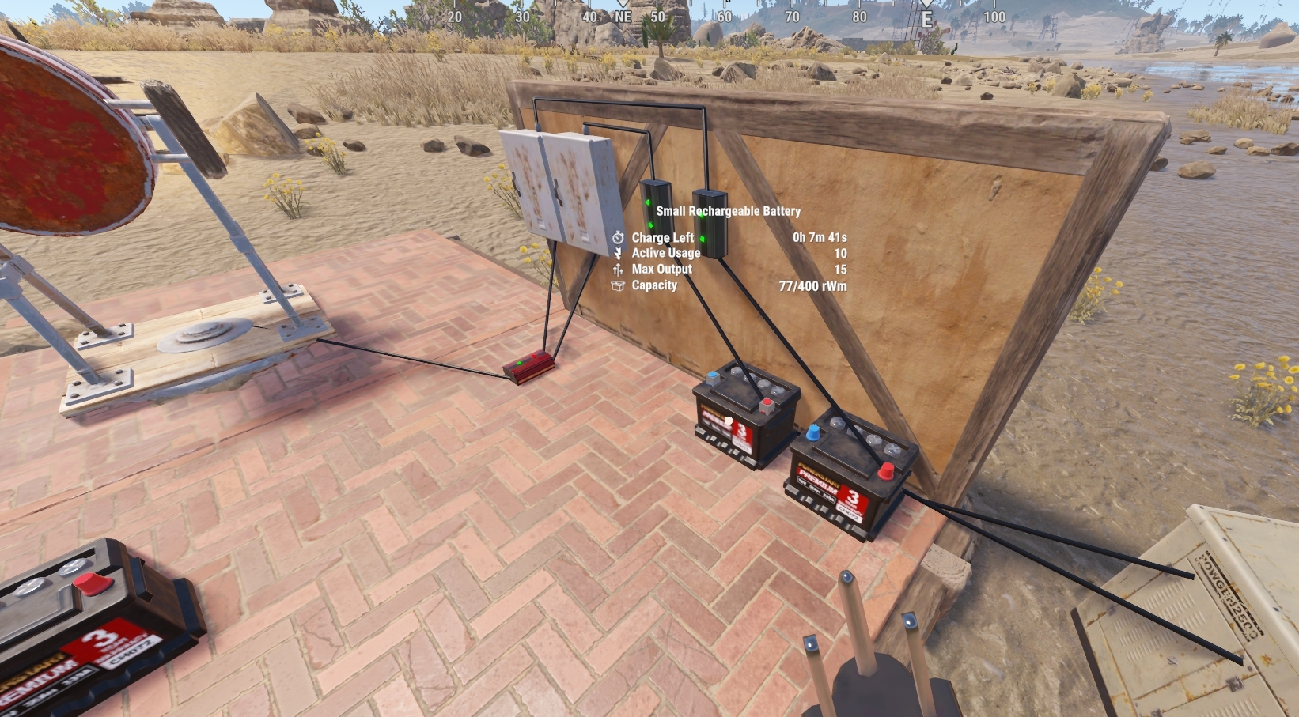

**Placement Considerations**

* Can be placed on all building block surfaces.
* Can be rotated with Reload (R) before placement.

# Splitter

**Item ID:** -563624462

**Description:** Splits power evenly between up to three outputs.

**Crafting Details**

* **Crafting Recipe:**
  + 100 Metal Fragments
* **Stack Size:** 5
* **Workbench Requirement:** Level 1
* **Research Table Cost:** 20 Scrap
* **Hit Points:** 500

**Functionality**

* The Splitter divides incoming power evenly between up to three connected outputs.

**Power Mechanics**

* **Power Connections:**
  + **Input:** Power In
  + **Outputs:** Power Out 1, Power Out 2, Power Out 3
* **Power Consumption:** 0rW
* **Active Usage:** 0
* **Power Output:**
  + Each output receives Input Power ÷ Number of Active Outputs.
* **Power distribution order:**
  + When the Splitter receives power, it does not pass power through all outputs at the same time.
  + Power is distributed sequentially, starting with Output 1, then Output 2, and finally Output 3.
* **Dynamic redistribution:**
  + If an output is destroyed or disconnected, the Splitter will automatically redistribute power between the remaining active outputs.
* **Uneven power distribution handling:**
  + If the input power cannot be divided evenly, the remaining power is prioritized as follows:
    - Output 1 and Output 2 receive the extra power first.
    - If power still cannot be split evenly, Output 1 gets the remainder.
  + **Example:**
    - 15rW input with 3 outputs → Each output gets 5rW.
    - 16rW input with 3 outputs → Output 1 = 6rW, Output 2 = 5rW, Output 3 = 5rW.

**Placement Considerations**

* Can only be placed on vertical walls.
* Can be flipped with Reload (R) before placement.
* Outputs can be connected to the inputs of Root Combiners

# Cable Tunnel (NOT CRAFTABLE)

**Item ID**: 1835946060

**Description**: Allows wires to pass through walls.

**Crafting Details**

* **Crafting Recipe**: Cannot be crafted
* **Recycles Into**: 5 High Quality Metal
* **Stack Size**: 1
* **Research Table Cost:** Blueprints cannot be created
* **Hit Points**: ∞

**Functionality**

* The Cable Tunnel is an admin-spawned item and was designed to allow wires to pass through walls when the idea existed to prevent direct wire placement through building block. This is clearly not the case today so this component is no longer used.
* When placed, the player-facing side provides four inputs, while the opposite side of the wall provides four matching outputs.
* The Cable Tunnel has no hit points, meaning it cannot be destroyed.
* Supports up to four independent connections, each with a matching input/output pair.

**Power Mechanics**

* **Power Connections**:
  + **Inputs**: Tunnel 1 In, Tunnel 2 In, Tunnel 3 In, Tunnel 4 In
  + **Outputs**: Tunnel 1 Out, Tunnel 2 Out, Tunnel 3 Out, Tunnel 4 Out
* **Active Usage**: 1 per Input
* **Power Consumption**: 1rW per Input
* **Power Output**: Input minus 1

**Placement Considerations**

* Can be placed on all building block.
* Cannot be rotated.
* Once placed, it cannot be picked up with a Hammer, making its placement permanent.
* It does not support component snapping.

Switches

Switches are components that, for the most part, require a player to Use(E). They can only be operated voluntarily and never by accident. They connect or disconnect the electrical path to a circuit, i.e. turn things on and off.

# Switch

**Item ID**: 1951603367

**Description**: A manually operated electrical switch that toggles power on and off.

**Crafting Details**

* **Crafting Recipe**: 100 Metal Fragments
* **Recycles Into**: 50 Metal Fragments
* **Stack Size**: 5
* **Workbench Requirement**: Level 1
* **Research Table Cost**: 20 Scrap
* **Hit Points**: 200

**Functionality**

* The Switch allows players to control power flow manually by pressing Use (E) while looking at it.
* Anyone can operate the Switch—it does not require TC authorization.

**Power Mechanics**

* **Power Connections**:
  + **Inputs**: Electric Input, Switch On, Switch Off
  + **Outputs**: Power Out
* **Power Consumption**: 0rW
* **Active Usage**: 0
* **Power Output**: Equal to input power when switched ON.
* **Power Control Inputs**:
  + Power applied to **"Switch On"** will turn the Switch ON.
  + Power applied to **"Switch Off"** will turn the Switch OFF.
* **No Input Priority**:
  + If power is applied to both Switch On and Switch Off, the last activated input determines the Switch's state.
  + **Example**: If "Switch On" is powered, and later "Switch Off" receives power, the switch will turn OFF, even if "Switch On" still has power.

**Placement Considerations**

* Can only be placed on vertical surfaces.
* Can be rotated with Reload (R) before placement.

# Button

**Item ID**: -1778897469

**Description**: Allows power to pass through when pressed.

**Crafting Details**

* **Crafting Recipe**: 75 Metal Fragments
* **Stack Size**: 5
* **Workbench Requirement**: Level 1
* **Research Table Cost**: 20 Scrap
* **Hit Points**: 200

**Functionality**

* The Button is a momentary switch that pulses power for 0.25 seconds when pressed.
* It remains visually depressed for 1 second, but the power pulse duration is always 0.25 seconds.

**Power Mechanics**

* **Power Connections**:
  + **Input**: Electric Input
  + **Output**: Power Out
* **Power Consumption**: 0rW
* **Active Usage**: 0
* **Power Output**:
  + Minimum 2rW (if no input power is provided).
  + Equal to input power if greater than 2rW.
* **Minimum Power Output**:
  + If pressed with no input power, it generates 2rW for 0.25 seconds.
  + If input power is greater than 2rW, it outputs the same power level as the input.

**Placement Considerations**

* Can only be placed on vertical surfaces.
* Can be rotated with Reload (R) before placement.

# Reactive Target

**tem ID**: -1736356576

**Description**: Use it for target practice, fun, and more.

**Crafting Details**

* **Crafting Recipe**: 100 Wood, 150 Metal Fragments, 1 Gear
* **Stack Size**: 1
* **Workbench Requirement**: Level 1
* **Research Table Cost**: 20 Scrap
* **Hit Points**: 250

**Functionality**

* The Reactive Target is an interactive shooting target that can pass power through when shot down and automatically stands back up.
* It has electrical inputs to control the position of the target.

**Power Mechanics**

* **Power Connections**:
  + **Inputs**: Power In, Reset, Lower
  + **Outputs**: Power Out
* **Power Consumption**: 1rW
* **Active Usage**: 1
* **Power Output**: Input power minus 1rW
* **Reset & Lower Inputs**:
  + **Reset**: Stands the target back up when powered.
  + **Lower**: Keeps the target down until reset.
  + **No priority between Reset and Lower**—whichever input is **last powered** determines the target's state.
* **Counter Interaction Issue**:
  + If the Reactive Target’s output is connected to the side input of a Counter, a ghost pulse may cause it to count twice.
  + **Fix**: Either do not power the target or place one power-consuming component between the target and the Counter’s side input.
* **Free Power Behavior**:
  + If no power is supplied and the target is lowered manually, it remains down and does not generate power.
  + If no power is supplied and the target is shot, it generates a 1rW pulse and remains down for 5 seconds before resetting to the upright position.
* **Powered Behavior**:
  + If powered and lowered manually, it stays down and continuously outputs the incoming power.
  + If powered and shot, it outputs the incoming power for 5 seconds, then resets to the upright position.
* Attaching the Power Out to the Lower input will prevent the target from standing up until it either receives power to the Reset input or is manually reset.

**Placement Considerations**

* Can be placed on floors, foundations, or the ground.
* Can be rotated with Reload (R) before placement.
* Takes damage when hit or shot so it will need to be repaired over time to maintain functionality.
* Health is displayed when looking at the target.
* Can be reskinned using the Spray Can tool.
* Can be connected to Root Combiners.

Sensors

Sensors are passive components that do not require a player to Use(E). They automatically detect or respond to the presence of a player's character model or explosions. Unlike switches, which require manual activation, sensors function autonomously to control power flow.

# HBHF Sensor

**Item ID**: -1507239837

**Description**: Detects heartbeats, breathing, humidity, and footsteps.

**Crafting Details**

* **Crafting Recipe**: 75 Metal Fragments
* **Stack Size**: 1
* **Workbench Requirement**: Level 2
* **Research Table Cost**: 75 Scrap
* **Hit Points**: 200

**Functionality**

* The HBHF Sensor detects awake players, NPCs, and scientists within its detection range. (Does not detect sleepers)
* **Detection Range**: Roughly 11 meters (approximately 3.5 square foundations).

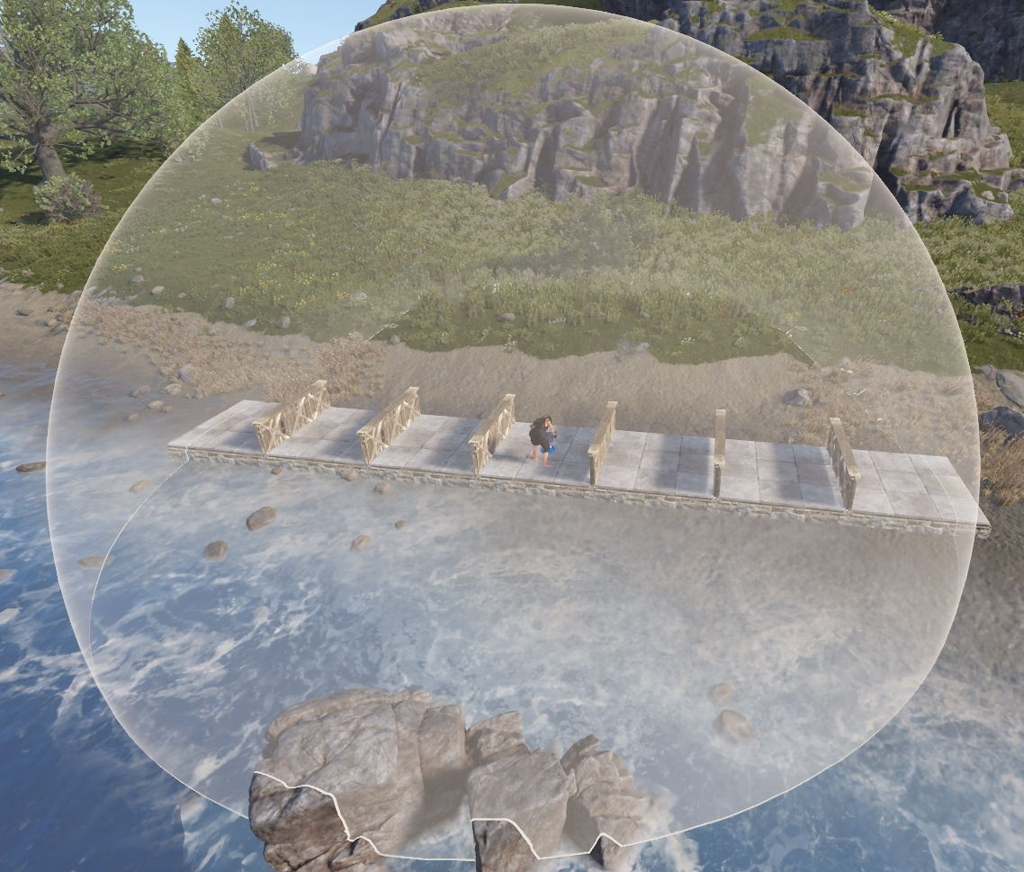

* **Line of Sight Required**:
  + The sensor must have an unobstructed view of the target to detect them.
  + Most deployables do not obstruct the sensor's line of sight.
  + Crouching under a half-height floor does not prevent detection from above.
  + The sensor can be built in ways that allow it to see through walls, floors, and roofs.
* **Deployables that do block the HBHF Sensor**:
  + Rustigé Egg - White
  + Vending Machines
  + Chippy Machine
  + Large Water Catcher
  + Oil Refinery
  + Deck of the Large Pool
* **Configuration Settings**:
  + Can be set to detect Authorized and Unauthorized players.
  + Sensor range can be set from 1 to 10 meters
  + If TC authorized, look at the sensor and press Use (E) to toggle settings.

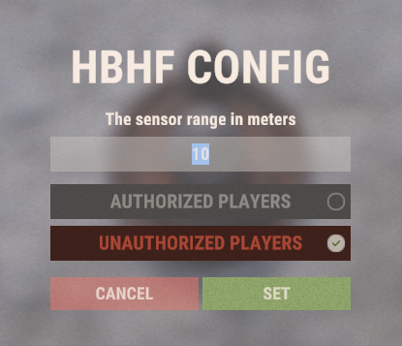

**Power Mechanics**

* **Power Connections**:
  + **Input**: Power In
  + **Output**: Power Out
* **Power Consumption**: 1rW
* **Active Usage**: 1
* **Power Output**:
  + 1rW per person detected.
  + If connected to a Counter set to Show Passthrough, it will display the number of people the sensor detects.
* **Scientist Detection**:
  + Detects all scientist types, including those riding in the CH-47 Chinook.

**Placement Considerations**

* Can be placed on all angled surfaces and the ground.
* Can be rotated with Reload (R) before placement.

# Laser Detector

**Item ID**: -798293154

**Description**: Passes power through when a person is in the beam.

**Crafting Details**

* **Crafting Recipe**: 75 Metal Fragments
* **Stack Size**: 5
* **Workbench Requirement**: Level 2
* **Research Table Cost**: 75 Scrap
* **Hit Points**: 200

**Functionality**

* The Laser Detector projects a continuous laser beam that activates power when a player enters the beam.
* **Detection Range**:
  + The laser extends just over 12 meters (4 foundations) and detects players across its full length.
* **Detection Mechanics**:
  + Detects players approaching straight on.
  + Can be crouched under and jumped over to avoid detection.
  + Placing the detector closer than 0.5m to a single door may cause it to miss detecting a player running through from the opposite side.
* **Deployable & Vehicle Interaction**:
  + The laser is blocked by all deployables.
  + The laser detects the following objects:
    - All Land, sea, and air vehicles (including NPC helicopters, excluding horses)
    - Mounted Ballistas, Battering Rams, Catapults, Siege Towers, Supply Crates and Drones

**Power Mechanics**

* **Power Connections**:
  + **Input**: Power In
  + **Output**: Power Out
* **Power Consumption**: 1rW
* **Active Usage**: 1
* **Power Output**: Power input minus 1rW

**Placement Considerations**

* Can be placed on all building structures.
* Can be rotated with Reload (R) before placement.
* Can be placed in floors before upgrading to detect players walking above.

# Pressure Pad

**Item ID**: -2049214035

**Description**: A floor-based sensor that activates when stepped on.

**Crafting Details**

* **Crafting Recipe**: 150 Wood, 1 Spring, 1 Gear
* **Stack Size**: 1
* **Workbench Requirement**: Level 1
* **Research Table Cost**: 20 Scrap
* **Hit Points**: 200

**Functionality**

* The Pressure Pad is a trigger mechanism that detects movement when stepped on.
* Detects land, sea, and air vehicles, including:
  + Horses
  + Frankenstein’s Monster
* Can be triggered through half-height floors from below or ramps from above.
* Many deployable items can be placed on top of the pad without affecting its functionality, including:
  + Sleeping Bags, Chairs, Rugs, and Planter Boxes.

**Power Mechanics**

* **Power Connections**:
  + **Input**: Power In
  + **Output**: Power Out
* **Power Consumption**: 0rW
* **Active Usage**: 0
* **Power Output**: Equal to input power
* Briefly generates 1rW when pressed, even without power input.
* If powered, the pad pulses 1rW first before outputting the incoming power.

**Placement Considerations**

* Can only be placed on floors or foundations.
* Can be rotated with Reload (R) before placement.
* Can be connected to Root Combiners.

# Seismic Sensor

**Item ID**: -94829630

**Description**: Detects vibrations from explosions within 30 meters.

**Crafting Details**

* **Crafting Recipe**: 3 High-Quality Metal, 1 Tech Trash
* **Stack Size**: 10
* **Workbench Requirement**: Level 2
* **Research Table Cost**: 75 Scrap
* **Hit Points**: 200

**Functionality**

* The Seismic Sensor is designed to detect explosions within a maximum radius of 30.5 meters (10 foundations).
* When an explosion occurs within range, the sensor outputs power for 3 seconds, with the amount of power depending on the explosion type.
* If placed within Tool Cupboard (TC) range, it will auto-repair over time using TC resources.

**Power Mechanics**

* **Power Connections**:
  + **Input**: Power In
  + **Output**: Power Out
* **Power Consumption**: 1rW
* **Active Usage**: 1
* **Power Output**:
  + 1rW, 2rW, or 3rW, depending on the explosion type and amount of available input power.
  + **Output Duration**: 3 seconds per explosion detected.
* **Explosion Detection & Power Output**
* **Outputs 1rW for:**
  + Beancan Grenade
  + F1 Grenade
  + Smoke Rocket
  + Incendiary Rocket
  + High Velocity Rocket
  + Homing Missile
  + SAM Ammo
  + Exploding Minicopter
  + Exploding Transport Helicopter
  + Exploding Attack Helicopter
  + Homemade Landmine
  + Patrol Helicopter (Rocket)
  + Bradley APC (Main Cannon)
  + Exploding Flame Turret
  + Firebomb
* **Outputs 2rW for:**
  + Explosive 5.56 Ammo
  + Satchel Charge
  + 40mm HE Grenade
  + Torpedo
  + Propane Explosive Bomb
  + Battering Ram
  + Hammerhead Bolt
* **Outputs 3rW for:**
  + Rocket
  + MLRS Rocket
  + Timed Explosive Charge

**Output Power Separation**

When the sensor outputs power, the question is often raised about how to identify which explosion was detected. One simple way is to wire a series of Electrical Branches all set to 1. With a large enough explosion, power will go into all 3 lights. The lights are just a representation of the signal. Players can choose what to do with the 1rW.

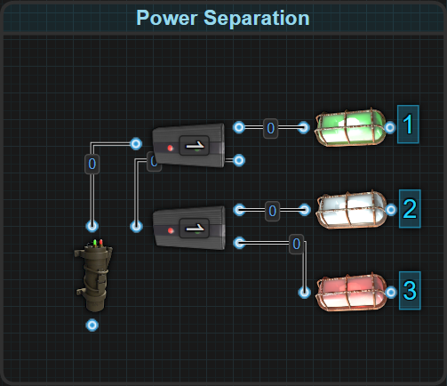

If players only want to trigger 1 thing instead of all 3, some Memory Cells can be introduced.

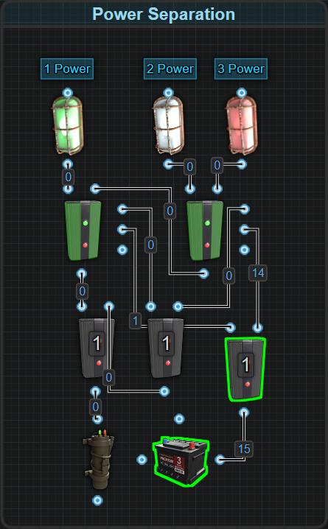

**Placement Considerations**

* Can be placed on the ground and all building structures.
* Cannot be rotated.

# 

Logic

Logic components are used to control power flow based on specific conditions. Unlike simple switches, which are manually operated, logic components allow circuits to function dynamically by determining when and how power should be transmitted. These components enable advanced automation and intelligent systems by combining multiple inputs and outputs to create logical operations within a circuit. Systems that use these components will often, but not limited to, follow the rules of Boolean logic.

# Blocker

**Item ID**: -690968985

**Description**: Blocks power passthrough when power is applied to its side input.

**Crafting Details**

* **Crafting Recipe**: 75 Metal Fragments
* **Stack Size**: 5
* **Workbench Requirement**: Level 1
* **Research Table Cost**: 20 Scrap
* **Hit Points**: 200

**Functionality**

* The Blocker functions as a NOT gate, preventing power from passing through when the Block Passthrough input is powered.
* Here is the components truth table
* 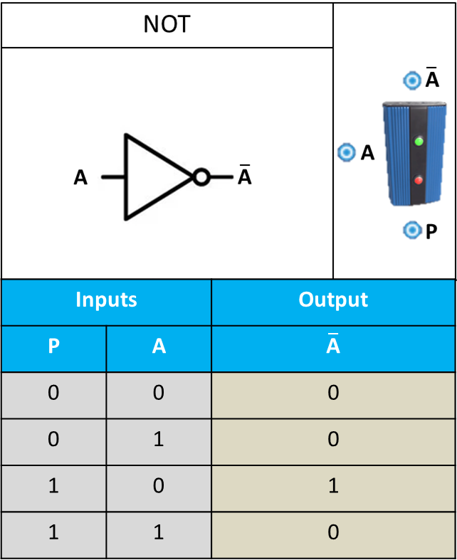

**Power Mechanics**

* **Power Connections**:
  + **Inputs**: Power In, Block Passthrough
  + **Output**: Power Out
* **Power In:** The main power input.
* **Block Passthrough:** A side input that, when powered, prevents power from passing through to the output.
* **Power Consumption**: 0rW
* **Active Usage**: 0
* **Power Output**: Equal to input power unless blocked.

**Placement Considerations**

* Can be placed on all building block and the ground.
* Can be rotated with Reload (R) before placement.

# Memory Cell

**Item ID**: -746647361

**Description**: Sends power through one of two outputs based on side inputs selected.

**Crafting Details**

* **Crafting Recipe**: 75 Metal Fragments
* **Stack Size**: 5
* **Workbench Requirement**: Level 2
* **Research Table Cost**: 75 Scrap
* **Hit Points**: 200

**Functionality**

* The Memory Cell functions as a flip-flop circuit, meaning it stores its power state until explicitly changed by an input.
* The Memory Cell only changes state when a Set, Reset, or Toggle signal is received.
* **Input Priority Order (Top to Bottom)**:
  + Set → Reset → Toggle
  + If power is applied to Set, and then Reset or Toggle, nothing changes and power flows through the right output (Output).
  + If power is applied to Reset, then Toggle, nothing changes and power flows through the left output (Inverted Output).
  + If power is applied to Reset, then Set, power is forced from the Inverted Output to Output.
  + 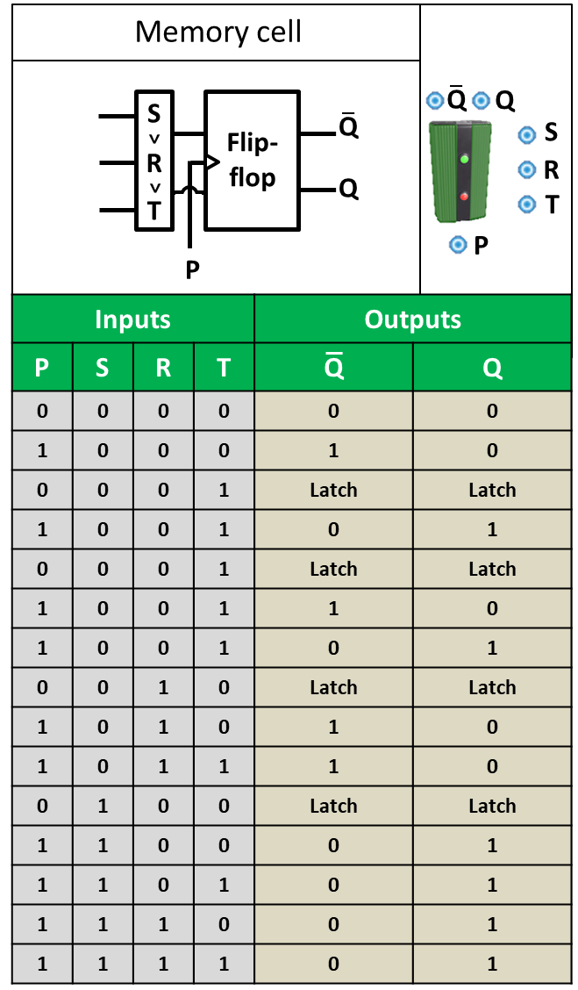
* **Switching Behavior**:
  + When switching from one output to the other, Output always reacts before Inverted Output.
  + If the Memory Cell is in its default state (power coming from Inverted Output) and receives a pulse on Set, the Inverted Output will stop sending power before Output begins sending power.
  + If a pulse is then applied to Reset, the Inverted Output will start sending power before Output stops sending power.
  + This means that when toggling states, there is a brief moment where both outputs will be active or inactive simultaneously before settling into the final state.
* **Requires Power**:
  + The Memory Cell must be powered for its side inputs to change its state.
  + If power is applied to one of the side inputs when the Memory Cell powers up, it will pass power through before changing state.

**Power Mechanics**

* **Power Connections**:
  + **Inputs**: Power In, Set, Reset, Toggle
  + **Outputs**: Output(Right), Inverted Output(Left)
* **Power Consumption**: 0rW
* **Active Usage**: 0
* **Power Output**: Equal to input power
* **Default Output:** When powered on, the Memory Cell's default output is the Inverted Output.
* **Set Input:** Sends power through Output.
* **Reset Input:** Sends power through Inverted Output.
* **Toggle Input:** Flips the current output state between Output and Inverted Output.
  + **Toggle BUG:** This feature is used by applying constant power to the Toggle input. Every time the circuit is updated, the Memory Cell will switch outputs. Updates include power fluctuations from wind or solar power and the addition or removal of components from a connected circuit. To avoid this causing issues, pulse power to the Toggle input rather than applying constant power.

**Placement Considerations**

* Can be placed on all building block.
* Can be rotated with Reload (R) before placement.

# Timer

**Item ID:** 665332906

**Description:** Passes power through for a set period of time.

**Crafting Details**

* **Crafting Recipe:** 75 Metal Fragments
* **Stack Size:** 5
* **Workbench Requirement:** Level 1
* **Research Table Cost:** 20 Scrap
* **Hit Points:** 200

**Functionality**

* The Timer allows power to pass through for a configurable duration before automatically shutting off.
* **Activation Methods:**
  + Can be manually activated by a player pressing Use (E).
  + Can be activated remotely by applying power to the Toggle On input.
* **Time Configuration:**
  + To adjust the duration, look at the Timer and hold Use (E) to bring up the configuration menu.
  + **Default duration:** 10 seconds.
  + **Minimum duration:** 0.25 seconds (may be too fast on some servers).
  + **Maximum tested duration:** At least 2 weeks IRL.
  + Only Tool Cupboard (TC) authorized players can adjust the timer duration.
  + It does not need to be powered to set the duration.
* **Triggering Condition:**
  + Power must reach Electric Input before the Toggle On input for the Timer to activate.

**Power Mechanics**

* **Power Connections:**
  + **Inputs:** Electric Input, Toggle On
  + **Output:** Power Out
* **Power Consumption:** 0rW
* **Active Usage:** 0
* **Power Output:** Equal to input power for the configured duration

**Placement Considerations**

* Can only be placed on vertical walls.
* Cannot be rotated.

# RAND Switch

**Item ID**: 492357192

**Description**: Achieves a 50% passthrough rate when Set.

**Crafting Details**

* **Crafting Recipe**: 75 Metal Fragments
* **Stack Size**: 5
* **Workbench Requirement**: Level 2
* **Research Table Cost**: 20 Scrap
* **Hit Points**: 200

**Functionality**

* This component is required when designing circuits that require randomness.
* **Probability Adjustments**:
  + On its own, the RAND Switch offers a 50% chance (1/2 probability).
  + When combined with multiple RAND Switches and logic gates, probabilities can be adjusted to 1/3, 1/4, or beyond.
  + 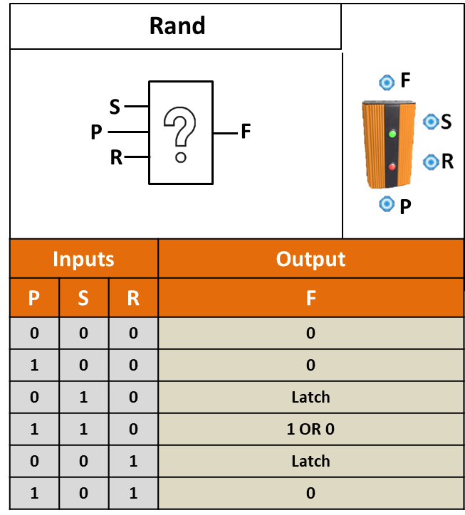

**Power Mechanics**

* **Power Connections**:
  + **Inputs**: Power In, Set, Reset
  + **Output**: Power Out
* **Power Consumption**: 0rW
* **Active Usage**: 0
* **Power Output**: Equal to input power
* When first placed, the RAND Switch's default state is off, meaning it does not send power through.
* **Set Input:** When power is applied, there is a 50% chance the switch will change states.
  + If the switch is on, it has a 50% chance to turn off.
  + If the switch is off, it has a 50% chance to turn on.
* **Reset Input:** When power is applied, it forces the switch off.

**Placement Considerations**

* Can be placed on all building block.
* Can be rotated with Reload (R).

# OR Switch

**Item ID**: -1286302544

**Description**: Passes power through from 1 input OR the other.

**Crafting Details**

* **Crafting Recipe**: 100 Metal Fragments
* **Stack Size**: 5
* **Workbench Requirement**: Level 1
* **Research Table Cost**: 20 Scrap
* **Hit Points**: 200

**Functionality**

* The OR Switch passes power through from either Input A or Input B, but only from the input with the higher power level.
* If both inputs have equal power, the switch prioritizes Input A over Input B.
* The inactive input is completely blocked, preventing unnecessary Active Usage on a connected battery.
* Here is a circuit diagram that explains the priority of the inputs on the OR Switch. <https://www.rustrician.io/?circuit=f8cf02fb8083ad5ff7e9a2fb0ea41a71>
* 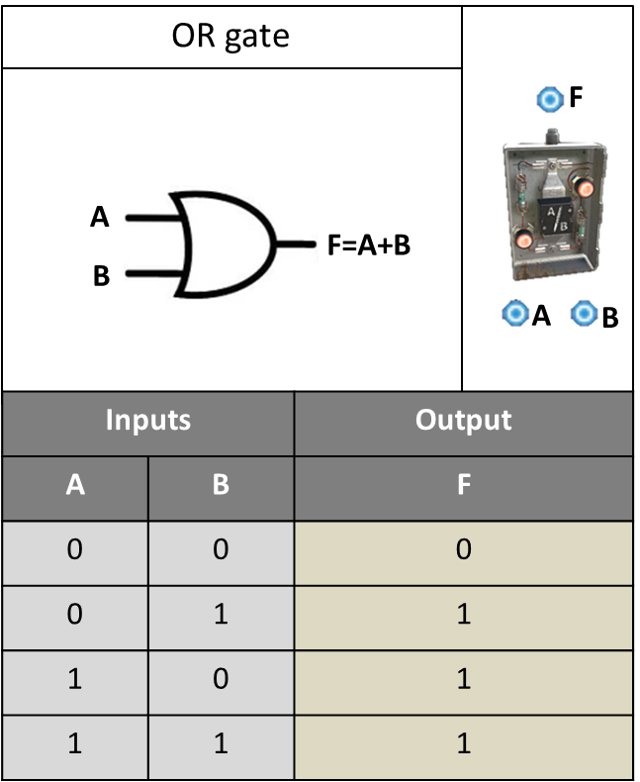

**Power Mechanics**

* **Power Connections**:
  + **Inputs**: Input A, Input B
  + **Output**: Power Out
* **Power Consumption**: 0rW
* **Active Usage**: 0
* **Power Output**: Equal to the higher power input

**Placement Considerations**

* Can only be placed on vertical building block.
* Cannot be rotated.

# AND Switch

**Item ID**: 1171735914

**Description**: **Passes power through when both inputs have power.**

**Crafting Details**

* **Crafting Recipe**: 100 Metal Fragments
* **Stack Size**: 5
* **Workbench Requirement**: Level 2
* **Research Table Cost**: 20 Scrap
* **Hit Points**: 200

**Functionality**

* The AND Switch **requires both Input A and Input B** to have power in order to pass power through.
* Only the input with the **higher power level will be passed through.** It is only through this input that power is consumed. Therefore it is through this input that Active Usage can be applied to a battery.
* If both inputs have equal power, the **switch prioritizes Input A** over Input B.
* Here is a circuit diagram that explains the priority of the inputs on the AND Switch. <https://www.rustrician.io/?circuit=24d63ce774a4a83d7f237e88049bf2e5>
* Here is the truth table for the AND Switch.
* 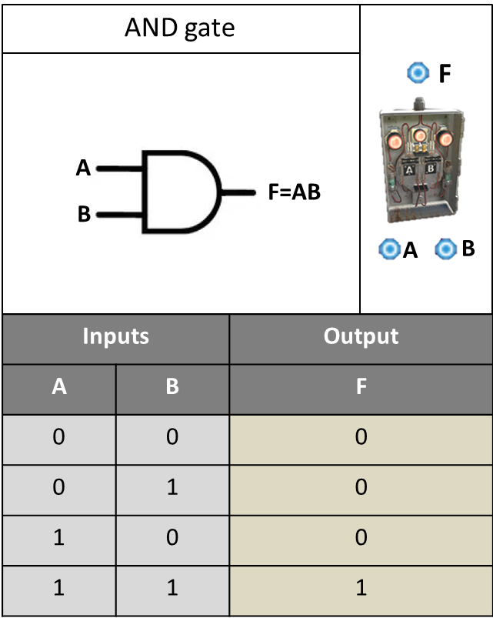

**Power Mechanics**

* **Power Connections**:
  + **Inputs**: Input A, Input B
  + **Output**: Power Out
* **Power Consumption**: 0rW
* **Active Usage**: 0
* **Power Output**: Equal to the higher power input

**Placement Considerations**

* Can only be placed on vertical building block.
* Cannot be rotated.

# XOR Switch

**Item ID**: 1293102274

**Description**: Passes power through from only 1 input at a time.

**Crafting Details**

* **Crafting Recipe**: 100 Metal Fragments
* **Stack Size**: 5
* **Workbench Requirement**: Level 1
* **Research Table Cost**: 20 Scrap
* **Hit Points**: 200

**Functionality**

* The XOR Switch allows power to pass through **only when one input is powered at a time**.
* If both Input A and Input B receive power simultaneously, the switch will block power from passing through entirely.
* This is the truth table for the XOR Switch.
* 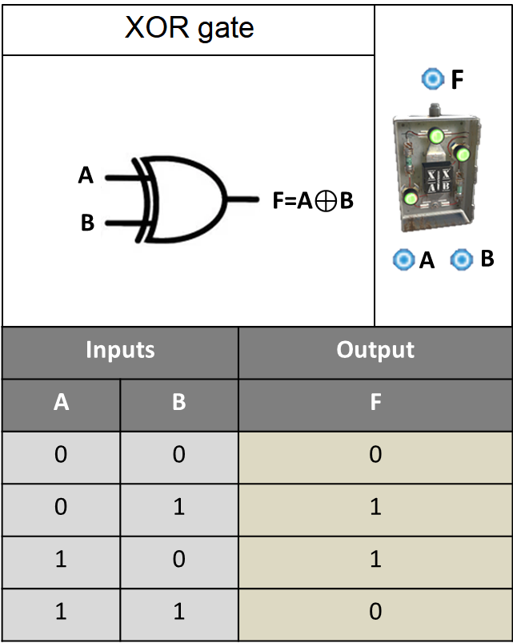

**Power Mechanics**

* **Power Connections**:
  + **Inputs**: Input A, Input B
  + **Output**: Power Out
* **Power Consumption**: 0rW
* **Active Usage**: 0
* **Power Output**: Equal to the powered input

**Placement Considerations**

* Can only be placed on vertical building block.
* Cannot be rotated.

# Counter

**Item ID**: -216999575

**Description**: Counts or monitors power levels.

**Crafting Details**

* **Crafting Recipe**: 75 Metal Fragments
* **Stack Size**: 5
* **Workbench Requirement**: Level 2
* **Research Table Cost**: 75 Scrap
* **Hit Points**: 100

**Functionality**

* The Counter tracks and stores a numerical value based on received power pulses.
* **Configuration**:
  + To configure the Counter, use a Wire Tool, look at it, and hold Use (E).
  + **Set Target**: Allows programming a target number between 1 and 999. When the Counter reaches this number, power will pass through.
  + **Show Passthrough**: Displays the incoming power amount instead of the stored count.
* Holding a Hammer while looking at the Counter will display its health.
* Auto-repairs over time.
* **Counting Behavior**:
  + **Increment Counter**: When powered, increases the stored value by 1.
  + **Decrement Counter**: When powered, decreases the stored value by 1.
  + **Clear Counter**: When powered, resets the stored value to 0.
* The Counter does not need power to increment, decrement, or reset.

**Power Mechanics**

* **Power Connections**:
  + **Inputs**: Power In, Increment Counter, Decrement Counter, Clear Counter
  + **Output**: Passthrough
* **Power Consumption**: 0rW
* **Active Usage**: 0
* **Power Output**: Equal to input power

**Destruction Feature**

* When Counters are placed on the floor or ground, on their thin side, they self-destruct under certain conditions.
* 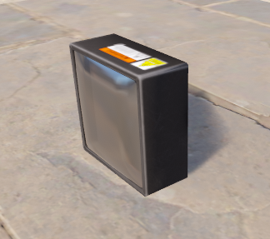
* Counters placed on their thin sides will disappear when nearby deployables (e.g., furnaces, sleeping bags) are removed within a 2-meter radius.
* 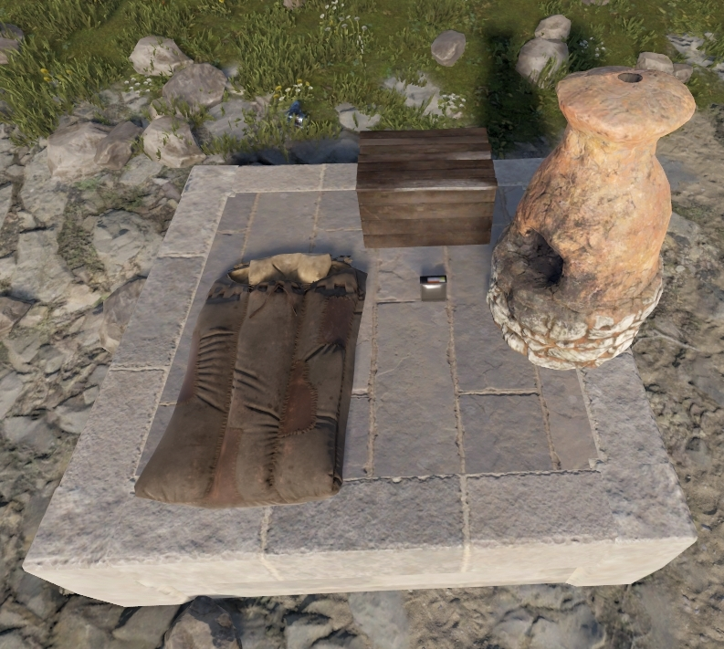
* Counters placed on their thin sides will disappear when a building structure is built or destroyed within a 3-meter radius.
* 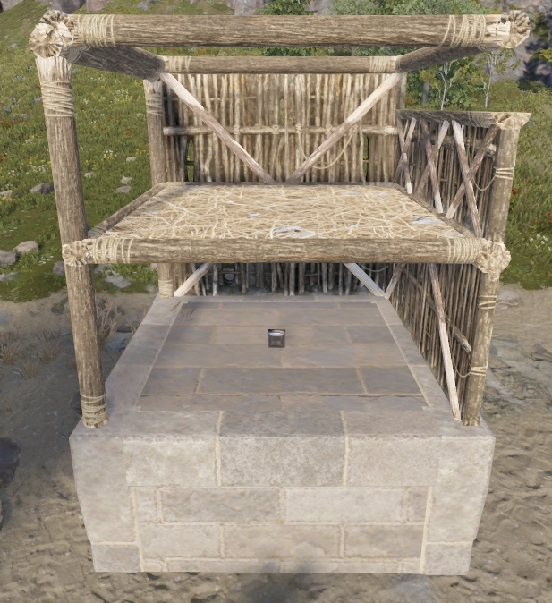

**Placement Considerations**

* Can be placed on vertical building block.
* Can be placed on horizontal surfaces and the ground using its thin side.
* Can be rotated with Reload (R).
* Certain items can be placed on top of a Counter, including: Lanterns, Jack-o-Lanterns, Carvable Pumpkins, Barricades, Pookie Bear, Twitch Trophy, Eggs, and Small Candle.
  + Multiple Counters can be combined to create a larger surface, allowing placement of larger items like Small Batteries.

Radio Frequency (RF)

RF Components allow for wireless communication and remote activation within electrical circuits. These devices transmit, receive, or interact with Radio Frequencies (RF) to react to or control power flow without the need for direct wiring. They are primarily used for remotely triggering electrical circuits, receiving alerts, and integrating automation systems.

**Radio Frequency (RF) Mechanics**

* Radio Frequency (RF) is a signal that can be sent or received anywhere on the map.
* **Frequency Range:** RF operates between 1 MHz and 999,999 MHz.
* **Pre-Set RF Signals for Monuments:**
  + **Small Oil Rig:** 4765 MHz
  + **Large Oil Rig:** 4768 MHz
  + **Giant Excavator:** 4777 MHz
  + These will transmit for 1 minute when activated.
* **Frequency Restrictions:**
  + Transmitters cannot be set to frequencies between 4760 and 4790 MHz.
  + Receivers can be set to frequencies between 4760 and 4790 MHz.

# RF Broadcaster

**Item ID:** -1044468317

**Description:** Generates an RF signal.

**Crafting Details**

* **Crafting Recipe:** 150 Metal Fragments
* **Stack Size:** 1
* **Workbench Requirement:** Level 2
* **Research Table Cost:** 20 Scrap
* **Hit Points:** 50

**Functionality**

* The RF Broadcaster transmits an RF signal to all RF Receivers and Pagers tuned to the same frequency.
* It continuously sends an RF signal as long as it receives power.
* Look at the Broadcaster and press Use(E) to set its frequency.

**Power Mechanics**

* **Power Connections:**
  + **Inputs:** Power In
* **Power Consumption:** 1rW
* **Active Usage:** 1
* **Power Output:** None (wireless transmission only)

**Placement Considerations**

* **Can be placed on most flat surfaces, including:**
  + Workbenches, Tool Cupboards, and even a Splitter.
  + Placing RF Broadcasters on top of locked Tool Cupboard will prevent raiders from ever acquiring the RF frequency.
* Can be rotated with Reload (R).
* Does not work with component snapping.
* Looking at the broadcaster will show its health.
* Auto-repairs over time with resources from the Tool Cupboard.

# RF Receiver

**Item ID**: 888415708

**Description**: Receives an RF signal to output power.

**Crafting Details**

* **Crafting Recipe**: 150 Metal Fragments
* **Stack Size**: 1
* **Workbench Requirement**: Level 2
* **Research Table Cost**: 20 Scrap
* **Hit Points**: 50

**Functionality**

* The RF Receiver listens for an RF signal from an RF Broadcaster or RF Transmitter tuned to the same frequency.
* When it receives a signal, it outputs power and will continue doing so until it stops receiving a signal.
* Look at the Receiver and press Use (E) to set its frequency.

**Power Mechanics**

* **Power Connections**:
  + **Inputs**: Power In
  + **Outputs**: Power Out
* **Power Consumption**: 1rW
* **Active Usage**: 1
* **Power Output**: Input power minus 1rW

**Placement Considerations**

* **Can be placed on most flat surfaces, including:**
  + Repair Bench, the top of Large Storage Boxes, and the ground.
* Can be rotated with Reload (R).
* Does not work with component snapping.
* Looking at the Receiver will show its health.
* Auto-repairs over time with resources from the Tool Cupboard.

# RF Transmitter

**Item ID**: 596469572

**Description**: Transmits an RF signal from your hand.

**Crafting Details**

* **Crafting Recipe**: 100 Metal Fragments
* **Stack Size**: 1
* **Workbench Requirement**: Level 2
* **Research Table Cost**: 75 Scrap
* **Where to Buy**: Available for 75 Scrap at Outpost
* **Despawn Time**: 5 minutes

**Functionality**

* The RF Transmitter is a handheld tool that sends an RF signal as long as the button is pressed.
* Used for remote triggering of electrical circuits.
* While triggering the transmitter to broadcast, jumping will stop transmission until the player lands, before starting to transmit again.

**Frequency Adjustment**

* **The frequency can be changed in two ways:**
  1. Select it in your hotbar and hold the right mouse button.
  2. Select it in your inventory and press Set Frequency.
* Takes 0.5 damage when changing frequencies.

# RF Pager

**Item ID**: -566907190

**Description**: Receives an RF signal in your pocket.

**Crafting Details**

* **Crafting Recipe**: 100 Metal Fragments
* **Stack Size**: 1
* **Workbench Requirement**: Level 2
* **Research Table Cost**: 20 Scrap
* **Where to Buy**: Available for 75 Scrap at Outpost
* **Despawn Time**: 5 minutes

**Functionality**

* The RF Pager is a handheld item that alerts the player when it receives an RF signal on a matching frequency.
* When activated, the pager will beep and vibrate upon receiving a signal.
* It can be placed in Silent Mode to prevent sound alerts.
* **Volume Control:** The pager's sound volume is controlled only by the Master Volume setting in the game options.

**Usage & Storage**

* The Pager can be carried in a player's inventory or stored in a storage container.

# Timed Explosive Charge

**Item ID**: 1248356124

**Description**: A high-explosive charge designed for destroying walls, doors, and deployables.

**Crafting Details**

* **Crafting Recipe**: 20 Explosives, 5 Cloth, 2 Tech Trash
* **Stack Size**: 10
* **Workbench Requirement**: Level 3
* **Research Table Cost**: 500 Scrap

**Functionality**

* The Timed Explosive Charge (C4) is a sticky explosive that attaches to walls, doors, deployables, and vehicles.
* **Explosion Control Modes**:
  + **Delay Mode**: Throw the charge with Left Click. The red light will turn on, and it will beep for 10 seconds before exploding.
  + **RF Mode**: Enable RF in your inventory, set a frequency, and throw the charge with Left Click. The green light will turn on, and after 10 seconds the charge will remain armed until an RF Broadcaster or RF Transmitter sends a signal to detonate.
* Anyone can pick it up after the beeping stops by looking at it and holding Use (E).
* Does not disappear on server restarts.

**Damage Mechanics**

* **Damage Output**: 550
* **Explosion Radius**: 4 meters
* Does not deal splash damage to other walls but will kill a player standing to close.
* **Building Damage**:
  + Metal Doors: Require 1 C4.
  + Armored Doors: Require 3 C4.
  + Stone Walls: Require 2 C4.
  + Metal Walls: Require 4 C4.
  + Armored Walls: Require 8 C4.

**Placement Considerations**

* Can only be placed on surfaces, not thrown like grenades.
* Decays after 24 hours when outside the TC range of the person who threw it.
* RF Broadcasters and Transmitters take 0.5 damage when changing frequencies due to the introduction of RF Mode.

Lights

Lights are electrical components primarily used as sources of illumination in a base or circuit. While, for us, their main function is to provide light, some lights can blink, spin, display art, grow plants, or even hold weapons. They require power to function and can be controlled via circuits, or automated through sensors and switches. Lights enhance visibility, indicate system statuses, and contribute to base security.

# Flasher Light

**Item ID:** -939424778

**Description:** A flashing blue light.

**Crafting Details**

* **Crafting Recipe:** 120 Metal Fragments
* **Stack Size:** 5
* **Workbench Requirement:** Level 1
* **Research Table Cost:** 20 Scrap
* **Hit Points:** 200

**Functionality**

* The Flasher Light emits a blinking blue light in a 3-fast-pulse pattern followed by a pause.
* Used for signaling, alerts, and hazard warnings.
* The light can be seen across 2 grid squares, making it highly visible at night or in dark environments.

**Power Mechanics**

* **Power Connections:**
  + **Inputs:** Power In
  + **Outputs:** Passthrough
* **Power Consumption:** 1rW
* **Active Usage:** 1
* **Power Output:** Input power minus 1rW

**Placement Considerations**

* Can be placed on all building block and the ground.
* Can be rotated with Reload (R).

# Siren Light

**Item ID:** 762289806

**Description:** A spinning red light.

**Crafting Details**

* **Crafting Recipe:**
  + 120 Metal Fragments
* **Stack Size:** 5
* **Workbench Requirement:** Level 1
* **Research Table Cost:** 20 Scrap
* **Hit Points:** 75

**Functionality**

* The Siren Light emits two red lights positioned 180 degrees apart that spin in a clockwise circle.
* Commonly used for alarm systems, hazard indicators, and base security alerts.
* The light is highly visible and can be seen across 2 grid squares.

**Power Mechanics**

* **Power Connections:**
  + **Inputs:** Power In
  + **Outputs:** Passthrough
* **Power Consumption:** 1rW
* **Active Usage:** 1
* **Power Output:** Input power minus 1rW

**Placement Considerations**

* Can be placed on all building block and the ground.
* Can be rotated with Reload (R) before placement.

# Ceiling Light

**Item ID**: 1142993169

**Description**: A bright overhead light designed for indoor lighting and growing plants.

**Crafting Details**

* **Crafting Recipe**: 50 Metal Fragments
* **Stack Size**: 10
* **Workbench Requirement**: Level 1
* **Research Table Cost**: 20 Scrap
* **Hit Points**: 300
* **Where to Buy**: Available for 30 Scrap at Bandit Camp

**Functionality**

* The Ceiling Light provides consistent, bright illumination when powered.
* Best used for indoor lighting in bases, compounds, or roleplay settings.
* Is the only light that can be used for growing plants.
* Can be controlled with switches, sensors, and timers for automation.

**Power Mechanics**

* **Power Connections**:
  + **Inputs**: Power In
  + **Outputs**: Passthrough
* **Power Consumption**: 2rW
* **Active Usage**: 2
* **Power Output**: Input power minus 2rW

**Placement Considerations**

* Can only be placed on ceilings.
* It cannot be rotated.
* Hanging this at 1.5 floors allows the light to cover more area.
* Looking at the light will show its health.

# Simple Light (NON-CRAFTABLE)

**Item ID**: -282113991

**Description**: A general light the devs won’t let us have.

**Crafting Details**

* **Not craftable**—can only be spawned by admins or with plugins.
* **Stack Size**: 1
* **Research Table Cost:** Blueprints cannot be created
* **Hit Points:** 200

**Functionality**

* Provides consistent, static lighting when powered.
* Commonly used for hallways, small rooms, or decorative lighting.
* Takes no damage but will be destroyed if the wall it is attached to is destroyed.

**Power Mechanics**

* **Power Connections**:
  + **Inputs:** Power In
  + **Outputs:** Passthrough
* **Power Consumption:** 1rW
* **Active Usage:** 1
* **Power Output:** Input power minus 1rW

**Placement Considerations**

* Can be placed on all building block and the ground.
* Can be rotated with Reload (R).

# Deluxe Christmas Lights

**Item ID**: -151387974

**Description**: Christmas themed lights.

**Crafting Details**

* **Crafting Recipe**: 50 Metal Fragments for 10ft
* **Stack Size**: 150
* **Research Table Cost:** Blueprints cannot be created
* **Hit Points**: 100
* **Where to Find**: Can only be crafted if purchased from the Steam Community Market and in your Steam Inventory.

**Functionality**

* The Deluxe Christmas Lights provide festive lighting with multiple effects.
* They have five different lighting modes:
  + Steady, Flashing, Chasing, Fade, and Slow Glow.

**Power Mechanics**

* **Power Connections**:
  + **Inputs**: Power In
  + **Outputs**: Passthrough
* **Power Consumption**: 5rW
* **Active Usage**: 5
* **Power Output**: Input power minus 5rW
* Power consumption remains the same regardless of strand length.

**Placement Considerations**

* Left-click to attach strand to surfaces. Right-click to end placement.
* Spanning a single square foundation will use 8ft of lights but foundations are typically 3 meters or 9.8ft.
* Can be crafted in stacks of 1,500ft, but inventory stacks are limited to 150ft.
* The lights can be run freely along any path with no anchor point limitations like wires, hoses, or pipes.
* Can be placed on all building block, including underwater.
* Does not work with component snapping.
* Looking at the lights will show their health.

# Search Light

**Item ID**: 2087678962

**Description**: A manually operated spotlight used for scanning and lighting up areas.

**Crafting Details**

* **Crafting Recipe**: 500 Wood, 200 Metal Fragments
* **Stack Size**: 1
* **Workbench Requirement**: Level 2
* **Research Table Cost**: 75 Scrap
* **Hit Points**: 150

**Functionality**

* The Search Light emits a powerful directional beam that can be manually rotated by a player.
* Used for scouting, security, and illuminating large areas.
* When receiving power, the light gradually increases in intensity. It takes about 5 seconds to reach max brightness.
* When losing power, the light gradually decreases in intensity. It takes about 5 seconds to fully turn off.
* When pulsing power to the light every 1 second or faster, the light will take 2.5 damage every pulse until it is destroyed.
* Requires TC authorization to operate.
* Has 360-degree rotation, allowing full coverage of an area.
* Maximum beam distance is 96 meters (32 foundations).
* The light will shine through walls if placed close enough to them.
* Can be controlled through ceilings and walls when positioned correctly.

**Power Mechanics**

* **Power Connections**:
  + **Inputs**: Power In
  + **Outputs**: Passthrough
* **Power Consumption**: 10rW
* **Active Usage**: 10
* **Power Output**: Input power minus 10rW

**Placement Considerations**

* Can only be placed on foundations and floors.
* Can be rotated with Reload (R).
* Use the light by looking at it and pressing Use (E).
* Stop using the light by walking away or looking at it and selecting Stop Using.
* Holding a hammer while looking at the light will show its health.
* It will auto-repair over time with resources from the Tool Cupboard.

# Small Neon Sign

**Item ID**: 1305578813

**Description**: A small neon sign!

**Crafting Details**

* **Crafting Recipe**: 150 Metal Fragments
* **Stack Size**: 5
* **Research Table Cost:** Blueprints cannot be created
* **Hit Points**: 300
* **Where to Find**: Can only be crafted if purchased from the Steam Community Market and in your Steam Inventory.

**Functionality**

* The Small Neon Sign provides illuminated signage for bases, shops, and other structures.
* Anyone can paint the sign unless it is locked.
* Paint the sign by looking at it and pressing Use(E).
* With the help of plugins, it can display custom images or text with a maximum resolution of 128x128 pixels.
* Painted signs keep their edits when picked up and moved somewhere else.
* Commonly used for decorative purposes, base identification, or advertisements.

**Power Mechanics**

* **Power Connections**:
  + **Inputs**: Electric Input
  + **Outputs**: Passthrough
* **Power Consumption**: 2rW
* **Active Usage**: 2
* **Power Output**: Input power minus 2rW

**Placement Considerations**

* Can be placed on vertical and angled building block.
* Can be placed underwater.
* It cannot be rotated.
* Looking at the sign will show its health.

# Medium Neon Sign

**Item ID**: -1423304443

**Description**: A medium neon sign!

**Crafting Details**

* **Crafting Recipe**: 200 Metal Fragments
* **Stack Size**: 5
* **Research Table Cost:** Blueprints cannot be created
* **Hit Points**: 300
* **Where to Find**: Can only be crafted if purchased from the Steam Community Market and in your Steam Inventory.

**Functionality**

* The Medium Neon Sign provides a larger illuminated display compared to the Small Neon Sign.
* Anyone can paint the sign unless it is locked.
* Paint the sign by looking at it and pressing Use(E).
* With the help of plugins, it can display custom images or text with a maximum resolution of 256x128 pixels.
* Painted signs keep their customizations when powered off or picked up and moved.
* Commonly used for shops, base identification, and decorative lighting.

**Power Mechanics**

* **Power Connections**:
  + **Inputs**: Electric Input
  + **Outputs**: Passthrough
* **Power Consumption**: 4rW
* **Active Usage**: 4
* **Power Output**: Input power minus 4rW

**Placement Considerations**

* Can be placed on vertical and angled building block.
* Can be placed underwater.
* It cannot be rotated.
* Looking at the sign will show its health.

# Medium Animated Neon Sign

**Item ID**: 42535890

**Description**: An animated neon sign!

**Crafting Details**

* **Crafting Recipe**: 300 Metal Fragment, 2 High Quality Metal
* **Stack Size**: 1
* **Workbench Requirement**: Level 2
* **Research Table Cost:** Blueprints cannot be created
* **Where to Find:** Can only be crafted if purchased from the Steam Community Market and in your Steam Inventory.
* **Hit Points**: 300
* **Despawn Time**: 5 minutes

**Functionality**

* The Medium Animated Neon Sign provides a larger illuminated display compared to the Small Neon Sign.
* Can store and cycle through three pages of designs, allowing for animated signage.
* Anyone can paint the sign unless it is locked.
* Paint the sign by looking at it and pressing Use(E).
* Press and hold Use(E) to access the three speed options for animation: Slow, Medium, Fast.
* With the help of plugins, it can display custom images or text with a maximum resolution of 256x128 pixels.
* Painted signs keep their customizations when powered off or picked up and moved.
* Commonly used for shops, base identification, and decorative lighting.

**Power Mechanics**

* **Power Connections**:
  + **Inputs**: Power In, Frame 1, Frame 2, Frame 3
  + **Outputs**: Passthrough
* **Power Consumption**: 5rW for any input
* **Active Usage**: 5
* **Power Output**: Input power minus 5
* When constant power is applied to Power In, the neon sign will cycle through the frames 1 at a time.
* When constant power is applied to Frame 1, 2 or 3, only that frame will show.
* There are priorities with the frames - NEEDS WORK
* If there is constant power applied to Power In, and power is applied to one of the frames, the sign will skip to that frame and start cycling from there.

**Placement Considerations**

* Can be placed on vertical and angled surfaces.
* Cannot be rotated.
* Can be placed underwater.
* Looking at the sign displays its health.

# Large Neon Sign

**Item ID**: 866332017

**Description**: A large neon sign!

**Crafting Details**

* **Crafting Recipe**: 250 Metal Fragments
* **Stack Size**: 1
* **Workbench Requirement**: Level 1
* **Research Cost**: Cannot be researched
* **Where to Find**: Can only be crafted if purchased from the Steam Community Market and in your Steam Inventory.
* **Hit Points**: 300
* **Despawn Time**: 5 minutes

**Functionality**

* The Medium Neon Sign provides a larger illuminated display compared to the Medium Neon Sign.
* Anyone can paint the sign unless it is locked.
* Paint the sign by looking at it and pressing Use(E).
* With the help of plugins, it can display custom images or text with a maximum resolution of 256x256 pixels.
* Painted signs keep their edits when picked up and moved somewhere else.
* Commonly used for decorative purposes, base identification, or advertisements.
* Using a low or half wall above a window with bars or glass, you can pull one of these down over the window to cover it. When the sign is painted, you can't see through the front but can through the back acting like a one-way window.

**Power Mechanics**

* **Power Connections**:
  + **Inputs**: Electric Input
  + **Outputs**: Passthrough
* **Power Consumption**: 6rW
* **Active Usage**: 6
* **Power Output**: Input power minus 6

**Placement Considerations**

* Can be placed on vertical and angled surfaces.
* Cannot be rotated after placement.
* Can be placed underwater, making it ideal for underwater bases or aesthetic builds.
* Looking at the sign displays its health for easy maintenance.
* Can be strategically placed over windows to create a one-way visibility effect.

# Large Animated Neon Sign

**Item ID**: 1643667218

**Description**: A large, animated neon sign!

**Crafting Details**

* **Crafting Recipe**: 5 High Quality Metal, 350 Metal Fragments
* **Stack Size**: 5
* **Workbench Requirement**: Level 2
* **Research Table Cost**: Blueprints cannot be created
* **Where to Find**: Can only be crafted if purchased from the Steam Community Market and in your Steam Inventory.
* **Hit Points**: 300
* **Despawn Time**: 5 minutes

**Functionality**

* The Large Animated Neon Sign provides a larger illuminated display compared to the Medium Animated Neon Sign.
* Can store and cycle through five(5) pages of designs, allowing for animated signage.
* Anyone can paint the sign unless it is locked.
* Paint the sign by looking at it and pressing Use (E).
* Press and hold Use(E) to access the three speed options for animation: Slow, Medium, Fast.
* With the help of plugins, it can display custom images or text with a maximum resolution of 256x256 pixels.
* Painted signs keep their customizations when powered off or picked up and moved.
* Commonly used for shops, base identification, and decorative lighting.
* Using a low or half wall above a window with bars or glass, you can pull one of these down over the window to cover it. When the sign is painted, you can't see through the front but can through the back acting like a one-way window.

**Power Mechanics**

* **Power Connections**:
  + **Inputs**: Power In, Frame 1, Frame 2, Frame 3, Frame 4, Frame 5
  + **Outputs**: Passthrough
* **Power Consumption**: 7rW for any input
* **Active Usage**: 7
* **Power Output**: Input power minus 7
* When constant power is applied to Power In, the neon sign will cycle through the frames 1 at a time.
* When constant power is applied to Frame 1, 2, 3, 4, or 5, only that frame will show.
* There are priorities with the frames - NEEDS WORK
* If there is constant power applied to Power In, and power is applied to one of the frames, the sign will skip to that frame and start cycling from there.

**Placement Considerations**

* Can be placed on vertical and angled surfaces.
* Cannot be rotated.
* Can be placed underwater.
* Looking at the sign displays its health.
* Can be strategically placed over windows to create a one-way visibility effect.

# Industrial Wall Light

**Item ID**: 1643667218

**Description**: A mountable white light.

**Crafting Details**

* **Crafting Recipe**: 30 Metal Fragments
* **Stack Size**: 10
* **Workbench Requirement**: Level 1
* **Research Table Cost**: Blueprints cannot be created
* **Where to Find**: Requires a Steam item purchased from the Item Store.
* **Hit Points**: 200
* **Despawn Time**: 5 minutes
* Cheapest crafting cost of all electrical components.

**Functionality**

* Provides a consistent white light when powered.
* Casts light in a range of approximately 3 meters, effectively illuminating a room 1 foundation wide and 1 floor tall.
* All 4 Industrial Light colors have been combined into a single item in the crafting menu.
* Players select the color when crafting and can use the Spray Can to change colors after placement.
* Light retains color customization even after being picked up and placed elsewhere.

**Power Mechanics**

* **Power Connections**:
  + **Inputs**: Power In
  + **Outputs**: Passthrough
* **Power Consumption**: 1rW
* **Active Usage**: 1
* **Power Output**: Input power minus 1

**Placement Considerations**

* Can be placed on all building block, including walls, ceilings and the ground.
* Can be rotated with Reload(R).

# Green Industrial Light

**Item ID:** 1268178466

**Description**: A mountable green light.

**Crafting Details**

* **Crafting Recipe**: 30 Metal Fragments
* **Stack Size**: 10
* **Workbench Requirement**: Level 1
* **Research Table Cost**: Blueprints cannot be created
* **Where to Find**: Requires a Steam item purchased from the Item Store.
* **Hit Points**: 200
* **Despawn Time**: 5 minutes
* Cheapest crafting cost of all electrical components.

**Functionality**

* Provides a consistent green light when powered.
* Casts light in a range of approximately 3 meters, effectively illuminating a room 1 foundation wide and 1 floor tall.
* All 4 Industrial Light colors have been combined into a single item in the crafting menu.
* Players select the color when crafting and can use the Spray Can to change colors after placement.
* Light retains color customization even after being picked up and placed elsewhere.

**Power Mechanics**

* **Power Connections**:
  + **Inputs**: Power In
  + **Outputs**: Passthrough
* **Power Consumption**: 1rW
* **Active Usage**: 1
* **Power Output**: Input power minus 1

**Placement Considerations**

* Can be placed on all building block, including walls, ceilings and the ground.
* Can be rotated with Reload(R).

# Red Industrial Light

**Item ID:** -1160621614

**Description**: A mountable red light.

**Crafting Details**

* **Crafting Recipe**: 30 Metal Fragments
* **Stack Size**: 10
* **Workbench Requirement**: Level 1
* **Research Table Cost**: Blueprints cannot be created
* **Where to Find**: Requires a Steam item purchased from the Item Store.
* **Hit Points**: 200
* **Despawn Time**: 5 minutes
* Cheapest crafting cost of all electrical components.

**Functionality**

* Provides a consistent red light when powered.
* Casts light in a range of approximately 3 meters, effectively illuminating a room 1 foundation wide and 1 floor tall.
* All 4 Industrial Light colors have been combined into a single item in the crafting menu.
* Players select the color when crafting and can use the Spray Can to change colors after placement.
* Light retains color customization even after being picked up and placed elsewhere.

**Power Mechanics**

* **Power Connections**:
  + **Inputs**: Power In
  + **Outputs**: Passthrough
* **Power Consumption**: 1rW
* **Active Usage**: 1
* **Power Output**: Input power minus 1

**Placement Considerations**

* Can be placed on all building block, including walls, ceilings and the ground.
* Can be rotated with Reload(R).

# Blue Industrial Wall Light

**Item ID**: 920930831

**Description**: A mountable blue light.

**Crafting Details**

* **Crafting Recipe**: 30 Metal Fragments
* **Stack Size**: 10
* **Workbench Requirement**: Level 1
* **Research Table Cost**: Blueprints cannot be created
* **Where to Find**: Requires a Steam item purchased from the Item Store.
* **Hit Points**: 200
* **Despawn Time**: 5 minutes
* Cheapest crafting cost of all electrical components.

**Functionality**

* Provides a consistent blue light when powered.
* Casts light in a range of approximately 3 meters, effectively illuminating a room 1 foundation wide and 1 floor tall.
* All 4 Industrial Light colors have been combined into a single item in the crafting menu.
* Players select the color when crafting and can use the Spray Can to change colors after placement.
* Light retains color customization even after being picked up and placed elsewhere.

**Power Mechanics**

* **Power Connections**:
  + **Inputs**: Power In
  + **Outputs**: Passthrough
* **Power Consumption**: 1rW
* **Active Usage**: 1
* **Power Output**: Input power minus 1

**Placement Considerations**

* Can be placed on all building block, including walls, ceilings and the ground.
* Can be rotated with Reload(R).

# 

# Strobe Light

**Item ID**: 2104517339

**Description**: A flashing light with 3 speeds.

**Crafting Details**

* **Crafting Recipe**: 2 High Quality Metal, 100 Metal Fragments
* **Stack Size**: 1
* **Research Table Cost**: Blueprints cannot be created
* **Hit Points**: 100
* **Where to Find**: Requires a Steam item purchased from the market.
* **Despawn Time**: 5 minutes

**Functionality**

* Emits a pulsing strobe effect with adjustable speeds.
* Can be manually turned on. Does not require power.
* Requires TC authorization to change settings.
* Look at the light and hold Use(E) to select between three strobe frequencies: 10Hz, 20Hz, and 40Hz.
* Best used for base alarms, party lighting, or tactical disorientation.

**Durability & Repairs**

* Takes damage when active at a rate of 1 HP every 3 minutes and 42 seconds.
* Can be picked up with a hammer but loses 10 HP when doing so.
* Auto-repairs over time.

**Power Mechanics**

* **Power Connections**:
  + **Inputs**: Toggle, Turn On, Turn Off
* **Power Consumption**: 1rW per input but none for itself
* **Active Usage**: 0

**Input Behavior**

* **Turn On Input**: Receiving power will turn the light on. The light will remain on until another input is used.
* **Toggle Input:** Turns the light on when power is received and off when power is removed.
* **Turn Off Input**: Receiving power will turn the light off.
* The last input to receive power is the input that will dictate the state of the light.
  + Example: If Turn on has power or Toggle is powering the light and Turn Off receives power, the light turns off. When Turn Off power is removed, the light will not turn back on automatically.

**Placement Considerations**

* Can be placed on flat and some angled surfaces, as well as the ground.
* Can be rotated before placement with Reload (R).
* Holding a hammer and looking at the light will show its health.

# Horizontal Weapon Rack

**Item ID**: -246672609

**Description**: A wall-mounted weapon rack to display your arsenal.

**Crafting Details**

* **Crafting Recipe**: 100 Wood, 120 Metal Fragments
* **Stack Size**: 10
* **Research Table Cost:** Blueprints cannot be created
* **Hit Points**: 200
* **Where to Find**: Requires a Steam item purchased from the Item Store.
* **Despawn Time**: 5 minutes

**Functionality**

* Allows weapons and tools to be mounted for display and quick access.
* Provides illumination, lighting up the board and a small area of the floor in front of it.
* Weapons and tools can be attached and removed by holding the item in your hand, looking at the rack, and pressing Use (E).
* Items can be rotated before placement by holding Sprint (Left Shift).
* Supports a 10x10 grid, enabling precise placement of displayed items.
* Can be used on tugboats, making it functional for maritime bases.
* Looking at the board displays its health.
* Auto-repairs over time.

**Power Mechanics**

* **Power Connections**:
  + **Inputs**: Power In
  + **Outputs**: Passthrough
* **Power Consumption**: 1rW
* **Active Usage**: 1

**Placement Considerations**

* Can be placed on walls and roofs.
* Cannot be rotated after placement.
* Does not use snapping mechanics, requiring manual alignment.

# Tall Weapon Rack

**Item ID**: 240752557

**Description**: A wall-mounted weapon rack to display your arsenal.

**Crafting Details**

* **Crafting Recipe**: 100 Wood, 175 Metal Fragments
* **Stack Size**: 10
* **Hit Points**: 200
* **Where to Find**: Requires a Steam item purchased from the Item Store.
* **Despawn Time**: 5 minutes

**Functionality**

* Allows weapons and tools to be mounted for display and quick access.
* When powered it provides illumination, lighting up the board and a small area of the floor in front of it.
* Weapons and tools can be attached and removed by holding the item in your hand, looking at the rack, and pressing Use (E).
* Items can be rotated before placement by holding Sprint (Left Shift).
* Supports a 10x15 grid, enabling precise placement of displayed items.
* Can be used on tugboats, making it functional for maritime bases.
* Looking at the board displays its health.
* Auto-repairs over time.

**Power Mechanics**

* **Power Connections**:
  + **Inputs**: Power In
  + **Outputs**: Passthrough
* **Power Consumption**: 1rW
* **Active Usage**: 1

**Placement Considerations**

* Can be placed on walls and roofs.
* Cannot be rotated after placement.
* Does not use snapping mechanics, requiring manual alignment.

# Wide Weapon Rack

**Item ID**: -96256997

**Description**: A wall-mounted weapon rack to display your arsenal.

**Crafting Details**

* **Crafting Recipe**: 100 Wood, 175 Metal Fragments
* **Stack Size**: 10
* **Hit Points**: 200
* **Where to Find**: Requires a Steam item purchased from the Item Store.
* **Despawn Time**: 5 minutes

**Functionality**

* Allows weapons and tools to be mounted for display and quick access.
* When powered, it provides illumination, lighting up the board and a small area of the floor in front of it.
* Weapons and tools can be attached and removed by holding the item in your hand, looking at the rack, and pressing Use (E).
* Items can be rotated before placement by holding Sprint (Left Shift).
* Supports a 17x10 grid, enabling precise placement of displayed items.
* Can be used on tugboats, making it functional for maritime bases.
* Looking at the light displays its health.
* Auto-repairs over time.

**Power Mechanics**

* **Power Connections**:
  + **Inputs**: Power In
  + **Outputs**: Passthrough
* **Power Consumption**: 1rW
* **Active Usage**: 1

**Placement Considerations**

* Can be placed on walls and roofs.
* Cannot be rotated after placement.
* Does not use snapping mechanics, requiring manual alignment.

Smart

Smart components can be paired with the Rust+ app, allowing players to interact with in-game devices remotely while not logged in. These components expand the capabilities of base automation and remote control through a mobile connection.

# Getting Started with Rust+

To use **Smart Components**, you need to install and set up the **Rust+ companion app**:

1. **Install Rust+**: Download the app from the App Store (iOS) or Google Play (Android).
2. **Sign into Steam**: Open the app and log in with your Steam credentials.
3. **Pair with a Server**:
   * Launch Rust and join a server that has Rust+ enabled.
   * Press ESC to open the main menu, then click on Rust+.
   * 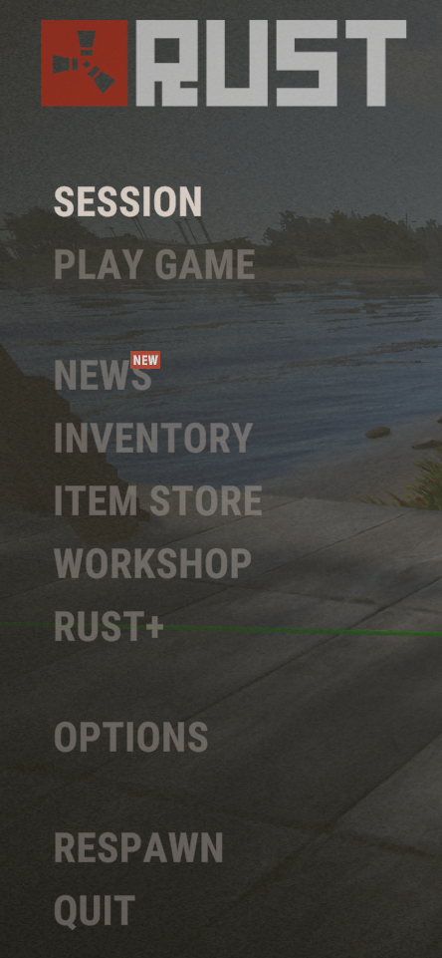
   * Select Pair With Server.
   * 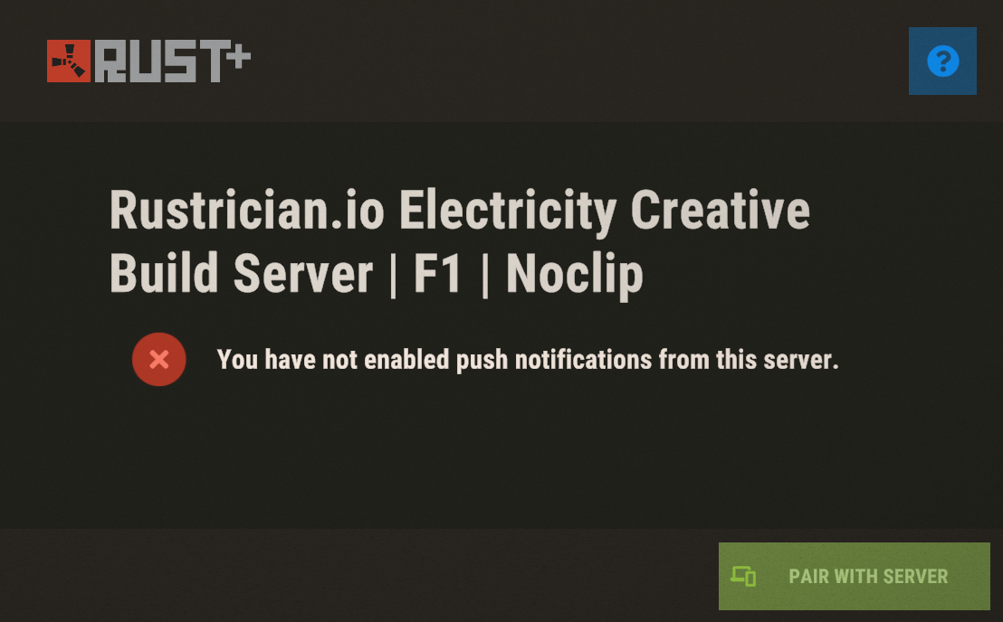
   * In the Rust+ app, you will see the server's details. Tap Pair Server to complete the pairing process.
   * **Note**: If you switch servers, you will need to pair Rust+ with each new server.

Once Rust+ is installed and paired, smart devices can now be linked to the app.

**Pairing Smart Components**

1. Look at the smart component in-game and hold Use(E) while holding a Wire Tool.
2. Select the option to Pair with Rust+.
3. A notification will appear in the app prompting you to name the device.
4. Tap Pair Device to add it to your paired devices list.
5. Paired devices can be accessed via the light bulb icon in the Rust+ app.

**Pairing Non-Smart Devices**

Some non-smart devices (such as Auto Turrets, Drones, and CCTV Cameras) can also be controlled through Rust+ by assigning them an ID:

1. Look at the device and hold Use(E).
2. Select Set ID from the menu.
3. Enter a name for the device.
4. In the Rust+ app, go to the camera icon.
5. Enter the device ID in the camera identifier field, then tap ADD.
6. Players must log off before they can control these devices. Using an alt account is not uncommon.

**Comparison: Smart vs. Non-Smart Devices**

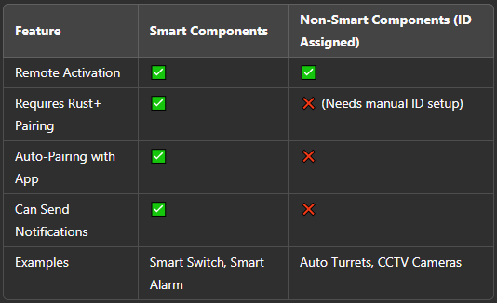

**Rust+ Features for Smart Components**

* **Remote Activation & Monitoring**: Toggle power for paired devices from the app.
* **Push Notifications**: Receive alerts when certain smart devices (like alarms) are triggered.
* **Smart Base Automation**: Combine smart switches and sensors to create automated security setups.
* **Live Camera Feeds**: Use assigned IDs to access CCTV feeds through Rust+.

**Notes**

* Smart components enable remote activation, monitoring, and automation via Rust+.
* Non-smart devices require manual ID assignment but can still integrate into Rust+.
* Rust+ pairing must be done per server—if you switch servers, you must re-pair.
* Smart devices remain connected to Rust+ even if the player logs out.

# Storage Monitor

**Item ID**: 1149964039

**Description**: Monitors the inventory of Tool Cupboards, Large Storage Boxes, Storage Barrels (Horizontal and Vertical), and Vending Machines.

**Crafting Details**

* **Crafting Recipe**: 3 High Quality Metal, 1 Tech Trash
* **Stack Size**: 1
* **Workbench Requirement**: Level 2
* **Research Table Cost**: 75 Scrap
* **Hit Points**: None (cannot be damaged)
* **Despawn Time**: 20 minutes

**Functionality**

* Tracks inventory changes in connected storage units.
* Pairs with Rust+ for remote inventory monitoring.
* Triggers a power pulse when inventory is added, removed, or moved.
* Compatible with Tool Cupboards, Large Boxes, Storage Barrels, and Vending Machines.
* Can be used on tugboats, making it functional for maritime bases.

**Power Mechanics**

* **Power Connections**:
  + **Inputs**: Power In
  + **Outputs**: Power Out, Passthrough
* **Power Consumption**: 1rW
* **Active Usage**: 1
* **Power Output**: 1rW pulse when triggered
* **Behavior**:
  + When inventory is added, removed, or moved, the Storage Monitor pulses 1rW for 0.25 seconds from Power Out.
  + This occurs regardless of whether a single item or a full stack is moved.
  + When pulsing power from Power Out, 1 power is removed from Passthrough.

**Placement Considerations**

* Must be attached to a supported storage unit to function.
* Can be used on tugboats, making it useful for naval bases.
* Pairs with Rust+ for inventory tracking outside the game.
* 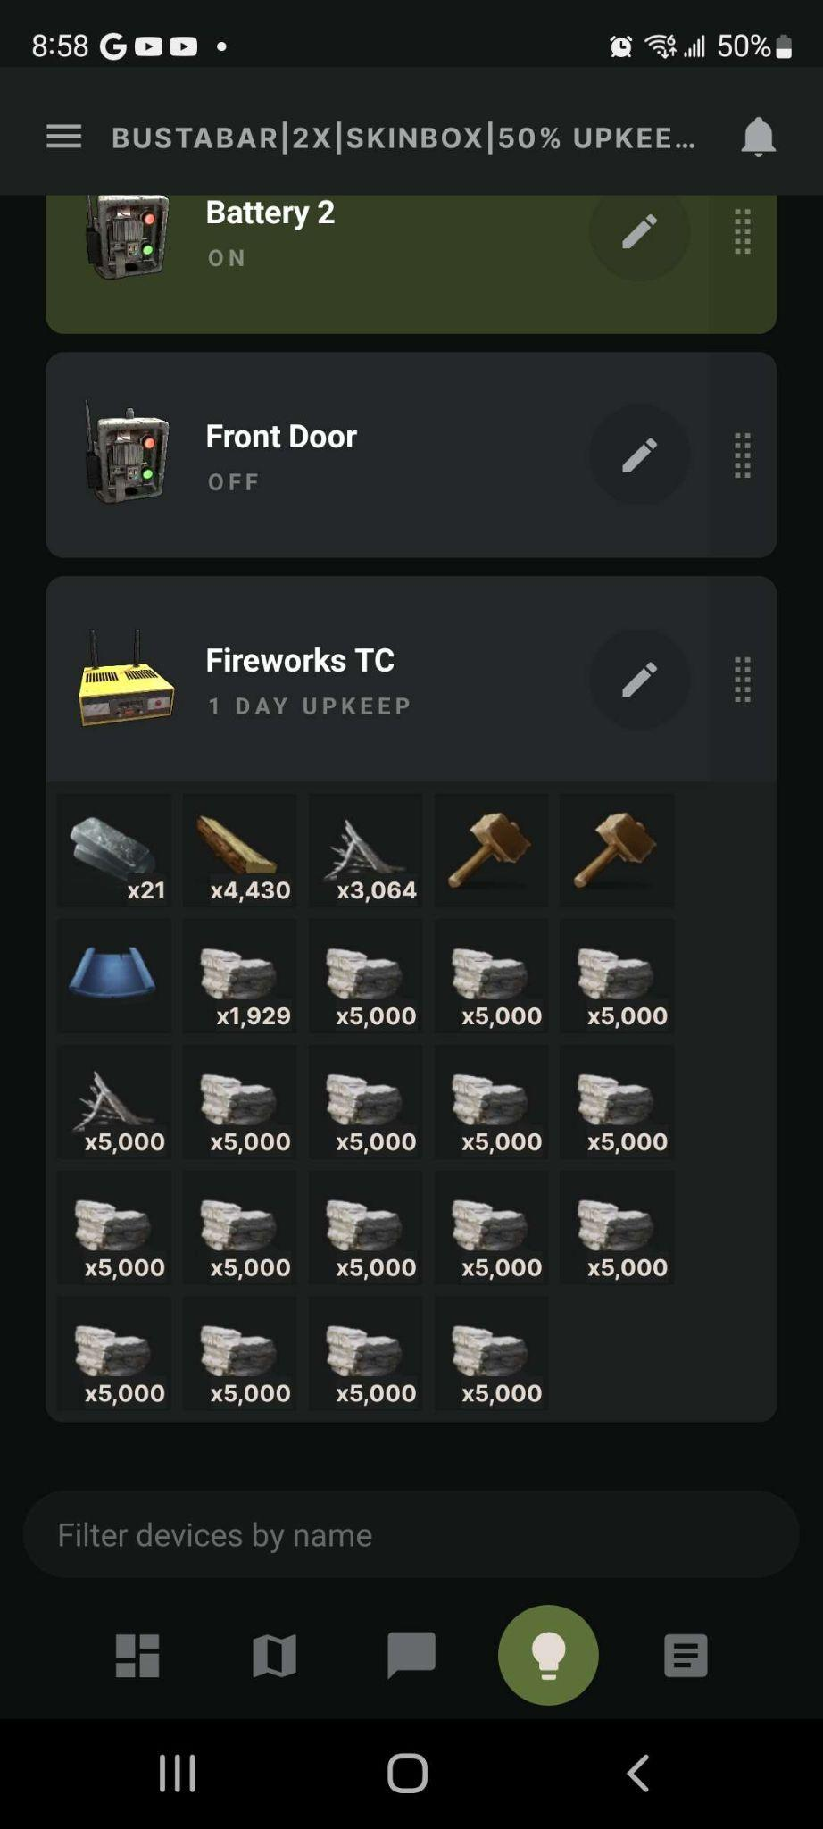

# Smart Switch

**Item ID:** 988652725

**Description:** A switch that can pair with Rust+ and also requires Tool Cupboard (TC) authorization to use.

**Crafting Details**

* **Crafting Recipe:** 3 High Quality Metal, 1 Tech Trash
* **Stack Size:** 5
* **Workbench Requirement:** Level 2
* **Research Table Cost:** 20 Scrap
* **Hit Points:** 200
* **Despawn Time:** 5 minutes

**Functionality**

* Operates as a switch with remote Rust+ integration.
* Requires TC authorization to operate in-game.
* Can be toggled manually or remotely via Rust+.

**Power Mechanics**

* **Power Connections:**
  + **Inputs:** Electric Input, Switch On, Switch Off
  + **Outputs:** Output
* **Power Consumption:** 0rW
* **Active Usage:** 0
* **Power Output:** Equal to input power
* **Behavior:**
  + Switch On and Switch Off inputs do not have priority over one another—whichever input receives power last dictates the state of the switch.
  + Applying power to Switch On will turn the switch on.
  + Applying power to Switch Off will turn the switch off.

**Placement Considerations**

* Can only be placed on vertical building block.
* Cannot be rotated.
* Pairs with Rust+, allowing remote activation and deactivation from outside the game.

# Smart Alarm

**Item ID**: -695978112

**Description**: Sends a notification to your phone via the Rust+ app when powered.

**Crafting Details**

* **Crafting Recipe**: 3 High Quality Metal, 1 Tech Trash
* **Stack Size**: 5
* **Workbench Requirement**: Level 2
* **Research Table Cost**: 75 Scrap
* **Hit Points**: 50
* **Despawn Time**: 20 minutes
* **Decay Time**: 48 hours

**Functionality**

* Sends a notification to Rust+ when activated.
* Pairs with Rust+ to receive pre-programmed messages when powered.
* TC authorization required to edit messages.
* Messages can be customized by looking at the alarm with a Wire Tool in hand and pressing Use (E).
* 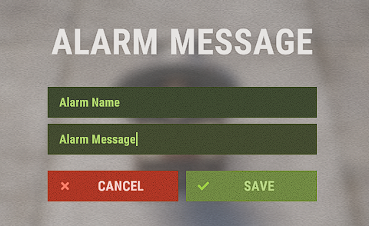
* Displays health when looked at.

**Power Mechanics**

* **Power Connections**:
  + **Inputs**: Power In
  + **Outputs**: Power Out
* **Power Consumption**: 1rW
* **Active Usage**: 1
* **Power Output**: Input power minus 1

**Placement Considerations**

* Can only be placed on flat building block or the ground.
* Can be rotated before placement using Reload (R).
* Does not work with component snapping.
* Auto-repairs over time with resources from the Tool Cupboard.

Utilities

Utility components provide various functional and environmental enhancements that improve gameplay quality and base management. These components interact with the game world in unique ways, offering automation, remote control, storage, climate effects, and more. While they may not require power to operate, their primary role is to enhance player convenience and expand interaction possibilities.

# Digital Clock

**Item ID:** 1619039771

**Description:** A digital clock that displays the in-game server time.

**Crafting Details**

* **Crafting Recipe:** 100 Metal Fragments
* **Stack Size:** 10
* **Workbench Requirement:** Level 2
* **Research Table Cost:** 75 Scrap
* **Hit Points:** 100
* **Despawn Time:** 20 minutes
* **Decay Time:** 8 hours

**Functionality**

* Displays the current in-game Rust time in hours and minutes.
* Requires power to function—if power is lost, the display turns off.
* Players can set a max of 5 alarms to trigger at specific times.
* Can be used for coordination, especially for teams planning night/day activities.
* When an alarm is triggered, power will pass through, and the clock will start to beep.
* Emits a small orange glow, making it slightly visible in the dark.
* Displays health when looked at.
* Auto-repairs over time.

**Power Mechanics**

* **Power Connections:**
  + **Inputs:** Power In
  + **Outputs:** Power Out
* **Power Consumption:** 1rW
* **Active Usage:** 1
* **Power Output:** Input power minus 1rW

**Placement Considerations**

* Can be placed on vertical and angled building block.
* Can also be placed on the ground, either flat or standing on its thin side.
* Cannot be rotated.

# Door Controller

**Item ID**: -502177121

**Description**: Manipulates the state of a door, opening or closing it based on power input.

**Crafting Details**

* **Crafting Recipe**: 75 Metal Fragments
* **Stack Size**: 5
* **Workbench Requirement**: Level 1
* **Research Table Cost**: 75 Scrap
* **Hit Points**: 200
* **Despawn Time**: 20 minutes

**Functionality**

* Used to open and close doors, shutters, and gates, including:
  + Single and double doors
  + Garage doors
  + Window shutters
  + Wooden shop fronts
  + Prison cell gates
  + Chainlink fence gates
  + Ladder hatches
  + High external wooden and stone gates
* Deploys directly onto the door or window shutter, except for the wooden shop front.
* Can be placed on either side of a door, but each door is limited to one controller.
* Shutters can have up to two controllers.
* When powered through Power In, the door opens; when power is removed, it closes.
  + When power is sent to it to open the door, the bottom light will turn green.
  + When no power is sent to it, the bottom light will turn off.
* Open and Close inputs allow direct control, but the controller itself must be powered to use them.

**Pairing**

* When deployed, it will automatically pair with the door and the top light will turn green.
  + When the Tool Cupboard is destroyed, the controller will unpair and the top light will turn red.
  + When the controller must be paired to use it to the door for it to control the door. When it becomes unpaired, the door will remain in its current state, open or closed.
  + The controller can be paired manually by looking at it and pressing Use(E) to pair to the door.

**Power Mechanics**

* **Power Connections**:
  + **Inputs**: Power In, Open, Close
  + **Outputs**: Passthrough
* **Power Consumption**: 1rW
* **Active Usage**: 1
* **Power Output**: Input power minus 1rW
* **Input Priority Behavior**:
  + No priority between Open and Close inputs—whichever is powered last determines the state.
  + Open/Close inputs have priority over Power In.
  + **Example Scenarios:**
    - If **Open** is powered and the door is open, removing **Power In** will not close the door.
    - If **Close** is powered and the door is closed, applying **Power In** will not open the door.
    - If **Close** is powered and the door is open, applying **Power In** will cause the door to close.
  + When sending **Power In** to a Door Controller with its **Passthrough** output connected to its **Close** input, a closed door will **remain closed** and not open first as might be expected.

**Placement Considerations**

* Must be attached directly to the door or shutter.
* Can be placed on either side of a door but is limited to one controller per door except for the Window Shutter that can have 2.
* Cannot be rotated.

# Igniter

**Item ID**: -44876289

**Description**: Ignites anything that burns.

**Crafting Details**

* **Crafting Recipe**: 75 Metal Fragments
* **Stack Size**: 3
* **Workbench Requirement**: Level 1
* **Research Table Cost**: 20 Scrap
* **Hit Points**: 250
* **Where to Buy**: Outpost for 50 Scrap
* **Despawn Time**: 5 minutes

**Functionality**

* Used to ignite various fire-based objects, including:
  + Barbeque, Beancan Grenade, Camp Fire, Candles, Carvable Pumpkin, Chinese Lantern, Confetti Cannon, Fireplace, Fireworks, Hobo Barrel, Jack O' Lanterns, Lanterns, Large Furnace, Skull Fire Pit, Sky Lanterns, Small Furnace, Small Oil Refinery, Satchel Charge, Torch in a holder, Tuna Can Lamp, Firebomb, and Propane Explosive Bomb.
* Has an ignition radius of about 3 meters or 1 square foundation.
* 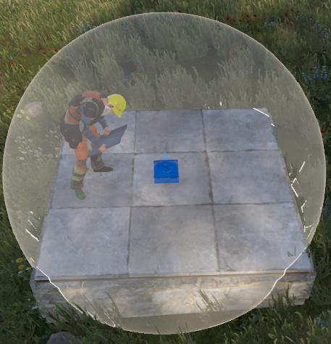
* Takes damage when active but has enough health to last 16 to 17 minutes.
* Displays health when looked at.
* Auto-repairs over time.

**Power Mechanics**

* **Power Connections**:
  + **Inputs**: Power In
* **Power Consumption**: 2rW (direct connection) or 1rW (via Electrical Branch set to 1)
* **Active Usage**: 2 or 0
* **Power Behavior**:
  + When connected directly to a battery, consumes 2rW and shows an Active Usage of 2.
  + If connected through an Electrical Branch set to 1, the Igniter still functions but the battery’s Active Usage reads 0.

**Placement Considerations**

* Can be placed on any angled building surface and the ground.
* Can be rotated before placement using Reload (R).

# PTZ CCTV Camera

**Item ID**: 140006625

**Description**: A camera with Pan, Tilt, and Zoom functionality.

**Crafting Details**

* **Crafting Recipe**: 1 CCTV Camera, 150 Metal Fragments
* **Stack Size**: 5
* **Workbench Requirement**: Level 2
* **Research Table Cost**: 75 Scrap
* **Hit Points**: 150
* **Despawn Time**: 20 minutes
* **Decay Time**: 48 hours

**Functionality**

* Provides remote surveillance capabilities with pan, tilt, and zoom controls.
* Requires pairing with a unique ID to be accessible from Computer Stations and Rust+.
* TC authorization is required to set an ID by looking at it and pressing Use(E).
* Can be viewed via Computer Stations by entering the assigned camera ID.
* Can be accessed via Rust+ but requires the player to disconnect from the server first.
* Pre-placed cameras exist at some monuments and can be accessed through the current Camera List in Uncategorized under Concepts.
* Displays health when looked at with a Hammer.

**Power Mechanics**

* **Power Connections**:
  + **Inputs**: Power In
* **Power Consumption**: 3rW
* **Active Usage**: 3

**Placement Considerations**

* Can be placed on ceilings or the inside of roofs.
* Can be rotated before placement using Reload (R).
* Aiming the camera: Stand in the direction you want the camera to face, hold a Hammer, and press Use (E) to adjust its position.
* To pick up the camera, hold Use (E).

**Usage Instructions**

1. **Assigning an ID**:
   * Gain TC authorization.
   * Look at the camera and press Use (E) to Set ID (maximum 31 characters).
2. **Viewing the Camera via Computer Station**:
   * Mount a Computer Station.
   * Add the camera's ID in the bottom left field.
   * Select the camera from the list to begin viewing.
3. **Controlling the Camera**:
   * **Mouse movement**: Pan and tilt the camera.
   * **Left-click**: Zoom in.
4. **Viewing the Camera via Rust+**:
   * Add the camera ID in the Rust+ app.
   * The player must disconnect from the server before remote access is allowed.
5. **Security Considerations**:
   * Anyone can add any camera to any Computer Station, so use unique names for IDs.

# CCTV Camera

**Item ID**: 634478325

**Description**: A camera to view from a Computer Station.

**Crafting Details**

* **Stack Size**: 64
* **Research Table Cost:** Blueprints cannot be created
* **Hit Points**: 150
* **Despawn Time**: 60 minutes
* **Decay Time**: 48 hours

**Functionality**

* Provides remote surveillance capabilities but has a fixed position (no pan, tilt, or zoom).
* Requires pairing with a unique ID to be accessible from Computer Stations and Rust+.
* TC authorization is required to set an ID.
* Can be viewed via Computer Stations by entering the assigned camera ID.
* Can be accessed via Rust+ but requires the player to disconnect from the server first.
* Pre-placed cameras exist at some monuments and can be accessed through the current Camera List in Uncategorized under Concepts.
* Displays health when looked at with a Hammer.
* Auto-repairs over time.

**Power Mechanics**

* **Power Connections**:
  + **Inputs**: Unnamed Input
* **Power Consumption**: 3rW
* **Active Usage**: 3

**Placement Considerations**

* Can only be placed on vertical surfaces.
* Cannot be rotated.
* To aim the camera: Stand in the direction you want the camera to face, hold a Hammer, and press Use (E) to adjust its position.
* To pick up the camera, hold Use (E).

**Usage Instructions**

1. **Assigning an ID**:
   * Gain TC authorization.
   * Look at the camera and press Use (E) to Set ID (maximum 31 characters).
2. **Viewing the Camera via Computer Station**:
   * Mount a Computer Station.
   * Add the camera's ID in the bottom left field.
   * Select the camera from the list to begin viewing.
3. **Viewing the Camera via Rust+**:
   * Add the camera ID in the Rust+ app.
   * The player must disconnect from the server before remote access is allowed.
4. **Security Considerations**:
   * Anyone can add any camera to any Computer Station, so use unique names for IDs.

## Camera ID List

* + **Abandoned Military Base:**
    - COMPOUND****
    - OUTDOOR****
    - Locate the computer station inside the monument, underground, and access it to find the randomly generated codes for the cameras.
  + **Airfield camera codes:**
    - AIRFIELDHELIPAD
  + **Bandit Camp camera codes:**
    - CASINO
    - TOWNWEAPONS
  + **Dome camera codes:**
    - DOME1
    - DOMETOP
  + **Large Oil Rig camera codes:**
    - OILRIG2HELI
    - OILRIG2DOCK
    - OILRIG2EXHAUST
    - OILRIG2L1
    - OILRIG2L2
    - OILRIG2L3A
    - OILRIG2L3B
    - OILRIG2L4
    - OILRIG2L5
    - OILRIG2L6A
    - OILRIG2L6B
    - OILRIG2L6C
    - OILRIG2L6D
  + **Nuclear Missile Silo camera codes:**
    - SILOEXIT1
    - SILOEXIT2
    - SILOMISSILE
    - SILOSHIPPING
    - SILOTOWER
  + **Outpost / Compound camera codes:**
    - COMPOUNDCHILL
    - COMPOUNDMUSIC
    - COMPOUNDCRUDE
    - COMPOUNDSTREET
  + **Small Oil Rig camera codes:**
    - OILRIG1HELI
    - OILRIG1DOCK
    - OILRIG1EXHAUST
    - OILRIG1L1
    - OILRIG1L2
    - OILRIG1L3
    - OILRIG1L4
  + **Underwater Labs:**
    - AUXPOWER****
    - BRIG****
    - CANTINA****
    - CAPTAINQUARTER****
    - CLASSIFIED****
    - CREWQUARTERS****
    - HALLWAY****
    - INFIRMARY****
    - LAB****
    - LOCKERROOM****
    - OPERATIONS****
    - SECURITYHALL****
    - TECHCABINET****
    - Once inside an Underwater Lab, find the Underwater Lab's CCTV Station Module. Access the computer station and locate the final 4-digits for the cameras. These camera codes are randomly generated. With those 4-digits, you can now input the correct name corresponding to each CCTV camera.

# Electric Heater

**Item ID**: -784870360

**Description**: A source of heat and comfort.

**Crafting Details**

* **Crafting Recipe**: 200 Metal Fragments
* **Stack Size**: 5
* **Workbench Requirement**: Level 1
* **Research Table Cost**: 75 Scrap
* **Hit Points**: 200
* **Where to Buy**: Outpost for 75 Scrap
* **Despawn Time**: 20 minutes

**Functionality**

* Provides heat and comfort in a spherical radius.
* Dries off players that are wet.
* Helps regulate crop temperatures, preventing freezing in cold areas.
* Can overheat plants in the desert biome.
* Emits an orange glow when powered.

**Power Mechanics**

* **Power Connections**:
  + **Inputs**: Power In
  + **Outputs**: Passthrough
* **Power Consumption**: 3rW
* **Active Usage**: 3
* **Power Output**: Input power minus 3rW

**Placement Considerations**

* Can be placed on vertical building block and some vertical ground surfaces.
* Cannot be rotated.
* **Three Distinct Heat Zones:**
  1. **Player Heat Bubble**:
     + Provides warmth to players and dries them off.
     + Creates a 2x2 diameter sphere in front of the heater. The heater is located on the edge of the sphere.

# 

* 1. **Comfort Bubble**:
     + Provides up to 50% comfort.
     + Located within the Player Heat Bubble, it is slightly smaller with a 4-meter (1⅓ foundations) diameter.
     + Players receive more comfort standing slightly back rather than directly on the heater.
  2. **Plant Heat Bubble**:
     + Helps regulate crop temperatures.
     + A visual bubble is created to show the area of effect.
     + 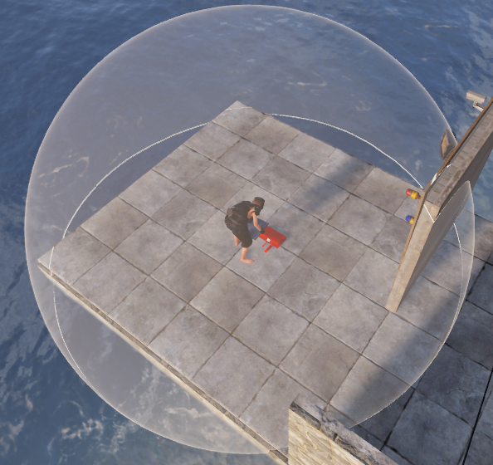
     + Covers a 2x2 spherical area but the heater is at the center of the sphere.
     + In cold biomes it prevents freezing; in hot biomes, can overheat plants if not turned off during the day.

# 

# Modular Car Lift

**Item ID**: 1696050067

**Description**: A work platform for modular cars.

**Crafting Details**

* **Crafting Recipe**: 5 High Quality Metal, 200 Metal Fragments, 1 Gear
* **Stack Size**: 1
* **Workbench Requirement**: Level 2
* **Research Table Cost**: 125 Scrap
* **Hit Points**: 250
* **Where to Buy**: Bandit Camp for 150 Scrap
* **Despawn Time**: 40 minutes
* **Decay Time**: 16 hours

**Functionality**

* Allows modification of modular cars by adding or removing modules.
* Requires power to access the user interface (UI). Look at the control stand and press Use (E).
* Storing cars on a powered lift prevents vehicle decay.
* Anyone can add or remove code locks. TC authorization is not required to access the UI.
* Using an HBHF Sensor to cut power when a non-auth player is nearby can prevent unauthorized access is a good idea.
* Displays health when looked at with a Hammer.
* Auto-repairs over time.

**Power Mechanics**

* **Power Connections**:
  + **Inputs**: Power In
* **Power Consumption**: 5rW
* **Active Usage**: 5

**Placement Considerations**

* Can only be placed on floors or foundations.
* Can be rotated before placement using Reload (R).
* The space it takes up is roughly equal to a 2x3 of square foundations.
* Best placed inside a garage or near roads for easy vehicle access.
* Can be picked up with a Hammer.

# Elevator

**Item ID**: 1177596584

**Description**: A powered lift for vertical transportation.

**Crafting Details**

* **Crafting Recipe**: 3 High Quality Metal, 200 Metal Fragments, 1 Gear
* **Stack Size**: 5
* **Workbench Requirement**: Level 2
* **Research Table Cost**: 125 Scrap
* **Hit Points**: 600
* **Despawn Time**: 40 minutes
* **Decay Time**: 8 hours

**Functionality**

* Used to transport players, horses, and small vehicles vertically.
* Can be stacked up to 11 floors high, with each module adding to the upkeep cost.
* **Upkeep Cost Breakdown**:
  + **Floor 1**: 1 High Quality Metal, 20 Metal Fragments
  + **Floor 2**: +20 Metal Fragments
  + **Floor 3**: +20 Metal Fragments
  + **Floor 4**: +1 High Quality Metal, +20 Metal Fragments
  + **Floor 5**: +20 Metal Fragments
  + **Floor 6**: +20 Metal Fragments
  + **Floor 7**: +1 High Quality Metal, +20 Metal Fragments
  + **Floor 8**: +20 Metal Fragments
  + **Floor 9**: +20 Metal Fragments
  + **Floor 10**: +20 Metal Fragments
  + **Floor 11**: +1 High Quality Metal, +20 Metal Fragments
* **Two-part structure:**
  + **Shaft**: Houses the motor and the call inputs.
  + **Carriage**: Moves between floors and contains player controls.
* **Control pad buttons on the carriage:**
  + **Front buttons:** Move one floor up or down.
  + **Side buttons:** Move to the top or bottom floor.
* Each floor has 2 Call Elevator inputs for external control.
* Standing under the elevator when descending results in instant death.
* If a player stands on a half-floor beneath the shaft, they may be pulled through the floor when crushed.
* Travel time is 1.6 seconds per floor.
* There are gaps in the shaft's chainlink that can be used to place components on walls around the shaft.
* Auto-repairs over time.

**Power Mechanics**

* **Power Connections**:
  + **Inputs**: Power, Call Elevator
* **Power Consumption**:
  + **Carriage**: 5rW
  + **Call Elevator Input**: 1rW
* **Active Usage**: 5
* Power must be given to the Power input first before sending power to a Call Elevator input. If power is not applied in this order, the carriage will not move.

**Placement Considerations**

* Must be placed on square floors or foundations.
* Can be rotated before placement using Reload (R).
* **Elevators are subject to upkeep scaling**:
  + 10% for the first 15 building blocks, 15% thereafter.
* Upkeep is based on the total number of elevator modules, not height (e.g., five 2-floor elevators have the same upkeep as one 10-floor elevator).
* Removing an elevator shaft from TC coverage resets upkeep to only the bottom floor, or 1 HQM and 20 Metal Fragments.
* Can be placed adjacent to another elevator, as long as carriages do not interfere with adjacent floors. Example images below.

Placing 1 floor side by side is no problem.

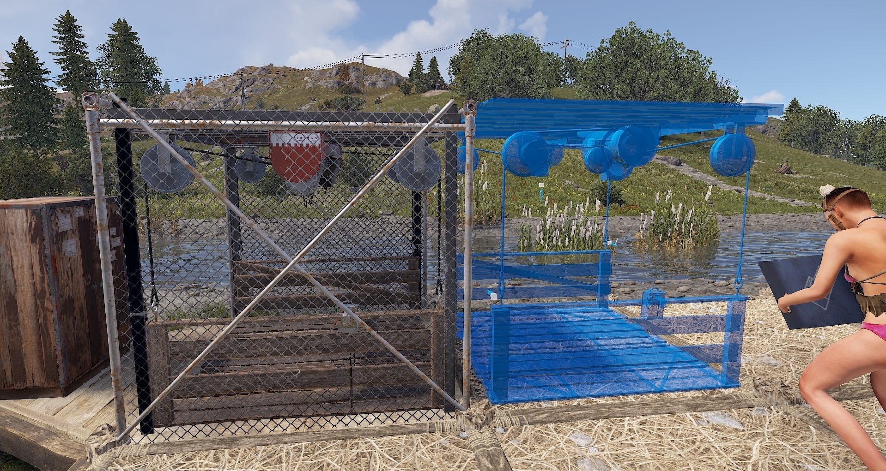

It wont let me build because the carriage is on the second floor. It ‘comes into contact with’ the new piece trying to be placed.

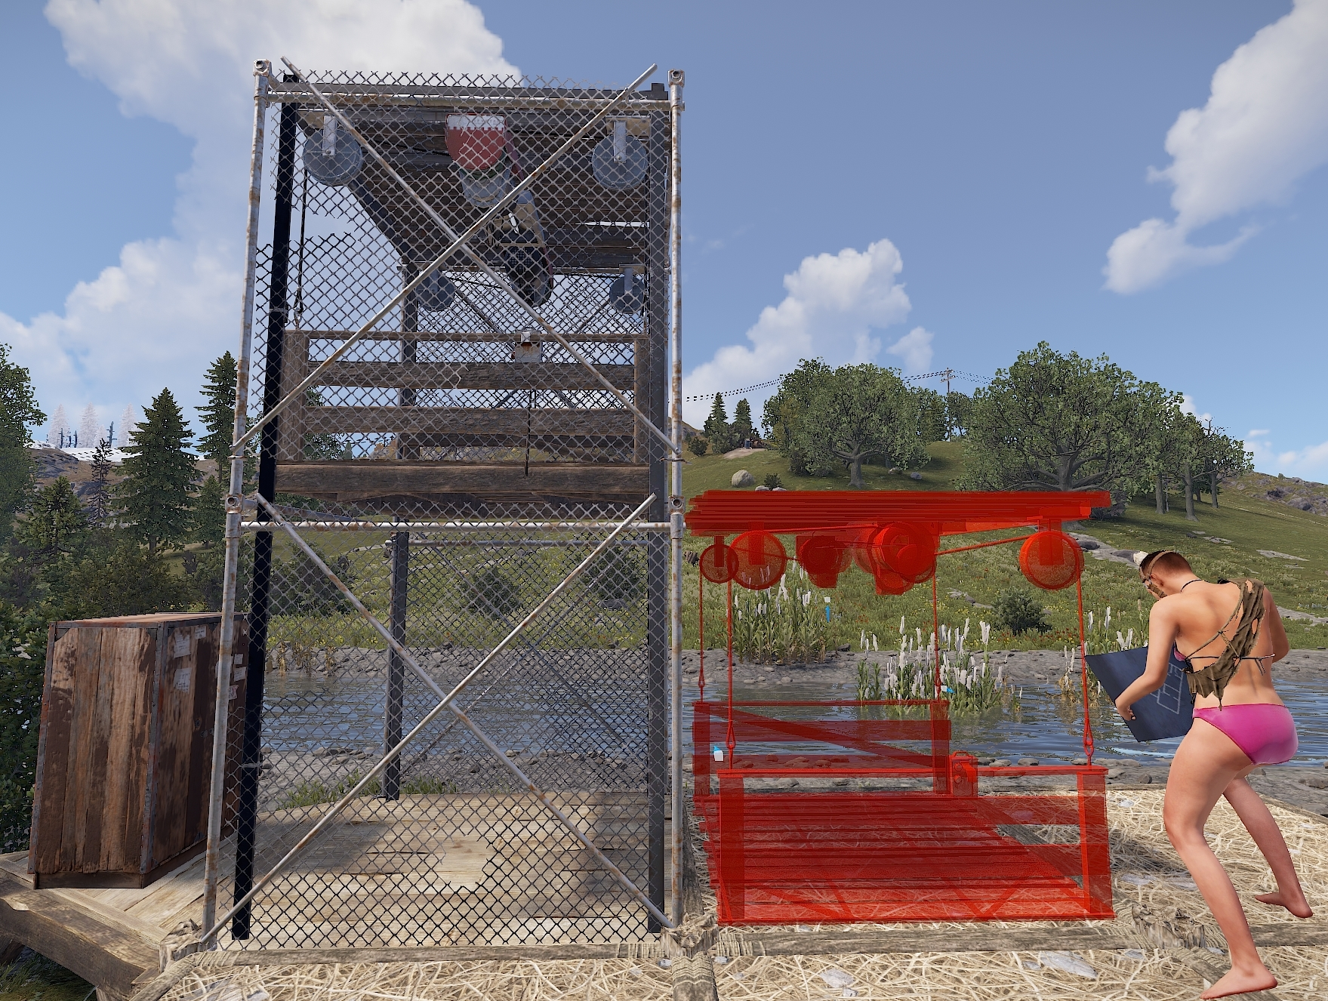

Drop the carriage to the first floor so placing the new elevator is possible.

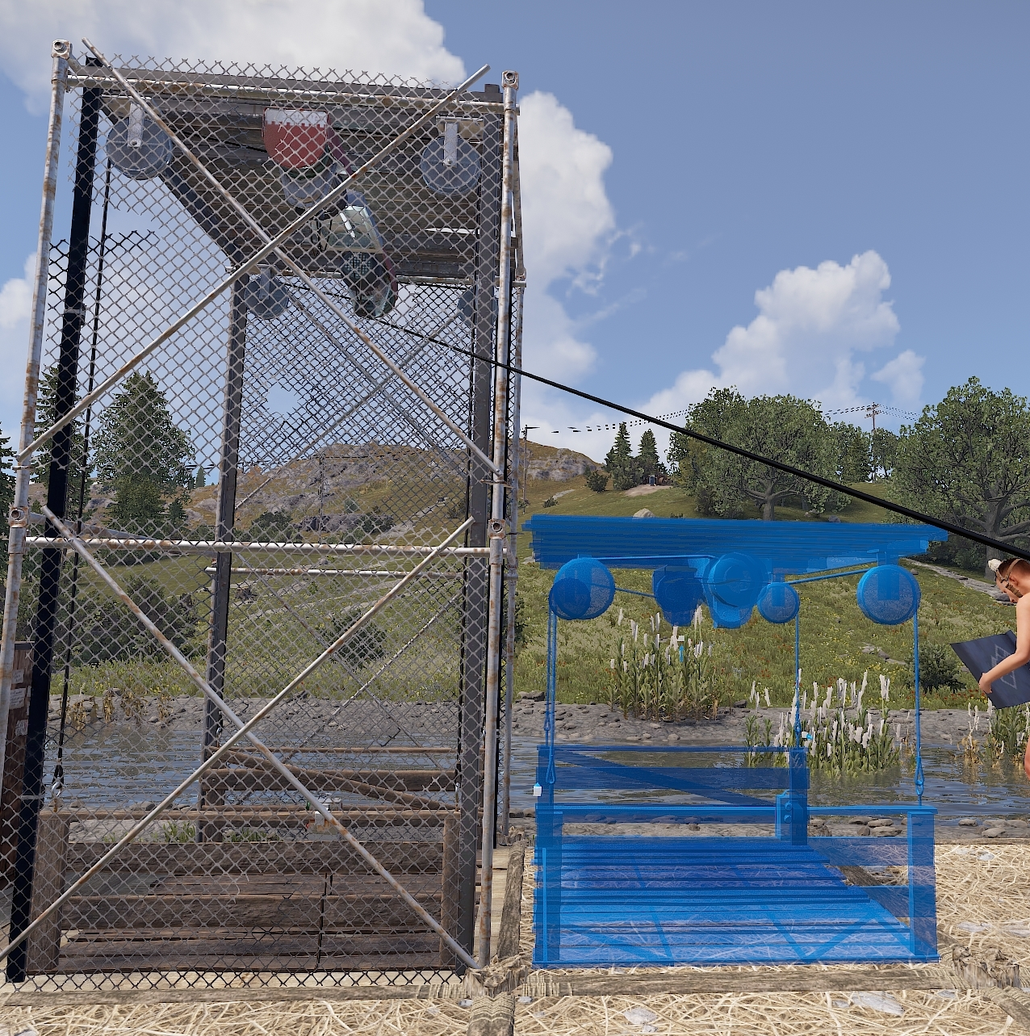

# Audio Alarm

**Item ID**: 2100007442

**Description**: A loud warning alarm speaker.

**Crafting Details**

* **Crafting Recipe**: 75 Metal Fragments
* **Stack Size**: 5
* **Workbench Requirement**: Level 1
* **Research Table Cost**: 20 Scrap
* **Hit Points**: 100
* **Despawn Time**: 5 minutes
* **Decay Time**: 96 hours

**Functionality**

* Emits a loud alarm sound when powered, alerting players in the vicinity.
* Commonly used for base security, warning of intrusions, breaches, or raid attempts.
* Can be integrated with sensors or switches for automatic activation.
* Has a fixed volume and cannot be adjusted.
* Displays health when looked at with a Hammer.
* Auto-repairs over time.

**Power Mechanics**

* **Power Connections**:
  + **Inputs**: Power In
* **Power Consumption**: 1rW
* **Active Usage**: 1

**Placement Considerations**

* Can only be placed on floors, foundations, or the ground.
* Can be rotated before placement using Reload (R).
* **Sound travel distance**:
  + **Unobstructed**: ~14 foundations (~42 meters).
  + **Behind 1 wall**: ~11 foundations (~33 meters).
  + Additional walls do not reduce sound range further

# Spooky Speaker

**Item ID**: 1885488976

**Description**: A speaker that makes creepy and spooky sounds.

**Crafting Details**

* **Crafting Recipe**: 400 Wood, 100 Metal Fragments, 20 Cloth
* **Stack Size**: 10
* **Research Table Cost**: Blueprints cannot be created
* **Hit Points**: 100
* **Where To Find**: Requires a Steam item purchased from the market
* **Despawn Time**: 5 minutes
* **Decay Time**: 96 hours

**Functionality**

* Plays creepy, eerie and spooky sounds when turned on.
* Does not require power to work. Can be manually turned on.
* Commonly used for psychological effects in PvP, base decoration, or traps.
* Cannot be crafted without owning the Steam item.
* Displays health when looked at with a Hammer.
* Auto-repairs over time.

**Power Mechanics**

* **Power Connections**:
  + **Inputs**: Turn On, Turn Off
* **Power Consumption**: 1rW
* **Active Usage**: 0
* **Power Behavior**:
  + The last input to receive power is the input that dictates the state of the speaker.
  + Sending power to Turn On will activate the speaker.
  + Sending power to Turn Off will deactivate the speaker.

**Placement Considerations**

* Can only be placed on floors, foundations, or the ground.
* Can be rotated before placement using Reload (R).
* **Sound travel distance**:
  + **Unobstructed**: Approximately 14 foundations (Approximately 42 meters).
  + **Behind 1 wall**: Approximately 11 foundations (Approximately 33 meters).
  + Additional walls do not reduce sound range further.

# Drone

**Item ID**: 1588492232

**Description**: A remote-controlled drone.

**Crafting Details**

* **Crafting Recipe**: 200 Metal Fragments, 2 Tech Trash, 1 CCTV Camera
* **Stack Size**: 1
* **Workbench Requirement**: Level 2
* **Research Table Cost**: 125 Scrap
* **Hit Points**: 200
* **Where To Buy**: Outpost for 300 Scrap
* **Despawn Time**: 40 minutes

**Functionality**

* Remotely controlled using a Computer Station.
* Capable of free flight within a limited range (Approximately 600 meters or 4 grid squares).
* Easily damaged from impacts.
* Loses control and falls to the ground if the player disconnects mid-flight.
* Displays health when looked at with a Hammer.

**Operation & Control**

* **To assign an ID:**
  + Deploy the Drone on the ground.
  + Look at it and press Use (E) to set an ID (31-character limit).
  + Hold Use (E) to pick up the Drone.
* **To control the Drone:**
  + Mount a Computer Station.
  + Add the Drone’s ID in the bottom left field.
  + Select the Drone from the list and start flying.
* **Flight Controls:**
  + **W, A, S, D**: Move forward, left, back, and right.
  + **Mouse**: Look around.
  + **Shift**: Ascend.
  + **Ctrl**: Descend.
* **Remote Control via Rust+:**
  + Add the Drone’s ID to the Rust+ app.
  + The player must disconnect from the server before remote access is allowed.

**Power Mechanics**

* **Power Consumption:** None (requires zero electricity)

**Placement Considerations**

* Can be placed on the ground, flat, or angled building block.
* Can be detected by Pressure Pads and Lasers.
* Can be rotated before placement using Reload (R).

# Computer Station

**Item ID**: -1588628467

**Description**: A place to view CCTV cameras and control Auto Turrets or Drones.

**Crafting Details**

* **Crafting Recipe**: 5 High Quality Metal, 1 Targeting Computer, 1 RF Broadcaster, 1 RF Receiver
* **Stack Size**: 1
* **Workbench Requirement**: Level 2
* **Research Table Cost**: 75 Scrap
* **Hit Points**: 500
* **Where To Buy**: Outpost for 300 Scrap
* **Despawn Time**: 20 minutes

**Functionality**

* Allows players to remotely view and control surveillance devices.
* Compatible with CCTV Cameras, PTZ Cameras, Drones, and Auto Turrets.
* Displays the in-game time in the bottom right of the interface.
* IDs must be assigned to cameras, drones, or turrets to be accessed remotely.
* Maximum number of IDs that can be added is at least 60.
* Displays health when looked at with a Hammer.

**Operation & Control**

* **To add an ID for viewing or control:**
  + Mount a Computer Station.
  + In the bottom left, enter an ID.
  + Cameras need to be powered to be added to the list; Auto Turrets do not.
  + Select the ID from the list on the left to begin viewing or controlling the device.
* **Compatible Devices:**
  + **CCTV Cameras & PTZ Cameras**: Provides a live feed when powered.
  + **Drones**: Allows remote piloting via the interface.
  + **Auto Turrets**: Allows controlling of turrets and shooting people.
* Anyone can add any ID to any Computer Station.
* IDs are limited to 31 characters.
* Pre-placed cameras exist at certain monuments, and their IDs can be found under Uncategorized Concepts.

**Power Mechanics**

* **Power Consumption:** None (requires zero electricity)

**Placement Considerations**

* Can be placed on flat surfaces, the ground, and the tugboat.
* Can be rotated before placement using Reload (R).

# Fogger-3000

**Item ID**: -1973785141

**Description**: A fog machine that runs on low-grade fuel.

**Crafting Details**

* **Crafting Recipe**: 100 Metal Fragments, 30 Low-Grade Fuel, 1 Metal Pipe
* **Stack Size**: 1
* **Hit Points**: 100
* **Where To Find**: Requires a Steam item purchased from the market
* **Despawn Time**: 5 minutes
* **Decay Time**: 96 hours

**Functionality**

* Emits a thick, localized fog when activated, reducing visibility in the surrounding area.
* Requires TC authorization to modify settings.
* To change settings: Look at the Fogger and hold Use (E) to access options for Activate, Open, or Motion Mode.
* **Has two modes: Active and Motion**.
  + **Active Mode**: Runs continuously, consuming 1 Low-Grade Fuel per minute.
  + **Motion Mode**: Triggers only when a non-authorized player moves nearby, emitting thicker fog every few seconds. Consumes 10 Low-Grade Fuel per minute.
* Fog covers an area of approximately a 2x2 foundation space and is thickest below half-height walls.
* Fog takes 5 seconds to fully form and 40 seconds to dissipate after deactivation.
* Multiple Foggers increase fog density, with 4 blocking light from fires and 5 blocking electrical light.
* Fog falls and accumulates on horizontal surfaces, meaning higher placement results in a falling fog effect.

**Power & Fuel Mechanics**

* **Power Connections**:
  + **Inputs**: Turn On, Toggle, Turn Off
* **Power Consumption**: 1rW to trigger inputs
* **Active Usage**: 0
* **Fuel Capacity**: 500 Low-Grade Fuel
* **Fuel Consumption**:
  + **Active Mode**: 1 Low-Grade Fuel per minute
  + **Motion Mode**: 10 Low-Grade Fuel per minute
* **Input Behavior:**
  + **Turn On Input**: Activates the fogger while power is applied.
  + **Turn Off Input**: Deactivates the fogger while power is applied.
  + **Toggle Input**: Turns the fogger on when power is received and off when power is removed.
  + If Turn On and Turn Off are both powered, the last input to receive power takes priority.

**Placement Considerations**

* Can be placed on flat and angled building block, as well as the ground.
* Can be rotated before placement using Reload (R).
* Can be picked up with a Hammer but loses 10 HP.
* Auto-repairs over time with resources from the Tool Cupboard.

# Snow Machine

**Item ID**: 1358643074

**Description**: A machine which will blanket the surrounding terrain in snow.

**Crafting Details**

* **Crafting Recipe**: 125 Metal Fragments, 30 Low-Grade Fuel, 1 Metal Pipe
* **Stack Size**: 1
* **Workbench Requirement**: Level 1
* **Hit Points**: 100
* **Where To Find**: Requires a Steam item purchased from the market
* **Despawn Time**: 5 minutes

**Functionality**

* Covers the surrounding terrain in snow when activated.
* Does not require electricity. It can be manually turned on and off.
* **To change settings:** Look at the machine and hold Use (E) to access options for Activate, Open, or Stop.
* Requires TC authorization to change settings.
* The snow pile has a radius of 3.5 square foundations.
* The snow pile takes 1 second to form and 2 minutes 45 seconds to disappear.
* The temperature within this area will drop and be similarly as cold as the Arctic Biome.
* Snow depth reaches up to a player's chin but does not increase with multiple machines.
* Items like Landmines and Snap Traps can be hidden under the snow.
* The visual snowfall effect reaches up to 3.5 floors high.
* Displays health when looked at with a Hammer.
* Auto-repairs over time with resources from the Tool Cupboard.

**Power & Fuel Mechanics**

* **Power Connections**:
  + **Inputs**: Toggle, Turn On, Turn Off
* **Power Consumption**: 1rW to trigger inputs
* **Active Usage**: 0
* **Fuel Capacity**: 500 Low-Grade Fuel
* **Fuel Consumption**: 1 Low-Grade Fuel per minute
* **Input Behavior:**
  + The last input to receive power is the input that dictates the state of the machine.
  + **Toggle Input**: Turns the machine on when power is received and off when power is removed.
  + **Turn On Input**: Activates the Snow Machine.
  + **Turn Off Input**: Deactivates the Snow Machine.
  + When turned on, there is a 10-second window where it cannot be turned off.

**Placement Considerations**

* Can only be placed on the ground.
* Can be rotated before placement using Reload (R).
* Can be picked up with a Hammer but loses 75 HP.

# Fridge

**Item ID**: 1413014235

**Description**: A powered storage container designed to preserve food.

**Crafting Details**

* **Crafting Recipe**: 75 Metal Fragments
* **Stack Size**: 1
* **Workbench Requirement**: Level 1
* **Research Table Cost**: 20 Scrap
* **Hit Points**: 200
* **Despawn Time**: 5 minutes

**Functionality**

* Provides 48 inventory slots for food and water storage.
* Prevents food from spoiling when powered. Applies a snowflake to the food items when active.

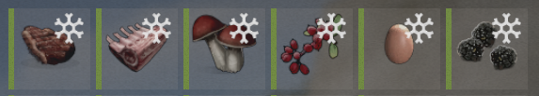

* + **Vegetables:** Normally spoils in 48 hours, but stops spoiling when inside a powered fridge.
  + **Raw Meat**: Normally spoils in 6 hours, but stops spoiling when inside a powered fridge.
  + **Cooked Meat**: Normally spoils in 24 hours, but stops spoiling when inside a powered fridge.
* Can be integrated into the Industrial System using a Storage Adapter attached to the top.
* Can be reskinned using the Spray Can.
* Displays health when looked at with a Hammer.

**Power Mechanics**

* **Power Connections**:
  + **Inputs**: Power In
* **Power Consumption**: 5rW
* **Active Usage**: 5
* When receiving power, a green LED will appear on the front of the Fridge at the bottom.

**Placement Considerations**

* Can be placed on floors and foundations.
* Can be rotated before placement using Reload (R).

# Telephone

**Item ID:** 1234878710

**Description:** A telephone for making and receiving calls

**Crafting Details**

* **Crafting Recipe**: 50 Wood, 100 Metal Fragments, 1 Tech Trash
* **Stack Size**: 1
* **Workbench Required**: Level 1
* **Research Table Cost**: 75 Scrap
* **Hit Points**: 150
* **Despawn Time**: 20 minutes
* **Decay Time**: 8 hours

**Functionality**

* This is a landline telephone sitting on top of a cassette tape answering machine.
* Used to place and receive calls with other phones on the map.
* Press Use (E) to interact with the phone or the answering machine.
* TC authorization is not required to rename the phone or access the cassette answering machine.
* Each phone is automatically assigned a number, and players can give it a custom name (max 30 characters).
* Renamed phones appear in the Directory.
* Use the Directory to find other phones including those at monuments, mobile phones or player bases.
* Phones can be added to the contacts list using the phone name or number.
* Calls are limited to 2 minutes by default unless changed by the server owner.
  + Server owners can use the command*telephonemanager.maxcalllength X* to adjust call duration.
* Call audio is two-way and occurs in real time.
* Auto-repairs over time.

**Answering Machine Mechanics**

* Requires a cassette to enable answering machine functionality.
* Accepts Short (10s), Medium (20s), and Long (30s) cassettes.
* Use a Cassette Recorder to record messages onto a cassette.
* Insert the cassette into the answering machine by looking at it and pressing Use(E).
* After 3 rings, the answering machine begins to play the outgoing message.
* Callers can leave a voicemail by pressing Jump(Spacebar) during the message.
* To listen to voicemails, access the phone and select Voicemail at the bottom of the screen.

**Power Mechanics**

* **Power Connections**:
  + **Inputs**: Power
  + **Outputs**: Call Passthrough
* **Power Consumption**: 1rW
* **Active Usage**: 1
* **Power Output**: Input power minus 1rW
* While a call is active, the phone outputs power through Call Passthrough for the duration of the call.

**Placement Considerations**

* Can be placed on horizontal building block and the ground.
* Rotatable with Reload (R) before placement.
* Can be picked up with a hammer.

# Command Block (NOT CRAFTABLE)

**Item ID:** -1247485104

**Description:** A block that runs commands

**Crafting Details**

* **Crafting Recipe:** Not craftable (only available in creative mode or via admin commands)
* **Stack Size:** 64
* **Research Table Cost:** Cannot be researched
* **Hit Points:** 100
* **Despawn Time:** ?
* **Decay Time:** ?

**Functionality**

* This an admin only command block that will execute 1 server side command when powered.
* Server owners will need to enable the use of the blocks with the following commands:
  + Commandblock.commands_enabled True or False
    - Allows the use of the Command Block on the server.
    - WARNING: DO NOT, FOR ANY REASON, let normal players get access to your Command Blocks if they are enabled.
  + Commandblock.use_player True or False
    - Allows for the use of commands that affect the player that last enters a command.

**Example Commands:**

* inventory.giveto <player_name_or_id> <item_name> <item_amount>
  + inventory.giveto <player_name_or_id> scrap 20000
* say <message>
  + say hello - prints hello in global chat
* env.time <0-24>
  + env.time 12 - changes the time to 1200hrs
* entity.spawn <entity> <position>
  + entity.spawn minicopter 0,0,0 - spawns a minicopter at the center of the map
* spawnitem <item> <position>
  + spawnitem fun.guitar 0,0,0 - spawns an Acoustic Guitar at the center of the map
  + Check out more spawnable items on [Corrosionhour](https://www.corrosionhour.com/rust-item-list/)
* killplayer <player_name_or_id>
  + killplayer SwiftCoyote - kills SwiftCoyote
* weather.load <weather>
  + Weather options:
    - Clear
    - Dust
    - Fog
    - Overcast
    - RainHeavy
    - RainMild
    - Storm
  + Check out more weather commands on [Corrosionhour](https://www.corrosionhour.com/rust-weather-command/)
* supply.call - calls a supply crate to the island
* heli.call - calls the attack heli to the island

Commands the effect the last player to enter a command into the Command Block

* teleportpos 0,0,0 - teleports the player to the center of the map
* Sleep - puts the player to sleep
* eat 100 - feeds the player 100 hunger points

**Power Mechanics**

* **Power Connections**:
  + **Inputs**: Power In
  + **Outputs:** Passthrough
* **Power Consumption**: 1rW
* **Active Usage**: 0

**Placement Considerations**

* Can be placed on floors, foundations and the top side of roofs.
* Can be placed underwater.
* It is not subject to stability.
* They can be stacked on themselves and other components.
* Can be rotated before placement using Reload (R).

# Vending Machine

**Item ID**: 198438816

**Description**: Trade goods with other players safely by creating sell and buy orders

**Crafting Details**

* **Crafting Recipe**: 20 High Quality Metal, 3 Gears
* **Stack Size**: 1
* **Workbench Requirement**: Level 1
* **Research Table Cost**: 10 Scrap
* **Hit Points**: 1250hp
* **Despawn Time**: 20 minutes

**Functionality**

* Looking at the front of the machine, players can press Use(E) to enter the Shop UI. Here is where players can make purchases from the listed items for sale.
* Looking at the back of the machine, players can press and hold Use(E) to open a radial wheel to access:
  + **Open:** To access the storage container. Provides 30 inventory slots.
  + **Disable Broadcasting:** Disables broadcasting of the location of this object.
  + **Administrate:** Opens the administration panel.
* Prevents food from spoiling when powered. Applies a snowflake to food items when active.



* + **Vegetables:** Normally spoils in 48 hours, but stops spoiling when inside a powered fridge.
  + **Raw Meat**: Normally spoils in 6 hours, but stops spoiling when inside a powered fridge.
  + **Cooked Meat**: Normally spoils in 24 hours, but stops spoiling when inside a powered fridge.
* Can be integrated into the Industrial System using a Storage Adapter attached to the back.
* Can be reskinned using the Spray Can.
* Displays health when looked at with a Hammer.

**Administration Panel**

The administration panel gives players the ability to configure and view several options and statistics.

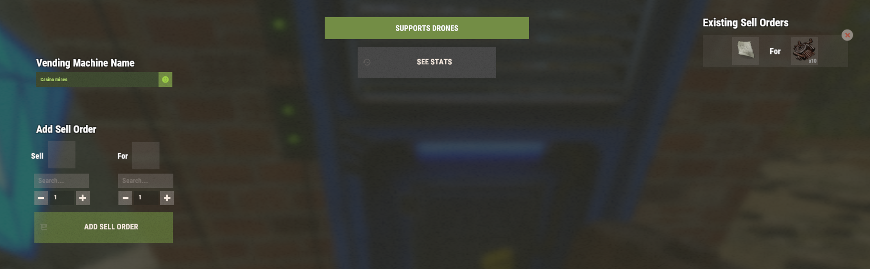

* Customize the Vending Machines name. This is the name that will appear on the Map(G)
* Add Sell orders by searching for items and selecting their quantities. Click on the item's blueprint to the right of the item if wanting to buy or sell a blueprint.
* Existing orders will appear on the right side of the menu.
* At the top of the menu will inform the player if their machine Supports Drones, or not.
* Clicking on See Stats will show things like:

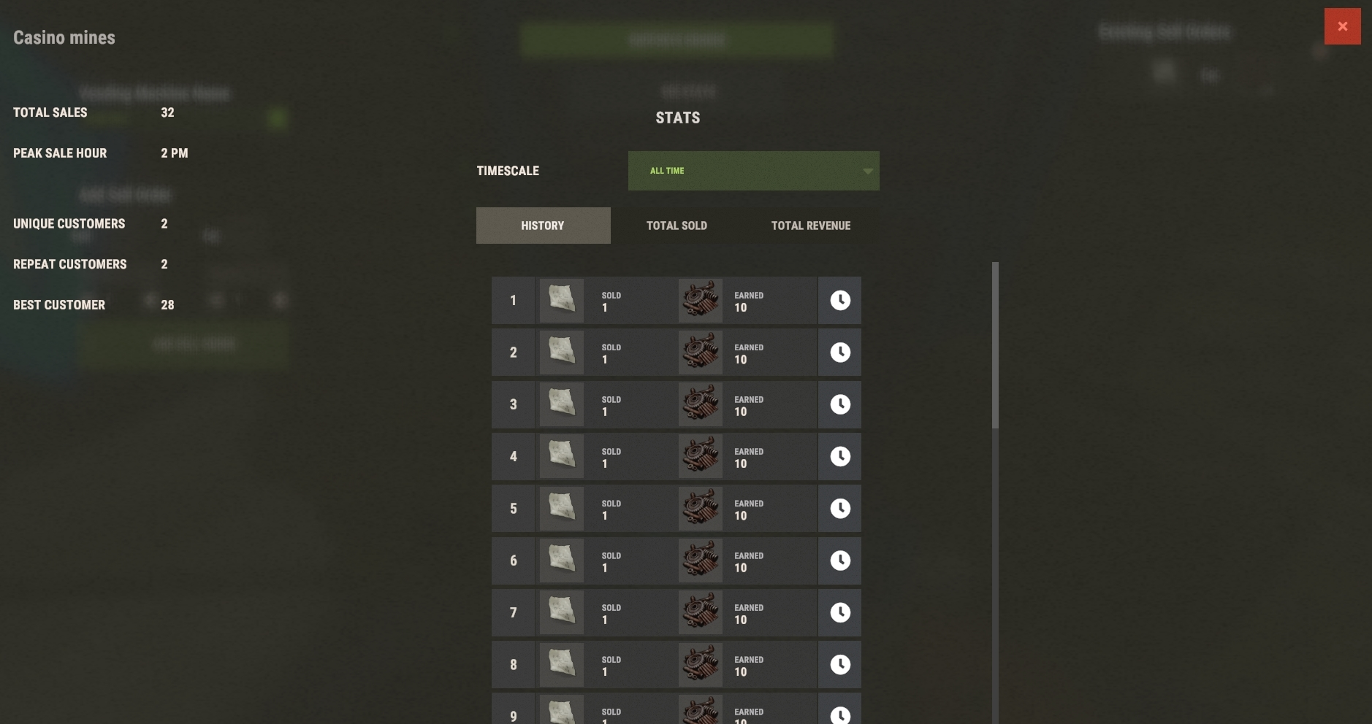

* + **Total Sales** - Tracks the total number of sales over the life of the machine.
  + **Peak Sale Hour** - Shows the players local time when the most sales were occurring.
  + **Unique Customers** - Tracks the number of first time purchasers.
  + **Repeat Customers** - Tracks the number of players that have returned to make 2 or more purchases.
  + **Best Customer** - Im not sure what this number means here.
  + **Timescale** - Allows players to select the time period of the statistics.

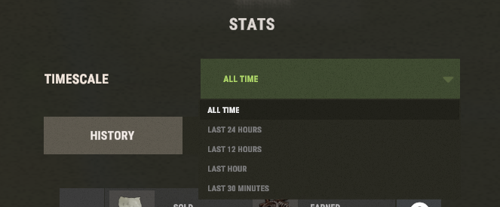

* + - All Time
    - Last 24 Hours
    - Last 12 Hours
    - Last Hour
    - Last 30 Minutes
  + **Stats** tabs, including:
    - **History** - How many of what was sold, for how much it was sold, along with the local date and time.
    - **Total Sold** - Shows the total amount of sold items.
    - **Total Revenue** - Shows the total amount earned from each item.

**Power Mechanics**

* **Power Connections**:
  + **Inputs**: (Fridge) Power In
* **Power Consumption**: 5rW
* **Active Usage**: 5

**Placement Considerations**

* Can be placed on floors and foundations.
* Can be snapped into single door frames.
* Can be rotated before placement using Reload (R).
* Can be rotated after placement by looking at its side and pressing Use(E)
  + Cannot be rotated after a Storage Monitor is applied to the top of it.

Defense

Defense components are automated security devices designed to protect bases and airspace from intruders. These components offer protection through automated targeting, area denial, and offensive capabilities. Their primary role is to provide defensive security.

# SAM Site

**Item ID**: -1009359066

**Description**: Defends against aerial threats.

**Crafting Details**

* **Stack Size**: 1
* **Hit Points**: 1000
* **Where To Buy**: Outpost for 500 Scrap
* **Despawn Time**: 5 minutes
* **Decay Time**: 12 hours

**Functionality**

* **Automatically detects and fires at airborne threats, including:**
  + MLRS Rockets
  + Minicopters, Scrap Helicopters, Hot Air Balloons, Attack Helicopters and Parachutes.
* Does not differentiate between friend or foe; all aircraft are targeted unless in Defender Mode.
* Defender Mode and Attack Mode can be enabled or disabled by looking at the SAM Site and holding Use (E):
  + **Defender Mode:** the SAM Site will only target incoming MLRS Rockets.
  + **Attack Mode:** the SAM Site will attack all flying modes of transportation.
* Range of 150 meters (1 grid square).
* Best used in clusters to maximize defense against MLRS attacks.
  + **Recommended:** 3 SAM Sites on the side of the base closest to the Abandoned Military Base.
  + Build them as high as the base itself to intercept rockets effectively.
* Looking at the SAM Site will show its health.
* Auto-repairs over time.

**Power Mechanics**

* **Power Connections**:
  + **Inputs**:
  + **Power In:** Needs 25rW here to power the SAM Site.
  + **Invert Mode:** When power is applied, the SAM Site will
  + **Outputs**: Has Target, Low Ammo, No Ammo, Passthrough
* **Power Consumption**: 25rW
* **Active Usage**: 25
* **Power Output**: 1rW
* **Power Passthrough**: Input power minus 25
* **Has Target Output**: Constant 1rW while locked onto a target.
* **Low Ammo Output**: Outputs 1rW when 10 or fewer SAM Ammo remain, stops when depleted.
* **No Ammo Output:** Outputs 1rW constantly when out of ammo.

**Placement Considerations**

* Must be placed on floors or foundations.
* Can be rotated before placement using Reload (R).
* Will not target anything below its own height.
* Avoid placement where they can be baited into damaging surrounding structures.

# Auto Turret

**Item ID**: -2139580305

**Description**: An automated sentry turret to neutralize targets.

**Crafting Details**

* **Crafting Recipe**: 10 High-Quality Metal, 1 CCTV Camera, 1 Targeting Computer
* **Stack Size**: 1
* **Workbench Requirement**: Level 2
* **Research Table Cost**: 500 Scrap
* **Hit Points**: 1000
* **Where To Buy**: Outpost for 400 Scrap
* **Despawn Time**: 60 minutes

**Functionality**

* Automatically detects and engages enemy players and threats.
* **Requires a weapon and ammunition to function.**
  + Supports weapons that use Pistol Bullets, 5.56 Ammo, Shotgun Ammo, Nails, Arrows and the Trumpet.
* **Can be placed into two modes:**
  + **Attack All (Default Mode)** – Fires at any unauthorized player in range. This mode is required for remote control.
  + **Peacekeeper Mode** – Only engages unauthorized players if they display aggression. Disables remote control.
* Has a 180-degree detection arc.
* Turret range is 30 meters or roughly 10 square foundations. Before placing, a bubble will show its area of effect.

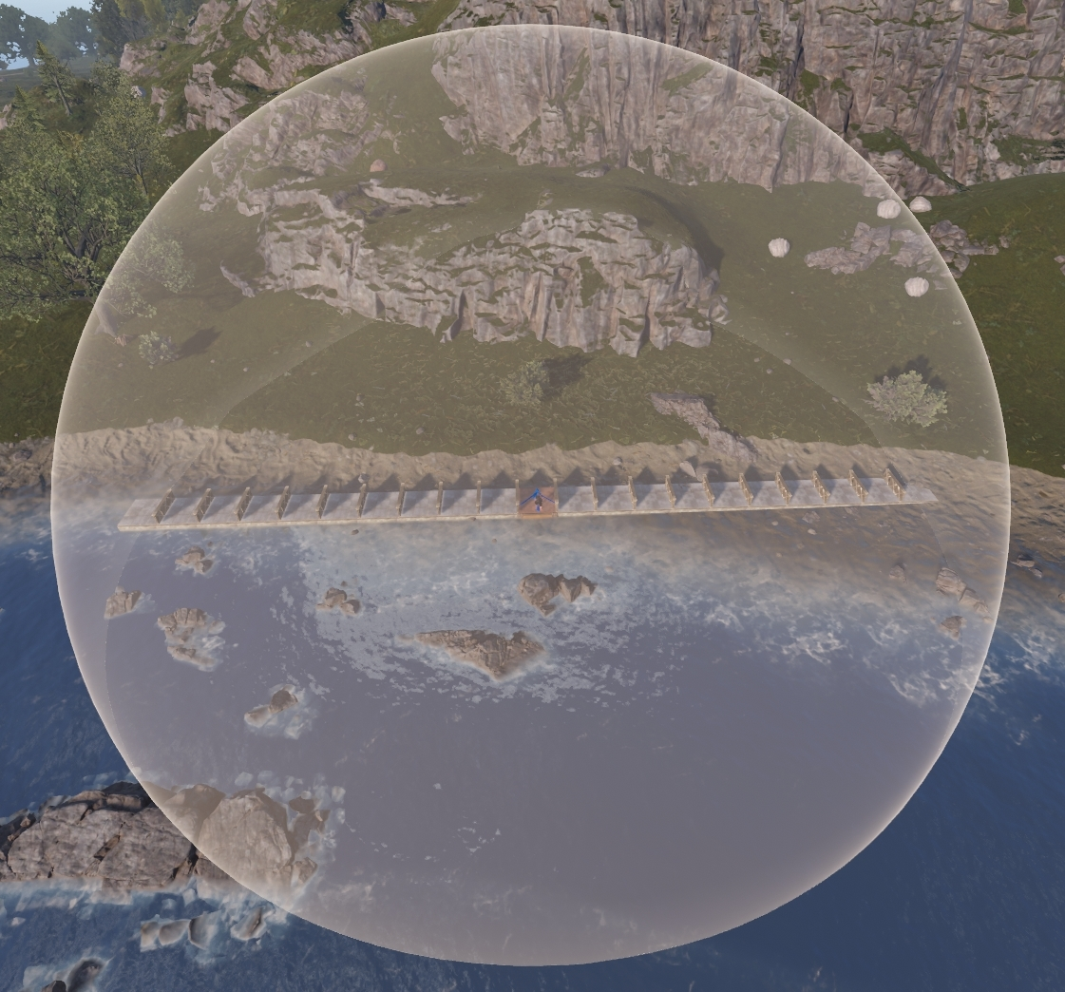

* Can be remotely controlled via Computer Station or Rust+ App when an ID is set.
* Looking at the turret will display its health.

**Turret Interference**

* Interference restricts how many turrets can be active in an area. This does not limit the number of turrets that can be placed, just the number of ones that are turned on at 1 time.
* Each turret has its own 40 meter, or 13.5 square foundation, radius where it is checking to see how many powered turrets it can see.
* Maximum active turrets in a 40-meter radius is 12. The 13th turret will not activate and will display a sparkling animation.

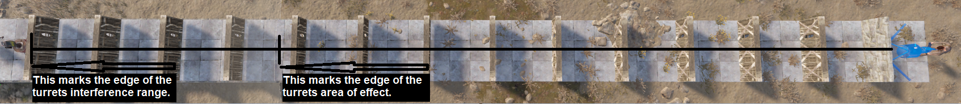

* When a player selects the turret in their hotbar, the icon will display how many active turrets there would be if a new one was placed down. That means this image shows 5 turrets are active with the 6th being the one the player is holding.
* 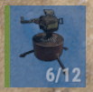
* If the icon is showing 13/12, that means there are 12 active turrets. Placing down a new turret and powering it on will result in interference affecting it causing a sparkling effect.
* 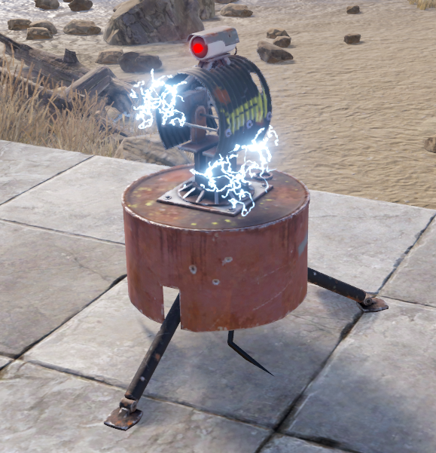
* When powering a turret, if it gets a target lock before it experiences interference, it will hold the lock and continue to shoot until it loses target.
* When trying to cover a large area with turrets that are always on, it will be important to plan their locations to avoid too many turrets overlapping one another.

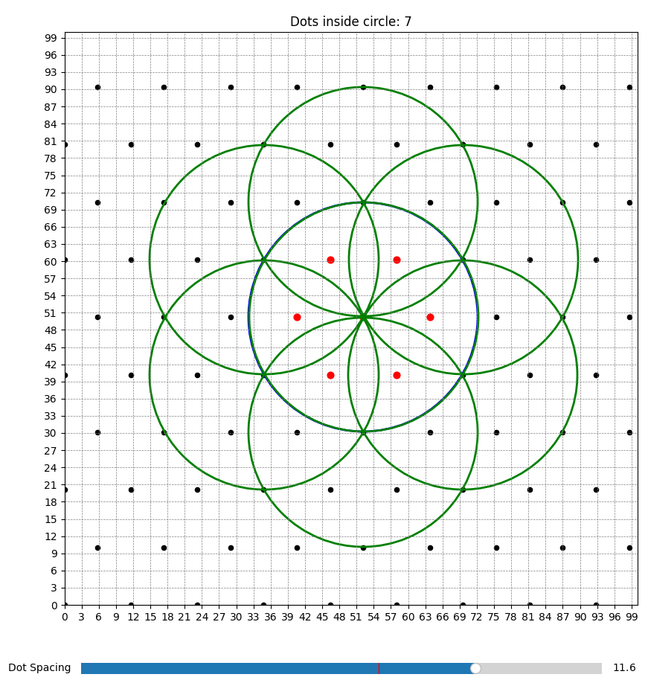

* Keeping no less than 11.6 meters between auto turrets should help prevent issues with interference.
* Use the Wire Tool to check spacing. Attach a wire to any IO connection and run over to another Auto Turret. It is recommended to stay closer to 12 meters because it is difficult to get exact enters on the turret.

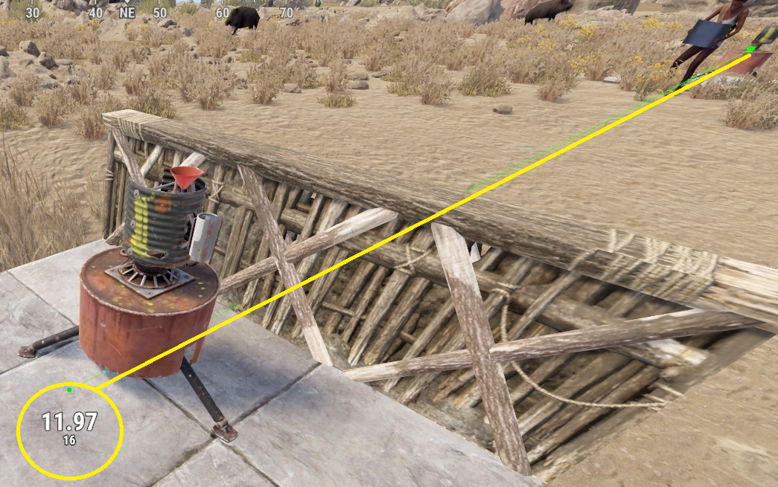

* **Bug/Feature:** Turrets can be disabled by forcing them to exceed the interference limit.

**Operation & Control**

* A player must be authorized to open the turret menu. Authorize by looking at a turn off turret and press Use(E). Open the menu by holding Use(E).
* **Turret Menu Options:**
  + **Open** – Access inventory to place a weapon and ammo.
  + **Peacekeeper Mode** – Enables Peacekeeper Mode (disables remote control).
  + **Attack All** – Default mode, allows remote control.
  + **Rotate** – Rotates the turret 180 degrees.
  + **Authorize Friend** – Add specific players to authorization.
  + **Clear Authorization List** – Removes all authorized players.
  + **Deauthorize** – Removes the player selecting the option from authorization.
  + **Set ID** – Assign an ID for remote control via Computer Station or Rust+ App.
* After giving the turret a name, enter that name into a Computer Station or the Rust+ app and take control. Move the turret around with the mouse and left click to shoot.
* When remotely controlled, anything within the visual range can be shot. The visual range is approximately 63 meters or 21 square foundations.
* Anyone can add the ID to any Computer Station and take control. Make the ID something other players won’t guess. Restrict access to any Computer Station with these IDs to trusted individuals only. IDs are limited to 31 characters.

**Power Mechanics**

* **Power Connections:**
  + **Inputs**: Power In
  + **Outputs**: Has Target, Low Ammo, No Ammo
* **Power Consumption**: 10rW (+1rW if outputs are used)
* **Power Output**: 1rW
* **Has Target:** Outputs a constant 1rW while it locks a target and a ghost pulse is generated when it stops targeting. The ghost pulse effects counting up and down on a Counter.
* **Low Ammo**: Outputs 1rW when 50 or fewer rounds remain.
* **No Ammo**: Outputs 1rW constantly when out of ammo.
* When turrets run low on ammo, they will output 1rW from Low Ammo. When they run out of ammo, they will output 1rW from No Ammo, while continuing to output power from Low Ammo. This also applies to Has Target. The turret can output 1rW from all 3 outputs at the same time while only receiving a total of 11rW.
* The turret takes 2.1 seconds to fully turn on before it can lock a target. It takes 2.1 seconds to fully turn off. The turret doesn't need to fully turn off before getting turned back on.

**Placement Considerations**

* Must be placed on floors or foundations.
* Can be rotated before placement using Reload (R).
* Try to position turrets where they cannot be baited or drained.
* Turrets can shoot through 20 layers of Chainlink Fence.

# Tesla Coil

**Item ID**: 1371909803

**Description**: An electrical trap that zaps nearby players.

**Crafting Details**

* **Crafting Recipe**: 3 High-Quality Metal, 1 Tech Trash
* **Stack Size**: 3
* **Workbench Requirement**: Level 2
* **Research Table Cost**: 20 Scrap
* **Hit Points**: 250
* **Where To Buy**: Outpost for 75 Scrap
* **Despawn Time**: 5 minutes

**Functionality**

* Emits electrical arcs to damage nearby players and entities.
* Requires electricity to function.
* **Damage scales based on power input.**
  + Deals damage at a rate of 1.75 HP/second per Rust watt (rW), up to a maximum of 25rW.
  + Example: If powered with 4rW, it deals 7 HP damage per second (4 × 1.75 = 7).
  + If powered with 25rW, it deals 43.75 HP damage per second (25 × 1.4 = 43.75).
    - Note: Decimal values are calculated internally by the game, even if not visually reflected on the player’s health bar.
* **Tesla Coils damage in cycles:**
  + Emits ¼ of the total input power every 250 ms over four pulses.
  + After four pulses (1 second total), it enters a 250 ms cooldown before repeating.
  + Example: 20rW input deals 7 damage per 0.25 seconds, totaling 28 damage per second.
* **Tesla Coil damage stacks.**
  + 100 Tesla Coils powered with 1rW each can instantly kill a player.
  + 12 Tesla Coils powered with 25rW each will instantly kill a player.
* **Range:** Has a radius of roughly 1 square foundation (3.5 meters).
* 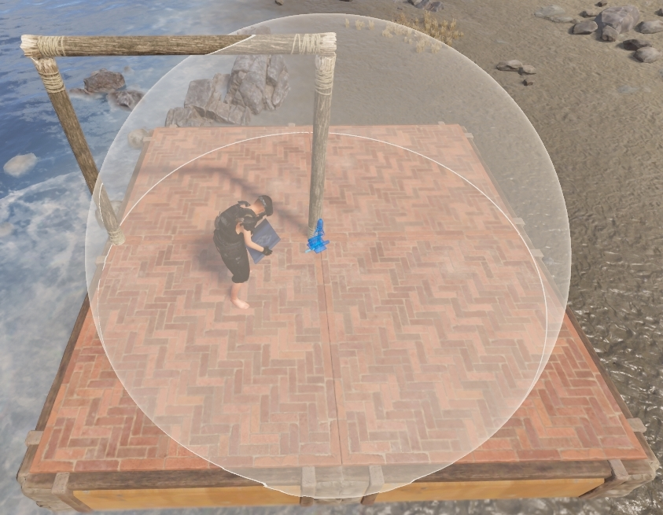
* Does not discriminate between friendly and enemy players.
* Tesla Coils self-damage at a rate of 2 HP/second, regardless of power input.
* They automatically shut off at 25 HP and will not turn back on until repaired.
* Even when disabled, Tesla Coils will occasionally emit sparks, but will not deal damage.
* Looking at the coil will display its health.
* Auto-repairs over time with resources from the Tool Cupboard.

**Power Mechanics**

* **Power Connections:**
  + **Inputs**: Power In
* **Power Consumption:** 1-25rW
* **Active Usage:** 25rW maximum

**Placement Considerations**

* Can be placed on all building block and the ground.
* Can be rotated before placement using Reload (R).
* Tesla Coils can damage enemies through walls, floors, and roofs using a building trick.

Water

**Water System Overview**

The Water system allows players to collect, store, transport, and distribute water using a network of water components using water IO connections. Similar to the electrical system, it uses a dedicated hand tool—the Hose Tool—and follows specific mechanical rules related to depth, gravity, and water types. While traditionally used for farming, water can now also be weaponized, making it a versatile system with both supportive and offensive applications.

**Common Traits of Water Components**

* Tool Cupboard authorization is required to make water IO connections with the Hose Tool.
* All components can be rotated using Reload (R) before placement.
* Components show their health when looked at with a Hammer. After enough damage, the health becomes visible without the hammer.
* **Gravity matters**:
  + Water flows down freely, assisted by gravity.
  + To move water upward, you must use a powered pumping component like the Water Pump and the Fluid Switch & Pump.

**Water Types**

Different water types cannot be mixed. Cross contamination is restricted.

1. **Fresh Water**
   * Found in rivers, ponds, and collecting rain.
   * Drinkable and used for plant growth.
   * Is the lowest priority water type.
2. **Salt Water**
   * Found in the ocean.
   * Must be converted to Fresh Water before use.
   * If players drink Salt Water, they will take damage, lose hydration and hunger points.
   * When given to planters, it will dry out the soil and eventually kill the plants.
3. **Radioactive Water**
   * Can only be found in Rad Town pools.
   * Can be collected in containers like the Jug or the Water Gun.
   * Players can safely carry up to 2499ml of Radiation Water. To carry more, players will need a minimum of 2 radiation protection.
   * Players will need an additional 2 radiation protection for every additional 8,865ml.
   * Works best when sprinkled from above rather than the side and does not from below.
   * Only 18 radiation protection is needed to overcome the radiation from sprinkled water.
   * When used on planters, it will delete the plants and dry out the soil.
   * Is the highest priority water type.

**System Limitations**

* 15-component limit between a water source or storage and a Fluid Combiner. Exceeding this causes a Short Circuit / Max Depth error.
* 15-component limit between an **Electrical Power Source** and the Sprinkler before it can no longer be used to fill planter boxes or pools with water.
  + Beyond this, water appears to function (sprinklers still animate and can wet players), but:
    - No water reaches planter boxes or pools.
    - No water is removed from the source.
    - This is referred to as "dead water."
  + Dead water can only be used for transferring into another water storage container.
* 32-component maximum distribution limit for transferring water between storage containers.

**Player Interaction Tips**

* Hold Sprint (Left Shift) and Left Click to plant an entire planter box at once.
* Look at a water container and hold Use (E) to access the transfer menu:
  + Hold Give or Take to automatically transfer water, avoiding repeated clicks.

# 

# Large Water Catcher

**Item ID**: -1100168350

**Description**: A large deployable that passively collects water.

**Crafting Details**

* **Crafting Recipe**: 200 Metal Fragments, 500 Wood, 2 Tarp
* **Stack Size**: 1
* **Workbench Requirement**: Level 2
* **Research Table Cost**: 75 Scrap
* **Hit Points**: 300
* **Despawn Time**: 20 minutes
* **Decay Time**: 8 hours

**Functionality**

* The Large Water Catcher is a passive water collection device that gathers Fresh Water from rain and dew over time.
* Water is always Fresh Water, usable for drinking or irrigation.
* The catcher cannot be given Salt or Radioactive water.
* Water can be transferred manually or through connected water IO.
* Look at the catcher and hold Use (E) to open the menu.
  + To transfer water: Hold Give or Take for automatic transfer.
* Players can also fill handheld containers by holding the container and holding Right-Click while looking at the catcher.
* Auto-repairs over time.

**Water Mechanics**

* **Capacity:** Stores up to 50,000mL of water.
* **Water Connections**:
  + **Inputs: Water In**
  + **Outputs: Water Out**
  + **Water Output Rate:** 12mL per second
* **Collection Rate**:
  + **Base Rate**: The base level collection rate is 8ml per minute but depending on the weather and biome, collection rates will change.
  + The catcher contains 1mL by default upon placement.
  + Collection rate is affected by the Biome, Rain Level and Fog Level:
    - For every 0.1 increase in Rain Level:
      * **Desert**: +15mL/min
      * **Temperate**: +30mL/min
      * **Arctic**: +0mL/min
    - For every 0.1 increase in Fog Level:
      * All biomes: +6mL/min
  + **Formula**:
    - **Use the following formula to calculate the collection rate:**
    - Collection Rate = 8mL + (Rain Level × (300mL × Biome)) + (Fog Level × 60mL)
    - **Biome Multipliers**: Temperate = 1, Desert = 0.5, Arctic = 0

**Placement Considerations**

* Requires an area of approximately 2x2 foundations.
* Must be placed on the ground.
* Can be built around and encapsulated with a ceiling height of at least 1.5 floors. When built inside, the collection rate is reduced to only the base rate.
* Cannot be placed on Icebergs.
* Can be rotated before placement with Reload (R).

**Notes**

* A **buff was added on November 2, 2023**, but is not reflected here. Anyone that can update the math, please do.

# Small Water Catcher

**Item ID**: -132247350

**Description**: A small deployable that passively collects water.

**Crafting Details**

* **Crafting Recipe**: 50 Metal Fragments, 100 Wood, 1 Tarp
* **Stack Size**: 1
* **Workbench Requirement**: Level 1
* **Research Table Cost**: 20 Scrap
* **Hit Points**: 200
* **Despawn Time**: 5 minutes
* **Decay Time**: 8 hours

**Functionality**

* The Small Water Catcher is a passive water collection device that gathers fresh water from rain and dew over time.
* Water is always Fresh Water, usable for drinking or irrigation.
* The catcher cannot be given Salt or Radioactive water.
* Water can be transferred manually or through connected water IO.
* Look at the catcher and hold Use (E) to open the menu.
  + To transfer water: Hold Give or Take for automatic transfer.
* Players can also fill handheld containers by holding Right-Click while looking at the catcher.
* Auto-repairs over time.

**Water Mechanics**

* **Capacity**: Stores up to 10,000mL of water.
* **Water Connections**:
  + **Inputs:** Water In
  + **Outputs:** Water Out
  + Water Output Rate: 6mL per second
* **Collection Rate**:
  + **Base Rate**: The base level collection rate is 3ml per minute but depending on the weather and biome, collection rates will change.
  + The catcher contains 1mL by default upon placement.
  + Collection rate is affected by the Biome, Rain Level and Fog Level:
    - For every 0.1 increase in Rain Level:
      * **Desert**: +5mL/min
      * **Temperate**: +10mL/min
      * **Arctic**: +0mL/min
    - For every 0.1 increase in Fog Level:
      * All biomes: +2mL/min
  + **Formula**:
    - **Use the following formula to calculate the collection rate:**
    - Collection Rate = 3mL + (Rain Level × (100mL × Biome)) + (Fog Level × 20mL)
    - **Biome Multipliers**: Temperate = 1, Desert = 0.5, Arctic = 0

**Placement Considerations**

* Can be placed on the ground or floor tiles.
* Can be built indoors using floor frames and grills above them.
  + Requires 3.5 floors of clearance above before placing a ceiling.
* Can be rotated before placement with Reload (R).

**Notes**

* A **buff was added on November 2, 2023**, but is not reflected here. Anyone that can update the math, please do.

# Water Barrel

**Item ID**: -1863559151

**Description**: A barrel to store water.

**Crafting Details**

* **Crafting Recipe**: 250 Wood, 1 Tarp
* **Stack Size**: 1
* **Workbench Requirement**: Level 1
* **Research Table Cost**: 20 Scrap
* **Hit Points**: 250
* **Despawn Time**: 5 minutes
* **Decay Time**: 8 hours
* **Where to Buy**: Bandit Camp for 30 Scrap

**Functionality**

* Can hold any type of water (Fresh, Salt, or Radioactive)
* Does not generate or convert water but is treated as a source within a water network.
* Can be manually filled or connected to water networks with the Hose Tool.
* Look at the barrel's spigot on the front and hold Use (E) to open the menu.
  + **To transfer wate**r: Hold Give or Take for automatic transfer.
* Auto-repairs over time.

**Water Mechanics**

* **Capacity**: 20,000 mL
* **Water Inputs/Outputs**:
  + **Input**: Water In
  + **Output**: Water Out
  + **Output Rate**: Up to 12mL/second

**Placement Considerations**

* Can be placed on floors or the ground.
* Can be rotated before placement using Reload (R).
* You can place a small box underneath the barrel for extra storage utility.

# Water Pump

**Item ID:** -1284169891

**Description:** Pumps and stores water from rivers or the ocean.

**Crafting Details**

* **Crafting Recipe:** 200 Metal Fragments, 250 Wood, 1 Gear
* **Stack Size:** 3
* **Workbench Requirement:** Level 2
* **Research Table Cost:** 75 Scrap
* **Hit Points:** 300
* **Despawn Time:** 20 minutes
* **Decay Time:** 8 hours
* **Where to Buy:** Outpost for 200 Scrap

**Functionality**

* The Water Pump collects water from external bodies like rivers, swamps, or the ocean.
* It acts as both a source and pumping unit within a water network.
* It includes a small internal reservoir of up to 2,000 mL.
* The pump pushes water against gravity and into connected containers or irrigation systems.
* Look at a connected water container and hold Use (E) to open the menu.
  + **To transfer water:** Hold Give or Take for automatic transfer.
* Players can also fill handheld containers by holding Right-Click while looking at the pump.
* Auto-repairs over time.

**Water Mechanics**

* **Collection Rate:** 8.5mL/second
* **Capacity:** 2,000 mL
* **Water Inputs/Outputs:**
  + **Input:** Power In
  + **Output:** Water Out
  + **Output Rate:** Up to 12mL/second
* **Power Consumption:** 5rW
* **Active Usage:** 5
* It will pump water out of itself to water a barrel, against gravity with no power required, but needs manual filling**.**

**Placement Considerations**

* Must be placed partially submerged in a valid water source (river, swamp, or ocean).
* **Placement depth matters:** too deep or too shallow will prevent deployment.
* Can be placed under wooden foundations.
* Can be rotated before placement with Reload (R).

# Powered Water Purifier

**Item ID**: -365097295

**Description**: Converts salt water to fresh water when powered.

**Crafting Details**

* **Crafting Recipe**: 300 Metal Fragments, 100 Wood, 20 Cloth
* **Stack Size**: 3
* **Workbench Requirement**: Level 2
* **Research Table Cost**: 75 Scrap
* **Hit Points**: 300
* **Despawn Time**: 20 minutes
* **Decay Time**: 8 hours
* **Where to Buy**: Outpost for 150 Scrap

**Functionality**

* Converts Salt Water into Fresh Water using electricity.
* Requires salt water input via the black tank and produces fresh water in the blue tank.
* The purifier will operate automatically when powered and supplied with salt water.
* Look at either tank and hold Use (E) to open the menu.
  + **To transfer water**: Hold Give or Take for automatic transfer.
* Players can also fill handheld containers by holding the container and holding Right-Click while looking at the tank.
* Auto-repairs over time.

**Water Mechanics**

* **Conversion Rate**: 62.5mL/second (at a 2:1 ratio of saltwater to freshwater)
* Can purify incoming salt water from up to 7 pumps.
* Does not purify radioactive water.
* **Fresh Water Output**: 12mL/second
* **Capacity**: 10,000 mL total (5,000 mL per tank)
* **Water Inputs/Outputs**:
  + **Input**: Water In
  + **Output**: Water Out

**Power Mechanics**

* **Input**: Power In
* **Power Consumption**: 5rW
* **Active Usage**: 5

**Placement Considerations**

* Must be placed on floors, foundations, or the ground.
* Can be rotated before placement using Reload (R).

# Fuel Tank Vehicle Module

**Item ID**: 1186655046

**Description**: A large water tank for car chassis.

**Crafting Details**

* **Crafting Recipe**: 175 Metal Fragments, 100 Wood
* **Stack Size**: 1
* **Workbench Requirement**: Level 2
* **Research Table Cost**: 125 Scrap
* **Hit Points**: 325
* **Despawn Time**: 40 minutes

**Functionality**

* Designed to be mounted on modular car chassis.
* Occupies 2 chassis sockets.
* Can store Fresh, Salt, or Radioactive Water.
* Safely transports Radioactive Water without exposing the player.
* Recommended to be stored on a Modular Car Lift to avoid decay.
* Look at the tank and hold Use (E) to open the menu.
  + **To transfer water**: Hold Give or Take for automatic transfer.
* Players can also fill handheld containers by holding the container and holding Right-Click while looking at the tank.

**Water Mechanics**

* **Capacity**: 200,000 mL (200L)
* **Water Inputs/Outputs**:
  + **Inputs**: 2x Fluid In (1 per side)
  + **Outputs**: 2x Fluid Out (1 per side)
  + **Output Rate**: Up to 500mL/second
  + When using both outputs, each output will be limited to 250ml each.

**Placement Considerations**

* Must be mounted on a modular vehicle chassis.
* Can only be used when attached to a vehicle.
* Hoses break and are removed when the vehicle moves.

# Fluid Switch & Pump

**Item ID**: 443432036

**Description**: A switch and pump that lets water through either manually or with electricity to pump water to a higher floor.

**Crafting Details**

* **Crafting Recipe**: 150 Metal Fragments
* **Stack Size**: 5
* **Workbench Requirement**: Level 1
* **Research Table Cost**: 20 Scrap
* **Hit Points**: 200
* **Despawn Time**: 20 minutes
* **Where to Buy**: Outpost or Bandit Camp for 30 Scrap

**Functionality**

* Acts as both a manual water switch and an electric-powered pump.
* When power is applied to Pump Power, water can be pumped upward against gravity.
* Gravity-fed systems do not require power, only toggle activation.
* Look at the switch and press Use(E) to operate manually.
* TC authorization is not required to manually operate the switch.

**Water Mechanics**

* **Water Inputs/Outputs**:
  + **Input**: Fluid Input
  + **Outputs**: Fluid Output
* **Output Rate**: Unknown (likely no limitations)

**Power Mechanics**

* **Inputs**: Pump Power, Toggle
* **Power Consumption**: 1rW
* **Active Usage**: 0
* **Applying power to Toggle** will activate the switch.
* **Removing power from Toggle** will turn the switch off.
* **Pump Power** is only required when pushing water upward against gravity.

**Placement Considerations**

* Can be placed on all angled building block and the ground.
* Can be rotated before placement using Reload (R).

# Fluid Combiner

**Item ID**: -265292885

**Description**: Combines 3 separate fluid connections into 1.

**Crafting Details**

* **Crafting Recipe**: 75 Metal Fragments
* **Stack Size**: 5
* **Workbench Requirement**: Level 1
* **Research Table Cost**: 20 Scrap
* **Hit Points**: 200
* **Despawn Time**: 5 minutes
* **Where to Buy**: Outpost for 30 Scrap

**Functionality**

* Combines input from up to 3 separate water sources into a single output stream.
* Does not require electricity to function.
* Useful for merging outputs from water catchers, barrels, or pumps.
* Cannot mix different water types (Fresh, Salt, Radioactive) simultaneously.
* **Water Type Priority**: Radioactive > Salt > Fresh. If multiple types are input, the highest priority is selected.
* If given 12mL from each input, the output will be 36mL total.
* **Bug:** You will get a Max Depth error if there are more than 16 water or electrical components between a power source and the fluid combiner.

**Water Mechanics**

* **Water Inputs/Outputs**:
  + **Inputs**: Water In 1, Water In 2, Water In 3
  + **Output**: Water Out
* **Water Output**: Sum of all valid inputs

**Placement Considerations**

* Can be placed on all angled building block and the ground.
* Can be rotated before placement using Reload (R).
* **Max Depth Limit**: There is a max depth of 15 components between a water source and a Fluid Combiner.

# Fluid Splitter

**Item ID:** -1166712463

**Description:** Splits 1 water connection evenly into 3.

**Crafting Details**

* **Crafting Recipe:** 75 Metal Fragments
* **Stack Size:** 5
* **Workbench Requirement:** Level 1
* **Research Table Cost:** 20 Scrap
* **Hit Points:** 200
* **Despawn Time:** 5 minutes
* **Where to Buy:** Outpost or Bandit Camp for 30 Scrap

**Functionality**

* Accepts a single water input and splits it into three outputs.
* Output water is divided evenly among connected outputs.
* **Examples:**
  + 12mL input with 2 outputs = 6mL per output.
  + 36mL input with 3 outputs = 12mL per output.

**Water Mechanics**

* **Inputs/Outputs:**
  + **Input:** Water In
  + **Outputs:** Water Out 1, Water Out 2, Water Out 3
* **Water Output:** Input divided by up to 3 connected outputs

**Placement Considerations**

* Can be placed on all building block, including the ground.
* Can be rotated before placement using Reload (R).

# Sprinkler

**Item ID**: -781014061

**Description**: A small sprinkler that sprays water around it.

**Crafting Details**

* **Crafting Recipe**: 75 Metal Fragments
* **Stack Size**: 10
* **Workbench Requirement**: Level 1
* **Research Table Cost**: 20 Scrap
* **Hit Points**: 200
* **Despawn Time**: 5 minutes
* **Decay Time**: 8 hours
* **Where to Buy**: Bandit Camp for 15 Scrap

**Functionality**

* Primarily used for indoor plant farms using planter boxes or pots.
* Can also be used to defend against bees and is best placed above the player.
* Sprays water in a radius a little over 1 foundation or 3 meters. A visual aid appears before placing them to help show their area of effect. It is not a complete sphere. The water only makes it 1.5 floors below the Sprinkler.
* 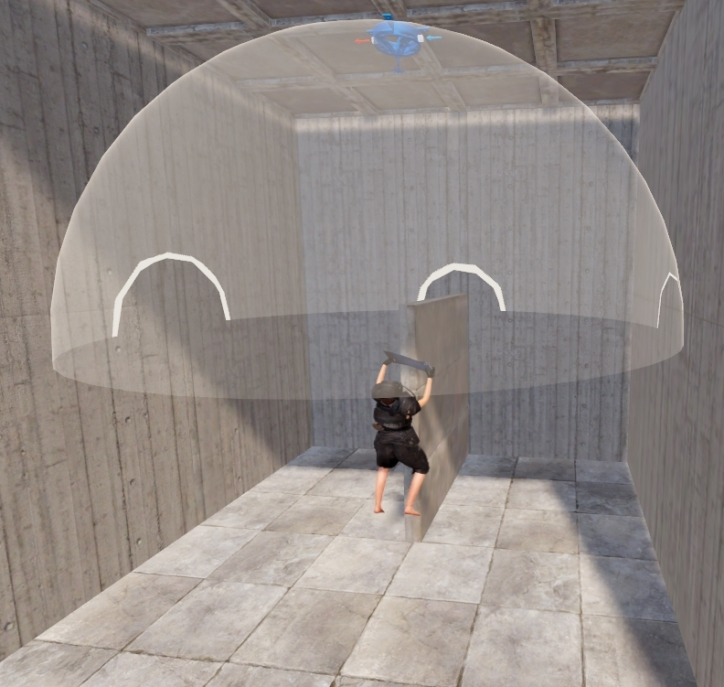
* Will wet players, and extinguish nearby campfires, furnaces, lanterns, and other similar items.
* Does not extinguish fire from flamethrowers or Molotov cocktails.
* Automatically activates when receiving water.
* Sprinklers can still appear active when underpowered, though no water may be dispensed.
* It will auto repair over time with resources from the Tool Cupboard.

**Water Mechanics**

* **Inputs/Outputs**:
  + **Input**: Water In
  + **Output**: Passthrough
* **Water Consumption**: Average 2ml/sec
* **Water Output**: Average 3ml/sec

**Sprinkler Output Behavior**

* Average consumption from a source is 120ml per minute +/- 2ml.
* Average output for a single planter is 180ml per minute +/- 15ml.
* Average output for a single pool is 120ml per minute +/- 10ml.
* Player entities within range are seen no differently than a pool or a planter.
* If multiple planter boxes, pools or players are in range, each will receive roughly an equal portion of water +/- 5ml.
  + Example: 1 sprinkler above a planter with a player in range, the planter will receive roughly 50% less water as compared to if the player was not present.
* **Cycle Duration:** Can be as fast as 2.55 seconds but **on average are roughly 5 seconds**, with **approximately 12 cycles a minute**, depending on server load.
  + Cycle times are how often water ticks up in a planter or a pool.
  + Single Planter Boxes gain 15ml per cycle.
  + Pools gain 10mL per cycle.
  + Sprinklers will take 2ml of water per second out of the water source or roughly 10 per cycle.
  + **Pulsing Sprinklers:** Can be used to decrease the watering time while also conserving the amount of water consumed.
    - **Warning:** Do not set timers shorter than 2.55 seconds. **Doing so will result in water leaving the source but never reaching the planter or pool.** Most servers cannot handle timers set this low. It is recommended timers should instead be kept to values that are divisible by 5 to avoid issues (e.g. 10, 20, 50, 85).
* Sprinklers given only 1mL/sec will still act as if given 2mL/sec.
* **BUG:** There is a max depth limitation of 15 components, water or electrical, between the Sprinkler and an **Electrical Power Source**. Past this limit, Sprinklers will still appear to function and get players wet, but will not fill a pool or planter with water.

**Water Types**

* **Fresh Water**:
  + Used for drinking and growing plants
* **Salt Water**:
  + When applied to crops, it will dry out the soil
* **Radiation Water**:
  + Works best when sprinkled from ceilings
  + Does not work when sprinkled from the floor
  + May work inconsistently when sprinkled from a wall
  + Creates a radiation zone that matches the wet radius, strongest at the edges
  + Requires 18 Radiation Protection to avoid poisoning
  + Deletes crops and removes any existing water from planters
  + Radiation does not stack from multiple sprinklers

**Placement Considerations**

* Can be placed on the ground or any building surface
* Can be rotated before placement using Reload (R)

Industrial

**What is the industrial system?**

The Industrial System is a specialized automation network that uses industrial components and connections to move items between containers, craft items, and smelt ores. It allows players to build fully automated base infrastructure for resource management, logistics, and production. Industrial systems operate using pipe connections, a dedicated Pipe Tool, and require electricity to power most components.

# Industrial Conveyor

**Item ID**: 610102428

**Description**: Moves items through the pipe system

**Crafting Details**

* **Crafting Recipe**: 75 Metal Fragments
* **Stack Size**: 5
* **Workbench Requirement**: Level 1
* **Research Table Cost**: 20 Scrap
* **Hit Points**: 200
* **Despawn Time**: 5 minutes
* **Decay Time**: 8 hours

**Functionality**

* The core component of the Industrial System. No items will move without at least one Conveyor.
* They work on a Pull/Push system. The conveyor will pull items from storage containers it can see, and push them into storage containers it can see.
* In order for the conveyor to see into a storage container, the container must be equipped with a Storage Adapter and the conveyor connected to it with a pipe.
* **Adapter ID:** Each adapter will create a new Adapter ID for the Conveyor to see. Multiple adapters on a single container turns that 1 container into multiple Adapter IDs.
* Storage containers are anything that a Storage Adapter can be applied to or the Industrial Crafter.
* Industrial Splitters and Industrial Combiners are used to expand the network allowing the conveyor to see into multiple storage containers.
* No items actually pass through conveyors, splitters, combiners or the pipes. Items are simply taken from one location to another when the conveyor says to do so. The pipes and other components are used to establish paths for the conveyor to see through.
* **Note:** Two conveyors cannot be connected to one another. They must be separated by a Storage Adapter or else nothing will transfer. They cannot see through each other.
* Conveyors do not need to transfer items to be useful. They can be used just to monitor a storage container. These are often referred to as Check Conveyors
  + Note: Check Conveyors only use 1 of its industrial connections to monitor a storage container's inventory.
  + Acts like an observer to allow for electrical automation based on inventory conditions using its Filter Pass and Filter Fail outputs.
  + Is not required but often uses different Filter Modes and Filter Options.
* If no filter is used, it will attempt to pull all items from the connected source and deposit them into any container it can see.
* Access the filter menu by looking at the conveyor and holding Use(E).
* Anyone can turn them on or off but only players with TC authorization can access the filters.
* Items are only moved if the destination has valid space for them and filter conditions are met.
* Using Industrial Splitters and Industrial Combiners can allow a single conveyor to see multiple containers or let multiple conveyors see a single container.
* The LCD display on the face of the Conveyor will display the images of the items currently being transferred.
* If the Conveyor has power and is on, it will remain on after a server restarts. If the Conveyor is turned on but has no power, after the server restarts, the Conveyor will default back to being turned off.
* Holding a Hammer and looking at the conveyor shows its health.
* It will auto repair over time using resources from the Tool Cupboard.
  + Industrial conveyors can now switch to a restricted mode if they are taking too long and degrading server performance

**Power Mechanics**

* **Power Connections**:
  + **Inputs:** Power In, Turn On, Turn Off
  + **Outputs:** Electrical Passthrough, Filter Fail, Filter Pass
* **Industrial Connections**:
  + **Inputs:** Industrial Input
  + **Outputs:** Industrial Output
* **Power Consumption**: 1rW (2rW if using filter outputs)
* **Active Usage**: 1
* **Power Output**: Input power minus 1
* **Turn On Input:** Applying power will allow the transfer of items.
* **Turn Off Input:** Applying power will halt the transfer of items. This is its default state.
* Whichever input is the last to receive power is the input that dictates the state of the conveyor. There are no priorities between them.
* Power must reach Power In before the Turn On input for the Conveyor to activate.
* **Filter Output Behavior**:
  + **Filter Pass** outputs 1rW when all filter conditions are met.
    - **No Filter:** Outputs power when it can transfer.
    - **MIN Filter:** Outputs power when greater than the set value.
    - **MAX Filter:** Outputs power when less than the set value.
  + **Filter Fail** outputs 1rW when filter conditions are not met.
    - **No Filter:** Outputs power when it cannot transfer.
    - **MIN Filter:** Outputs power when equal to, or less than the set value.
    - **MAX Filter:** Outputs power when equal to or greater than the set value.
  + Outputs refresh every 5 seconds. If conditions have not changed, power remains constant.
    - There are times where server performance can cause power to flip outputs and back again even though conditions never changed.
  + Will not function unless connected to at least 1 valid industrial input/output and has access to 2rW of power or more.
  + Powering passing through is only reduced by 1rW but because it is more than 2rW, the filter outputs will function making the Conveyor only consume 1rW.

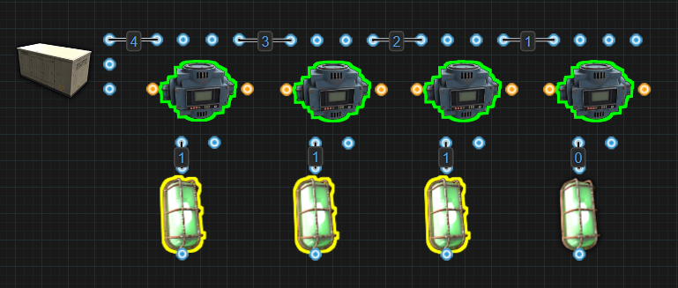

**Industrial Mechanics**

* **General Filters**: You can filter by specific items or by general filter groups:
  + bp_deployables, Ammo, Clothing, Components, Construction, Electrical, Food, Fun, Medical, Other, Resources, Tools, Traps, Weapons
* **Transfer Rate**: Up to 60 items per stack, from a max of 12 stacks, per 5 seconds, (60 items x 12 stacks = a max of 720 items per 5 seconds). If there is only 1 stack, a max of 60 will be transferred.
  + Each Storage Adapter added to the same container can allow a Conveyor to see the container an additional time.
  + Example: 4 adapters added on a large box, all connected together with a combiner or daisy chained, will let a Conveyor see said container 4 times.
* **Transfer Time:** Approximately 5 seconds for the first transfer and 3 to 5 seconds for subsequent transfers thereafter.
* **Filter Capacity**: Up to 30 individual items or grouped filters can be listed.
* **Filter Modes**:
  + **Any Item:** This is the default setting. It will move all items unless there are Item Filters that have been applied.
  + **Require All**: All listed items must be present to begin transfer.
    - This filter works as expected when a conveyor can only see 1 storage container through 1 storage adapter to pull items from. Conveyors apply the filter to each adapter individually. Multiple adapters don’t get merged into a unified group.
    - This filter mode works by checking to see how many Positive IDs (PIDs) it gets and if it matches the number of filtered items, the transfer begins.
    - Each Storage Adapter creates a new Adapter ID.
    - The conveyor will check each Adapter ID it sees for the item. If the item is present, that Adapter ID will return a Positive ID (PID). PIDs do not factor in the amount of the item present. Only the Filter Options factor in the number of stacks or their sizes.
    - Having too many Positive IDs (PIDs) is the same as not having enough.
      * **Example 1:** A Conveyor has 1 item filter set for Wood. The Conveyor will need 1 Positive ID before transferring. When it is connected to only 1 storage container with 1 Storage Adapter, or 1 Adapter ID, if any inventory slots have Wood, this will equal 1 Positive ID. Even if there are 10 slots with Wood, the Conveyor counts this as 1 Positive ID, not 10.
      * **Example 2:** A Conveyor has 1 item filter set for Wood. The Conveyor will need 1 Positive ID before transferring. When it can see 2 storage containers from 2 Storage Adapters, or 2 Adapter IDs, and there is Wood in both, the Conveyor will get 2 Positive IDs. When this happens, nothing will transfer. There are too many PIDs.
      * **Example 3:** A Conveyor has 1 item filter set for Wood. The Conveyor will need 1 Positive ID before transferring. When it can see the same storage container multiple times, like a Large Storage Box with 4 adapters daisy chained together, the Conveyor will get 4 Positive IDs, 1 from each Adapter ID. When this happens, nothing will transfer. There are too many PIDs.
    - This filter mode can be used in situations where a Conveyor can see multiple containers or the same container multiple times. It can also be used in situations where multiple items are set in the filter list. These are situations where False Positive IDs (FPIDs) can be created.
    - **Adapter ID:** Each adapter will create a new Adapter ID for the Conveyor to see. Multiple adapters on a single container turns that 1 container into multiple Adapter IDs.
    - A Conveyor set to filter multiple items, only needs the exact number of Positive IDs to start the transfer. The number of Positive IDs are based on the number of items in the filter list. If there are 5 items in the list, the Conveyor only needs 5 Positive IDs. These PIDs do not need to be 1 from each item on the list, just that the Conveyor receives the correct number of Positive IDs.
      * **Example 4:** A Conveyor has 4 items in the filter list. Wood, Stone, Cloth and Sulphur. The Conveyor will need 4 Positive IDs before transferring can start. If it's pulling from a single storage container with a single adapter, so 1 Adapter ID, each item present will return 1 Positive ID. Therefore, at least 1 of each item will need to be in that container before transferring to begin.
      * **Example 5:** A Conveyor has 4 items in the filter list. Wood Stone, Cloth and Sulphur. The Conveyor will need 4 Positive IDs before transferring can start. When it is pulling from a single storage container with 4 adapters daisy chained together, it sees 4 different Adapter IDs. If all 4 items are present in the storage container, 16 Positive IDs are being returned. Nothing will transfer.
      * **Example 6:** A Conveyor has 4 items in the filter list. Wood Stone, Cloth and Sulphur. The Conveyor will need 4 Positive IDs before transferring can start. When it is pulling from a single storage container with 4 adapters daisy chained together, it sees 4 different Adapter IDs. If only 1 out of the 4 items on the list is present, the Conveyor will receive 4 Positive IDs, 1 from each Adapter ID. This matches the required number of PIDs to start the transfer and so it does, even though not all of the specific items are present. This is a False Positive ID.
      * **Example 7:** A Conveyor has 3 items in the filter list. Wood, Stone and Cloth. The Conveyor will need 3 Positive IDs before transferring can start. When it pulls from 2 different containers, the first container having Wood and Stone and the second container also has some Wood, 3 Positive IDs will be returned. 2 PIDs from the first Adapter ID plus 1 from the second. This totals the required 3 Positive IDs and transferring will begin, even though Cloth was not present.
  + **Exclude Listed Items**: Moves all items except the ones listed items
    - Items in the filter list will be prevented from transferring.
    - **Bug/Filter:** When more than 1 item is on the filter list, the Conveyor applies the exclusion to each item individually. This causes Filter Pass to output power, even when only the excluded items are present.
      * **Example:** A Conveyor has Wood and Stone on the list with this filter applied. The Wood filter says to move everything but the Wood. The Stone filter says to move everything but the Stone. They don’t tell each other to not move themselves. So the Wood tries to move the Stone and the Stone tries to move the Wood. This results in the Filter Pass to output power because each item filter thinks it should be moving the other.
* **Filter Options**:
  + **MAX**: conveyor will stop moving the item when all output containers reach this amount.
    - **Single Container Example:** There are 12 stacks of Wood and the Wood filter is set to a MAX of 1000. The first transfer will be 60 from all 12 stacks for 720. The second transfer will be 280 then the transfers will stop.
    - **Multi Container Example:** There are 12 stacks of Wood and the Wood filter is set to a MAX of 1000. The first transfer will be 60 from all 12 stacks for 720, divided by the number of containers. Each container will receive an equal amount. This will repeat until all the output containers have 1000 in each of them.
    - This filter does not care about input containers and only looks at output containers.
  + **MIN**: conveyor will only move items in excess of this amount from all input containers.
    - **Single Container Example:** Wood set to a MIN of 1000. If there are 1000 or less, no transfer happens. The conveyor will only transfer the wood when there is 1001 or more. 1 will be transferred.
    - **Multi Container Example:** Wood set to a MIN of 1000. Every container the conveyor can pull from will need to have 1001 or more. If there are 2 containers, and each has 900 in each. Even though there is 1800 total, the conveyor is not adding both containers together. It can only apply the filter to each adaptor individually, not as a collective.
    - This filter does not care about output containers and only looks at the input containers.
  + **BUFFER**: Conveyors will only move items in chunks of this size.
    - Each adapter will create a new Adapter ID for the Conveyor to see. Multiple adapters on a single container turns that 1 container into multiple Adapter IDs.
    - Conveyors will calculate the total number of items available by adding up the amount it can see from each Adapter ID.
      * **Example 1:** A Conveyor has a Buffer for Wood set to 100. It is connected to a single adaptor on a storage container so it only sees 1 Adapter ID. There is only 50 Wood available. Nothing gets transferred.
      * **Example 2:** A Conveyor has a Buffer for Wood set to 100. It is connected to a single storage container through 2 Storage Adapters. The Conveyor now sees 2 Adapter IDs. This causes the Conveyor to see the same 50 Wood 2 times. Now the Conveyor thinks there is 100 Wood available and will start to transfer.
    - Conveyors do have a limited transfer rate. 60 items from up to 12 stacks for a max 720 items per transfer. The BUFFER can be set higher or lower than this limit.
    - It will try to provide the BUFFER amount in the first transfer. If it can't, attempts will be made in the following transfers to provide the remainder. In the last transfer, only the required amount that is needed to meet the BUFFER value will be transferred before the process begins again.
      * **Low Buffer:** Wood has a BUFFER set to 15. The conveyor will move 15 Wood each transfer.
      * **High Buffer:** Wood has a BUFFER set to 135. If there is 1 stack of Wood available, the conveyor will move 60 Wood in the first transfer, 60 in the second and 15 in the third, before the process repeats.
    - **Buffer In Progress:** It is caused when the Conveyor cannot move the Buffers value in a single transfer. The remainder of what could not be moved is held in memory and will continue to be transferred on the cycle or when able to do so.
      * The Buffer In Progress can be viewed inside the Conveyors menu on the top left side. It will show the remaining amount left to be transferred to meet the Buffer value.
      * When Buffer is used in tandem with a MAX setting, if the Buffer exceeds the MAX number, it will cause a “Buffer In Progress”.
        + **Example:** A Conveyor has a Wood filter. Its MAX is set to 10 and the Buffer is set to 15. If the Conveyor is only connected to 1 Storage Adapter, in the first transfer, 10 Wood will be moved. This satisfies the MAX filter and transfers will stop. The 5 remaining will be held in the Buffer. When able to do so, the last 5 from the Buffer will be transferred and on the following cycle, only 5 more will move which once again satisfies the MAX filter. Now there will be 10 held in the Buffer.
      * When used in tandem with a MIN setting, from multiple Adapter IDs, if there is not enough of the item to be pulled, it will pull the max amount on the first transfer then get stuck causing a “Buffer In Progress”.
        + **Example:** A Conveyor has a Wood filter. Its MIN is set to 500 and the Buffer is set to 80. The Conveyor is connected to 1 storage container though 2 Storage Adapters, and in that container there is 1 stack of 570 Wood. The 2 adapters will cause 2 Adapters IDs for the 1 storage container. This makes the Conveyor see the 570 Wood twice. This will total 1140 Wood and so the Conveyor can transfer. The 2 adapters also means that up to 120 Wood can be moved per transfer. So in the first transfer, 70 Wood will be moved, dropping the total amount remaining in the container at 500. This will satisfy the MIN filter and nothing more will be transferred. The remaining 10 will be held in the Buffer.
    - The Conveyor can only evenly transfer into a number of Storage Adapters that are divisible by the maximum number of items that can be transferred which is determined by the number of stacks or Adapter IDs.
      * If there is 1 stack, a max of 60 can be pulled. Take 60 and divide it by the number of adapters the Conveyor is pushing into.
      * If there are 2 stacks, a max of 120 can be pulled. Take 120 and divide it by the number of adapters the Conveyor is pushing into.
      * If there is 1 stack but the container has 2 adapters, a max of 120 can be pulled. Take 120 and divide it by the number of adapters that the Conveyor is pushing into.
    - **Note:** Pulling from more than 1 stack or through more than 1 adapter, will result in increasing the max possible pull rate. Which then will make the conveyor calculate its dividing of material with a much higher number.  
      And by having a lower buffer setting(60) than the pull rate, it will skew the dividing of material across the connected adapters.
      * **Example:** A Conveyor with a Buffer set to 135. Pulling from 1 stack through 1 adaptor and split between 7 adapters. We need to take 60, the max it can pull from 1 stack, and divide that by the 7 adapters, 60 / 7 = 8.5. 8.5 items would need to be transferred to keep things even, but it can't, so it rounds down. 8.5 rounded down is 8. 8 will be transferred into each adapter. 8 items multiplied by the 7 adapters is 56, 8 x 7 = 56. Only 56 will be taken per transfer.
        + The first transfer will take the 56 and put 8 in each of the 7 adapters. (56/7) = 8/8/8/8/8/8 = 79 of the 135 remains in the Buffer.
        + The second transfer will take another 56 and put 8 more in each of the 7 adapters. (56/7) = 16/16/16/16/16/16 = 23 of the 135 remains in the Buffer.
        + The third transfer will take the 23 and still try to put 8 more in each adapter. (56/7) = 24/24/23/16/16/16 = 0 of the 135 remains in the Buffer.
        + The last transfer will still try to take 56 as well, but the buffer setting is limiting the transfer to the remaining 23. But since the conveyor is trying to split 56 by 7, the 2 first adaptors will get 8 each and the 3rd will get the remaining 7, leaving none remaining for the last 4 adaptors.
        + **Note:** By Limiting the amount we are moving(23) compared to the amount the conveyor is realistically able to move(60), the splitting of the items gets skewed, and whatever material we transfer with a limited transfer, is dropped in the adaptors with the highest priority after it has been divided as if it were a full transfer(56/7).
* **Splitting / Combining / Daisy Chaining:**
* When an Adapter ID is added to a network that a Conveyor can see, each adapter is assigned a priority. Within each inventory, each slot is also prioritized top to bottom, left to right, from 1 to 48.
* Priorities are used by the Filter Options when trying to limit the Conveyor below its default Transfer Rate.
* **Daisy Chain Priority**:
  + **Daisy In:**
  + 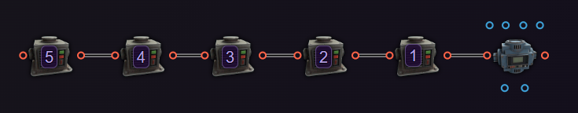
  + **Daisy Out:**
  + 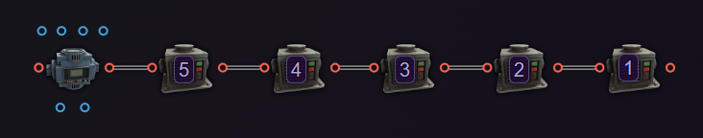
  + The adapter with the highest priority is the one that is closest. The closest is the one directly connected to a Conveyor’s Input or Output. The furthest one, or the deepest one, is assigned the lowest priority.
* **Combining Priorities:**
  + 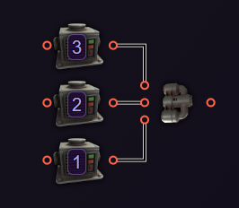
  + The adapter with the highest priority is connected in the order, Industrial In 1 > Industrial In 2 > Industrial In 3. Up to the maximum amount of an item will be taken first from the adapter connected to its first input, Industrial In 1. If more is required than the amount available from the first input, it will take what it can or needs from the next input, Industrial In 2. The process will repeat for input 3, Industrial In 3, if required.
  + 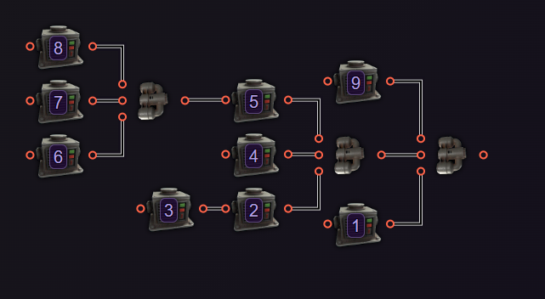
  + Combining always prioritizes the first input and anything connected to it. This includes another combiner, which will then prioritize its inputs before returning back to the original combiners next input. If a third combiner happens to be connected to the second combiner, its inputs will be prioritized before the original combiners next input.
* **Splitting Priorities:**
  + 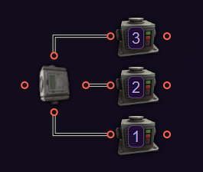
  + An attempt will be made to give each output an even amount. When a situation arises where an amount cannot be evenly shared, the remainder will be given to the adapters with the highest priority. Priorities are assigned in the order, Industrial Out 1 > Industrial Out 2 > Industrial Out 3.
  + 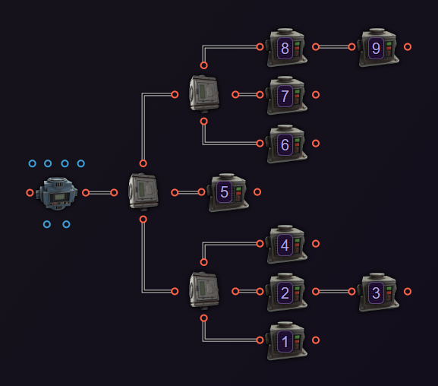
  + Splitting always prioritizes the first output and anything connected to it. This includes another splitter, which will then prioritize its outputs before returning back to the original splitters next output. If a third splitter happens to be connected to the second splitter, its inputs will be prioritized before the original splitter's next output.
* **Filter Sharing**:
  + Use Copy/Paste within the menu to copy filter settings and paste into multiple conveyors easily.
  + Holding Sprint (Shift) lets a user Copy(JSON). This can then be pasted into a text file allowing a player to share their conveyor filters outside of the game and between servers. Hold Sprint (Shift) to Paste(JSON).
    - 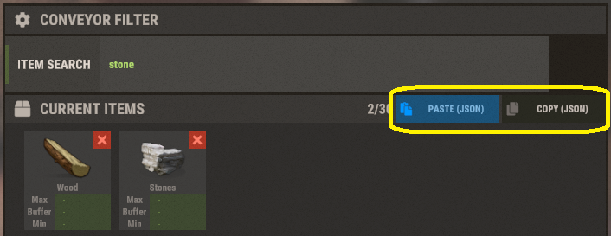
    - Example of copied JSON:

[

{

"TargetCategory": null,

"MaxAmountInOutput": 0,

"BufferAmount": 0,

"MinAmountInInput": 0,

"IsBlueprint": false,

"BufferTransferRemaining": 0,

"TargetItemName": "wood"

},

{

"TargetCategory": null,

"MaxAmountInOutput": 0,

"BufferAmount": 0,

"MinAmountInInput": 0,

"IsBlueprint": false,

"BufferTransferRemaining": 0,

"TargetItemName": "stones"

}

]

* + - The ‘Filter Mode’ does not get copied.
    - The line for "TargetItemName": "stones" can be modified to include any item in the F1 menu, including hidden items. Players can find a complete list of items and their shortnames from [Corrosionhour](https://www.corrosionhour.com/rust-item-list/). Some items cannot be filtered for.
* **Limitations**:
  + **Max Storage Adapters:** 32 is the most adapters the conveyor can see from either its Input or its Output.
  + **Max Depth:** 32 components is the deepest a conveyor can see from either its Input or its Output. Adapters past this limit cannot be seen so nothing will move in or out of them.
  + The **Max Depth / Short Circuit error** will appear but that is not always the case. It is best to learn how to count depth to avoid issues.
  + **Unstackable items** count as 1 stack each. A max of 12 can be moved per transfer.

**Placement Considerations**

* Can be placed on all building block or the ground
* Can be rotated before placement using Reload (R)

# Industrial Crafter

**Item ID**: 1430085198

**Description**: Attaches to a workbench to allow automated crafting

**Crafting Details**

* **Crafting Recipe**: 3 High Quality Metal, 2 Tech Trash
* **Stack Size**: 5
* **Workbench Requirement**: Level 2
* **Research Table Cost**: 75 Scrap
* **Hit Points**: 200
* **Despawn Time**: 20 minutes
* **Decay Time**: 8 hours

**Functionality**

* Installs directly onto Workbenches. Maximum of 2 per bench, only 1 on the Engineering Workbench.
* Allows automated crafting of items using blueprints and input materials.
* Can be operated manually by putting materials and blueprints in, then taking the crafted items out as well as manually turning the crafter on.
* Crafting speed is the same regardless of workbench type or tier.
* Items can only be crafted if the attached workbench matches or exceeds the blueprint's tier requirement.
* Only one blueprint can be crafted at a time per crafter.
* It cannot craft armor with plate slots. That can only be done by the player.
* Blueprints are prioritized from left to right when crafting from the same materials.
  + **Example:** There are 2 blueprints in order, High Velocity Rock and HV 5.56 Rifle Ammo. For items, there are a few metal pipes, a stack of gun powder and a few hundred metal fragments. The HV Rockets will be crafted first until it runs out of pipes before the HV 5.56 starts to be crafted.
* If the output container is full, crafting will not proceed.
* Anyone can turn the crafter on or off as well as access the inventory.

**Internal Inventory**

* **Blueprint Slots:** Holds up to 4 blueprints and only blueprints.
* **Input Slots**: Has 4 inventory slots to hold crafting ingredients. Items can only go in. If items need to be removed, manual removal is required.
* **Output Slot**: Has 4 inventory slots to hold crafted items. Removal can be done manually or via a conveyor through the Industrial Out output.

**Power Mechanics**

* **Electrical Inputs**:
  + **Power In**: Enables the ability to craft.
  + **Turn On**: Forces crafting to begin.
  + **Turn Off**: Forces crafting to stop.
  + **Toggle**: Turns on while powered. Turns off when power is removed
* **Power Consumption**: 1rW
* **Active Usage**: 1

**Input Priority Behavior**

* The last electrical input to receive power dictates the crafter’s behavior.
* Toggle is an exception. Removing power from Toggle turns the crafter off.

**Industrial Mechanics**

* **Industrial Inputs:**
  + **Industrial In**: Allows for the transfer of ingredients into the input slots.
  + **Blueprint In:** Allows for the transfer of blueprints into the blueprint slots.
* **Industrial Outputs:**
  + **Industrial Out**: Allows for the removal of crafted items out of the output slots.
  + **Blueprint Out**: Allows for the removal of blueprints from the blueprint slots.

**Placement Considerations**

* Must be placed on a Workbench (Tier 1, 2, or 3) or Engineering Workbench.
* The Engineering Workbench has 1 spot for the crafter. The other Workbenches have 2 spots for the crafter.
* Can be used on workbenches placed on Tugboats.

# 

# Storage Adapter

**Item ID**: -1049172752

**Description**: Connects a container to the industrial system for item transfer.

**Crafting Details**

* **Crafting Recipe**: 100 Metal Fragments
* **Stack Size**: 5
* **Workbench Requirement**: Level 1
* **Research Table Cost**: 20 Scrap
* **Hit Points**: 30
* **Despawn Time**: 5 minutes
* **Decay Time**: 8 hours

**Functionality**

* These get installed onto containers like boxes, furnaces, fridges, lockers, etc., so a Conveyor can see and access their inventories.
* Allows for automated transfer of items into or out of the container by a conveyor.
* Can function as both input and output depending on the connected Conveyor.
* Some containers support multiple adapters.
* Each adapter will create a new Container ID for the Conveyor see. Multiple adapters on a single container turns that 1 container into 4 Container IDs.
* The number of items that a Conveyor can pull/push from a single container increases with the number of adapters:
  + 1 adapter = 60 items from 12 stacks.
  + 2 adapters = 120 items from 12 stacks.
  + etc., up to the maximum number of adapters on a container.
  + Conveyors see each adapter connected to a single container as a separate instance of the container.
* Conveyors can only see a maximum of 32 adapters from its input or its output.
* **Daisy Chaining:**
  + Each container in the chain will receive approximately an equal portion pulled from it or pushed to it.
  + Each adapter in a daisy chain adds to the depth of the circuit.
  + Conveyors have a Max Depth of 32 components on either its input or output side.
* Holding a Hammer and looking at the adapter will show its health.

**Adapter Limits by Container**

* Fridge: 1
* Coffin: 1
* Small Box: 2
* Large Box: 4
* Small Furnace: 1
* Electric Furnace: 2
* Large Furnace: 4
* Refinery: 1
* Drop Box: 1
* Lockers: 3
* Vending Machine: 1
* Tool Cupboard: 2

**Industrial Mechanics**

* **Industrial Connections**:
  + **Industrial In**: Allows items to be transferred into the container.
  + **Industrial Out**: Allows items to be extracted out of the container.

**Placement Considerations**

* Must be placed directly on the container.
* Building structures and other deployables can block placement.
* Health is separate from the container it is attached to.
* Can be used on deployables placed on Tugboats.

# 

# Electric Furnace

**Item ID**: -1196547867

**Description**: An electrical version of a furnace that uses electricity instead of a fuel source

**Crafting Details**

* **Crafting Recipe**: 5 High Quality Metal, 200 Metal Fragments
* **Stack Size**: 1
* **Workbench Requirement**: Level 2
* **Research Table Cost**: 75 Scrap
* **Hit Points**: 500
* **Despawn Time**: 40 minutes
* **Decay Time**: 96 hours

**Functionality**

* A powered alternative to traditional furnaces that requires electricity instead of wood.
* Smelts ores and cans into usable materials like metal fragments, sulfur, and high quality metal.
* Cannot burn wood and produces no charcoal.
* Smelts faster than the Small Furnace by approximately 66%.
* Holding a Hammer and looking at the furnace will show its health.
* Auto-repairs over time.

**Inventory System**

* **Input Slots**: 2 slots for raw ores or empty cans. Only items that can be smelted can be inserted into these slots. There is no way to remove items from these slots other than manual removal.
* **Output Slots**: 3 slots for smelted materials. Items must be removed manually or via Industrial Out on a Storage Adapter.

**Industrial Mechanics**

* **Is not required** but supports up to 2 Storage Adapters for integration with an industrial network.
* **Players can load and unload the furnace manually.** It is recommended to place a switch nearby to turn the furnace on and off.

**Power Mechanics**

* **Electrical Inputs**: Power In
* **Power Consumption**: 3rW
* **Active Usage**: 3
* When the furnace receives power, it turns on and will start smelting. Removing power turns it off.

**Placement Considerations**

* Must be placed on foundations or floors.
* Can be rotated before placement using Reload (R).
* Cannot be used with component snapping.

# 

# Industrial Splitter

**Item ID**: 742745918

**Description**: Splits an industrial connection into 3 separate connections

**Crafting Details**

* **Crafting Recipe**: 75 Metal Fragments
* **Stack Size**: 5
* **Workbench Requirement**: Level 1
* **Research Table Cost**: 20 Scrap
* **Hit Points**: 200
* **Despawn Time**: 5 minutes

**Functionality**

* It splits 1 industrial connection into three industrial connections.
* No items are transferred through the splitter itself. It acts as a junction point between Conveyors and Storage Adapters allowing them to see each other.
* Can be stacked on a variety of components including: Industrial Lights, Blockers, Electrical Branch, Memory Cell, and the RAND Switch.
* Holding a Hammer and looking at the component will show its health.
* Auto-repairs over time.

**Industrial Mechanics**

* **Industrial Connections**:
  + **Inputs:** Industrial In
  + **Outputs:** Industrial Out 1, Industrial Out 2, Industrial Out 3
* Adds to the depth of a circuit on either side of a Conveyor.
* If pipes are split into a number of storage adapters that does not divide evenly into 60, Conveyors will pull fewer than 60 items per group per stack. (60 ÷ # of Storage Adapters, rounded down)

**Placement Considerations**

* Can be placed on all building block including angled and flat surfaces, as well as the ground.
* Can be rotated with **Reload (R)** before placement.

# 

# Industrial Combiner

**Item ID:** 1538126328

**Description:** Merges up to 3 separate industrial connections into 1.

**Crafting Details**

* **Crafting Recipe:** 75 Metal Fragments
* **Stack Size:** 5
* **Workbench Requirement:** Level 1
* **Research Table Cost:** 20 Scrap
* **Hit Points:** 200
* **Despawn Time:** 5 minutes

**Functionality**

* It merges up to 3 industrial connections into a single connection.
* No items are transferred through the combiner itself. It acts as a junction point between Conveyors and Storage Adapters allowing them to see each other.
* Prioritizes input connections in the order: Industrial In 1 > Industrial In 2 > Industrial In 3.
* If items being pulled cannot be split evenly, the remainder will come from the highest priority input.
* Holding a Hammer and looking at the component will show its health.
* Auto-repairs over time.

**Industrial Mechanics**

* **Industrial Connections:**
  + **Inputs:** Industrial In 1, Industrial In 2, Industrial In 3
  + **Output:** Industrial Out
* Adds to the industrial depth on either side of a Conveyor.

**Placement Considerations**

* Can be placed on all building block including angled and flat surfaces, as well as the ground.
* Can be rotated with Reload (R) before placement.

# Hopper

**Item ID:** 1428574144

**Description:** Will suck up any dropped items in its radius while powered.

**Crafting Details**

* **Crafting Recipe:** 200 Metal Fragments, 1 Gear
* **Stack Size:** 5
* **Workbench Requirement:** Level 1
* **Research Table Cost:** 20 Scrap
* **Hit Points:** 200
* **Despawn Time:** 5 minutes

**Functionality**

* Sucks up any dropped items within a 1 foundation (3 meter) radius when powered.
* Can automatically harvest animal and player corpses, collecting all loot.
  + Does not suck up loot bags from destroyed storage containers.
* Items are deposited directly into the connected container.
* Can be placed on top of Large Storage Boxes and Barrels.
* Prevents one Storage Adapter from being placed so it has industrial connections.
* Requires line of sight to function. Things like the bars on window bars can block line of sight.
* Holding a Hammer and looking at the component will show its health.
* Auto-repairs over time.

**Power Mechanics**

* **Electrical Input:** Power In
* **Power Consumption:** 8rW
* **Active Usage:** 8

**Industrial Mechanics**

* **Industrial Connections:**
  + **Input:** Industrial In
  + **Output:** Industrial Out
* Functions similarly to a Storage Adapter in industrial systems just with an added feature.

**Placement Considerations**

* Must be attached to a Large Storage Box or Barrel.
* Cannot pull items through walls, doors, floors, strengthened glass, or window shutters.
* Can pull through chainlink fence, prison cells, window bars, rugs, vending machines, lockers, workbenches, and out of Camper Modules interior.
* Requires line of sight to function. Things like the bars on window bars can block line of sight.

**Known Quirks**

* **Bug/Feature:** When daisy chaining adapters on the same storage container.
  + Hopper > Adapter > Adapter > Adapter = 4 adapters seen by Conveyor.
  + Adapter > Adapter > Adapter > Hopper = only 1 adapter seen.
  + May cause a possible industrial depth reset or affect Conveyor behavior in an unrealized way. Needs more testing.

Voice Props Pack DLC

The **Voice Props Pack DLC** was released on July 2, 2021. It is meant to enhance the game by introducing a variety of audio and visual components, allowing players to record, play, and broadcast sounds, as well as create dynamic environments with music and lighting effects.

**Key Features:**

* **Audio Devices:**
  + ***Cassette Recorder* and *Cassettes*:** Record and playback audio, including player voices and environmental sounds.​
  + ***Connected Speaker*:** Extend audio playback to multiple areas within your base.
  + ***Boom Box* and *Portable Boom Box*:** Play recorded cassettes or stream internet radio stations within the game.
  + ***Megaphone* and *Microphone Stand*:** Amplify your voice to project across distances or throughout your base.
  + ***Mobile Phone*:** Make and receive calls in-game, anywhere on the map. There is no voicemail service.
  + ***Modular Car Radio*** **(added in 2024):** Enhance vehicles with radio and audio playback capabilities. ​
* **Visual and Interactive Elements:**
  + ***Disco Floor* (multiple variants):** Create dance floors that react to in-game music.
  + ***Disco Ball*:** A rotating mirrored ball that adds dynamic reflections and lighting effects to your dance floors or event spaces.
  + ***Sound Lights* and *Laser Lights*:** Lighting elements that synchronize with audio for dynamic visual effects.​
  + ***Dance Gestures*:** Three new emotes to express yourself on the dance floor. ​

These components and abilities enable players to host in-game events, set up communication networks, and personalize their environments with music and lighting, adding depth and entertainment to the Rust experience.

**How To Acquire:** The Voice Props Pack DLC must be purchased separately from the Rust base game. The DLC can be bought from the games store page on Steam or from the Item Store on the home screen of the game. Once purchased, items from the pack become available to craft and use in-game.

# Understanding the Audio System in Rust

The Audio System is a unique network, similar to the Water and Industrial systems. While those systems transport physical resources, the Audio System focuses on broadcasting sound and triggering visual effects based on audio signals. It integrates fully with the Electrical System and uses the Wire Tool to make connections.

**Core Functionality**

* This system allows for dynamic player-made content like clubs, events, or audio-triggered alerts.
* The system is powered through electrical IO connections and requires power to operate.
* Sound-producing devices generate audio signals that other components can respond to visually.
* Components are connected using Audio Out connections to route sound signals.

**Audio ID Binding**

* Audio Sources, Boomb Boxes and Microphone Stands, create an Audio ID that is used by Reactive Components to synchronize audio or visual effects. This ID is transferred along wires connected to their Audio Out output.
* Reactive Components (e.g. Disco Floor, Sound Light, Laser Light and Connected Speaker) need to be powered via the Audio Out output on an Audio Source to enable audio and visual light syncing.
* Reactive Components can only bind to one Audio ID at a time and will bind to the one with the highest priority when more than 1 is available.
* When the Boom Box or Microphone Stand is providing the Reactive Components with their power, everything will work as expected.

**Binding Priorities with OR/XOR Switches**

When multiple Audio Sources (Boom Boxes and Microphone Stands) are connected through OR or XOR Switches, binding behavior becomes less predictable. Reactive Components only bind to a single Audio ID at one time, and their priority changes depending on the order of connections and power events.

**🟩 Sound Light, Laser Light, and Disco Floor:**

* **Input A has highest priority.**Even if Input B’s Boom Box receives power or starts playing music first, if both inputs are connected, the reactive component binds to the Audio Source on Input A of the OR/XOR switch.
* **Input B only binds if it’s first to play before Input A is physically connected.**If Input B's Audio Source provides power before Input A's Audio Source is physically connected at all, the bind will go to Input B. The bind will only swap to Input A once Input B is turned off.
* **Once bound to Input A, Reactive Components will only switch to Input B once Input A is physically disconnected.**Even if the Audio Source on Input A stops playing music or is powered off, the bind will not automatically switch to Input B. The connection to Input A must be removed before Input B receives power.

**🟦 Connected Speaker:**

* **More flexible binding behavior.**Unlike other reactive components, the Connected Speaker can rebind to a different Audio ID but only after both itself and the Audio Source are turned off or lose power.
* **Switching from 1 input to another.**If the Audio Source on Input A is active and you want to switch to the Audio Source on Input B, simply turn off the Audio Source connected to Input A before turning on the Audio Source connected to Input B. The speaker unbinds when it loses power allowing a new bind from a different input.
* **If rebinding doesn’t work right away, turn the speaker off and on again.**Try turning the Audio Source off and on again. If that doesn't work, detach and reattach the wire connected to Audio Out on the Audio Source.

**Binding Reset**

* **To reset a binding:**
  + **Power Off and On both the audio source and reactive component(s):** Ensure the Reactive Component is no longer powered before turning the Audio Source back on. When the Reactive Component loses power, it unbinds from the current Audio ID allowing a new bind when it powers back on. It will rebind to the Audio ID with the highest priority.
  + Priorities are assigned by OR/XOR Switches. Input A over Input B.
  + If the Reactive Component(s) can be powered by an alternative power source, disconnecting the Audio Source will not reset the bind.

# Boom Box

**Item ID:** -1113501606

**Description:** A large speaker to play recorded cassette tapes and also stream audio from the internet.

**Crafting Details**

* **Crafting Recipe**: 100 Metal Fragments, 200 Wood, 20 Cloth
* **Stack Size**: 1
* **Workbench Required**: Level 1
* **Research Cost**: 10 Scrap
* **Where to Buy**: Requires a DLC purchase
* **Hit Points**: 100
* **Despawn Time**: 5 minutes
* **Decay Time**: 96 hours

**Functionality**

* Plays music from cassette tapes or internet radio streams.
* Accepts cassettes of all three lengths: 10s, 20s, and 30s.
* Internet radio stations can be selected through the Boom Box UI.
* Can be used with reactive components like the Sound Light, Laser Light, Disco Floor or Connected Speaker to enhance a player's audio and visual experience.
* Creates an Audio ID for reactive components to bind to. When multiple Boom Boxes connect to the same reactive components, Audio IDs are prioritized based on wiring order and connection timing (see Audio System Overview).
* Can be activated manually or with electricity.
* Anyone can turn the Boom Box on and off.
* TC Authorization is required to access the UI. Look at the speaker and hold Use (E) to access Radio Settings or Open.
  + **Open** allows for a cassette to be inserted.
  + **Radio Settings** access the list of radio stations.
* Can be picked up with a Hammer, but not while a cassette is still inside. Picking it up does **not** cause damage.
* Holding a hammer and looking at the Boom Box will show its health.
* It will auto-repair over time using resources from the Tool Cupboard.
* Audio range is 30 meters (10 square foundations).
* Best placed in central or visible areas for audio and aesthetic impact.

**Power Mechanics**

* **Power Connections:**
  + **Inputs**: Power, Toggle Play
  + **Output:** Audio Out
* **Toggle Play:** Needs constant power to function. When power is removed, the Boom Box will stop playing.
* **Power Consumption**: 10rW
* **Active Usage**: 10rW
* **Power Output**: Input power minus 10rW
* Power needs to receive power before Toggle Play if players want the Boom Box to turn on.

**Audio Output Behavior**

* When an Audio Source, Boom Boxes and Microphone Stands, are the ones to give power to Reactive Components, things work as expected.
* Reactive Components (e.g., Disco Floor, Sound Light, Laser Light and Connected Speaker) need to be powered via the Audio Out output on an Audio Source to enable audio and visual light syncing.
* Audio Sources create an Audio ID that is used by Reactive Components to synchronize audio or visual effects. This ID is transferred along wires connected to their Audio Out output.
* When multiple Audio Sources are connected through OR/XOR Switches, to Reactive Components, things do not work as expected.
  + Reactive Components will bind to the first Audio ID detected after receiving power. This is not always the case when using OR/XOR Switches.
  + **Binding Priorities with OR/XOR Switches:**
    - **Sound Light / Laser Light/ Disco Floor:**
    - When 2 Audio Sources are connected, the one connected to Input A, takes priority. It doesn't matter if Input B is the one to be powered or play music first, Input A has priority.
    - The Audio Source connected to Input B, will only take priority when power and audio is passed through it first, before Input A is physically connected.
    - Once Input B loses power, Input A will bind even if power is restored to Input B.
    - **Connected Speaker:**
    - It will take the Audio ID from either input, as long as the previous Audio Source is turned off first.
    - If it doesn't rebind to the new Audio Source, try turning it off and on again.
  + **Binding Reset:**
    - To reset a binding, detach and reattach the Reactive Component from the circuit allowing it to power off.
    - Turn the Audio Source off and on again.

**Placement Considerations**

* Can be placed on horizontal building block, the ground, and some deployables (e.g., Work Benches, Tables).
* Can be rotated with Reload (R) before placement.

# Connected Speaker

**Item ID:** 968421290

**Description:** A small speaker that will play any audio from a connected Boom Box or Microphone Stand

**Crafting Details**

* **Crafting Recipe**: 75 Metal Fragments
* **Stack Size**: 5
* **Workbench Required**: Level 1
* **Research Table Cost**: 10 Scrap
* **Where to Find**: Requires a DLC purchase
* **Despawn Time**: 5 minutes
* **Decay Time**: 96 hours
* **Hit Points**: 50

**Functionality**

* Relays and plays audio from Boom Boxes or Microphone Stands using their Audio Out connection.
* Will only bind to one Audio ID at a time. When connected to multiple sources, it prioritizes based on wiring order and connection timing (see Audio System Overview).
* Designed to extend audio coverage over larger areas.
* Produces the same sound as the original source but with slightly lower audio quality.
* Has an approximate audio range of 30 meters (10 square foundations).
* Audio Passthrough allows daisy-chaining of additional reactive components.

**Audio Output Behavior**

* When an Audio Source, Boom Boxes and Microphone Stands, are the ones to give power to Reactive Components, things work as expected.
* Reactive Components (e.g., Disco Floor, Sound Light, Laser Light and Connected Speaker) need to be powered via the Audio Out output on an Audio Source to enable audio and visual light syncing.
* Audio Sources create an Audio ID that is used by Reactive Components to synchronize audio or visual effects. This ID is transferred along wires connected to their Audio Out output.
* When multiple Audio Sources are connected through OR/XOR Switches, to Reactive Components, things do not work as expected.
  + Reactive Components will bind to the first Audio ID detected after receiving power. This is not always the case when using OR/XOR Switches.
  + **Binding Priorities with OR/XOR Switches:**
    - **Sound Light / Laser Light/ Disco Floor:**
    - When 2 Audio Sources are connected, the one connected to Input A, takes priority. It doesn't matter if Input B is the one to be powered or play music first, Input A has priority.
    - The Audio Source connected to Input B, will only take priority when power and audio is passed through it first, before Input A is physically connected.
    - Once Input B loses power, Input A will bind even if power is restored to Input B.
    - **Connected Speaker:**
    - It will take the Audio ID from either input, as long as the previous Audio Source is turned off first.
    - If it doesn't rebind to the new Audio Source, try turning it off and on again.
  + **Binding Reset:**
    - To reset a binding, detach and reattach the Reactive Component from the circuit allowing it to power off.
    - Turn the Audio Source off and on again.

**Power Mechanics**

* **Power Connections**:
  + **Input**: Power/Audio In
  + **Output**: Passthrough
* **Power Consumption**: 1rW
* **Active Usage**: 1
* **Power Output**: Input power minus 1rW

**Placement Considerations**

* Can be placed on horizontal or angled building block.
* Can be rotated with Reload (R), but rotation is currently bugged and will cause the speaker to clip into the wall.
* Holding a Hammer while looking at the speaker will show its health.
* Will auto-repair over time using resources from the Tool Cupboard.

# Disco Ball

**Item ID:** 1895235349

**Description:** Get groovy with this stunning disco ball.

**Crafting Details**

* **Crafting Recipe**: 50 Metal Fragments
* **Stack Size**: 5
* **Workbench Required**: Level 1
* **Research Table Cost**: 10 Scrap
* **Where to Find**: Requires a DLC purchase
* **Despawn Time**: 5 minutes
* **Decay Time**: 96 hours
* **Hit Points**: 25

**Functionality**

* Spins and reflects light to simulate a disco party effect when powered.
* Functions as a light source, and does not require a Boom Box or Microphone Stand to operate.
* Can be used in combination with other visual components like the Music Light, Laser Light, or Disco Floor to create full light shows.
* Does not react to audio or bind to Audio IDs—purely visual.
* The visual shimmer effect passes through walls, making it ideal for atmospheric lighting even in enclosed areas.
* Holding a Hammer while looking at the Disco Ball will show its health.
* Will auto-repair over time using resources from the Tool Cupboard.

**Power Mechanics**

* **Power Connections**:
  + **Input**: Power
  + **Output**: Passthrough
* **Power Consumption**: 1rW
* **Active Usage**: 1
* **Power Output**: Input power minus 1rW

**Placement Considerations**

* Can only be placed hanging from ceilings or angled roofs.
* Can be rotated with Reload (R) before placement.
* Best used in dark indoor areas to maximize light projection.

# Disco Floor

**Items ID: Left Picture:** 286648290 (Default) **Right Picture:** 1735402444

**Description**: A vibrant flashing floor that pulses in time to music.

**Crafting Details**

* **Crafting Recipe**: 75 Metal Fragments
* **Stack Size**: 5
* **Workbench Required**: Level 1
* **Research Table Cost**: 10 Scrap
* **Where to Find**: Requires a DLC purchase
* **Despawn Time**: 5 minutes
* **Decay Time**: 8 hours
* **Hit Points**: 50

**Functionality**

* Lights up and pulses in sync with audio received from a Boom Box or Microphone Stand.
* Will only bind to one Audio ID at a time. When connected to multiple sources, it prioritizes based on wiring order and connection timing (see Audio System Overview).
* **Players with Tool Cupboard authorization can configure:**
  + **Pattern**: Determines the animation style of the lights (sweeps, waves, pulses, etc.).
  + **Volume Sensitivity**: Controls how reactive the tiles are to audio volume. Higher sensitivity = stronger response.
  + **Speed**: Adjusts how fast the light pattern moves or flashes.
  + **Gradient**: Changes the color scheme and transition style of the lights.
* **There are two variants of Disco Floors:**
  + One with larger tiles
  + One with smaller tiles
  + Select the one to make at the time of crafting.
* Will auto-repair over time using resources from the Tool Cupboard.

**Audio Behavior**

* When an Audio Source, Boom Boxes and Microphone Stands, are the ones to give power to Reactive Components, things work as expected.
* Reactive Components (e.g., Disco Floor, Sound Light, Laser Light and Connected Speaker) need to be powered via the Audio Out output on an Audio Source to enable audio and visual light syncing.
* Audio Sources create an Audio ID that is used by Reactive Components to synchronize audio or visual effects. This ID is transferred along wires connected to their Audio Out output.
* When multiple Audio Sources are connected through OR/XOR Switches, to Reactive Components, things do not work as expected.
  + Reactive Components will bind to the first Audio ID detected after receiving power. This is not always the case when using OR/XOR Switches.
  + **Binding Priorities with OR/XOR Switches:**
    - **Sound Light / Laser Light/ Disco Floor:**
    - When 2 Audio Sources are connected, the one connected to Input A, takes priority. It doesn't matter if Input B is the one to be powered or play music first, Input A has priority.
    - The Audio Source connected to Input B, will only take priority when power and audio is passed through it first, before Input A is physically connected.
    - Once Input B loses power, Input A will bind even if power is restored to Input B.
    - **Connected Speaker:**
    - It will take the Audio ID from either input, as long as the previous Audio Source is turned off first.
    - If it doesn't rebind to the new Audio Source, try turning it off and on again.
  + **Binding Reset:**
    - To reset a binding, detach and reattach the Reactive Component from the circuit allowing it to power off.
    - Turn the Audio Source off and on again.

**Power Mechanics**

* **Power Connections**:
  + **Input**: Audio In
  + **Output**: Audio Passthrough
* **Power Consumption**: 1rW
* **Active Usage**: 1
* **Power Output**: Input power minus 1rW

**Placement Considerations**

* Must be placed flat on the floor.
* Cannot be stacked or have other deployables placed on top.
* Can be rotated with Reload (R) before placement.

# Laser Light

**Item ID:** 853471967

**Description:** A small device that shoots out visible lasers in time to music.

**Crafting Details**

* **Crafting Recipe**: 100 Metal Fragments
* **Stack Size**: 5
* **Workbench Required**: Level 1
* **Research Table Cost**: 10 Scrap
* **Where to Find**: Requires a DLC purchase
* **Despawn Time**: 5 minutes
* **Decay Time**: 96 hours
* **Hit Points**: 50

**Functionality**

* Emits 3 lasers that move in response to audio from a Boom Box or Microphone Stand.
* Laser range is about 10 foundations or 30 meters.
* Will only bind to one Audio ID at a time. When connected to multiple sources, it prioritizes based on wiring order and connection timing (see Audio System Overview).
* Players with **Tool Cupboard authorization** can interact with it by pressing **Use (E)** to configure the following settings:
  + **Color:** Select from multiple preset laser colors.
  + **Volume Sensitivity:** Adjust how strongly the lasers respond to audio.
  + **Speed:** Select how fast or slow the laser will move around.
* Can be picked up with a Hammer, but doing so reduces health by 25%.
* Will auto-repair over time using resources from the Tool Cupboard.

**Power Mechanics**

* **Power Connections**:
  + **Input**: Power/Audio In
  + **Output**: Audio Passthrough
* **Power Consumption**: 1rW
* **Active Usage**: 1
* **Power Output**: Input power minus 1rW

**Audio Behavior**

* When an Audio Source, Boom Boxes and Microphone Stands, are the ones to give power to Reactive Components, things work as expected.
* Reactive Components (e.g., Disco Floor, Sound Light, Laser Light and Connected Speaker) need to be powered via the Audio Out output on an Audio Source to enable audio and visual light syncing.
* Audio Sources create an Audio ID that is used by Reactive Components to synchronize audio or visual effects. This ID is transferred along wires connected to their Audio Out output.
* When multiple Audio Sources are connected through OR/XOR Switches, to Reactive Components, things do not work as expected.
  + Reactive Components will bind to the first Audio ID detected after receiving power. This is not always the case when using OR/XOR Switches.
  + **Binding Priorities with OR/XOR Switches:**
    - **Sound Light / Laser Light/ Disco Floor:**
    - When 2 Audio Sources are connected, the one connected to Input A, takes priority. It doesn't matter if Input B is the one to be powered or play music first, Input A has priority.
    - The Audio Source connected to Input B, will only take priority when power and audio is passed through it first, before Input A is physically connected.
    - Once Input B loses power, Input A will bind even if power is restored to Input B.
    - **Connected Speaker:**
    - It will take the Audio ID from either input, as long as the previous Audio Source is turned off first.
    - If it doesn't rebind to the new Audio Source, try turning it off and on again.
  + **Binding Reset:**
    - To reset a binding, detach and reattach the Reactive Component from the circuit allowing it to power off.
    - Turn the Audio Source off and on again.

**Placement Considerations**

* Can be placed on any angled building surface and the ground.
* Can be rotated with Reload (R) before placement.
* Best used in dark or open spaces to maximize laser visibility.

# Microphone Stand

**Item ID:** 39600618

**Description:** A powered microphone that lets you broadcast your voice.

**Crafting Details**

* **Crafting Recipe**: 75 Metal Fragments
* **Stack Size**: 5
* **Workbench Required**: Level 1
* **Research Table Cost**: 10 Scrap
* **Where to Find**: Requires a DLC purchase
* **Despawn Time**: 5 minutes
* **Decay Time**: 96 hours
* **Hit Points**: 25

**Functionality**

* Allows players to speak into it and broadcast their voice to connected components.
* Tool Cupboard authorization is not required to use the mic. Look at it and press Use (E) to speak into the mic.
* **Right-click while using to toggle voice pitch modes:** Normal, High, and Low.
* Generates an Audio ID that Reactive Components like Disco Floor, Laser Light, and Sound Light will bind to.
* Can be connected to a Connected Speaker via Audio Out to amplify and project the voice over longer distances.
* Will auto-repair over time using resources from the Tool Cupboard.

**Audio Behavior**

* When an Audio Source, Boom Boxes and Microphone Stands, are the ones to give power to Reactive Components, things work as expected.
* Reactive Components (e.g., Disco Floor, Sound Light, Laser Light and Connected Speaker) need to be powered via the Audio Out output on an Audio Source to enable audio and visual light syncing.
* Audio Sources create an Audio ID that is used by Reactive Components to synchronize audio or visual effects. This ID is transferred along wires connected to their Audio Out output.
* When multiple Audio Sources are connected through OR/XOR Switches, to Reactive Components, things do not work as expected.
  + Reactive Components will bind to the first Audio ID detected after receiving power. This is not always the case when using OR/XOR Switches.
  + **Binding Priorities with OR/XOR Switches:**

**Sound Light / Laser Light/ Disco Floor:**

* + - When 2 Audio Sources are connected, the one connected to Input A, takes priority. It doesn't matter if Input B is the one to be powered or play music first, Input A has priority.
    - The Audio Source connected to Input B, will only take priority when power and audio is passed through it first, before Input A is physically connected.
    - Once Input B loses power, Input A will bind even if power is restored to Input B.

**Connected Speaker:**

* + - It will take the Audio ID from either input, as long as the previous Audio Source is turned off first.
    - If it doesn't rebind to the new Audio Source, try turning it off and on again.
  + **Binding Reset:**
    - To reset a binding, detach and reattach the Reactive Component from the circuit allowing it to power off.
    - Turn the Audio Source off and on again.

**Power Mechanics**

* **Power Connections**:
  + **Input**: Power
  + **Output**: Audio Out
* **Power Consumption**: 5rW
* **Active Usage**: 5
* **Power Output**: Input power minus 1rW

**Placement Considerations**

* Can be placed on the floor or the ground.
* Can be rotated with Reload (R) before placement.
* Best used in communal areas or bases where voice announcements are useful.

# Sound Light

**Item ID:** -343857907

**Description:** A light that will pulse in time to music.

**Crafting Details**

* **Crafting Recipe**: 100 Metal Fragments
* **Stack Size**: 5
* **Workbench Required**: Level 1
* **Research Table Cost**: 10 Scrap
* **Where to Find**: Requires a DLC purchase
* **Despawn Time**: 5 minutes
* **Decay Time**: 96 hours
* **Hit Points**: 50

**Functionality**

* Reacts to music and audio by flashing and pulsing in sync with the sound.
* Players with Tool Cupboard authorization can interact with it by pressing Use (E) to configure the following settings:
  + **Color**: Choose from multiple preset color options.
  + **Volume Sensitivity**: Adjust how intensely the light reacts to audio.
  + **Speed**: Control how quickly the light pulses and moves.
* Light intensity is strongest when the player is close to the Sound Light.
* Will auto-repair over time using resources from the Tool Cupboard.

**Audio Behavior**

* When an Audio Source, Boom Boxes and Microphone Stands, are the ones to give power to Reactive Components, things work as expected.
* Reactive Components (e.g., Disco Floor, Sound Light, Laser Light and Connected Speaker) need to be powered via the Audio Out output on an Audio Source to enable audio and visual light syncing.
* Audio Sources create an Audio ID that is used by Reactive Components to synchronize audio or visual effects. This ID is transferred along wires connected to their Audio Out output.
* When multiple Audio Sources are connected through OR/XOR Switches, to Reactive Components, things do not work as expected.
  + Reactive Components will bind to the first Audio ID detected after receiving power. This is not always the case when using OR/XOR Switches.
  + **Binding Priorities with OR/XOR Switches:**

**Sound Light / Laser Light/ Disco Floor:**

* + - When 2 Audio Sources are connected, the one connected to Input A, takes priority. It doesn't matter if Input B is the one to be powered or play music first, Input A has priority.
    - The Audio Source connected to Input B, will only take priority when power and audio is passed through it first, before Input A is physically connected.
    - Once Input B loses power, Input A will bind even if power is restored to Input B.

**Connected Speaker:**

* + - It will take the Audio ID from either input, as long as the previous Audio Source is turned off first.
    - If it doesn't rebind to the new Audio Source, try turning it off and on again.
  + **Binding Reset:**
    - To reset a binding, detach and reattach the Reactive Component from the circuit allowing it to power off.
    - Turn the Audio Source off and on again.

**Power Mechanics**

* **Power Connections**:
  + **Input**: Power/Audio In
  + **Output**: Audio Passthrough
* **Power Consumption**: 1rW
* **Active Usage**: 1
* **Power Output**: Input power minus 1rW

**Placement Considerations**

* Can be placed on vertical and angled surfaces.
* Can be rotated with Reload (R) before placement.
* Can be picked up with a Hammer, but doing so will reduce its hit points by 25%.

# Mobile Phone

**Item ID:** -20045316

**Description:** A mobile phone that lets you take and place calls from anywhere.

**Crafting Details**

* **Crafting Recipe**: 125 Metal Fragments
* **Stack Size**: 1
* **Workbench Required**: Level 1
* **Research Table Cost**: 10 Scrap
* **Where to Find**: Requires a DLC purchase
* **Despawn Time**: 5 minutes
* **Hit Points**: 0

**Functionality**

* Functions as a mobile communication device players can carry in their inventory.
* To open the phone dialer and contacts list, select the phone in your hotbar and Attack(Left-Click).
* Can be used to place or receive voice calls from anywhere on the map.
* When receiving a call, the phone rings and vibrates.
* Mute the ringer by selecting the phone in inventory and clicking "Silent ON".
* Each phone is automatically assigned a number.
* Phones can be renamed by the player. Names appear in the Directory.
* Maximum name length is 30 characters.
* Use the Directory to look up phone names and numbers, including monument phones and other players' phones.
* Add phones to the contacts list using their phone number or name.
* Calls are limited to 2 minutes by default unless changed by the server owner.
  + Server owners can use the command*telephonemanager.maxcalllength X* to adjust call duration.

**Power Mechanics**

* **Power Consumption**: None
* **Power Connections**: None

**Placement Considerations**

* It is not a deployable. It is a handheld item like guns or tools.
* Does not require electricity.
* Portable and usable on the move.

# 

Exhibit Decor Pack DLC

Light up the room with the Exhibit Decor Pack. A collection of 15 deployable decor items including interactive lights, a poseable clothing mannequin, wall storage, comfy seats and more! Released on **September 4, 2025**. Adds décor and lights so players can dress spaces, showcase outfits, and tune ambiance. Includes **15 deployable items**.

**Key Features:**

**Lighting**

* **Bulb String Lights:** decorative string lights.
* **Fairy Lights:** smaller, twinkling strands.
* **Moveable Spotlights:** wall-mount and floor tripod; orient via Hammer.
* F**luorescent Strip Lights:** wall and ceiling variants.
* **Chandelier:** height-adjustable hanging light.
* **Electric Table Lamp:** small area lamp.

**Furniture & Props**

* **Clothing Mannequin:** poseable; swap outfits like a locker.
* **Wall Cabinet:** wall storage with shelf, 18 slots.
* **Beanbag Chairs:** two seat variants

**Wallpapers**

* **“Cosy Wallpapers”:** themed patterns such as shag carpet, hex tiles, gold-star ceiling décor. Note: the broader **Floor & Ceiling Wallpaper Pack** is a separate DLC

These items let you light stages, build showcases, and theme interiors without touching core Rustricity mechanics. Facepunch’s store page also lists the included item types (mannequin, wall cabinet, beanbag, chandelier, string lights, spot lights, fluorescents, table lamp, wallpapers).

**How To Acquire:** The Exhibit Decor Pack DLC must be purchased separately from the Rust base game. The DLC can be bought from the games store page on Steam or from the Item Store on the home screen of the game. Once purchased, items from the pack become available to craft and use in-game.

# Wall Cabinet

**Item ID:** 656829501

**Description:** A cabinet with a shelf and lights

**Crafting Details**

* **Crafting Recipe**: 250 Wood, 50 Metal Fragments
* **Stack Size**: 1
* **Workbench Required**: Level 1
* **Research Table Cost**: 10 Scrap
* **Where to Find**: Requires a DLC purchase
* **Hit Points**: 300
* **Despawn Time**: 5 minutes
* **Decay Time:** 8 hours

**Functionality**

* It has 18 inventory slots like a small box
* It has a couple light bulbs in it to light up casting some light on the floor in front of it
* It has a shelf allowing players a spot to place small deployable items

**Power Mechanics**

* **Power Connections**:
  + **Input**: Power In
  + **Output**: Passthrough
* **Power Consumption**: 1rW
* **Active Usage**: 1
* **Power Output**: Input power minus 1rW

**Placement Considerations**

* It is 1.5m wide (half a wall wide)
* It is 2.25m tall (¾ of a wall tall)
* Can only be placed on vertical building blocks
* Cannot be rotated

# Fairy Lights

**Item ID:** 54436981

**Description:** A wire of small fairy bulbs.

**Crafting Details**

* **Crafting Recipe**: 50 Metal Fragments for 10ft
* **Stack Size**: 150ft
* **Workbench Required**: Level 1
* **Research Table Cost**: Blueprints cannot be created
* **Where to Find**: Requires a DLC purchase
* **Hit Points**: 100
* **Despawn Time**: 5 minutes

**Functionality**

* After placing the fairy light controller, players can now start to anchor the lights to building blocks, the ground, rocks and trees with left click
* Anchor points can be removed with a right click.
* The string of lights will start with some slack, but players can adjust the slack by holding Sprint(SHIFT) while rolling their mouse wheel up and down
* Players can complete a run by selecting a hotbar slot or rotating their mouse wheel.
* If players want to extend the length of a wire strand, craft more, then look at the fairy light controller and press Use(E). This can allow a run to be longer than the 150ft stack size.
* If a player has 2 stacks in their inventory, the first stack must run out of length at an anchor point before the second stack will be used. This prevents the player from having to return to the controller to continue the run.
* Light emitted can be seen from half a grid away

**Power Mechanics**

* **Power Connections**:
  + **Input**: Power In
  + **Output**: Passthrough
* **Power Consumption**: 5rW
* **Active Usage**: 5
* **Power Output**: Input power minus 5rW

**Placement Considerations**

* Can be placed on any building block surface or the ground
* Can be rotated with Reload(R) before placement

# Bulb String Lights

**Item ID:** 104856514

**Description:** A string of glowing bulbs.

**Crafting Details**

* **Crafting Recipe**: 50 Metal Fragments for 10ft
* **Stack Size**: 150ft
* **Workbench Required**: Level 1
* **Research Table Cost**: Blueprints cannot be created
* **Where to Find**: Requires a DLC purchase
* **Hit Points**: 100
* **Despawn Time**: 5 minutes

**Functionality**

* After placing the bulb light controller, players can now start to anchor the lights to building blocks, the ground, with left click
* Anchor points can be removed with a right click.
* The string of lights will start with some slack, but players can adjust the slack by holding Sprint(SHIFT) while rolling their mouse wheel up and down
* Players can complete a run by selecting a hotbar slot or rotating their mouse wheel.
* If players want to extend the length of a wire strand, craft more, then look at the bulb light controller and press Use(E). This can allow a run to be longer than the 150ft stack size.
* If a player has 2 stacks in their inventory, the first stack must run out of length at an anchor point before the second stack will be used. This prevents the player from having to return to the controller to continue the run.
* Light emitted can be seen from half a grid away

**Power Mechanics**

* **Power Connections**:
  + **Input**: Power In
  + **Output**: Passthrough
* **Power Consumption**: 5rW
* **Active Usage**: 5
* **Power Output**: Input power minus 5rW

**Placement Considerations**

* Can be placed on any building block surface or the ground
* Can be rotated with Reload(R) before placement

# Chandelier

**Item ID:** -1510616686

**Description:** A large adjustable electric chandelier. Very fancy.

**Crafting Details**

* **Crafting Recipe**: 100 Metal Fragments
* **Stack Size**: 10
* **Workbench Required**: Level 1
* **Research Table Cost**: Blueprints cannot be created
* **Where to Find**: Requires a DLC purchase
* **Hit Points**: 300
* **Despawn Time**: 5 minutes

**Functionality**

* Players with Tool Cupboard authorization can raise and lower the Chandelier.
* Max drop distance is roughly 8 meters or almost 2 floors
* It is static and does not swing from getting shot or nearby explosions
* Players can use them as a makeshift elevator. **CAUTION:** It is very easy to get stuck in the Chandelier.
* The light emitted will cover an area roughly equal to a 3x3x3

**Power Mechanics**

* **Power Connections**:
  + **Input**: Power In
  + **Output**: Passthrough
* **Power Consumption**: 4rW
* **Active Usage**: 4
* **Power Output**: Input power minus 4rW

**Placement Considerations**

* Can only be placed on horizontal building blocks
* Cannot be rotated with Reload(R)

# Spot Light

**Item ID:** -1258821205

**Description:** A spotlight you can orient with a hammer.

**Crafting Details**

* **Crafting Recipe**: 50 Metal Fragments
* **Stack Size**: 10
* **Workbench Required**: Level 1
* **Research Table Cost**: Blueprints cannot be created
* **Where to Find**: Requires a DLC purchase
* **Hit Points**: 100
* **Despawn Time**: 5 minutes

**Functionality**

* Players with Tool Cupboard authorization can re-angle the light by looking at it with a Hammer tool in hand and tapping Use(E)
* The emitted light will travel for roughly 18 meters, or 6 floors/foundations
* At max distance, it will illuminate an area roughly the size of a 3x3
* The light dissipates the further from the source it gets.

**Power Mechanics**

* **Power Connections**:
  + **Input**: Power In
  + **Output**: Passthrough
* **Power Consumption**: 5rW
* **Active Usage**: 5
* **Power Output**: Input power minus 5rW

**Placement Considerations**

* Can be placed on all building block surfaces, the ground and rocks.
* Can be rotated with Reload(R).

# Tripod Spot Light

**Item ID:** -2134097299

**Crafting Details**

* **Crafting Recipe**: 50 Metal Fragments
* **Stack Size**: 10
* **Workbench Required**: Level 1
* **Research Table Cost**: Blueprints cannot be created
* **Where to Find**: Requires a DLC purchase
* **Hit Points**: 100
* **Despawn Time**: 5 minutes

**Functionality**

* Players with Tool Cupboard authorization can re-angle the light by looking at it with a Hammer tool in hand and tapping Use(E).
* The emitted light will travel for roughly 18 meters, or 6 floors/foundations.
* At max distance, it will illuminate an area roughly the size of a 3x3.
* The light dissipates the further from the source it gets.

**Power Mechanics**

* **Power Connections**:
  + **Input**: Power In
  + **Output**: Passthrough
* **Power Consumption**: 5rW
* **Active Usage**: 5
* **Power Output**: Input power minus 5rW

**Placement Considerations**

* Can be placed on horizontal building block surfaces and flat areas of the ground.
* Can be rotated with Reload(R).

# Ceiling Fluorescent Light

**Item ID:** 640470230

**Description:** A flicker-free fluorescent light

**Crafting Details**

* **Crafting Recipe**: 50 Metal Fragments
* **Stack Size**: 10
* **Workbench Required**: Level 1
* **Research Table Cost**: 20 Scrap
* **Where to Find**: Requires a DLC purchase
* **Hit Points**: 200
* **Despawn Time**: 5 minutes

**Functionality**

* These are a skin for the normal Ceiling Light.
* To craft these lights, players will need to select the Ceiling Light and then choose this skin.
* When researching this item, it will produce a standard Ceiling Light Blueprint.
* They can be used to grow plants with.
* The emitted light will travel for roughly 9 meters, or 3 floors/foundations.
* At max distance, it will illuminate an area roughly the size of a 1x1.
* The light dissipates the further from the source it gets.

**Power Mechanics**

* **Power Connections**:
  + **Input**: Power In
  + **Output**: Passthrough
* **Power Consumption**: 2rW
* **Active Usage**: 2
* **Power Output**: Input power minus 2rW

**Placement Considerations**

* Can be placed hanging from the bottom side of ceilings and roofs.
* Can be rotated with Reload(R).

# Fluorescent Light

**Item ID:** 1892536031

**Description:** Bright enough to see what you’re doing

**Crafting Details**

* **Crafting Recipe**: 50 Metal Fragments
* **Stack Size**: 10
* **Workbench Required**: Level 1
* **Research Table Cost**: Blueprints cannot be created
* **Where to Find**: Requires a DLC purchase
* **Hit Points**: 200
* **Despawn Time**: 5 minutes

**Functionality**

* Offers an alternative white lighting solution.
* Light emits in the direction the light is facing.
* It will illuminate an area roughly 1.5x1.5x1.5

**Power Mechanics**

* **Power Connections**:
  + **Input**: Power In
  + **Output**: Passthrough
* **Power Consumption**: 1rW
* **Active Usage**: 1
* **Power Output**: Input power minus 1rW

**Placement Considerations**

* Can be placed on all building block surfaces and the ground.
* Can be rotated with Reload(R).

# Electric Table Lamp

**Item ID:** 1717250161

**Description:** A small light source made out of an old oil can.

**Crafting Details**

* **Crafting Recipe**: 50 Metal Fragments
* **Stack Size**: 10
* **Workbench Required**: Level 1
* **Research Table Cost**: Blueprints cannot be created
* **Where to Find**: Requires a DLC purchase
* **Hit Points**: 100
* **Despawn Time**: 5 minutes

**Functionality**

* Light emits in the direction the light is facing.
* It will illuminate an area roughly 1.5x1.5x1.5

**Power Mechanics**

* **Power Connections**:
  + **Input**: Power In
  + **Output**: Passthrough
* **Power Consumption**: 1rW
* **Active Usage**: 1
* **Power Output**: Input power minus 1rW

**Placement Considerations**

* Can be placed on any horizontal building block, the ground and some deployables
* Can be rotated with Reload(R)

Fireworks

# Fireworks Overview

The Fireworks system in Rust provides players with a fun and visual way to celebrate, signal, or simply decorate their bases. While fireworks are not inherently part of any utility or automation system, they can be integrated into Rustricity circuits using the Igniter, allowing for remote or timed detonation.

**Acquisition & DLC Requirements**

Fireworks in Rust are paid items and require purchasing from the Steam Market or in-game Item Store:

* **Small Fireworks Pack (Steam Market):**
  + Allows crafting of Volcano Fireworks and Roman Candles.
* **Large Fireworks Pack (Steam Market):**
  + Allows crafting of Boomers and Champagne Boomers.
* **Pattern Boomers:**
  + Must be purchased individually from the General tab in the Item Store in game.

Players must own the corresponding DLC or item in their Steam inventory in order to craft each firework type.

**General Firework Characteristics**

* Fireworks are non-recoverable after use.
* Once lit (manually or with an Igniter), fireworks cannot be turned off or stopped.
* Typically used for events, raids, celebrations, or base aesthetics.
* A firework is considered active when the fuse on the side is sparkling. While active, it cannot be picked up.
* The default number of Boomers, Patterns, and Champagnes that can be active at one time is 25 total, not 25 of each. There is currently no limit on Roman Candles and Volcano Fireworks.

**Rustricity Integration**

* **Igniter Compatibility:** All fireworks can be triggered by electricity using the Igniter component.
  + When connected to power, the Igniter will activate and ignite nearby fireworks.
  + Fireworks must be placed close enough to the Igniter's flame to be lit.
* They can also be ignited with a lit Torch, Flamethrower, or Fire Arrows.

**Placement Considerations**

* Fireworks can be placed on flat ground, building floors, foundation surfaces, or tugboats.
* They can be oriented before placement but cannot be rotated after being placed.
* Ensure there is clear vertical space above to avoid obstruction.
* Place fireworks near Igniters if you intend to use electricity to activate them.
* They can be picked up with a Hammer unless the fuse is already sparkling.

**Usage Tips**

* Use Timers or Buttons with Igniters to synchronize fireworks for a coordinated show.
* Combine multiple types for more elaborate displays.

**Firework Timing Definitions**

* **Start Time:** The delay between the fuse starting to sparkle and the first projectile launching.
* **Launch Time:** The duration it takes a projectile to reach its maximum height.
* **Number of Shots:** How many projectiles the firework launches.
* **Time Between Shots:** Delay between each projectile's launch.
* **Active Time *(also called Duration)*:** Total time from activation to the final visual or explosion.

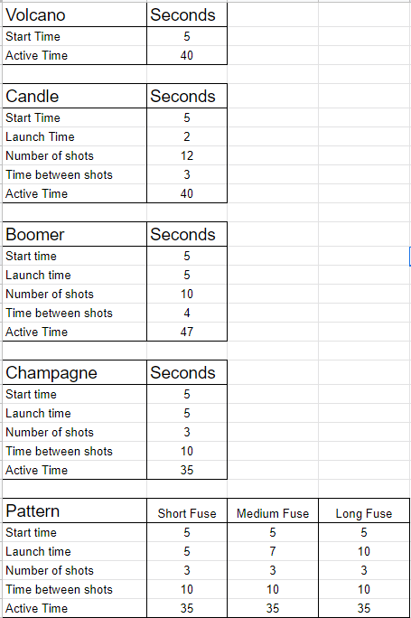

# Volcano Fireworks

The Volcano Firework is a ground-based display that erupts in a colorful fountain of colorful sparks.

**Item Details**

* **Item ID**:
  + **Red:** -454370658
  + **Violet:** -1538109120
  + **White:** 261913429
* **Crafting Recipe**: 20 Metal Fragments, 15 Gun Powder
* **Stack Size**: 20
* **Workbench Requirement**: Level 1
* **Research Cost**: Cannot be researched
* **Hit Points**: 100
* **Where To Find**: Requires Small Fireworks Pack DLC
* **Despawn Time**: 5 minutes

**Functionality**

* Emits a sustained vertical spray of colored sparks.
* Ideal for atmospheric effects or indoor firework shows.
* Does not shoot into the sky like other fireworks — it remains ground-bound.
* No shrapnel or explosion radius, it's purely visual.
* Makes a hissing/sizzling sound while active.
* Available in three colors: Red, Violet, and White.
* Foundations and floors provide 1 launch direction: straight up.
* Ramps provide 2 launch directions at different angles.

**Firework Timing**

* Has a startup time of 5 seconds before it starts erupting. Erupts for 35 seconds. Total active time is 40 seconds.

**Ignition Sources**

* Can be ignited with an Igniter, Torch, Flamethrower, or Fire Arrow.
* Compatible with Rustricity for automation and synchronized shows.
* Consider placing near an Igniter controlled by a Timer or Button for event sequences.

**Placement Considerations**

* Can be placed on flat ground, building block, and tugboats.
* Cannot be rotated after placement.
* Cannot be picked up once the fuse has started sparkling.
* The shower of sparks will come up through floors if the firework is placed underneath.

# Roman Candle

The Roman Candle Firework is a small, repeating firework that launches a sequence of colored balls into the sky. It provides a fast-paced, colorful display ideal for mid-sized shows or filler effects between larger boomer launches.

**Item Details**

* **Item ID**:
  + **Blue:** -515830359
  + **Green:** -1306288356
  + **Red:** -1486461488
  + **Violet:** -99886070
* **Crafting Recipe**: 25 Metal Fragments, 10 Low Grade Fuel
* **Stack Size**: 20
* **Workbench Requirement**: Level 1
* **Research Cost**: Cannot be researched
* **Hit Points**: 100
* **Where To Find**: Requires Small Fireworks Pack DLC
* **Despawn Time**: 5 minutes

**Functionality**

* Launches 12 colorful projectiles into the air with timed intervals.
* Available in four colors: Blue, Green, Red, and Violet.
* Provides rapid visual and audio feedback with each shot.
* Designed for use in mid-scale or supplementary firework displays.

**Firework Timing**

* There is a 5 second start up time before it starts launching flares. There are 3 seconds between shots. Each shot takes 2 seconds to reach max height. There are a total of 12 shots. Total active time is 40 seconds.

**Ignition Sources**

* Can be ignited with an Igniter, Torch, Flamethrower, or Fire Arrow.
* Compatible with Rustricity for automation and synchronized shows.
* Consider placing near an Igniter controlled by a Timer or Button for event sequences.

**Placement Considerations**

* Can be placed on flat ground, building floors, foundations, and tugboats.
* Foundations/floors provide 1 launch direction, straight up.
* Ramps offer 3 launch directions at 2 different angles.
* Can shoot through ceilings and will not be blocked by above structures.
* Cannot be rotated after placement.
* Cannot be picked up once the fuse is sparkling.

# Boomer

The Boomer Firework launches colorful explosions into the sky, making it one of the most dramatic firework types in Rust. It is best used for outdoor shows and is ideal for creating impressive aerial effects.

**Item Details**

* **Item ID**:
  + **Blue:** 1744298439
  + **Green:** -656349006
  + **Red:** -1553999294
  + **Violet:** -280223496
  + **Orange:** -7270019
* **Crafting Recipe**: 25 Metal Fragments, 15 Low Grade Fuel, 30 Gun Powder
* **Stack Size**: 20
* **Workbench Requirement**: Level 1
* **Research Cost**: Cannot be researched
* **Hit Points**: 100
* **Where To Find**: Requires Large Fireworks Pack DLC
* **Despawn Time**: 5 minutes

**Functionality**

* Launches a series of colorful explosions into the sky.
* Available in five colors: Blue, Green, Red, Violet, and Orange.
* Emits explosive sound effects and visual burst patterns.
* Designed for large-scale outdoor displays or coordinated shows.

**Firework Timing**

* There is a 5 second start up time before it starts launching flares. There are 4 seconds between shots. Each shot takes 5 seconds to reach max height. There are a total of 10 shots. Total active time is 47 seconds.

**Ignition Sources**

* Can be ignited with an Igniter, Torch, Flamethrower, or Fire Arrow.
* Compatible with Rustricity for automation and synchronized shows.
* Consider placing near an Igniter controlled by a Timer or Button for event sequences.

**Placement Considerations**

* Can be placed on flat ground, building floors, foundations, and tugboats.
* Foundations/floors provide 1 launch direction, straight up.
* Ramps provide 2 launch directions at different angles.
* Steps provide 6 launch directions. 5 angles plus straight up.
* Cannot be rotated after placement.
* If placed under a ceiling, the firework will detonate against the ceiling instead of launching fully.
* Cannot be picked up once its fuse is sparkling.

# Champagne Boomer

The Champagne Boomer Firework is a large mortar-style firework that offers one of the longest and most dramatic displays in Rust. It launches a powerful champagne-colored burst followed by smaller orange starbursts, making it a centerpiece in any coordinated show.

**Item Details**

* **Item ID:** 1324203999
* **Crafting Recipe**: 30 Metal Fragments, 30 Low Grade Fuel, 75 Gun Powder
* **Stack Size**: 20
* **Workbench Requirement**: Level 1
* **Research Cost**: Cannot be researched
* **Hit Points**: 100
* **Where To Find**: Requires Large Fireworks Pack DLC
* **Despawn Time**: 5 minutes

**Functionality**

* Produces 3 large firework shots with champagne colored explosions.
* Offers a grand and spaced-out visual ideal for finales or key moments.
* Only one color is available: Champagne (yellow).

**Firework Timing**

* There is a 5 second start up time before it starts launching projectiles. There are 10 seconds between shots. Each shot takes 5 seconds to reach max height. There are a total of 3 shots. Total active time is 35 seconds.

**Ignition Sources**

* Can be ignited with an Igniter, Torch, Flamethrower, or Fire Arrow.
* Compatible with Rustricity for automation and synchronized shows.
* Consider placing near an Igniter controlled by a Timer or Button for event sequences.

**Placement Considerations**

* Can be placed on flat ground, building floors, foundations, and tugboats.
* Foundations/floors provide 1 launch direction, straight up.
* Ramps provide 2 launch directions at different angles.
* Steps provide 6 launch directions. 5 angles plus straight up.
* Cannot be rotated after placement.
* If placed under a ceiling, the firework will detonate against the ceiling instead of launching fully.
* Cannot be picked up once its fuse is sparkling.

# Pattern Boomer

The Pattern Boomer Firework is a customizable large mortar-style firework that allows players to design their own aerial explosion patterns. It's a visual centerpiece used for creating coordinated and personalized firework displays.

**Item Details**

* **Item ID:** -379734527
* **Crafting Recipe**: 50 Metal Fragments, 15 Low Grade Fuel, 30 Gun Powder
* **Stack Size**: 20
* **Workbench Requirement**: Level 1
* **Research Cost**: Cannot be researched
* **Hit Points**: 100
* **Where To Find**: Requires Pattern Boomer Firework item from the Rust Item Store
* **Despawn Time**: 5 minutes

**Functionality**

* Launches 3 large projectiles that explode into a pattern set by the player.
* If no custom pattern is created, a default pattern will be used.
* TC authorization is required to customize firework. Look at the firework and press USE(E) to Open Designer or change the Fuse type between Short, Medium and Long.
* Patterns can use up to 35 dots and one of 8 different colors (white, yellow, orange, red, green, teal, blue, pink).
* Players can save up to 5 patterns and name each for reuse.
* Customization requires Tool Cupboard authorization.
* If the firework is picked up, the saved pattern is lost.

**Firework Timing**

* **Short Fuse:**
  + There is a 5 second start up time before it starts launching projectiles. There are 10 seconds between shots. Each shot takes 5 seconds to reach max height. There are a total of 3 shots. Total active time is 35 seconds.
* **Medium Fuse:**
  + There is a 5 second start up time before it starts launching projectiles. There are 10 seconds between shots. Each shot takes 7 seconds to reach max height. There are a total of 3 shots. Total active time is 35 seconds.
* **Long Fuse:**
  + There is a 5 second start up time before it starts launching projectiles. There are 10 seconds between shots. Each shot takes 10 seconds to reach max height. There are a total of 3 shots. Total active time is 35 seconds.

**Ignition Sources**

* Can be ignited with an Igniter, Torch, Flamethrower, or Fire Arrow.
* Compatible with Rustricity for automation and synchronized shows.
* Consider placing near an Igniter controlled by a Timer or Button for event sequences.

**Placement Considerations**

* Can be placed on flat ground, building floors, foundations, and tugboats.
* Foundations/floors provide 1 launch direction, straight up.
* Ramps provide 2 launch directions at different angles.
* Steps provide 6 launch directions. 5 angles plus straight up.
* Cannot be rotated after placement.
* If placed under a ceiling, the firework will detonate against the ceiling instead of launching fully.
* Cannot be picked up once its fuse is sparkling.

Concepts

This section is now in the process of being updated

Getting Started with Rust Electricity

Whether encountering Rust electricity for the first time or revisiting it after a break, this section provides a structured foundation for understanding how base circuits are designed. It focuses on universal principles that apply to all builds, from the simplest setups to complex, multi-system bases. No prior experience is assumed, but those already familiar with Rustricity will still find guidance on best practices and design clarity.

# The Structure of a Base Circuit

Designing electrical circuits in *Rust* begins with understanding that all base circuits, no matter their size or complexity, follow the same core framework. Every circuit is built from **four main stages**, with an **optional fifth** that enhances monitoring and reliability. These stages form the structural foundation for nearly every electrical setup used in a base.

There are **four main stages**, plus an **optional fifth** that can be added when needed:

1. **Power Source**
2. **Battery Backup**
3. **Distribution**
4. **End Devices / Circuits**
5. *(Optional)* **Component Destruction Detection**

To help illustrate how these parts connect, refer to the visual flowchart:

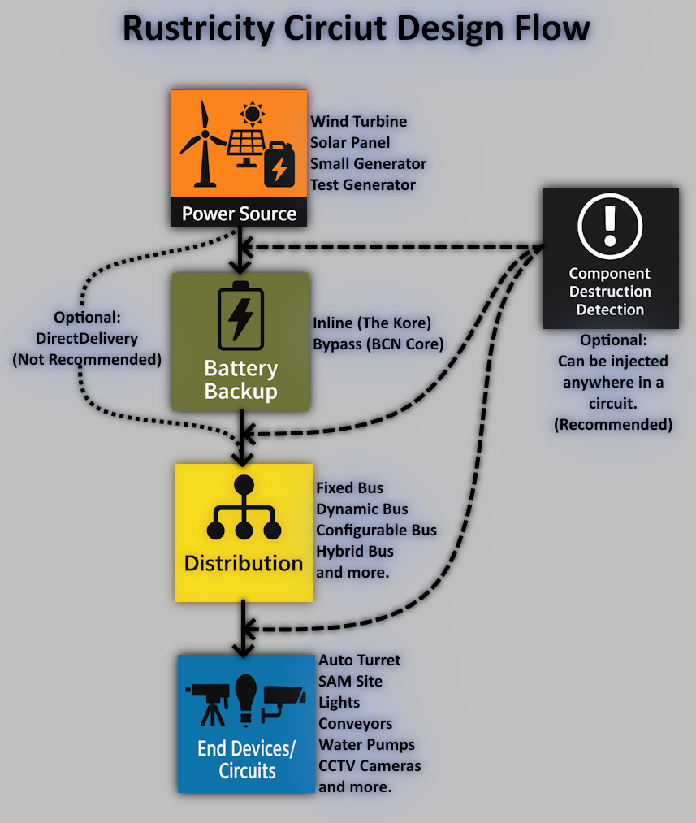

**Power Source**

This is the starting point of Root Power and the foundation of nearly all circuits. Without a source, nothing else functions. Although not all systems require Root Power directly, it remains the backbone of every sustained and efficient electrical network.

Available power sources include:

* **Wind Turbine** – Ideal for elevated bases with consistent output
* **Solar Panel** – Suited for daytime use and roof-based installations
* **Small Generator** – Fueled by Low Grade Fuel, dependable but requires maintenance
* **Test Generator** – Available only in creative mode

**Battery Backup**

After generating power, stability and redundancy becomes essential. A Battery Backup ensures circuit uptime by compensating for dips in power generation or temporary failures.

Options include:

* **Inline** – Directly powers circuits and recharges with surplus power
* **Bypass** – Activates only when Root Power is lost or insufficient
* **Direct Delivery** – Power can be routed directly to circuits without a battery, though this is not recommended for most use cases due to lack of redundancy

💡 **Tip**: Even a small battery can extend circuit uptime significantly.

**Distribution**

Once power is stabilized, it must be distributed to the appropriate systems and devices. Distribution is responsible for organizing how power is delivered from the Battery Backup to the rest of the base — including all logic, defense, automation, and utility circuits.

**Common methods:**

* **F-Bus** – Fixed outputs using Electrical Branches
* **D-Bus** – Dynamic load balancing with Splitters
* **C-Bus** – Configurable distribution via Memory Cells
* **H-Bus** – Hybrid logic for intelligent routing
* **Other Buses** – Including specialized and modular variations

The choice of distribution affects circuit responsiveness, power prioritization, and automation capabilities.

**End Devices / Circuits**

This stage contains the **functional goals** of the circuit — the systems that perform work or fulfill a specific purpose. These can include individual components or complete mini-circuits made up of sensors, logic, and supporting elements.

An end circuit is any configuration designed to perform a defined task, such as defense, automation, or environmental control.

**Examples include:**

* **Auto Turrets** with logic for flipping or authorization control
* **SAM Sites** with condition-based toggles
* **Interior and Exterior Lights** tied to time or occupancy sensors
* **Industrial and Water equipment** like **Conveyors** and **Water Pumps**, activated by conditions
* **CCTV Cameras** with selection and activation logic
* **Door Controllers** within secure access systems

These circuits determine the power demands of the base and inform design decisions upstream.

⚠️ **Tip**: Plan each end circuit as a small system. Knowing its components, logic, and power needs helps shape the entire base's electrical design.

**Optional: Component Destruction Detection**

Component Destruction Detection is used to monitor for problems in the circuit, such as:

* Destruction of downstream components
* Addition or removal of a component
* Changes to Electrical Branch values

This detection can be placed anywhere after the Power Source. A common placement is immediately after the Battery Backup for early warning and centralized monitoring.

With this structure in mind, circuits can be broken down into logical, manageable parts. Planning starts from the desired end devices and works backward to ensure the appropriate infrastructure is in place.

# 

# Centralized vs Decentralized Theory

When discussing **centralized** or **decentralized** theory, we are referring to two distinct aspects:

* The **physical placement** of components throughout a base
* The **flow of power** from generation to the circuits that consume it

A **fully centralized system** places all core components, such as batteries, switches, logic, and distribution in a single physical location. Power is collected, stored, routed, and managed through one central circuit.

A **fully decentralized system** assigns electrical responsibility to multiple locations throughout the base. Each area or subsystem maintains its own independent circuit, complete with a dedicated power source, battery, and logic. These circuits function autonomously and are typically not aware of or connected to one another.

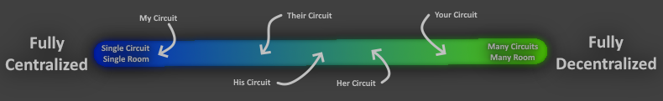

Both approaches exist on opposite ends of a spectrum. Most bases will fall somewhere in between — using a mix of centralized infrastructure for critical systems and decentralized elements for redundancy or physical reach.

There is no single “best” layout. The ideal approach depends on:

* Server settings and component limits
* Wipe frequency
* Group size and playstyle
* Base footprint and vulnerability
* Functionality vs redundancy
* Personal comfort with Rustricity design

The **best circuit** is the one that does **what** it needs to — **when** it needs to — in the way that was needed.

This section begins by exploring the **physical placement** of electrical infrastructure, followed by how these principles apply to circuit layout and power flow.

## Physical Locations

When discussing centralized or decentralized locations, we are not referring to the placement of all electrical components throughout the base. This section does **not** cover:

* Auto Turrets mounted on roofs
* Heaters placed throughout Arctic bases
* The placement of Ceiling Lights in a farm

Instead, the focus is on the **core infrastructure** — the systems that collect, store, control, and distribute electricity across the base. This includes:

* Collection points from **power sources**
* Placement of **battery backups**
* Locations for **distribution logic**
* Control centers for automation and monitoring

In essence, it’s about where a Windmill sends its power, or where the wire powering an Auto Turret originates. These placements shape the survivability, security, and scalability of a base’s electrical network.

* A **well-planned location strategy** is just as important as circuit design. Where these systems are placed can determine whether they resist raids or are taken out with a single breach of a wall.

### Centralized Locations

A fully **centralized location** refers to a single room or compact area that houses all of the base’s core electrical components, including batteries, logic circuits, collection and distribution systems. This location serves as the **nerve center** of the electrical network. In real-world infrastructure, this would be called a **Main Distribution Frame (MDF),** a central node where power is received, stored, routed, and managed. Due to the nature of its critical role, it deserves protection **equal to or greater than** that of the Tool Cupboard.

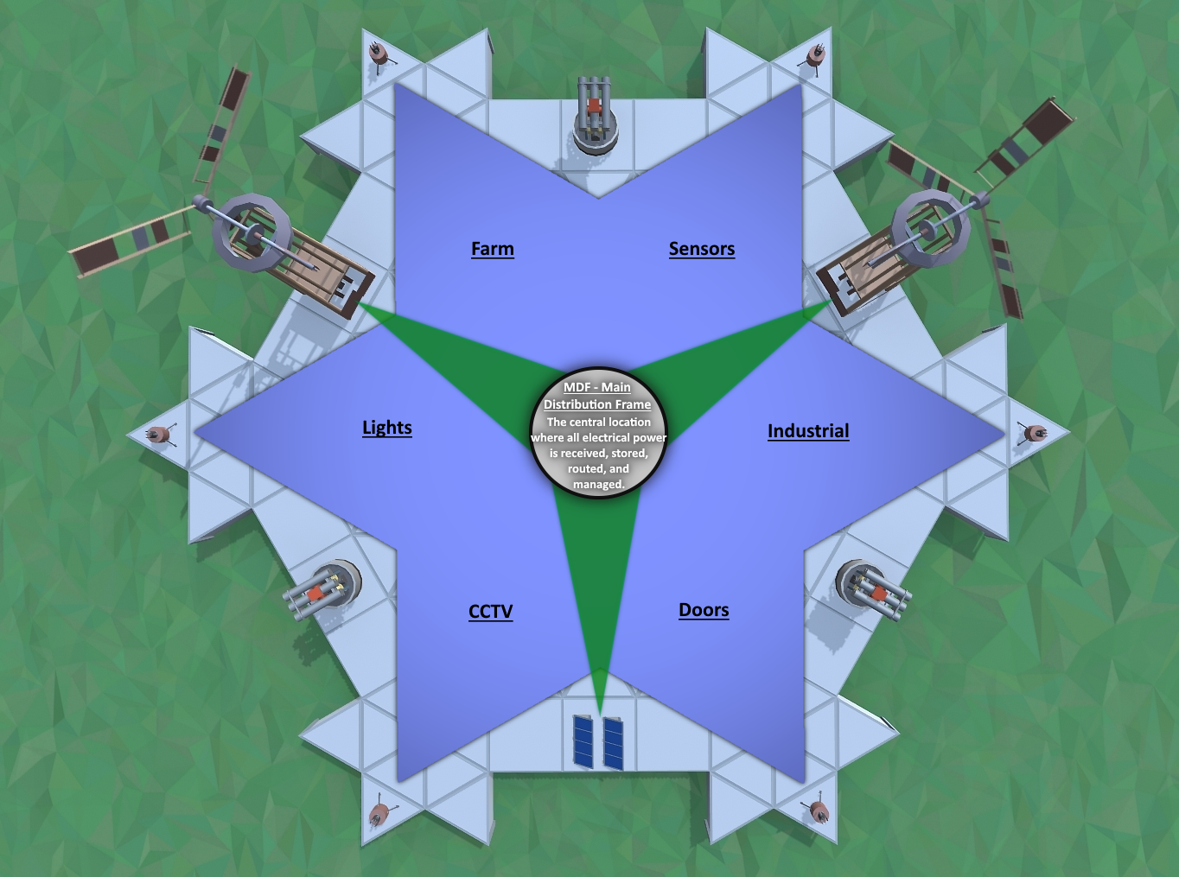

Centralizing components in one location offers major convenience. It’s easier to build honeycomb, add doors and traps, and reinforce one high-value room. However, this comes with a tradeoff: **when raiders break into this room, a single rocket will disable every system at once.**

Where this room (MDF) is placed must be **intentional and pre-planned**, not improvised. A well-designed base doesn’t sacrifice bedrooms or loot rooms just to make last-minute space for electrical infrastructure. Planning ahead ensures that this high-value room has both the security and space it needs and that wires can reliably reach the systems they’re meant to power without compromising layout or protection.

For protection, it’s not just about adding walls. Location matters. Positioning the room deep within the core adds raw durability through layered protection and honeycomb. Placing it within the China Wall or in a Gatehouse floor offers protection through misdirection and raiders may overlook it entirely. Regardless of the method, the key is building these locations into the base from the start. They are not just utility rooms; they are critical infrastructure and deserve thoughtful placement from the beginning.

No matter the location, **concealing wires** is essential. This is not about keeping wires clean and tidy. Its about hiding them from other rustricians so they cannot trace them back to their origin.

* Avoid running wires on the exterior of the base, such as the roof. Bring the wire through the floor and into the interior of the base before routing towards the central location (MDF).
* When running wires along the ground or foundations, take advantage of Wire Slack. Sink them into the foundations or ground and hide them from sight.
* Wires can be 30 meters long, don't be afraid to use the whole amount. Utilize decoy paths or route wires through multiple entry points into the MDF if necessary. Avoid having all wires taking the same path, pointing at the single room.

Wire length is a natural constraint. In small bases, most devices can be reached directly but in large bases, **wire extension components** may be required. These components must be placed securely. For instance:

If a **Memory Cell** is used to extend a wire to a Turret, the Memory Cell should not be easier to destroy than the Turret itself.

Any passthrough-capable component can serve this function. Items like the Blocker, OR Switch, Memory Cell, Smart Switch are excellent choices because they do not consume any power and they cause no extra Active Usage on batteries. If these components cannot be adequately secured, players can consider components that can camouflage but consume a little bit of power. For instance, the Industrial Light is a reliable alternative. They make a great choice due to their low crafting cost and their ability to stealthy camouflage as just another light on the base.

### Decentralized Locations

Fully **decentralized locations** spread power infrastructure across multiple rooms, making electrical networks more resilient during a raid or just easier to run wires. A decentralized layout distributes core electrical components across two, three or more rooms. Each of these rooms serve as a regional hub that is designed to manage its own power generation, storage, and logic.

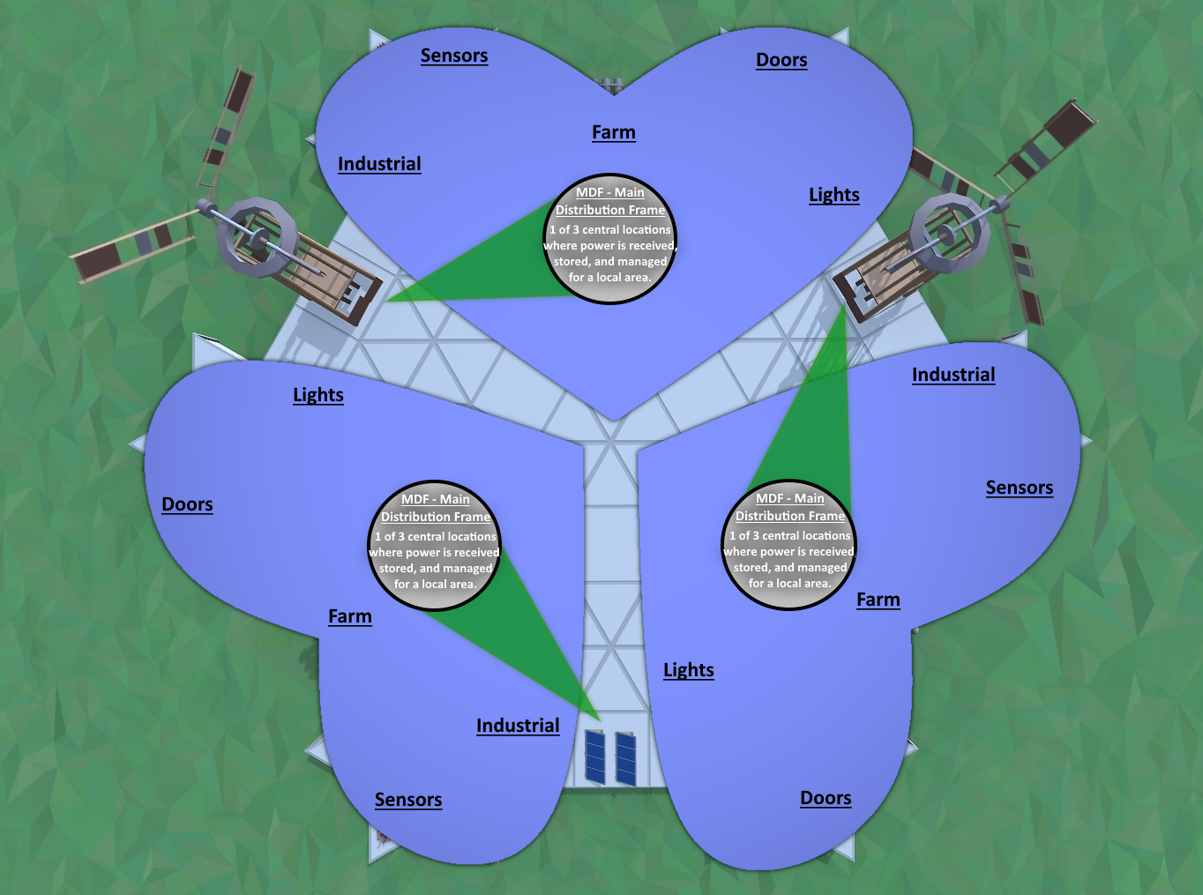

In real-world infrastructure, each of these would be called **Main Distribution Frames (MDFs)**. They are central nodes where power is received, stored, routed, and managed for a specific zone or area. They operate completely independently without any interconnections between one another.

* Think of each MDF as a self-contained, localized circuit room, producing and regulating its own power for a specific zone, like the North, South, East and West sides of a base.

However, in some bases, each decentralized room may be interconnected with one another within the overall circuit design. When it does, these decentralized rooms will function as **Intermediate Distribution Frames (IDFs)**. These are secondary distribution hubs linked to a central **Main Distribution Frame (MDF)**. However, whether a room qualifies as an IDF is determined by its electrical role and interconnection, not merely by the fact that multiple rooms exist.

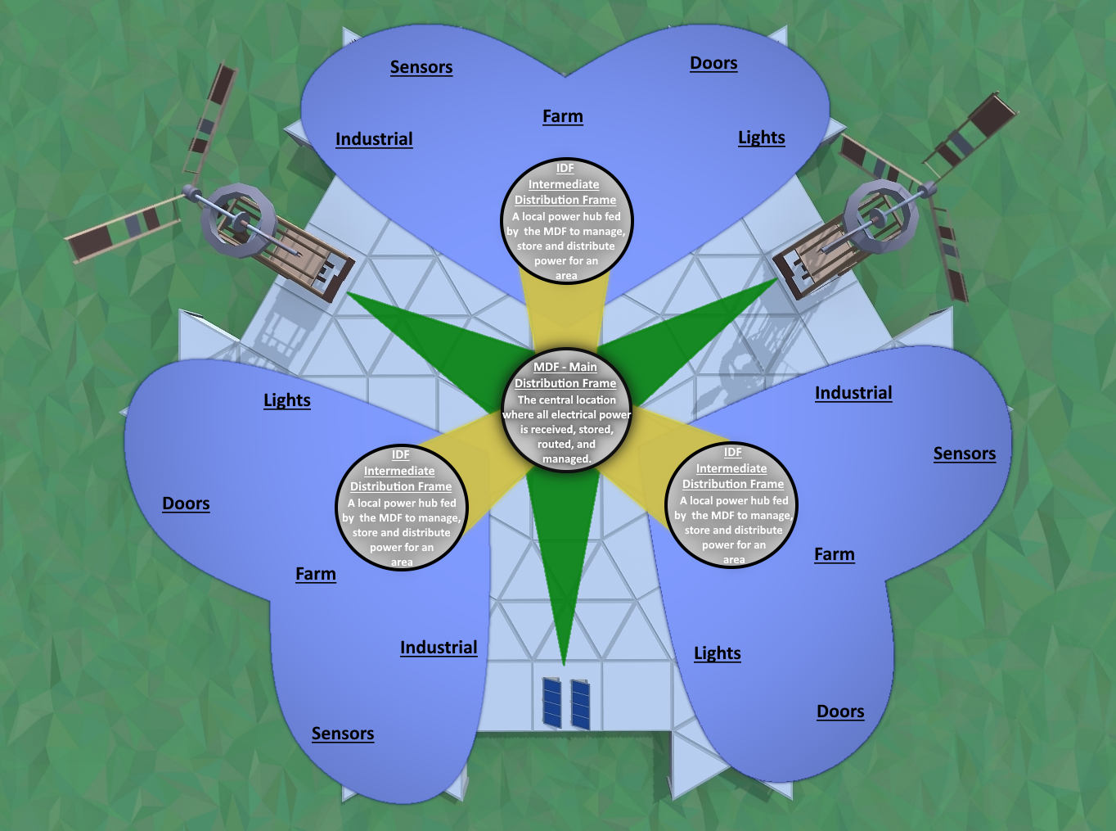

💡 A common example is placing an **IDF** room near the roof as a collection point for Root Power from wind and solar before forwarding it to a secure **MDF** deeper inside the base for backup and distribution.

These rooms should be intentionally integrated into the base design, not added as an afterthought, to ensure they're both secure and functional. These locations deserve the same planning and protection as a Tool Cupboard.

They should also be:

* Hard to locate and/or heavily protected
* Placed in areas raiders wouldn’t expect or prioritize, eg. in the floor
* Distributed in a way that reduces the impact if a single one of them is breached

The more spread out these locations are, the better their **resilience,** especially when a base is large. With very large bases, raiders often "cut a base in half" with rockets. With decentralized locations, even if one room is lost, the others should continue to operate without interruption.

Decentralization also brings **efficiency by saving time**. By placing power near where it’s used, players reduce the need for long, complicated routes needing lots of running back and forth and/or the use of wire extensions. It can simplify circuit planning by helping eliminate extra components just for distance.

💡 Turrets above the gatehouse don’t need to be powered from deep inside the base. They can be powered by a **fully independent MDF** built into the gatehouse. This room would include its own power generation, battery backup, turret control logic, and sensors, operating completely separate from the main base infrastructure.

Each decentralized location should avoid drawing attention through visible wiring. **Wire concealment** is critical. Distribute entry points and leverage full wire lengths creatively.

* Avoid running wires on the exterior of the base, such as the roof. Bring the wire through the floor and into the interior of the base before routing towards the MDF.
* When running wires along the ground or foundations, take advantage of Wire Slack to hide them from sight.
* Wires can be 30 meters long, don't be afraid to use the whole amount. Utilize decoy paths or route wires through multiple entry points into the IDF if necessary. Avoid having all wires take the same path, pointing at these rooms.

Decentralization offers more than just safety, it delivers smart efficiency. With power already positioned near where it's needed, circuits require fewer passthrough components, fewer exposed wires, and fewer compromises. In large bases, these small advantages add up to a major difference.

## Circuit Design

When discussing centralized, decentralized, or hybrid circuits, what’s really being described is *how electricity moves from power sources to the systems that need it.* This isn’t about physical placement of components, it’s about whether everything runs through **one master circuit** or gets split across **multiple smaller ones**.

A **centralized circuit** sends all power into one system that handles everything: turrets, sensors, lights, and more. There’s one set of batteries, one set of logic, and one set of wires feeding the whole base. This creates a single, unified circuit.

A **decentralized circuit** splits things up. Each area or system, like the North gatehouse, the rooftop turrets, or the farm, gets its own power source, battery, and logic. These parts run independently. Power is delivered independently, without relying on a central hub.

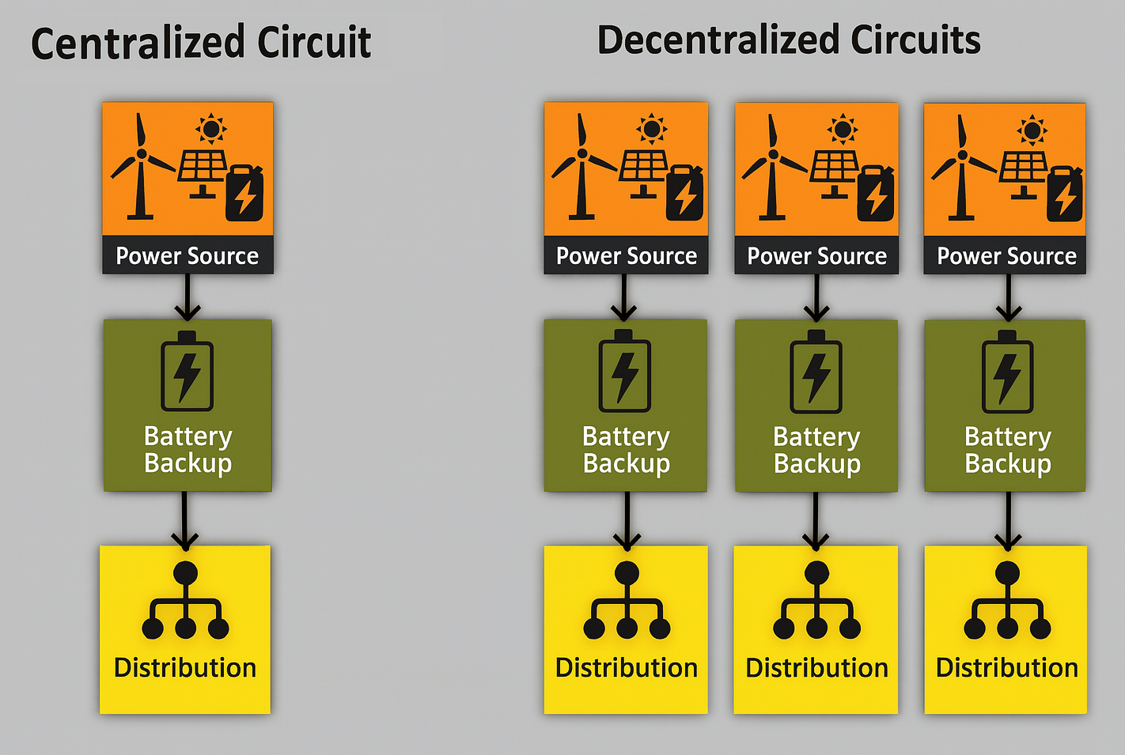

This decision impacts how the base is built. A well-designed circuit avoids wasting power, losing everything to one rocket, or needing extra rooms just to stretch wires. Understanding the difference early makes it easier to plan circuits that match the layout, power demand, and playstyle.

### Centralized Circuit

In a base, a centralized circuit is one in which all power sources, storage, logic, and distribution are combined into a single unified system. Every electrical component in the base, from turrets and sensors to lighting and water pumps, receives power through this one master circuit.

Power sources such as Wind Turbines, Solar Panels, and Generators feed into a single battery-backed core, typically an Inline Backup (*The Kore*) or a Bypass Backup (*BCN Core*). These cores provide built-in double redundancy where if the sources are destroyed, the battery will continue to supply power, or if the battery is lost, direct source power may continue supplying all or part of the circuit. No matter the situation, they will avoid selecting a power path that is supplying 0rW.

Despite this redundancy, centralized circuits have an inherent vulnerability, a single point of failure. In a standard Inline backup, the battery is the point of failure. In modern backups, like the Kore or BCN Core, it’s the final OR Switch that connects the 2 halves of the power core to the distribution system. If this OR Switch is destroyed the entire base circuit goes offline. No subsystems will continue functioning, regardless of battery charge or available source power.

**Power Capacity Limits**

While centralized circuits can support substantial power loads, they are typically limited to around 1600rW. This limitation arises from the mechanics of the Root Combiner, which has a maximum depth of 16 components between it and any connected power source.

If a centralized core is designed to support 1600rW worth of battery backup, that requires combining 16 Large Batteries together using multiple Root Combiners. These, along with the batteries, additional components in the Power Core and the combiners for the power sources, all add to the circuit’s total depth.

In practice, this means a standard BCN Core powering 1600rW will be able to support roughly 16 power sources. These sources will need to be high-elevation Wind Turbines to provide the sustained output needed to maintain such a large centralized system.

This is typically more than enough power for nearly all use cases, but it also marks the practical ceiling for centralized circuits. Beyond this point, circuit depth, wire clutter, and repair difficulty begin to outweigh the simplicity of a single system.

**Key Traits**

* All power sources are combined into one core
* A single circuit powers every system, subsystem, and device
* Distribution is centralized through a single bus
* No electrical independence between subsystems
* Best suited to small bases or tight, compact layouts

**Advantages**

* Simplified wiring design
* Efficient power use, no duplicate systems
* Quick to deploy and easy to monitor
* Compact and ideal for limited space

**Disadvantages**

* Single point of failure at the OR Switch
* Poor scalability in large bases
* Only 1 power core. If it fails, all systems go offline
* Challenging to route wires across long distances without IDF closets or wire extensions

Centralized circuits are ideal for smaller bases or self-contained systems where all devices are in close proximity and easy to wire. As base size or power requirements grow, the limitations of a single unified circuit often outweigh its simplicity.

### Decentralized Circuits

Decentralizing circuits really comes down to how extreme a player wants to take it. The idea behind decentralizing is adding security and reliability by segmenting different systems and areas with their own independent power supplies and backups. Instead of all systems drawing power from a single unified system, power is divided across separate cores, each responsible for specific locations or functions.

Each decentralized unit is essentially a centralized circuit, complete with its own power source, battery backup, logic, and distribution, but scoped to a limited area or purpose. Basically, any base that is using 2 or more circuits is decentralizing.

For example, a base may have a dedicated circuit for each side, North, South, East, and West, plus an additional core for the roof. The base may dedicate a core to its industrial system, or one for a Farm. Each one operates independently and a breach or failure in one area does not affect the others.

**Key Traits**

* Composed of multiple self-contained circuits
* Each system has its own power, battery, and logic
* Designed around location, function, or both
* Systems do not rely on a central bus or core

**Advantages**

* Decentralized circuits offer high resilience, as there is no single point of failure that can bring down the base's entire electrical system.
* Each system has local control, with logic placed close to the devices it manages.
* These circuits scale more easily since new systems can be added without placing strain on a central power core.
* Their structure often aligns better with the physical layout of a base, such as organizing by region with one MDF per area.

**Disadvantages**

* The component cost is higher, as each independent circuit requires its own batteries, switches, branches, and other components.
* The overall system becomes more complex and requires additional planning to maintain clear organization.
* Some logic may need to be duplicated across multiple circuits, leading to redundant setups.
* Monitoring becomes more difficult because each circuit operates independently and must be checked separately.

Decentralized circuits are often the only practical option in large or segmented bases. When distance, compartmentalization, or redundancy is important, decentralization offers greater reliability and flexibility.

### Hybrid Circuits (Updating in Progress)

A hybrid circuit is one that both centralizes, for convenience, and decentralizes, for security, different parts of the same circuit. While it is more common to see hybridization between power sources and battery backup, it can also be done with distribution. To help demonstrate this concept, we have the following 3 examples. The first 2 are using Inline Battery Backups because it's the easiest way to demonstrate the concept. In each example, a Counter is used to both show the available amount of power but also represents an end circuit like lights or turrets.

This first example demonstrates decentralizing the main power by having each power source charge its own battery, with a centralized Inline backup by combining the batteries before powering a circuit. This is a less than ideal way to set up your power production and battery backup. Keep in mind that Root Combiners do not share the load between batteries. This means that a circuit needing 100 power or more will force all the batteries to have a max Active Usage of 100. Read the section Battery Active Usage vs Actual Power Consumed for an in depth explanation into Active Usage.

This kind of battery configuration is convenient to achieve a lot of power on 1 line but because in this example we are using Inline batteries, this becomes progressively more expensive to maintain as you need to be producing a significant amount more power than you need to. This also removes the ability to take advantage of game mechanics to minimize Active Usage on the batteries which should be a primary focus when using an Inline backup. 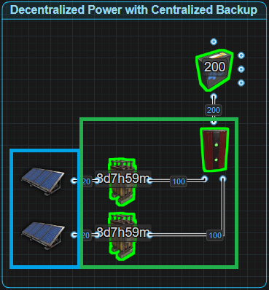

Let's say you want to power 18 Auto Turrets. That is 180rW plus the cost of distribution so we are going to need 2 large batteries which give us 200 power, just like in the picture below. With no load sharing between the batteries, they both will have an Active Usage of 100. With the battery’s 80% efficiency, we need to give each battery 125rW. That’s a minimum of 250rW we need to produce all the time so the batteries do not drain.

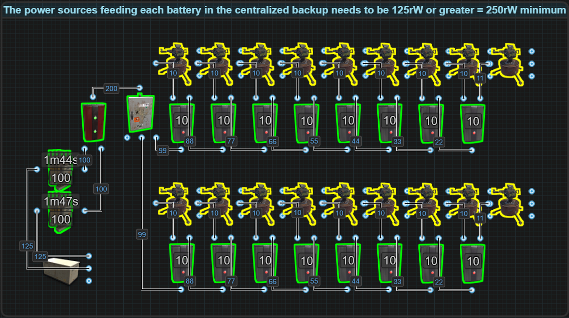

If we power 9 turrets from 1 battery and the other 9 from the other battery and each battery has its own power source, this allows each battery to only have an Active Usage of 90. With the batteries 80%, we only need a power supply of 114rW per battery for a total of 228rW to not lose power. Decentralizing is more efficient in this situation

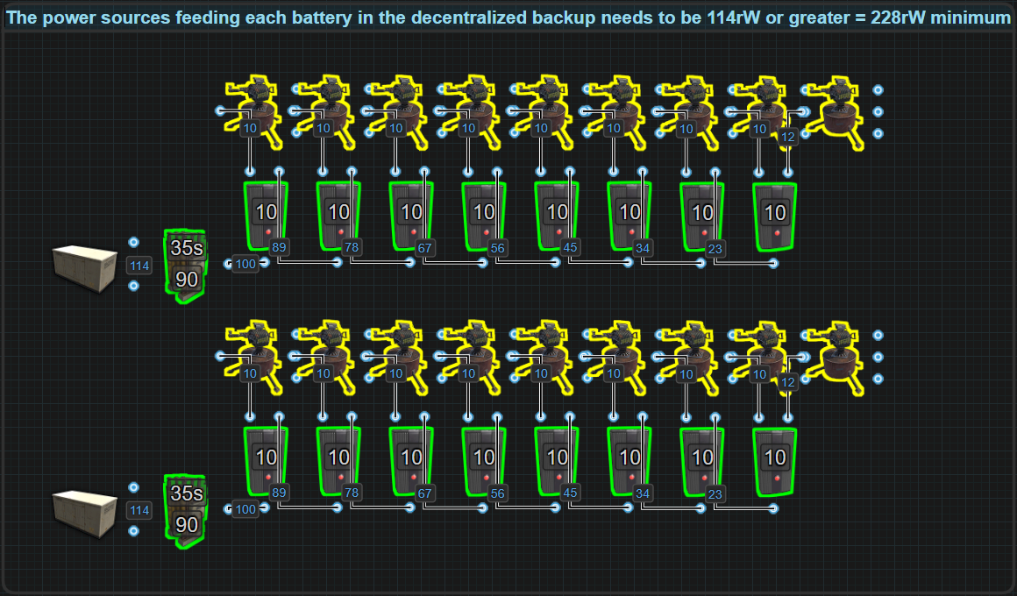

The larger this is scaled up, it is easy to see how much wasted power, time and materials there are when trying to centralize the batteries when each battery has its own power source. That is why it is seen as unsustainable for use in situations that are continuously online, however, if you have a circuit that spends most of its time offline and there are long enough periods of time between activity to let the batteries charge, then it becomes much more practical to just get a lot of power on a single line for a shorter period of time.

In the next example we demonstrate centralizing power by combining it before the Inline batteries, while decentralizing the battery backup by letting each battery power its own circuit. This gives us the benefit of convenience by combining all the power sources into a single line then using Splitters to evenly divide that power between all batteries,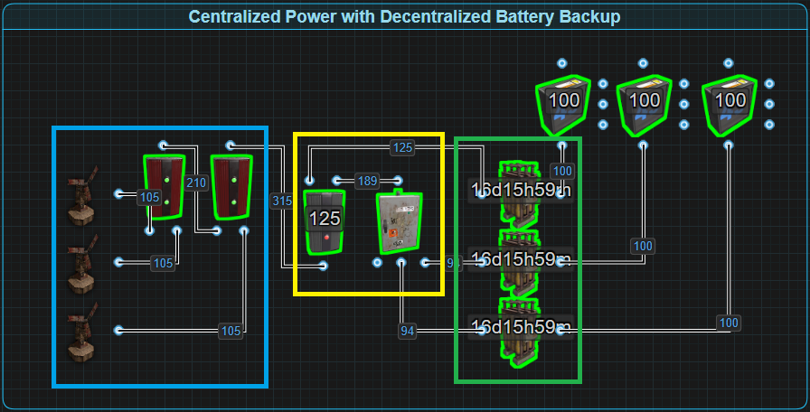

or, like in the above picture, use an Electrical Branch to give priority to 1 battery while evenly dividing the remaining power between the other 2. This gives us the ability to prioritize batteries and still take advantage of minimizing Active Usage per battery based on the circuit it is powering. This leads to a lower material and labor cost and wastes less power.

Decentralizing the batteries is almost always the better option when creating a hybrid circuit. While the above examples have used Inline battery backups, in our 3rd example, we use a bypass battery backup known as the Nih Core.

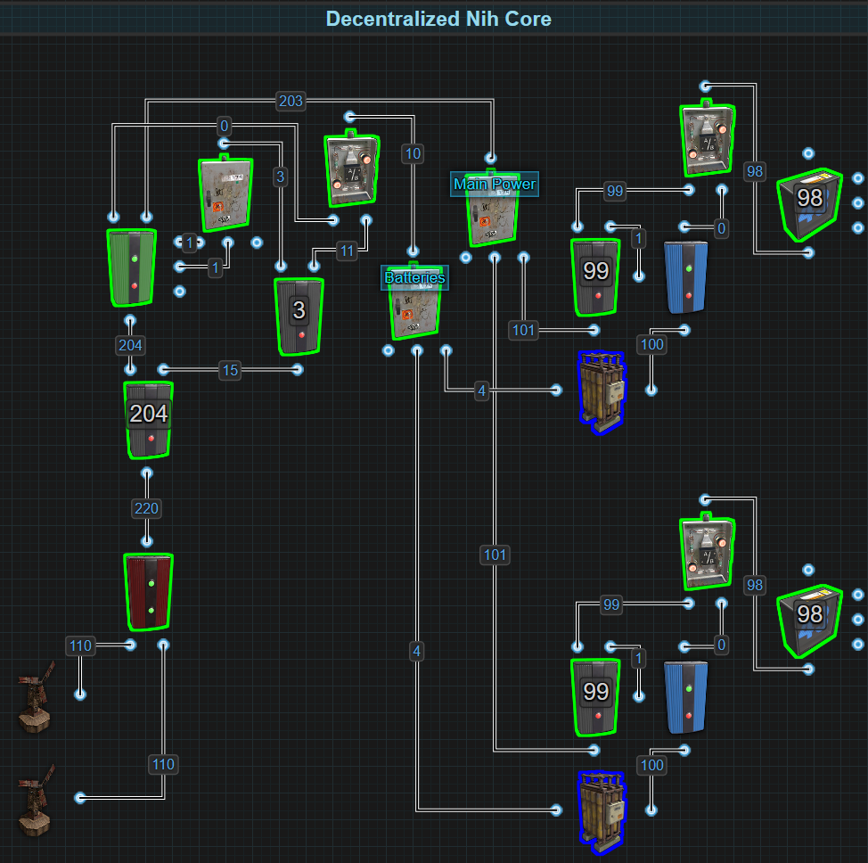

This battery backup is natively a centralized system but here, we have decentralized the batteries by dedicating them to specific systems. We have combined the power sources before sending power into the Nih Core. Instead of having the batteries combined, which is traditional, we are instead separating the batteries so they each only backup a smaller portion of the circuit. It still gives us the benefit of powering our circuits the majority of the time with a centralized main power source but it is also providing security by decentralizing the battery backup. If the main power source or the core is destroyed, the batteries will take over. If the main power source or the core is not destroyed but a battery is, the circuit will remain powered by the main power source. Only once both are destroyed will a circuit go offline. If you want to build in some prioritization, what circuit is last to kick on to the battery, you can replace the Main Power Splitter with an Electrical Branch.

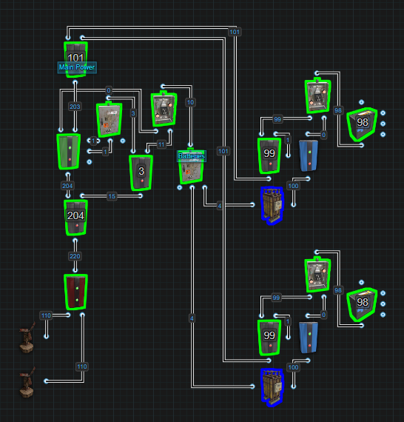

Replacing the Splitter with an Electrical Branch allows you more control over what circuit is the first to lose power and kick on to battery vs the last to kick over to battery. On the Electrical Branch, the output Branch Out lets you dedicate a specific amount of power to a circuit while the output Power Out sends out the remaining amount. As power falls, the circuit that is connected to Power Out will be the first to lose main power and switch over to battery backup before the circuit connected to Branch Out switches over to battery backup.   
  
Hybridizing like this is great when space is also limited and batteries are not kept in the same location. Another option can be to keep a centralized primary BCN Core, and add secondary batteries to see subsystems or sections. This now has the benefit of a central battery backed core while also the security of decentralized secondary backups. This also has the benefit of increased runtime when on batteries if the sources get destroyed.

## *Distribution (Out Of Date)

Centralized distribution is how 99.9% of all circuits are wired as illustrated in the picture below. All end devices or circuits are fed from a single source of power using a single battery backup following the path of a single distributor.

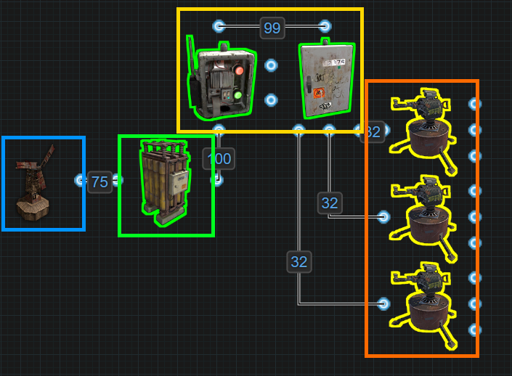

Decentralized distribution at its simplest is using OR Switches (outlined by purple in the picture below) to send power to each end device (or circuit) from 2 or more power sources, battery backups or distributors.

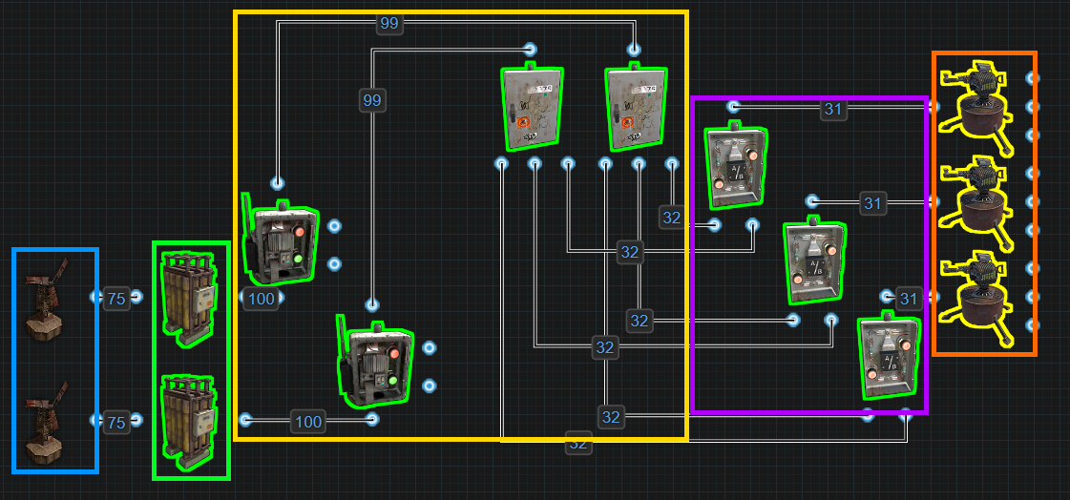

Power Theory and Efficiency

# Introduction

Understanding Rust’s electrical system isn’t just about knowing what components do, it’s about mastering how power flows, what gets consumed, and where inefficiencies can be eliminated. This section explores the different types of power used in Rust circuits and shows how players can optimize circuit design by strategically choosing how and when each type is used.

This section builds a foundation for how to evaluate and compare circuits not just by functionality, but by power efficiency. It answers essential questions like:

* Should a battery be used here, or should Root Power handle the load?
* Can part of this circuit be offloaded to free or logic-only power?
* What’s the real cost of combining batteries or powering always-on components?

Whether you're wiring a small trap base or designing a smart base that runs autonomously, this section helps you think critically about what kind of power you’re using, how much you're wasting, and how much you could save by refining the design.

# Key Definitions

Modern circuitry relies on more than just connecting wires, it requires an understanding of how power behaves across different systems. Not all power is equal. Some is generated, some is stored, some is used efficiently, and some disappears without doing any real work.

The following definitions break down the six core properties of power and explain how they interact with one another. These terms will serve as the foundation for building efficient circuits, selecting battery backups, and minimizing unnecessary power production.

— **Root Power, Stored Power, Active Usage, Available Power, Consumed Power, Control Power, and Free Power** —

These aren't just random labels, they shape the design philosophy behind every circuit, battery backup, and automation system. Mastering these power mechanics means more efficient setups, longer-lasting batteries, and smarter automation.

If a player misunderstands these properties of power, they are likely to waste electricity, overproduce power, or mismanage their battery systems. Understanding the differences between them is essential for mastering Rustricity.

**⚙️ Root Power**

Root Power, often called Main Power or Source Power, is electricity generated by power sources such as Wind Turbines, Large Solar Panels, and Small Generators (using Low Grade Fuel). This power is created passively or through fuel consumption and is the core power source for all powered circuits and is measured in rust Watts (rW).

This power is generated externally and does not contribute to Active Usage, regardless of how it is consumed or routed. Root Power supports batteries to overcome Active Usage, directly powers components, and sustains circuit logic. It is the only power form that must be continually produced, and its availability defines the size and complexity of sustainable systems.

Efficiency with Root Power is essential. Every unit of energy wasted, through poor design or unnecessary always-on components, increases the amount of power that must be constantly produced. To improve circuit performance, players should ask:

1. What components are always on and can run directly from Root Power?
2. Which circuits are not always on and can safely run off batteries to leverage Active Usage?
3. What logic, toggle, or timing behavior can be offloaded to Control Power or Free Power?

Designing around Root Power means minimizing waste and maximizing efficiency. Any power not consumed is lost, so systems should aim to allocate Root Power intelligently, combining direct use, battery storage, and offloading logic where possible.

* All Root Power is Consumed Power but not all Consumed Power is Root Power.

**🔋 Stored Power**

Stored Power refers to the electrical energy held inside a battery, measured in Rust Watt Minutes (rWm). This value is visible when looking at a battery with a Wire Tool equipped and is labeled as the battery’s Capacity.

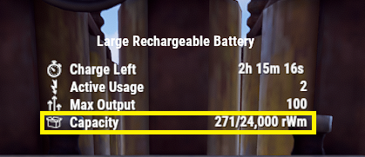

Stored Power plays a crucial role in battery-backed systems, especially when managing power availability during outages or low production. As components draw power from the battery (Active Usage), this value decreases over time.

Understanding how to work with Stored Power involves two key use cases:

1. How long a battery can run a circuit based on its current charge.
2. How long it will take to charge a battery to a desired capacity.

**🧮 1. Discharge Duration — "How long will this stored energy last?"**

To find out how long a specific amount of Stored Power will last, use the following equation.

DischargeTime = StoredPower ÷ PowerDraw

* **DischargeTime:** The total run time in minutes
* **StoredPower:** The current or desired rWm in the battery
* **PowerDraw:** The amount of power the circuit is consuming (rW)

🧪**Example:**

A Large Battery with 18,000rWm is powering a 75rW circuit:

DischargeTime = StoredPower ÷ PowerDraw

= 18000 ÷ 75

DischargeTime = 240 minutes (4 hours)

**🔋 2. Charge Duration — "How long to charge to a specific capacity?"**

To find out how long it will take to charge to a specific amount of capacity, use the following equation.

ChargeTime = (TargetCapacity − CurrentCapacity) ÷ (InputPower × 0.8)

* **ChargeTime:** time (in minutes) to reach the desired rWm level
* **TargetCapacity:** desired battery charge (rWm)
* **CurrentCapacity:** current battery charge (rWm)
* **InputPower:** how many rW are being supplied
* **0.8:** battery efficiency (80%)

🧪**Example:**

A player wants to charge a Large Battery from 3000rWm to 15,000rWm using 100rW of power:

ChargeTime = (TargetCapacity − CurrentCapacity) ÷ (InputPower × 0.8)

= (15000 − 3000) ÷ (100 × 0.8)

= 12000 ÷ 80

ChargeTime = 150 minutes (2.5 h)

**🔋 Active Usage**

Active Usage, often referred to as Drain, is the number shown in the battery's UI when looking at it while holding a Wire Tool. It represents how much power the battery is currently discharging. This number is critical for inline battery setups, as it dictates how fast the battery drains and how much power must be input to remain neutral.

Since batteries operate at 80% efficiency, the rule is simple:

Power In = Active Usage ÷ 0.8 or Active Usage × 1.25

If a battery has 20 Active Usage, it must receive 26rW of power to avoid draining. This number includes any component actively consuming power from the battery, but not every component that consumes power will increase Active Usage.

Active Usage is a reflection of power being consumed by a component in the system, but not all consumed power generates Active Usage. This means:

* Active Usage is always Consumed Power, but Consumed Power is not always Active Usage.

**🗑️ Available Power**

When looking at an IO connection on any component, the amount of power that is shown is the amount of power available that could be used.

**⚡ Consumed Power**

Consumed Power refers to the amount of electricity needed for a component to function or an action to take place, whether or not it generates Active Usage. It applies to components like Timers or Memory Cells that actively require energy to operate but have no Active Usage. It also applies to components such as Auto Turrets, Ceiling Lights, Electric Furnaces, etc, that do have an Active Usage.

* Many of these components will reflect their consumption as Active Usage when powered by a battery.
* However, some components like the Fluid Switch & Pump or the Toggle inputs on items like the Fogger-3000 and the Boom Box, all consume power to function, but do not cause any Active Usage.

This distinction is especially important when using bypass battery backups because they are supplying Root Power to the circuits that need to function. Using Root Power to constantly supply and reserve power for logic or systems even when they are turned off is an inefficient use of Root Power. If a circuit needs 29rW to function but will only register 18 Active Usage on a battery, it is more efficient to switch to an inline and give the battery 23rW. Switching to an inline backup can significantly reduce the need for excessive power production. Bypass backups are ideally used for circuits that are always on and consuming large amounts of power.

* Consumed Power includes all energy used for functionality, regardless of whether or not it registers as Active usage on a battery.

**🟡 Control Power**

Control Power is electricity used purely to trigger or toggle components, and it does not contribute to Active Usage but is consumed. These 1rW signals are used in logic and control circuits, enabling behavior such as toggling Timers, resetting Memory Cells, or blocking passthrough on Blockers.

Control Power does not create any Active Usage, and because of that, it can be supplied by batteries that have no power input. These Control Batteries will not drain as long as the circuit only uses these types of signals. This makes it possible to build entire logic systems that never require power production, only a one-time battery installation.

For instance, a Timer powering the Block Passthrough input on a Blocker, the extra input on an AND Switch, or a timing circuit that triggers SET on a RAND Switch, can all be run solely on Control Power. Entire automatic sprinkler systems can be run off of Control Power. If the entire system is composed of logic components with no Active Usage, it can run indefinitely from a charged battery, without needing a power source to recharge.

* All Control Power is Consumed Power, but not all Consumed Power is Control Power.

Once players realize how useful taking advantage of this mechanic is, it will become commonplace to install a battery solely to utilize Control Power.

**⚡ Free Power**

Some components generate small amounts of free power when triggered without any need for additional input power or even an input connection. These outputs are temporary and low in power (typically 1–2rW), but can be used to trigger logic circuits or send signals without consuming any additional electricity from power sources or batteries.

This generated power is entirely free and is especially useful in circuits where simple player inputs are needed without the need to produce additional power.

**Components that Generate Free Power**

| **Component** | **Output** | **Trigger Condition** |
| --- | --- | --- |
| Button | 2rW pulse | When pressed by a player |
| Pressure Pad | 1rW pulse | When stepped on |
| Reactive Target | 1rW pulse | When shot and falls flat |

**Power Multipliers**

While the components above are the power source, these ones below need power to provide some Free Power.

| **Component** | **Output** | **Trigger Condition** |
| --- | --- | --- |
| Seismic Sensor | Up to 3rW | Nearby explosions (requires 1rW input) |
| Auto Turret | 2rW | Actively Has Target, Low Ammo AND No Ammo (required 11rW input) |
| SAM Site | 2rW | Actively Has Target, Low Ammo OR No Ammo (required 25rW input) |

⚠️ Other then the Auto Turret and SAM Site which are constant, these pulses are brief — usually under 1 second — and are only suitable for triggering logic (e.g., flipping a Memory Cell or activating a Timer). They should not be relied on for sustained power delivery.

# Where the Past, Meets the Present

Now that the different types of power have been defined, the next step is to demonstrate how they interact and how misunderstanding these interactions can lead to inefficient circuit design and wasted electricity.

Historically, this section was called Active Usage vs Power Consumed and focused on the debate between Electrical Branch vs Splitter and the behavior of the Root Combiner. In earlier versions of Rust's electrical system, every component consumed power and generated Active Usage, even when turned off. Players needed to understand these mechanics to build power-efficient circuits, especially when selecting between Inline or Bypass Battery Backups.

Today, things are different. Most components no longer consume 1rW just for being connected, and Active Usage is only registered when a component is both powered and in use. This shift dramatically reduces baseline power requirements for most circuits but understanding how power is handled is still just as important.

**⚖️ Electrical Branch vs Splitter Debate**

In the past, comparing the **Electrical Branch** to the **Splitter** was central to understanding efficiency. Every component consumed 1rW and generated Active Usage, and the way those two components handled power had significant differences — especially with inline battery setups. Today, while most components no longer consume power for themselves or generate Active Usage by default, the legacy of that comparison still matters.

**⚡ Electrical Branch**

**Old Behavior:**

* Consumed 1rW for itself
* Registered 0 Active Usage for itself
* Forced Active Usage based on its Branch Out setting
* Blocked the Active Usage of downstream components (like turrets)

If players set the Branch Out to 10rW for an Auto Turret, the battery would see 10 Active Usage regardless of what was connected beyond it. This made Electrical Branches a popular choice for minimizing visible Active Usage, even if actual consumption was higher.

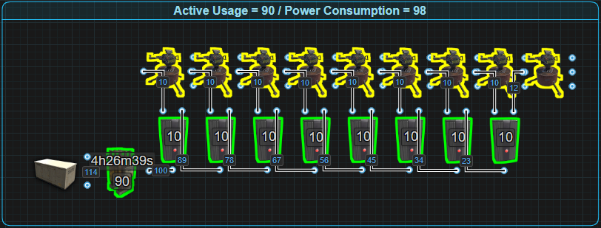

**Example:**

* 8 Electrical Branches each set to 10rW powering 9 turrets =  
   98rW consumed, 90 Active Usage.

**Today:**

* Consumes 0rW
* Has 0 Active Usage
* Does not force Active Usage based on Branch Out
* Does not block downstream Active Usage

Now, components connected to Branch Out must be powered on and actually consuming electricity in order to register any Active Usage. The branch simply limits the amount of power available — it no longer masks what’s happening after it. This makes the branch better suited for setting fixed power levels, not for reducing battery draw.

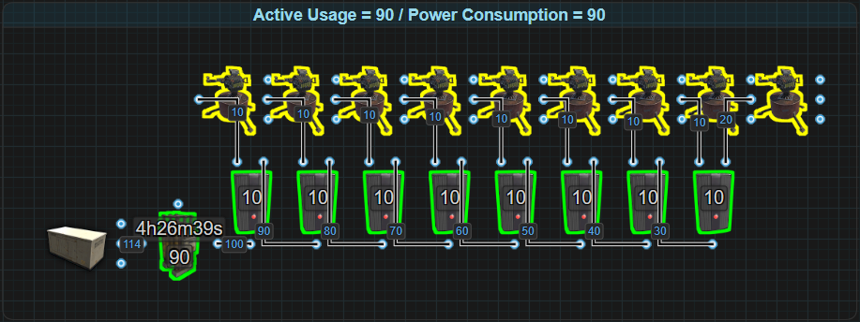

**Example:**

* 8 Electrical Branches each set to 10rW powering 9 turrets =  
   90rW consumed, 90 Active Usage

**🔀 Splitter**

**Old Behavior:**

* Consumed 1rW for itself
* Registered 1 Active Usage
* Divided input power evenly between its 3 outputs
* Did not dynamically adjust if outputs were destroyed

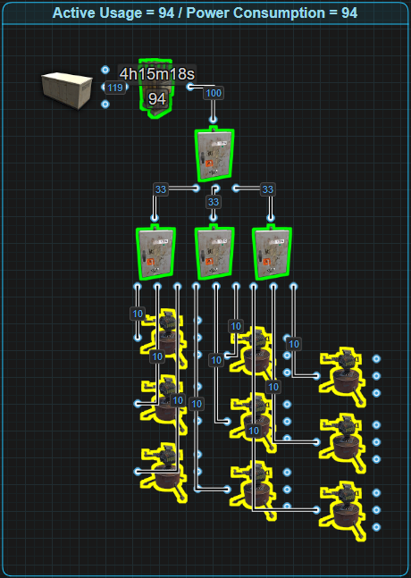

Players using 4 Splitters to power 9 turrets would have 94 Active Usage, and 94rW consumed. Compared to Electrical Branches, the Splitter cost 4 extra rW more drain to the battery.

**Today:**

* Consumes 0rW
* Has 0 Active Usage
* Redistributes power dynamically if an output is lost

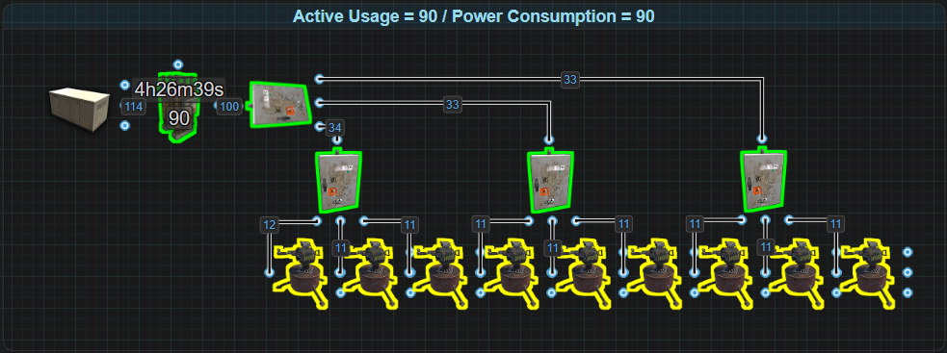

Modern Splitters are highly efficient in the same 9-turret setup:

4 Splitters = 90rW consumed, 90 Active Usage

**🧠 Final Thoughts**

Today’s Electrical Branch vs Splitter discussion is no longer about which one uses less power, but rather:

* Which combination of components costs the least amount of resources? 8 Electrical Branches for 9 outputs is 600 Metal Fragments vs 4 Splitters for 9 outputs is only 400 Metal Fragments
* Do you need fixed power distribution with prioritization? → Use Electrical Branch
* Do you need an equally divided distribution that dynamically adjusts? → Use Splitter

Both components have zero overhead now, so the choice comes down to material cost and control vs flexibility. Understanding how they route power, how that interacts with Active Usage and how power is consumed remains essential for smart circuit design.

# Electrical Branch vs Splitter Prioritization (Needs Work)

Needs work

# Root Combiner Behavior

When combining batteries using a Root Combiner, the resulting behavior might not be what one would expect unless being familiar with wiring batteries in series. The output is increased but the capacity stays the same. This is different from running multiple separate batteries in parallel, giving the same output but increasing the capacity, and has important implications on Active Usage.

Each battery connected to a Root Combiner will register the full Active Usage of the connected circuit, there is no load sharing between batteries.

* 2 Large Batteries powering a 200rW circuit = 100 Active Usage per battery
* 2 Large Batteries powering a 60rW circuit = 60 Active Usage per battery

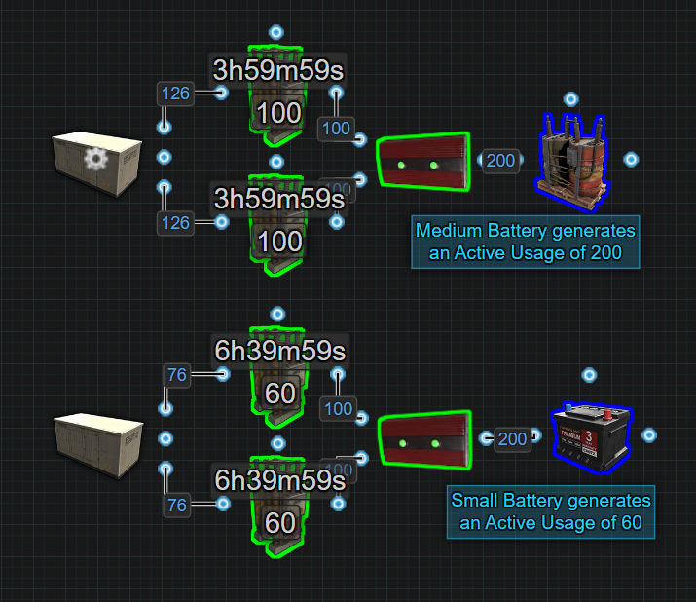

This is true regardless of how much power is actually being consumed by the circuit. The Root Combiner does not split or balance the load between the batteries, each one sees the full value.

This behavior is covered in greater detail in Batteries: Parallel vs Series, but for the purposes of understanding power efficiency here:

* If combining batteries, either fully utilize their combined output, or split the circuit and use separate batteries. Otherwise, the battery drain may be disproportionately high for what the circuit actually needs.

**⚠️ Avoid Combining Batteries in Inline Backups**

**Do not use a Root Combiner to combine batteries in a primary Inline backup.**

When batteries are wired in series (via Root Combiner), each one will register the full Active Usage of the circuit, even if more power is being supplied than needed.

* For example, a 200rW circuit powered by two Root Combined Large Batteries will result in 100 Active Usage per battery, requiring 252rW of Root Power just to stay neutral.
  + That’s 252rW produced for 200rW usable output, a net loss of efficiency.

Using a Bypass backup instead would allow the same 200rW circuit to run with only 220rW of Root Power, depending on how much power is needed to recharge the batteries.

**💡 Tip:** Two Large Batteries powering a 120rW circuit through a Root Combiner will still have 100 Active Usage per battery. This means they will last only 4 hours. If a circuit only needs 120rW and uptime is important, split the circuit across two 60rW segments powered by separate batteries to increase the runtime.

**Additional Root Combiner Rules**

While Root Combiners are powerful tools, there are two important rules that can impact their use in larger or more complex circuits:

* **Max Depth Limitation**: Root Combiners are subject to a 16-component Max Depth limit. If a power path exceeds 16 components between a Power Source and the Root Combiner, it will result in a Short Circuit / Max Depth error and power will not be delivered past this point. This becomes particularly relevant in pyramid-stacked RC-Bus systems and battery backups with long chains of components.
* **No Self-Feeding Power Loops**: A Root Combiner will not recombine power that has already passed through itself. If power is routed through a Root Combiner, used in a circuit, and then sent back into one of its inputs (intentionally or not), the combiner will ignore that power source. This fails silently — the Root Combiner simply refuses to recombine that recycled signal. This can occur in circuits with poor layout or in attempts to merge power that has already been merged before. Each input must be a clean, non-circular source.

# Basic Dive into Modern Active Usage and Power Consumption

**When defining Active Usage, it says:**

* Active Usage is always Consumed Power, but Consumed Power is not always Active Usage.

Let’s break down what this means with two clear demonstrations.

**⚙️ Active Usage is Always Consumed Power**

Take an Auto Turret that is powered, has locked onto a target, but is out of ammo. To use any of its three outputs (Has Target, Low Ammo, No Ammo), it must be given 11rW, 10rW for the turret itself and 1rW for output functionality.

Internally, the turret generates 2rW of Free Power (1rW from 2 outputs if given 11rW). If all three outputs are connected to Industrial Lights, each light will consume 1rW and create 1 Active Usage.

If this setup is powered by a battery, the total Active Usage shown will be 13:

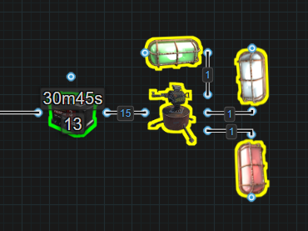

* 10rW for the turret
* 1rW for the first light
* 2rW from the lights consuming the free power

Even if the turret is powered through an Electrical Branch set to 11rW, the result is the same. The turret still generates 2rW of Free Power. The Electrical Branch limits the flow of power to the turret, but it does not limit the Active Usage passed back to the battery. So, the battery still shows 13 Active Usage, despite consuming only 11rW from the branch.

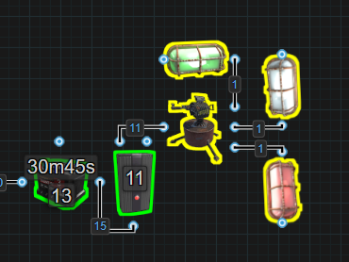

This shows that Active Usage is always tied to power being consumed, even when that power is created internally.

**⚠️ Consumed Power is Not Always Active Usage**

Now consider a SAM Site configured to "Attack All," with a Smart Switch controlling its Invert Mode input.

* The SAM Site itself requires 25rW.
* The Invert Mode input (to switch behavior) requires 1rW.

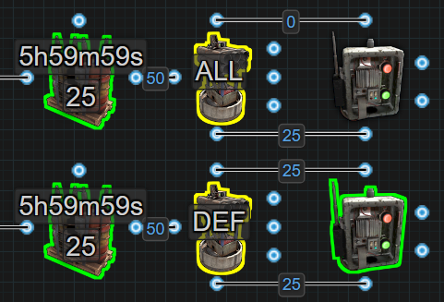

So, in total, the setup consumes 26rW. However, when powered by a battery, only 25 Active Usage is shown. This happens because the 1rW sent to Invert Mode is consumed but does not contribute to Active Usage. The battery doesn't count that part of the load, even though it's necessary for the circuit to function correctly.

This illustrates the second half of the principle: Power can be consumed by a components auxiliary inputs without generating Active Usage, which is why it can also be said when defining Consumed Power that Consumed Power includes all energy used for functionality, regardless of whether or not it registers as Active usage on a battery.

To dive deeper into the different power types, how they interact with each other and how players can leverage one against another, the following examples are used to help demonstrate what players should be considering when designing a circuit or selecting a battery backup.

# Example: Backup Turrets Using A Splitter

This example demonstrates how a circuit that consumes a lot of power can leverage Active Usage to reduce overall Root Power demand, especially when switching between Bypass and Inline battery backup strategies.

In this setup, there are six Auto Turrets, each with its own backup turret hidden behind a door. When a turret is destroyed, a Door Controller opens the door and secondary turret powers on. This is achieved using the Splitter’s ability to redistribute power when an output is disconnected.

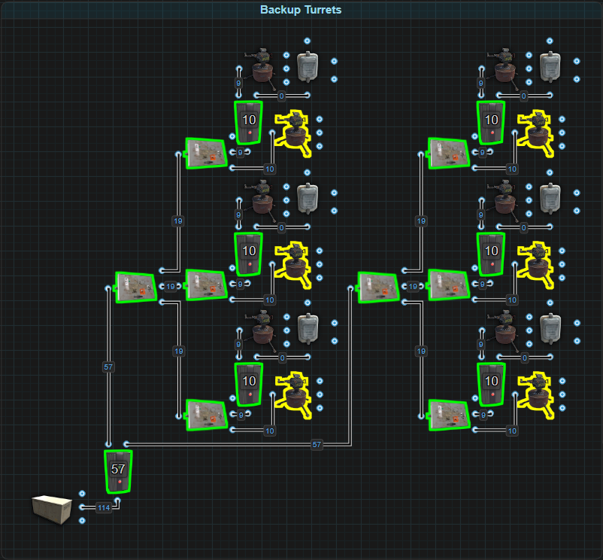

The structure of this circuit is built from two mirrored groups:

* Each group uses 1 Splitter to feed 3 additional Splitters.
* Each of those three outputs connects to:
  + Output 1: the primary Auto Turret
  + Output 2: an Electrical Branch set to 10
    - Branch Out powers the secondary Auto Turret
    - Power Out opens the Door Controller

Each group of turrets needs 57rW to function. Each of the 3 local Splitters receive 19rW. When splitting unevenly, Splitters distribute power with Output 1 prioritized over 2 and 3. 10rW is sent to the primary turret, and 9rW is passed to the Electrical Branch. Since the branch is set to 10, the secondary turret remains off because of insufficient power. When the primary turret is destroyed, the full 19rW flows to the Electrical Branch, activating the backup turret and opening the door.

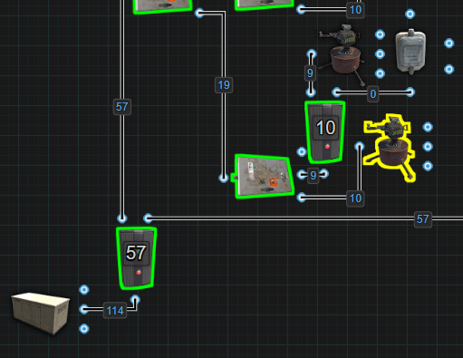

This system powers 6 turrets + 6 backups = 12 turrets total, with a continuous demand of 114rW to keep all logic and primary turrets running.

**⚡Solving For Efficiency**

If powered using a BCN Core or similar Bypass battery backup, the full 114rW must be reserved at all times. That’s a significant amount of Root Power allocated just for turret logic and failover behavior. To get more than 100rW of power using an Inline Battery backup, like the Kore, 2 batteries would need to be combined and that is never recommended. So what's the solution?

Break the circuit into 2 parts and use two Large Batteries instead. One for each group of 3 turrets. The Active Usage per battery is only 30 (10 per active turret). The remaining 27rW used for logic is classified as Control Power and does not register Active Usage. Each battery, with 30 Active Usage, requires only 38rW of input to stay neutral. Using two batteries, this entire system can be maintained with just 76rW of Root Power instead of 114rW, a 33% savings.

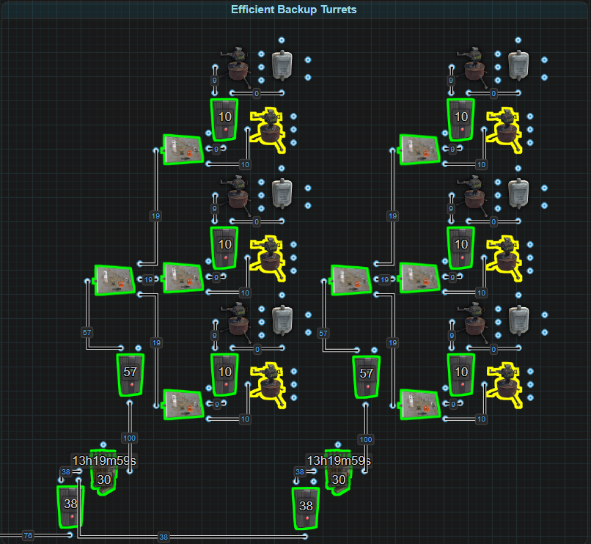

* This example illustrates how introducing inline batteries, even when using a Bypass backup like the BCN Core can result in lower Root Power production requirements.

A bypass backup can benefit dramatically by adding an Inline Secondary battery backup. By placing a battery between the BCN Core’s distribution grid and the turret system, all the power that needed to be reserved for logic is offloaded onto the battery for free because it is Control Power and Control Power does not generate Active Usage. Not only is this a 33% reduction in Root Power requirements, it also added a 325% bonus in battery backup time. After the 4 hours of primary backup power, these turrets will have an additional 13 hours of backup time. This is a huge gain in efficiency.

This demonstrates the power of leveraging a battery to take advantage of Active Usage and Control Power. The more complex and logic driven systems are, the larger the benefit can be by taking advantage of Active Usage and offloading logic control to Control Power.

# Example: Flipping Flop Turrets

This example demonstrates how circuits with high baseline power consumption but a lower Active Usage may be more efficiently powered by Root Power directly, rather than through a battery.

In this setup, a group of six Auto Turrets is powered for a period of time, then turned off while a second group of six turrets is powered. The system flips between these two groups using a Memory Cell, creating a rotating turret defense that stays under the turret interference limit while extending coverage.

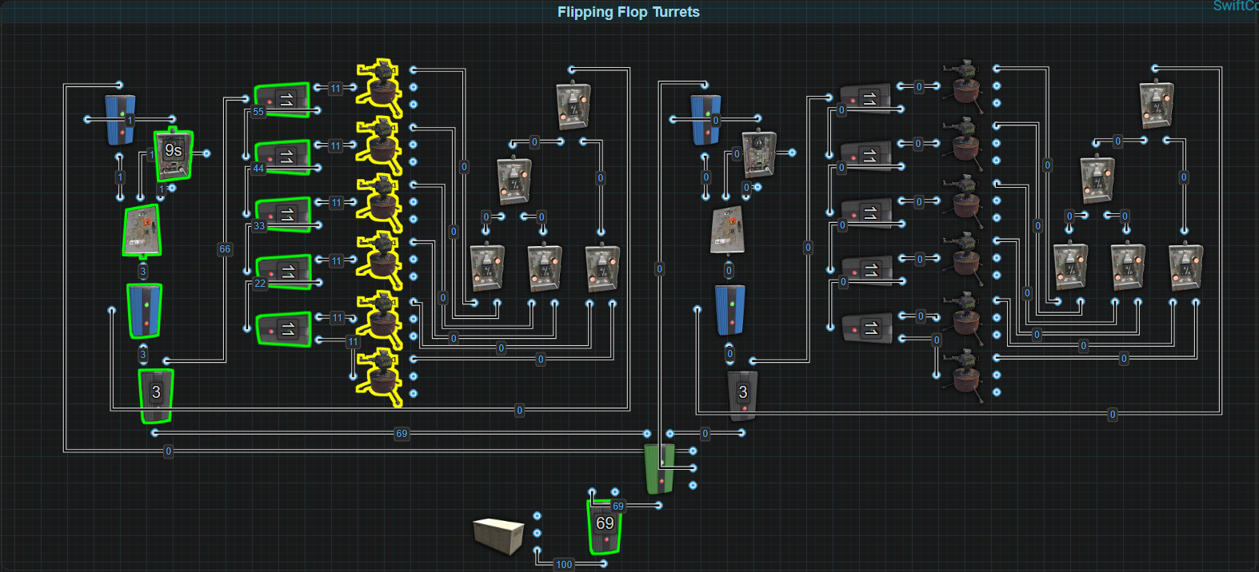

A Timer triggers the Memory Cell to flip outputs every X seconds, alternating power between the two turret groups. If a turret in the active group locks onto a target, its Has Target output disables the timer, freezing the cycle until the threat is cleared. This ensures defense presence is maintained without flipping turrets unnecessarily during a raid.

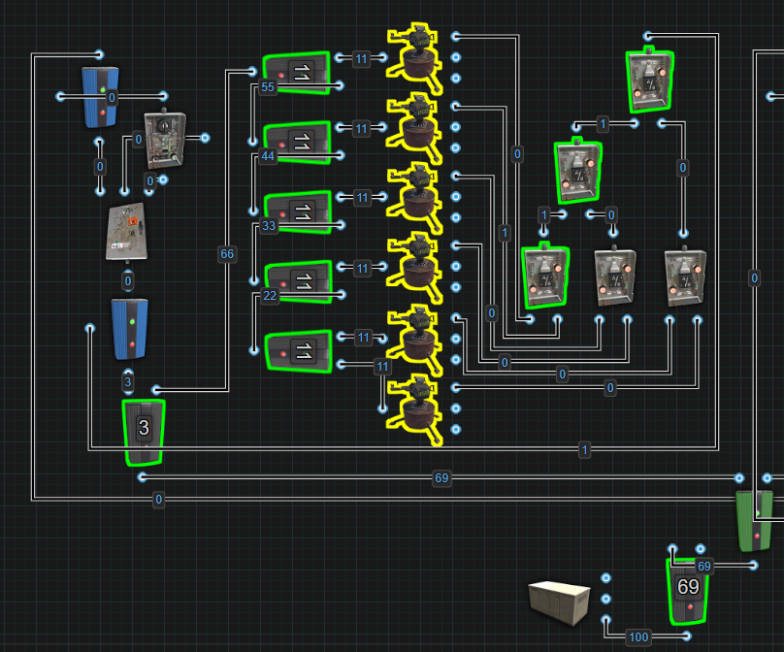

The structure of this circuit is built from two mirrored groups:

* Memory Cell Output or Inverted Output → Electrical Branch 1 (set to 3)
  + Branch Out → Blocker (used to disable the timer system if any turret has an active target)
  + Power Out → Electrical Branch 2 (set to 11)
    - Branch Out → Turret 1
    - Power Out → Electrical Branch 3 (set to 11)
      * Branch Out → Turret 2
      * Power Out → Electrical Branch 4 (set to 11)
        + Branch Out → Turret 3
        + Power Out → Electrical Branch 5 (set to 11)

Branch Out → Turret 4

Power Out → Electrical Branch 6 (set to 11)

Branch Out → Turret 5

Power Out → Turret 6

* All Has Target outputs → OR Switch network → Block Passthrough input on Blocker
* Blocker Input → Power from Electrical Branch 1 (Branch Out)
* Blocker Output → Splitter
  + Power Out 1 → Timer
  + Power Out 2 → Timer Toggle
  + Power Out 3 → Blocker (which controls SET/RESET of Memory Cell)

When the Splitter receives power, it triggers the Timer and blocks the Blocker. When the Timer ends, it sends power through the final Blocker to SET or RESET the Memory Cell, flipping turret groups.

**⚡ Solving For Efficiency**

This turret system needs 69rW to function. 60rW is used to power the six turrets, while the remaining 9rW supports the logic that flips turret groups back and forth. That includes the Memory Cell, Timer, OR Switches, and Blockers.

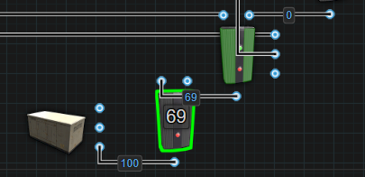

If a player powers this setup with a Bypass Battery Backup, the logic will need Root Power to function, the full 69rW must be produced and supplied at all times. The battery is bypassed entirely, and while this means there’s no charging overhead, it also means no potential savings. Every bit of Root Power must be generated.

On the other hand, an Inline Battery Backup changes the equation slightly. Here, the battery only “sees” the six turrets and registers 60 Active Usage, and because batteries are only 80% efficient, the battery now needs 75rW of input power just to break even.

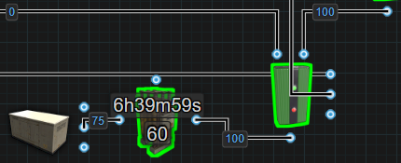

Even though the logic portion doesn’t create any Active Usage, the battery still needs more Root Power than the bypass setup, about 6rW more, just to hold its charge. That’s not a huge difference on its own, and might be with the cost for an additional 6 hours and 40 minutes of uptime, but this system is designed to scale. If each group was to be increased to 10 or more turrets, and powered by batteries, the gap grows by 25rW or more and that’s significant.

This is a perfect example of when produced Root Power is the better choice. When a circuit’s power demand is primarily functional (e.g., Auto Turrets), there is little efficiency benefit to routing power through an Inline battery. Offloading control logic to a battery works best when that logic makes up a larger portion of the circuit’s power cost. This is not one of those cases.

* Produced Power is ideal for direct-use, high-drain components.
* Inline batteries should be reserved for circuits that benefit from Active Usage scaling or Control Power offloading.

When logic overhead is low and component demand is high, Root Power offers better scalability and efficiency. Not every system benefits from leveraging Control Power or Inline backups. Sometimes, direct Root Power is the smartest approach.

# Example: Automatic Sprinklers

This example demonstrates how a circuit can benefit from the player’s understanding of Control Power, power used for logic and timing that does not generate Active Usage. When 30% or more of a circuit’s power is used for logic rather than function, it may be possible to increase efficiency by isolating that portion of the circuit and offloading it onto a standalone battery that doesn’t need to be recharged.

This is a simple watering system for a farm. It contains four Ceiling Lights, four Sprinklers, and a basic timing circuit using two Timers. The left Timer turns the water on (short cycle), while the right Timer resets the loop (long cycle). Water is collected from a Large Water Catcher and delivered to the Sprinklers using a Fluid Switch & Pump.

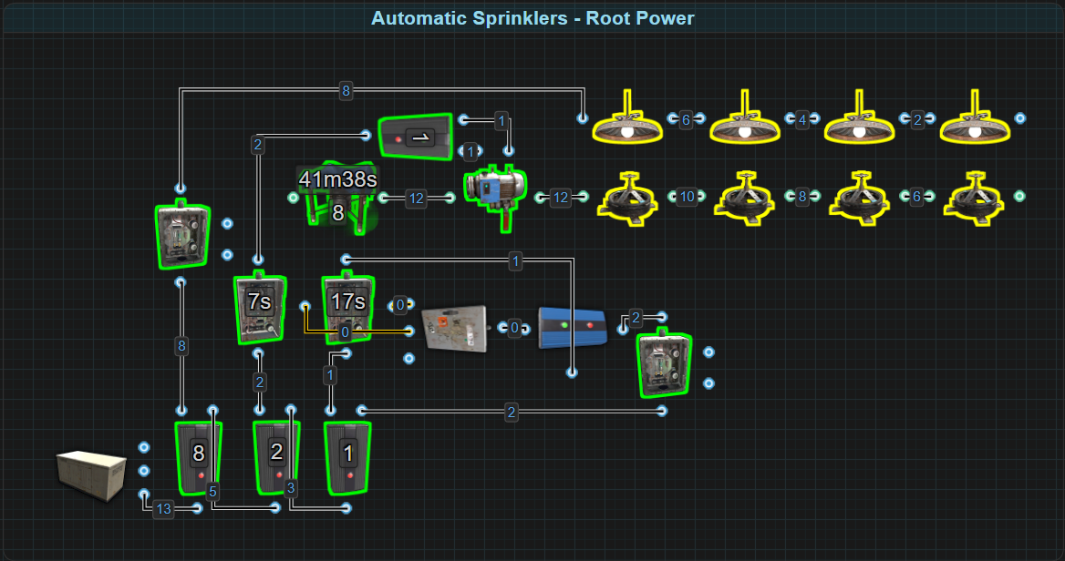

The structure of the circuit is:

* Power In → Electrical Branch 1 (set to 8)
  + Branch Out → Switch → Ceiling Light 1 → 2 → 3 → 4
  + Power Out → Electrical Branch 2
* Power In → Electrical Branch 2 (set to 2)
  + Branch Out → Short Timer → Electrical Branch 4 (set to 1)
    - Branch Out → Toggle on Fluid Switch & Pump
    - Power Out → Pump Power input
  + Power Out → Electrical Branch 3
* Power In → Electrical Branch 3 (set to 1)
  + Branch Out → Long Timer → Block Passthrough input on Blocker
  + Power Out (sending 2rW) → Switch → Blocker
    - Blocker Output → Splitter
      * Power Out 1 → Toggle Short Timer
      * Power Out 2 → Toggle Long Timer

When the short timer starts, it enables the pump and Sprinklers. The long timer restarts the short timer and itself, keeping the cycle running. The lights remain on independently.

**⚡ Solving For Efficiency**

This circuit draws 13rW total:

* 8rW powers the four Ceiling Lights
* 5rW powers the logic system—timers, splitters, blockers, and the pump controller

This means that 38% of the circuit’s energy demand is tied to automation rather than functional components. Understanding how to handle this distribution can greatly improve overall efficiency depending on the power delivery method used. If connected to a Bypass Battery Backup, all 13rW must be provided constantly from Root Power. While this works, it’s not the most power-conscious setup.

By switching to an Inline Battery Backup, only the power that generates Active Usage matters. Since the lights are the only components that produce Active Usage, the battery sees just 8rW of drain. As a result of the battery’s 80% efficiency, only 10rW of power input is needed to maintain charge. This already provides a 3rW savings in Root Power, translating to a 23% improvement in power efficiency. This setup is great for small-scale farms powered by a dedicated solar panel or generator. If players actually use the Switches when they log off, power demand will drop to 0.

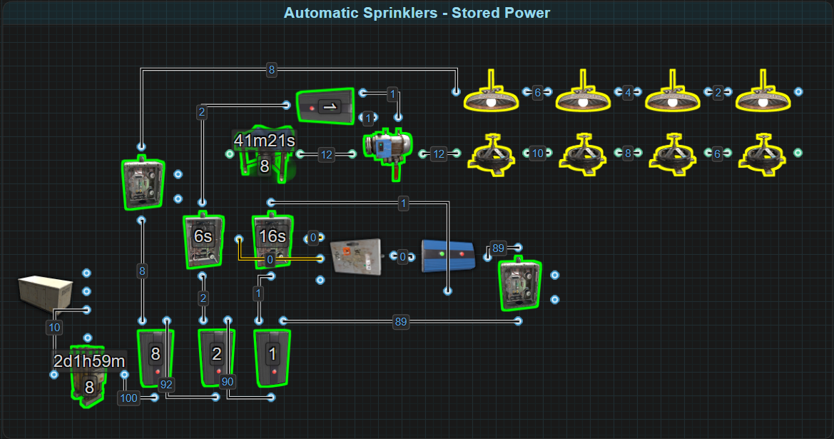

Players using a modern Bypass Backup System, like the BCN Core, and just want to leave the lights turned on all the time, can optimize even further by leveraging Control Power. Since the logic components in this circuit do not create Active Usage, they can be powered by a battery that doesn’t need recharging, resulting in zero drain on Root Power. If a modern BCN Core is being used, it already has a battery for Control Power that can be used to supply Control Power for a circuit like this.

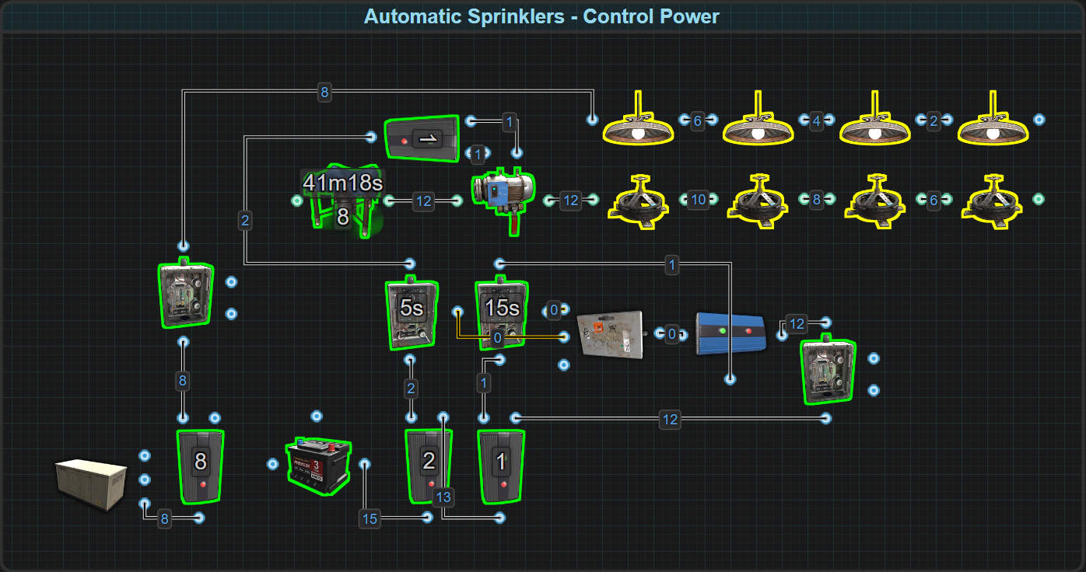

In this setup:

* The Bypass Backup only needs to provide 8rW for the lights
* A Control Battery supplies the remaining 5rW for the logic system

This configuration reduces Root Power consumption by 38%, without compromising functionality.

This example highlights the importance of recognizing when a circuit’s automation or logic can be separated from its functional load. By offloading Control Power and understanding where Active Usage is actually generated, players can design systems that are more sustainable, more efficient, and better suited for expansion.

# Example: Automatic Furnace

This circuit demonstrates how circuits that don’t need to operate continuously can benefit from smart management of Stored Power. While it’s commonly said that a battery needs Active Usage × 1.25 to stay charged, that formula assumes continuous operation. If a circuit is only active part of the day, the player can input less power, as long as the battery has enough downtime to recover its capacity.

This design uses 6 Electric Furnaces managed by two Conveyors and a filtering system. The furnaces will only activate when Ore is detected. The first Conveyor detects ore and activates the Switch. When both Conveyors detect no items, they trigger an AND Switch that turns the furnaces off. The goal is to minimize energy usage while maintaining full automation.

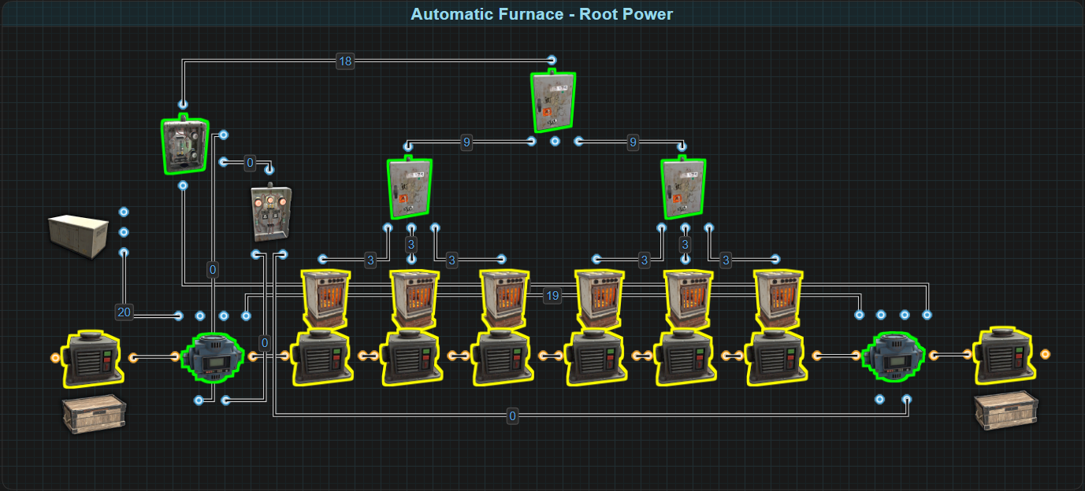

Power In → Conveyor 1 → Conveyor 2 → Switch → Splitter

* Splitter → 2 additional Splitters → 6 Electric Furnaces

Conveyor 1:

* Checks the Input Box
* If Ore is present, sends Filter Pass → Switch Turn On
* If Ore is absent, sends Filter Fail → AND Switch

Conveyor 2:

* Transfers items as needed
* If smelted ore is absent, sends Filter Fail → AND Switch

When both conveyors signal completion, the AND Switch sends a pulse to the Turn Off input on the Switch, deactivating the furnaces.

This circuit is already intelligently designed by placing the furnaces after the Conveyors. Normally, if a conveyor is going to use an output, it needs to be given 2rW. The exception is when they are passing power through, they will only use 1rW.

**⚡ Solving for Efficiency**

This system has two clear power states:

* Active: 20rW required (furnaces on + conveyors)
* Idle: 2rW required (just conveyors monitoring)

Powering this from Root Power would require reserving 20rW at all times, whether the furnaces are active or not. Powering from a battery and always supplying 25rW to overcome Active Usage (20 × 1.25) would also be overkill if the system isn’t always running.

If a player can estimate the duration of usage per day, we can calculate the exact Root Power required to keep a battery neutral across that period. For example, let’s say the furnaces are active for 11 hours per day and idle for 13 hours.

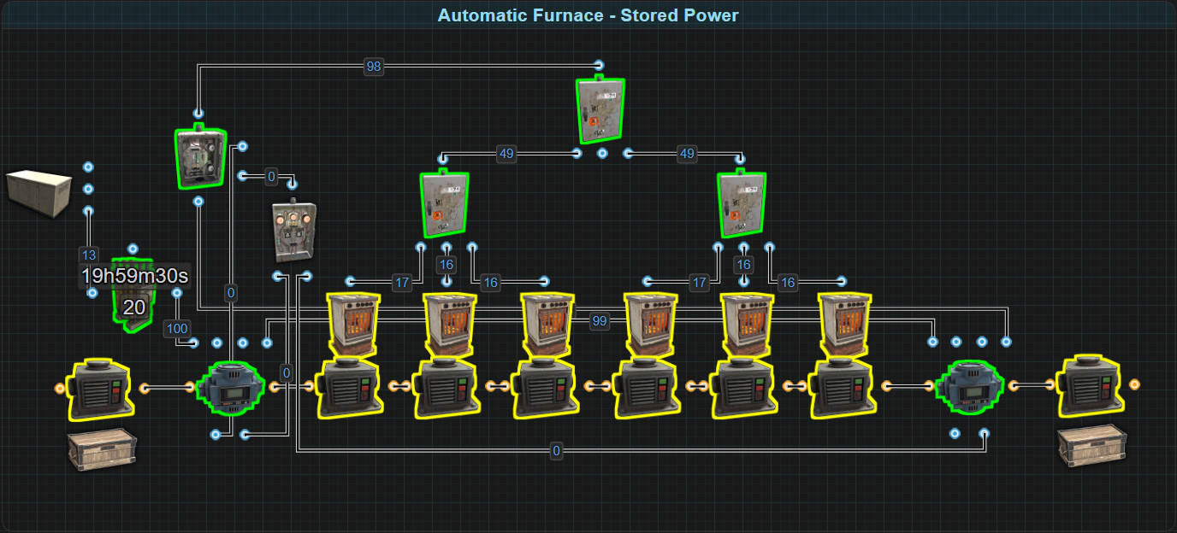

**📈 Step 1: Calculate Total Daily Capacity Use**

**Formula:**

DailyCapacity = (ActiveUsageActive × MinutesActive) + (ActiveUsageIdle × MinutesIdle)

**Legend:**

* **DailyCapacity:** Total rust watt minutes (rWm) used in 24 hours
* **ActiveUsageActive:** Power draw during activity
* **MinutesActive:** Minutes the system is on
* **ActiveUsageIdle:** Power draw during standby
* **MinutesIdle:** Minutes the system is idle

**Example:**

DailyCapacity = (20 × 660) + (2 × 780)

= 13,200 + 1,560

= 14,760rWm

Therefore 14,760rWm of capacity will be consumed over a 24 hour period.

**🔋 Step 2: Calculate Input Power to Stay Neutral**

**Formula:**

RequiredInput = DailyCapacity ÷ (1440 × 0.8)

**Legend:**

* **RequiredInput:** Minimum Root Power input in rW to keep battery neutral
* **1440:** Minutes in a day
* **0.8:** Battery efficiency

**Example:**

RequiredInput = 14,760 ÷ (1440 × 0.8)

= 14,760 ÷ 1152

≈ 12.8rW ➞ rounded up to 13rW

By inputting just 13rW constantly into the battery, the system will break even over the day.

**📊 Step 3: Check Battery Capacity Requirements**

This step verifies if the battery can survive the discharge cycle.

**Formula:**

NetLoss = (ActiveUsageActive × MinutesActive) - ((RequiredInput × MinutesActive) × 0.8)

**Legend:**

* **NetLoss:** Total rWm lost from battery during activity
* **ActiveUsageActive:** Power draw during activity
* **MinutesActive:** Minutes the system is on
* **RequiredInput:** Minimum Root Power input in rW to keep battery neutral
* **0.8:** Battery efficiency

**Example:**

NetLoss = (20 × 660) - ((13 × 660) × 0.8)

= 13,200 - 6864

NetLoss = 6,336rWm

This means the battery will lose 6,336rWm over the 11 hours of operation. A Medium Battery (9,000rWm) would be more than enough to handle the load.

**✅ Alternate Example (Quick and Dirty Method)**

RequiredInput = ((PowerRequiredActive - PowerRequiredInactive) × (MinutesUsed ÷ 1440) + PowerRequiredInactive) × 1.25

**Legend:**

* **RequiredInput:** Minimum Root Power input in rW to keep battery neutral
* **PowerRequiredActive:** The amount of power the circuit needs to fully function
* **PowerRequiredInactive:** The amount of power the circuit needs in when not being used
* **MinutesUsed:** The number of minutes in a day the circuit will be active for
* **1440:** The number of minutes in 24 hours
* **× 1.25:** Battery efficiency

Example: Let’s assume the circuit uses 20rW for 11 hours a day and 2rW the rest of the time it is in standby.

RequiredInput = ((20 - 2) × (660 ÷ 1440) + 2) × 1.25

= ((18) × (0.46) + 2) × 1.25

= (8.28 + 2) × 1.25

= (10.28) × 1.25

RequiredInput = 12.85rW ➞ rounded up to 13rW

**Note:** This equation does not take into account how much capacity will be consumed during the active time. Not taking this into consideration can lead to the battery becoming depleted.

This balance of charge/discharge is key. It allows players to operate high-drain systems intermittently without needing large-scale power generation. This strategy is ideal for automated systems that react to player input or inventory states. Perfect for furnaces, doors, alarms, or anything event-triggered.

* Reduces constant power draw from 20rW → 13rW, a 35% reduction in Root Power
* Introduces flexibility to scale up without needing more Root Power
* By balancing discharge with recharge cycles, the battery can sustain operations efficiently.
* Smart use of Stored Power can significantly reduce Root Power demands.

# Example: The Simple Trap

This example demonstrates how circuits triggered by basic player inputs can greatly benefit from using Free Power for Control Power to reduce Root Power requirements.

The goal of this trap base is simple: trap an intruder between two doors. When the victim steps on a Pressure Pad, one door shuts behind them, and another opens ahead, exposing a deadly room full of Shotgun Traps. A Memory Cell handles the power switching between the two doors. To reset the trap, the base owner presses a Button, but only if they’re detected by the HBHF Sensor, which prevents outsiders from resetting the system.

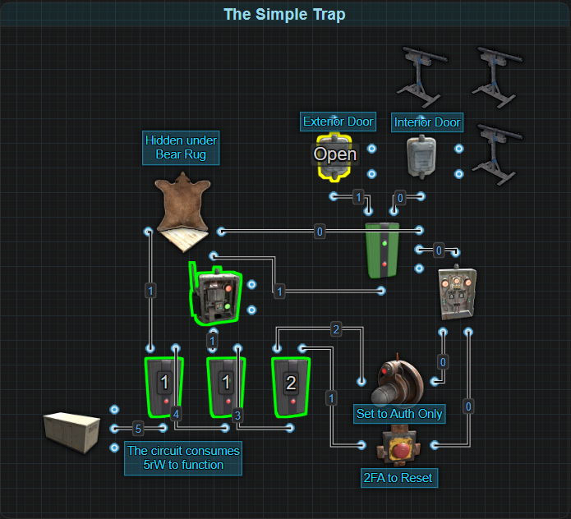

Power enters a series of 3 Electrical Branches:

* Branch 1 ( Set to 1)
  + Branch Out: 1rW to the Pressure Pad → Sends pulse to SET on the Memory Cell
  + Power Out: Feeds Branch 2
* Branch 2 (Set to 1)
  + Branch Out: 1rW to a Smart Switch → Keeps the Memory Cell Input powered
  + Power Out: Feeds Branch 3
* Branch 3 (Set to 2)
  + Branch Out: 2rW to the HBHF Sensor (set to authorized players only)
  + Power Out: 1rW to the Button

The Button and HBHF Sensor outputs are wired into an AND Switch. When both inputs are active, the AND Switch sends 1rW to the RESET input of the Memory Cell, flipping it back. This provides players with a 2 factor authentication system.

The Output and Inverted Output of the Memory Cell are each connected to a Door Controller, ensuring only one door is powered (and therefore open) at a time.

**⚡ Solving for Efficiency**

At first, this circuit appears fairly lightweight, it only draws 5rW. A closer inspection shows that only the Door Controller (whichever is currently active) and the HBHF Sensor actually generate Active Usage. That means we could place the entire system on an Inline backup, and only see 2 Active Usage, requiring just 3rW input to remain neutral, already a 40% power savings compared to using Root Power directly.

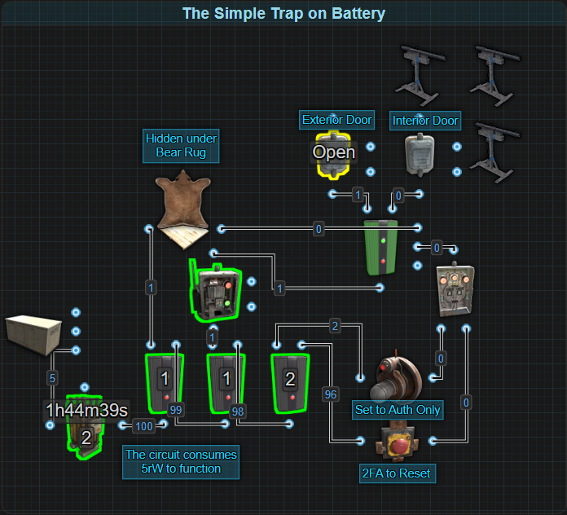

But things can go further.

Two of the components, the Pressure Pad and the Button, generate Free Power when activated. The Pressure Pad sends a free 1rW pulse to SET, removing the need for an Electrical Branch. Likewise, the Button generates 2rW when pressed, just enough to both power the HBHF Sensor (which needs 1rW) and pass the second 1rW to RESET on the Memory Cell. Now the logic circuit is entirely self-powered, the circuit will only need 1rW to keep the Smart Switch (and by extension, the Memory Cell’s Input) constantly powered.

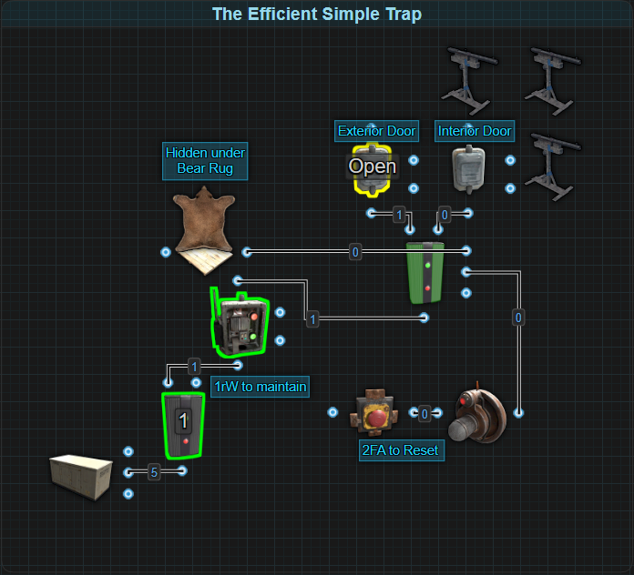

That’s an 80% reduction in Root Power requirements, from 5rW down to 1rW, all by understanding the components and leveraging Free Power. In larger circuits, small reductions like this can add up fast.

🔍 Pro Tip: The Reactive Target also produces 1rW of Free Power when shot down with no input power, offering another creative input option for similar designs.

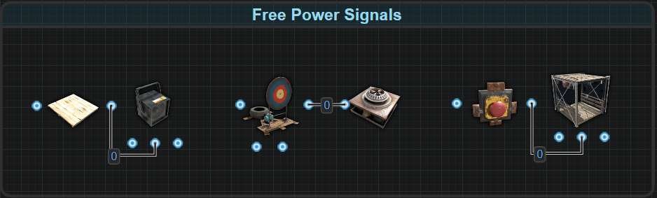

This example illustrates how a circuit that relies on player input can do it at zero cost to Root Power. From turning on a Strobe Light, activating fireworks at a distance or calling an Elevator, there are many situations where simple traps or logic systems can be optimized drastically by utilizing these components. Even circuits with low power requirements benefit from minimizing Root Power dependency. Components like the Button and Pressure Pad are not just inputs, they are power sources, and when used wisely, they can eliminate the need for continuous power input entirely in parts of a circuit.

# Summary

This section redefines how players evaluate and build circuits in Rust. By breaking down the different forms of power and showing how they interact, this section helps players:

* **Identify waste** in circuit design by understanding where power is being used vs. where it's being drained.
* **Leverage Control and Free Power** to offload logic components from Root Power.
* **Use batteries strategically**, choosing between Inline or Bypass backups depending on circuit behavior.
* **Reduce overproduction**, avoid unnecessary battery drain, and extend circuit uptime through smarter design.

Each example, from turret arrays to sprinklers, auto furnaces, and trap systems, shows how even small adjustments can make a circuit more efficient. The result is not just power savings, but greater design flexibility, lower upkeep costs, and better performance under pressure.

This foundation will carry forward into the next chapters, where more advanced circuit logic, distribution, and power routing will be explored.

Power Generation

# Wind Power

Generating power from the wind with Wind Turbines is the most common way to generate rustricity. They are very reliable and can produce anywhere from 0rW up to 150rW. Wind Turbine power is greatly influenced by tower height to buildable ground and surrounding structures.

How close to a Wind Turbine is too close? That answer is 15 meters or 5 square foundations. Wind Turbines are large deployables and need a lot of room. If something is blocking the path of the wind, the turbine will produce zero power until the wind shifts direction. The picture below shows an area called ‘Restricted Build Zone’. Building outside of this area is completely safe. Building within the restricted zone could lead to blocking the wind but if some precautions are taken. (The shape should be a circle but squares are just easier to work with in game.)

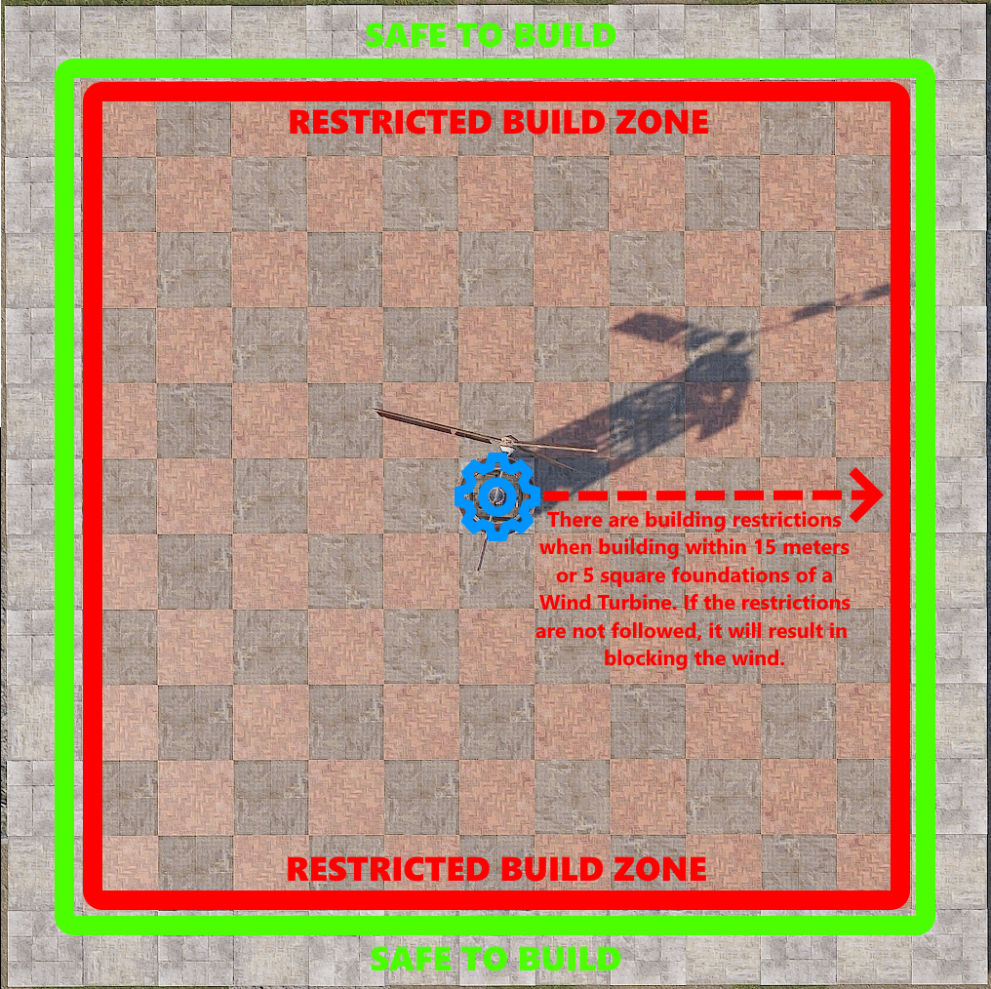

Building within the restricted zone is possible and it’s easier than people think. There is an invisible beam that sticks out the front of the turbine, at the intersection of the blades. It is inline with the horizontal drive shaft and sticks out 15 meters, or 5 square foundations. If this beam gets blocked by trees or rock formations, something a player deploys or builds, the turbine will stop spinning and stop producing power.

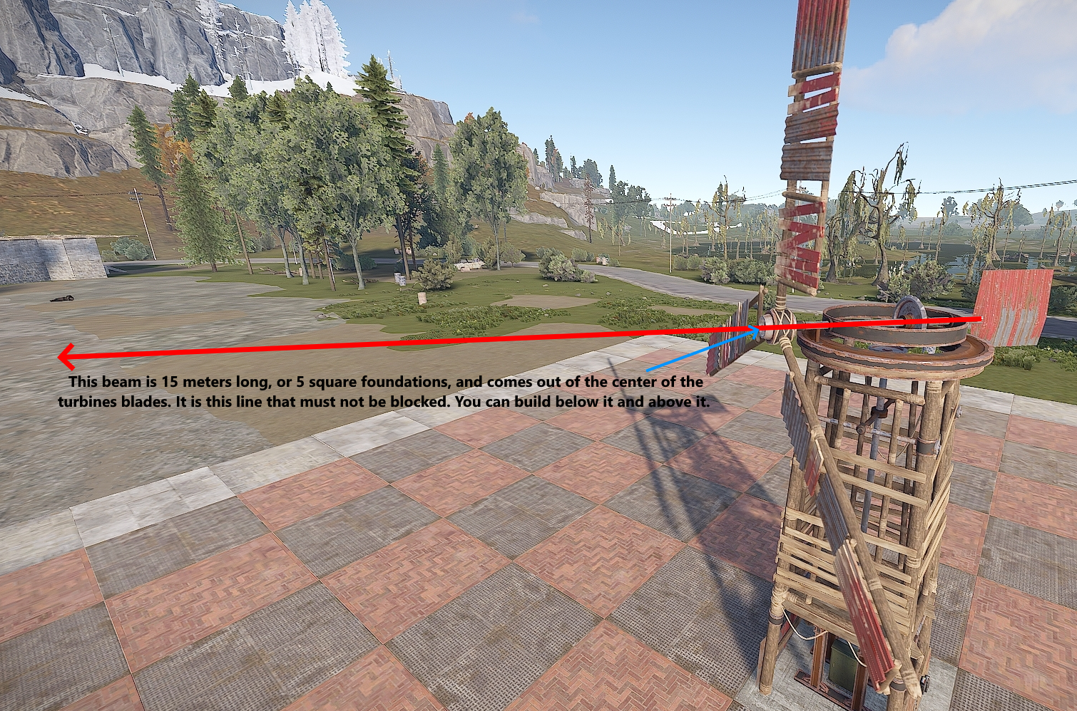

This beam is not very thick and its height is just over 2 floors high. As long as there are no obstructions out to 15 meters, the turbine will continue to produce power. Obstructions are anything from building structures to deployable items. This next picture shows where walls and floors can be placed below the beam without interfering with power production.

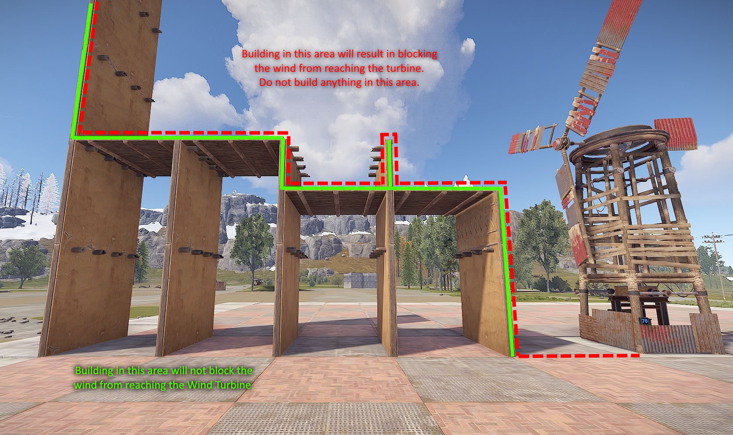

It is technically possible that something could be built in the area that would be the 3rd floor, but floors can’t be suspended. Angled roofs on the 2nd floor will block the wind because they stick up just enough into the 3rd floor to block the beam.

The frame of double door frames will block the wind. The following items can be placed into the double door frame and not block the wind.

* Chainlink Fence
* Netting
* Open Garage Door

This next picture shows a way to fully enclose the turbine inside a building. The 2 requirements to do this are:

1 - The 3rd floor needs to be free of obstructions out to 5 square foundations.

2 - Directly above the turbine needs to be 7 floors high.

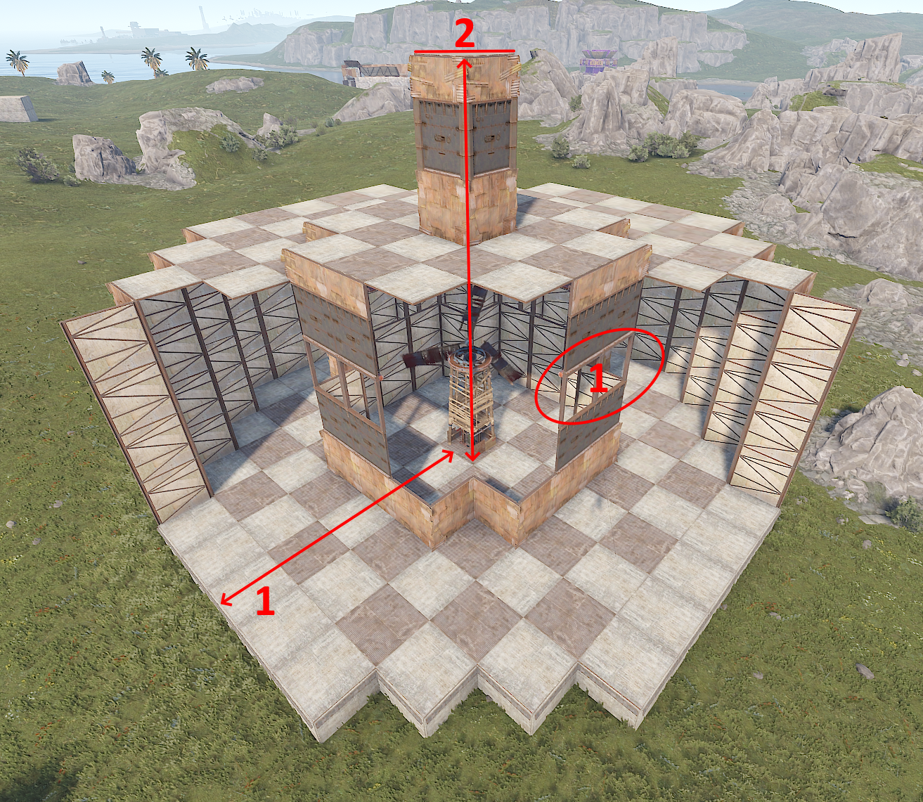

Fun fact, the turbine always rotates clockwise and it takes 1 hour to complete a full 360 degrees.

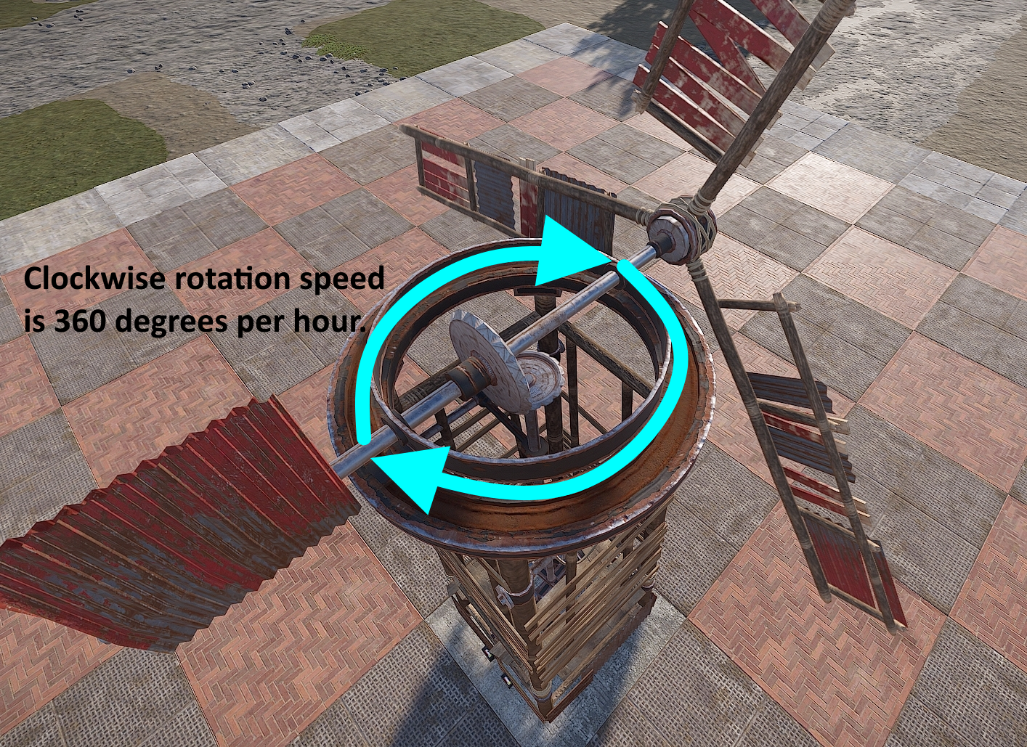

Knowing how close to the Wind Turbine structures and deployables can be placed is the first step. The next part is knowing how high they need to be built. The higher a turbine is placed, the more power it will produce on average. Height is referring to the distance between the turbine and the buildable ground below it. This means there is no difference between a turbine built on ground level at the beach or on the top of a mountain. If they are built at the same height off the ground, they will both produce the same amount of power. The next image is showing us how much average power can be expected when it is built above ground level.

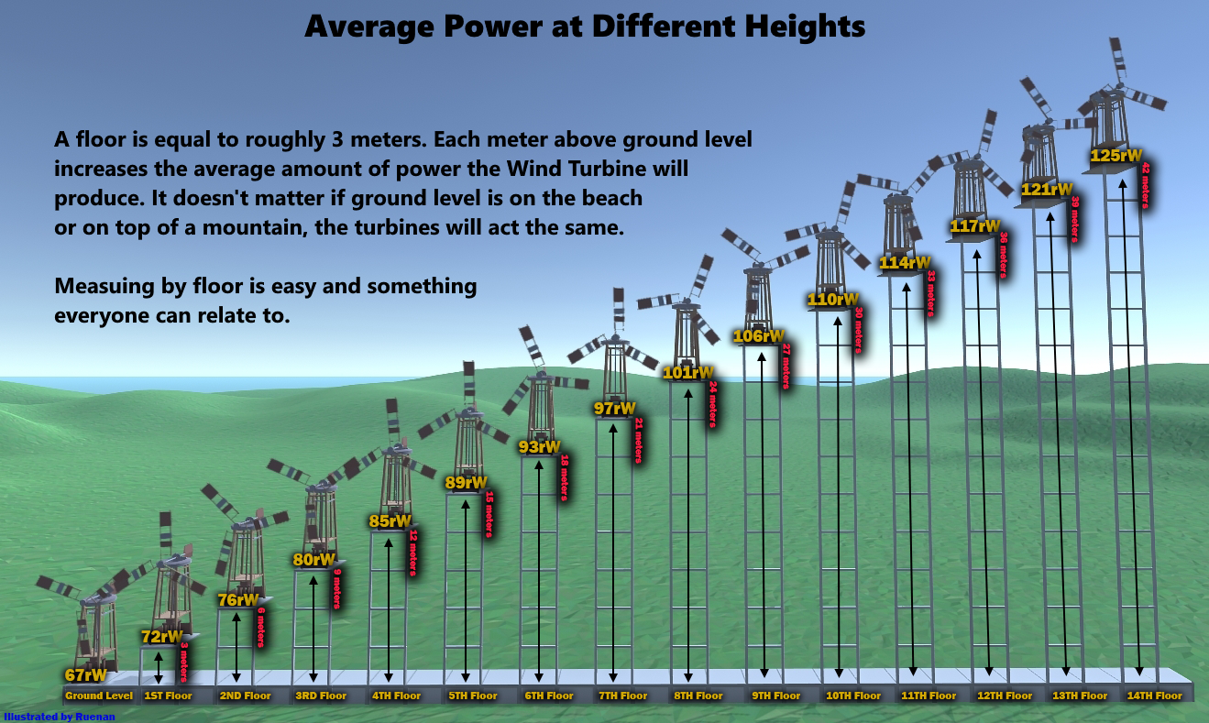

When measuring height, people will regularly refer to how tall or high their Wind Turbines are by counting the number of floors down to the foundations. This is a very easy way to relay information to everyone that plays Rust but if it was necessary to be more accurate, the height of the foundation could be taken into account.

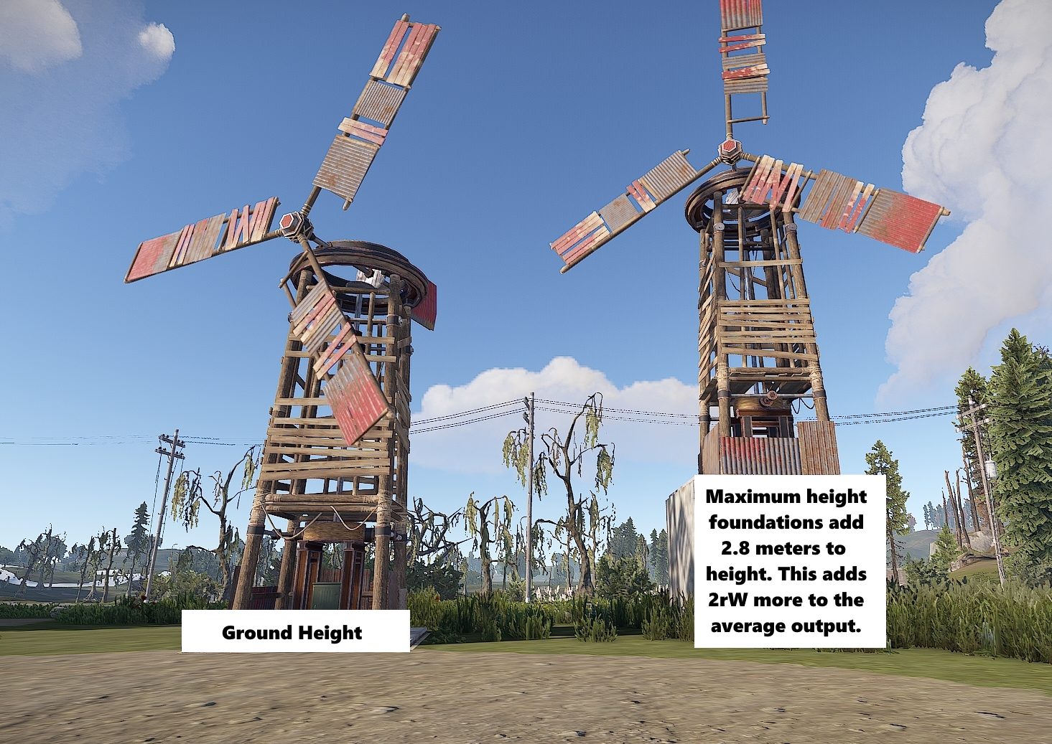

The strength of the wind varies over time. This means the amount of power a Wind Turbine produces fluctuates up and down. It is the reason why an average is used when talking about how much power a Wind Turbine produces. To help illustrate this, in the picture below, the blue line shows the amount of power a turbine at ground level was producing over the period of an hour. It consists of approximately 180 data points. The red line is what is said to be the average output for a turbine at ground level.

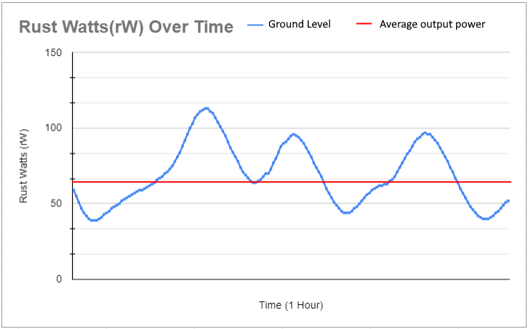

The picture above is from a random hour and its purpose is to show the randomness of wind. During this hour, the turbine's max output was only 113rW and its lowest output was 39rW. If this graph was stretched out to 100+ hours, it would show that the most common fluctuations are about 50rW + or - the average output. However, at some point, if the graph was stretched out long enough, we would see the turbine max out and produce 150rW. Likewise, we would also see its production drop to 0rW. The higher the turbine is, the more often it will max out at 150rW. The lower the turbine is, the less often it will max out at 150rW. At all heights, they have an equal chance to hit 0rW though it is very rare. Due to this fluctuation, the most reliable thing to do was find the average over a long period of time and that is how 93rW on the 6th floor became the number that is used today.

If average output means that 50% of the time the turbine is producing more or less power, then with the same data points, it's also possible to find out the amount of time a turbine will be producing a specific amount of power or more for. For example, let’s say there was a need for a turbine to produce 30rW but it had to produce that much 99.9% of the time. How high would this turbine need to be? In this next picture, there are examples of the 2nd, 6th and 9th floors. Using this data, a turbine built 6 floors or more high, would be able to supply 30rW, 99.9% of the time. If anyone would like to collect the data for the remaining floors, I'd happily add it.

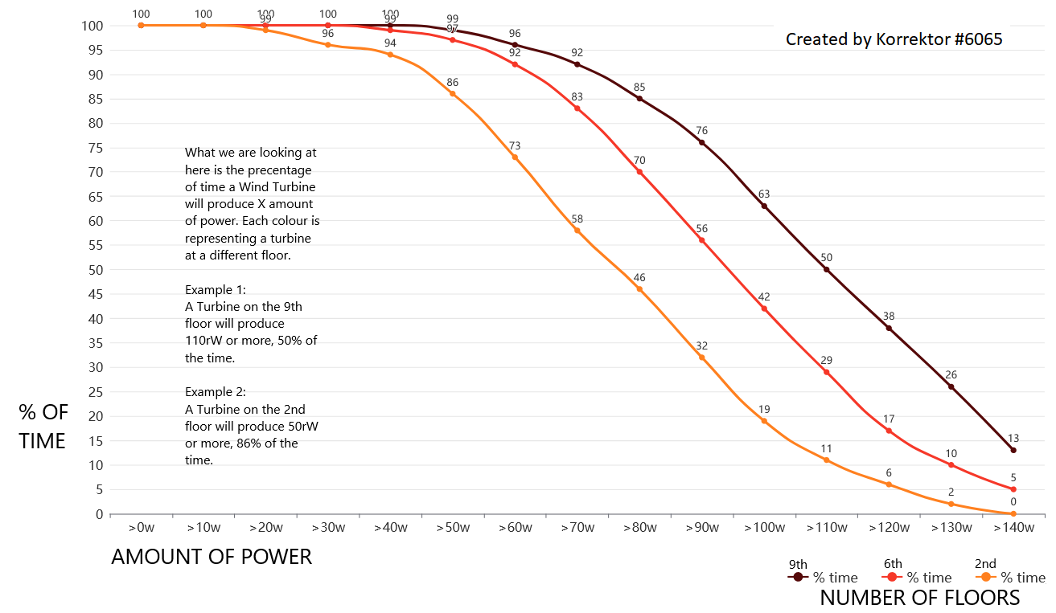

Knowing this detailed information is not a necessity but if it is understood, it will help prevent running out of power, or better yet, being more efficient. Knowing how much power a circuit needs will help determine how many turbines need to be built and at what height they should be placed. The inverse of that is also true. If the number of turbines and their height is limited, knowing how much power that can be reliably produced will determine how big the circuit can be.

This next image is a very nice breakdown specifically for the Inline battery backup. Please keep in mind the image is out of date as most components don't consume power anymore. It shows the turbines average power per floor and the usable amount of power from a battery. It also shows how many Auto Turrets a single Wind Turbine and Large Battery combo could support. It even shows how much stone each Rust Watt costs when building dedicated Wind Turbine towers. The stone calculations are now a little low. There was an update to the game that prevents turbines from being built on the tops of double door frames. Now a floor is needed under them which adds to the stone cost.

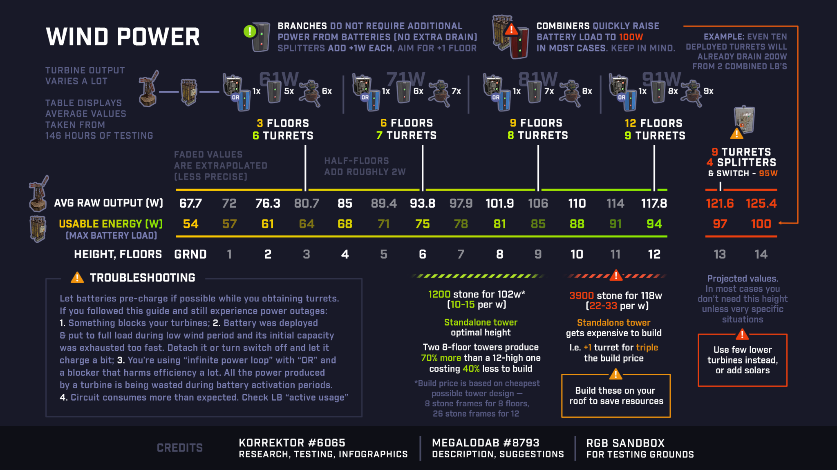

Need new image

If viewing the above image on the website, right click on them and open in a new tab. This will increase its size and make it easier to read.

# Solar Power

**On Console:**

Point the panels South.

**On PC:**

Depending on the time of year, the Sun will take a different path through the sky. Most Rust players live in the northern hemisphere. Places like Europe and North America. It is normal to have summers in June and winters in December. Rust island is located in the southern hemisphere, like Australia and South America. This means winters are in June and summers are in December.

* **The winter solstice is the shortest day of the year**. The Sun will travel its most Northern path. On this day, the sunrise is the latest and sunset is the earliest. During the winter months, solar panels capture less power.
* **The summer solstice is the longest day of the year.** The Sun will travel its most Southern path. On this day, the sunrise is the earliest and the sunset is the latest. During the summer months, solar panels capture more power.

In the picture below, it shows how the Sun will traverse the sky over 6 Rust months or 7ish real days. A day in the game is an hour of real time. This means it takes about 15ish days for a full Rust Year.

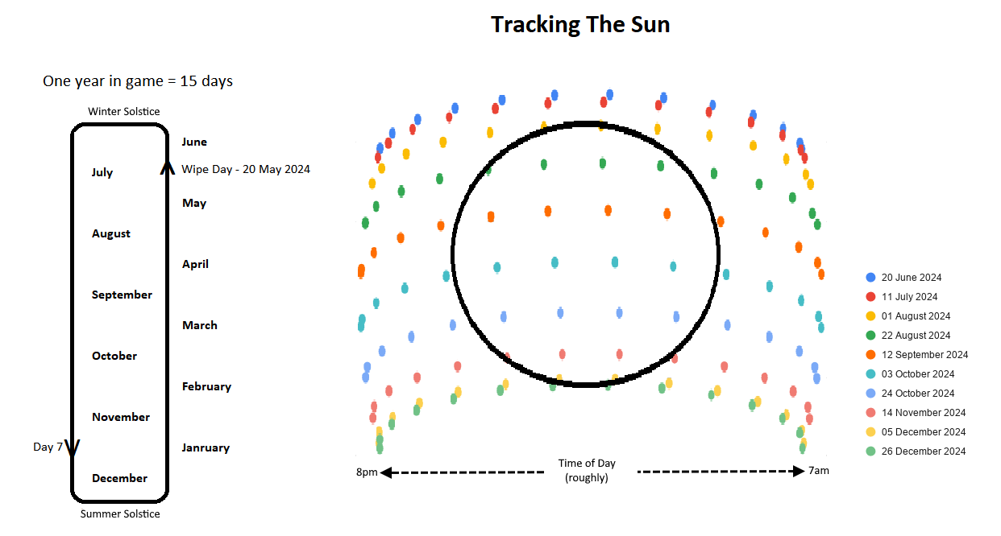

Wipe day is always May 20th 2024. Depending how long or short the wipe is, and where on the map a Solar Panel is located, might determine the direction the Solar Panel is placed. If the wipe is 5 days or less and the panel is located on the southern tip of the island, facing it North would be acceptable. However, if the wipe is any longer than that, the idea of having to pick up the panels to reangle them does not sound like fun. Placing a panel facing East and a panel facing West is the best way to set it and forget it.

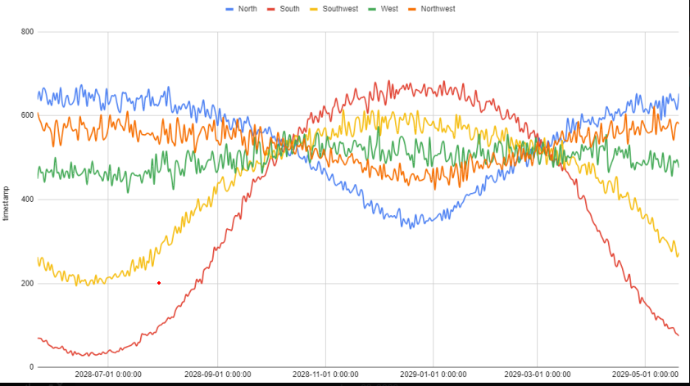

Solar Panels will produce power when the face of the panel can seD e the Sun. The Sun rises in the East and sets in the West. To take full advantage of a Solar Panel, try to capture the Sun in the morning the moment it rises above the horizon, and all the way to the moment the Sun drops below the horizon at night. In order to accomplish this, line of sight to each horizon is required.

Things like the ground, cliffs, trees and building blocks can all block the Sun. Avoid placing solar panels in their shadows. Solar Panels need an unobstructed view of the Sun as much as possible. Deployables do not appear to block the Sun.

The best chance of achieving line of sight to both horizons is by building on top of the highest mountain.

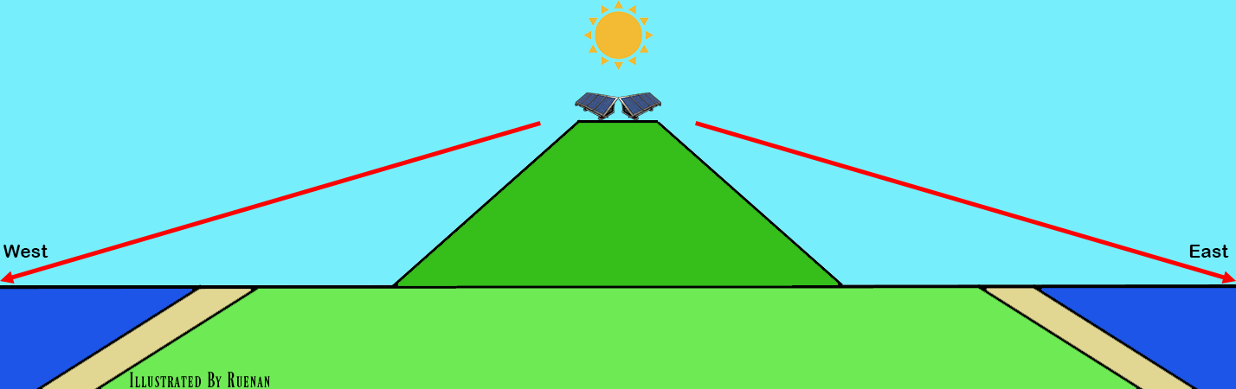

Otherwise, in the mornings, Eastward facing panels on the West side of the map will need to wait for the Sun to get high enough in the sky to clear the hills and mountains. The panels on the East side could catch the sun the moment it peaks above the horizon.

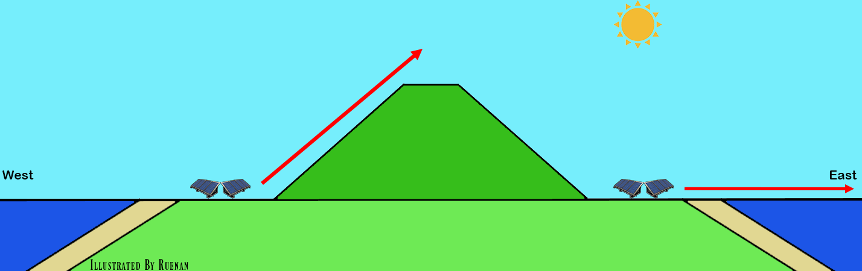

In the evenings, Westward facinging panels on the East side of the map will have the amount of time they could produce power cut short as the Sun moves behind the hills and mountains. The panels on the West side could catch the sun up to the moment it drops below the horizon.

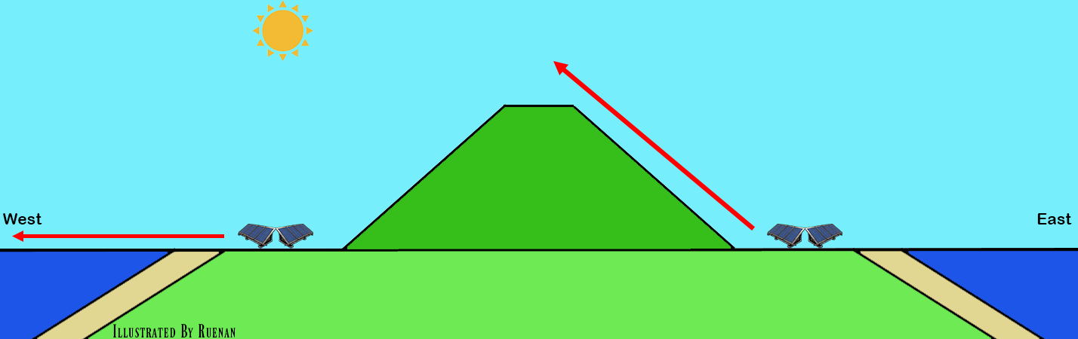

Only an admin can get the exact date and time. This is what players cannot see.

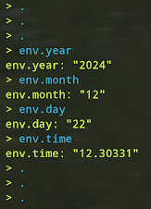

Watching where the Sun rises and sets on the horizon can give a player an idea of the time of year. Some modded servers will have a plugin that gives players a clock and might show the sun up and down times. Some might even show the date.

If a pair of panels are placed so each could see either the East or West horizons, the following could reasonably be expected, within a reasonable margin or error.

**The Winter Solstice (June 20 2024):**

* Solar Panels facing East can start to capture the Sun around 7:10 am. Power levels will slowly increase until around 9:05 am when they will be producing a full 20rW. This lasts until about 1:30 pm. Around this time, it will slowly start decreasing power production until around 3:45 pm when it stops.
* The panel facing West can start to capture the Sun around 11:40 am. A few minutes later at around 1:45 pm, it will start producing a full 20rW. Around 6:15 pm the panel will start decreasing the amount of power produced until about 8:15 pm when it stops.
* During the winter solstice, 2 combined panels, 1 facing East and 1 facing West, can collect around 940rWm of power.

**The Summer Solstice (December 21 2024):**

* Solar Panels facing East can start to capture the Sun around 6:30 am. Power levels will slowly increase until around 8:20 am when they will be producing a full 20rW. This lasts until about 2:30 pm. Around this time, it will slowly start decreasing power production until around 4:15 pm when it stops.
* The panel facing West can start to capture the Sun around 11 am. A few minutes later at around 1 pm, it will start producing a full 20rW. Around 7 pm the panel will start decreasing the amount of power produced until about 9 pm when it stops.
* During the summer solstice, 2 combined panels, 1 facing East and 1 facing West, can collect around 1075rWm of power.

When working with solar panels for a primary source of power, it is very helpful to know how to calculate how much capacity a circuit needs to last 1 in game day. Knowing the capacity will dictate how many panels are needed. Base the number of panels used on the lowest amount of power they will produce on the shortest day of the year.

**The Maths**

**rWm:** rust watt minutes (capacity)

**rW:** Rust Watt (aka power)

**S:** Seconds

**τ:** 60 (The number of minutes in an hour)

**M:** Minutes

**A:** The battery’s Active Usage

**H:** Hours

**To figure out how much capacity is needed to support a circuit of a specific load, use the following equation:**

A × τ = rWm

**To figure out how many pairs of panels are needed to support a specific amount to power, use the following equation:**

rWm ÷ 940rWm = Solar Panel pairs

Example: A circuit with an Active Usage of 64rW.

A × τ = rWm

64 × 60 = 3840rWm

Therefore a circuit needing a constant 64rW over the course of 1 hour will consume 3840rWm worth of power.

rWm ÷ 940rWm = Solar Panel pairs

3840rWm ÷ 940rWm = 4.08

Therefore 5 pairs of panels are needed to capture enough rWm to cover the power cost of a 64rW circuit. 2 solar panels make a pair, so 10 panels total.

**To figure out how much time a given capacity will run for, outputting a specific amount of power, we use the following equations:**

**Seconds:** (rWm ÷ A = M) × τ = S

**Minutes:** rWm ÷ A = M

**Hours:** (rWm ÷ A = M) ÷ τ = H

Power Storage

TL:DR

Batteries can accept incoming power at the same time they are sending power out.

Batteries are 80% efficient.

The charging and discharging rate is based on the 80% efficiency and something called Active Usage. Check out the section on Battery Active Usage Vs Actual Power Consumed for a better breakdown.

Example: 20rW from a Solar Panel × 0.8 = 16rW usable through a battery.

Example: If your Medium Battery is supplying 16rW to a circuit, 16 ÷ 0.8 = 20rW is the minimum you want to give the battery so it doesn’t lose any charge.

It is recommended to supply slightly more than you need if you want to charge the battery.

When you combine batteries with Root Combiners, they do not split the load as one would expect. They cannot see each other, so each battery tries to power the whole circuit.

For example, in a circuit with 2 root combined batteries supporting a load of 50, it would seem to make sense that 50 power divided by 2 batteries equals 25 per battery. Rustricity doesn't work like that and 50 power is taken from each battery and seen as Active Usage on both batteries. This means both batteries are draining at a rate of 50.

This means when we get to circuits that need more than 100 power, all the batteries combined will show a max Active Usage, which is used to calculate how fast a battery drains.

So if we are forcing batteries to max drain, then we might as well try to use as much of the power the combined batteries will provide.

When using a bypass battery backup like the Nih Core, Active Usage does not matter because the circuits are not getting power from the battery. from the main power source most of the time and not the battery.

Rustricity has its own version of battery configurations for wiring in series or parallel

1rW will charge a Large Battery in 34 IRL days.

When a battery is depleted because it is not receiving enough power, no power is output until it charges up for a couple seconds before outputting to the connected circuit. The battery still not receiving enough power will deplete in a second and the process repeats. If the circuit after a battery is turning on and off, you do not have enough power charging your batteries.

When they get picked up, they lose 25% HP but retain their current capacity. This means if a large battery has a full charge, when you pick it up and place it back down, it will still have a full charge.

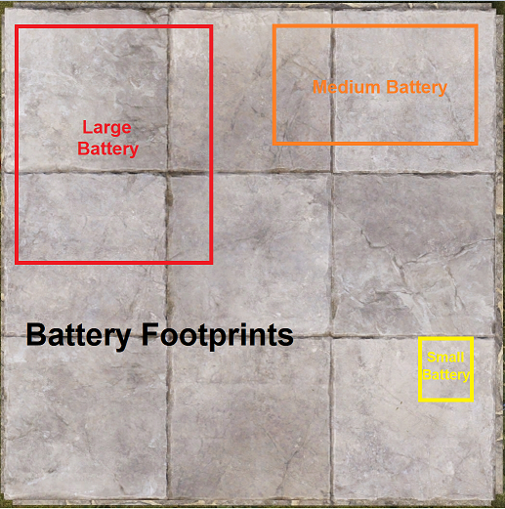+

# Battery Backups

A battery backup system in Rust is a circuit designed to automatically supply power when the primary power source fails. It ensures continuity for critical systems like turrets, traps, lights, or communication devices, especially during night cycles, storms, or fuel shortages. In real-world power infrastructure, similar systems are known as UPS (Uninterruptible Power Supplies) that keep essential devices operational during power outages. Rust may be a post-apocalyptic sandbox, but backup theory remains applicable.

# Real-Life Inspiration: Rust vs UPS Systems

**In real-world power infrastructure, there are two major types of UPS configurations:**

* **Bypass (Line-Interactive)** UPS: These remain idle during normal operation and only activate when power loss is detected.
* **Inline (Double Conversion)** UPS: These always supply power through the battery, ensuring seamless delivery and built-in filtering against power fluctuations.

**Rust mirrors these designs with its own terms:**

| **Real Life** | **Rust Equivalent** | **Description** |
| --- | --- | --- |
| Line-Interactive UPS | **Bypass Backup** | Main power flows directly to the circuit. The battery is *bypassed* unless needed. |
| Double Conversion UPS | **Inline Backup** | All power flows *through* the battery first. Battery is always active. |

Additionally, rustricians have introduced a third tier. Battery-Checked Backups which monitor the amount of power the battery bank can supply. If the batteries cannot provide the required amount of power, because some were destroyed or depleted, the circuit will begin feeding main power to the circuit, regardless of how much power is available. Some power is better than no power.

**↻ Types of Battery Backup Systems in Rust**

There are three main styles of backup circuits, each with their own advantages and disadvantages.

**1. Inline Backup**

* **Example**: The Inline circuit.
* The battery is always active. It's simple to build and easy to set up.
* Efficiency loss scales poorly when multiple inline batteries are used due to the 80% efficiency rule.
* Best suited for short-term or isolated systems where long-term efficiency loss due to 80% battery efficiency is not a concern.

**2. Bypass Backup**

* **Example**: The Nih Core circuit.
* Battery is inactive unless needed. It's only used if primary power fails to meet the required demand.
* Offers greater efficiency when scaling with multiple batteries. The 80% efficiency rule does not apply allowing for less power generation to remain stable as compared to an Inline backup.
* Best suited for large centralized systems supporting circuits in the multiple hundreds of power with a shared power infrastructure.

**3. Battery-Checked Backups**

* **Examples**: The Kore, BCN Core.
* These add logic to check if the battery is present and able to provide the required amount of power. If the battery cannot fulfil its obligations, the system will switch to providing whatever amount of power is available from the source.
* These offer a similar level of efficiency to their non battery checked counterparts but their complexity is slightly higher requiring a greater understanding of their core functions.
* Best suited as the modern replacement for a standard Inline or Bypass battery backup. Defenders of a raid often claim their batteries get destroyed before their power sources. Advanced players will understand this is actually a flaw in base design so having the additional, built in redundancy is now highly recommended.

# Power Waste and System Efficiency

All power systems in *Rust*, including backup and direct delivery designs, result in some level of wasted electricity. Waste occurs whenever more power is generated than is actively being consumed or stored. The important consideration is not whether waste happens — it is inevitable — but rather where it happens and how much waste a player is willing to accept.

* **Inline Backups** waste power when batteries are fully charged. Any additional power that continues to be supplied, beyond what is needed to maintain a positive charge, serves no purpose. Minimize waste by not over producing.
* **Bypass Backups** waste power when batteries are fully charged but also can cause waste by supplying power to circuits that are turned off. Minimizing power waste relies on efficient use of Root Power.
* **Battery-Checked Backups** minimize waste more effectively when batteries are destroyed, but still waste power charging batteries that are full and on the conditional logic of circuits that are receiving powering.
* **Direct Delivery** is a clear example of visible waste. If a power source produces more power than the circuit requires, the excess is immediately lost because there is no storage.

There is no perfect system that avoids waste entirely. Efficient circuit design involves making informed choices. Players should focus on managing waste and deciding how much is acceptable in exchange for faster charging, longer uptime, or greater redundancy. Efficiency is about balance — not total elimination of loss.

# Choosing the Right Backup

Selecting the appropriate backup style depends on the application, available resources, circuit design preferences and the player's level of knowledge. The following examples illustrate common use cases:

* **Low-demand and fast decentralized deployment**:  
  Inline backups are suitable for circuits with minimal power requirements or where setup speed and simplicity are prioritized over long-term efficiency. What makes them ideal is they use very few components, so their crafting cost is cheap, and the number of wires players will need to connect is minimal. The battery checked Inline, The Kore, is particularly effective as it allows fallback to the main power source if the battery is destroyed.
* **High power, centralized systems**:  
  Bypass Battery Backups are effective for managing circuits with large power requirements (300–1000rW+), especially when used with multiple batteries and power sources. The bypass design significantly reduces the amount of Root Power that needs to be generated to power both the circuits and charge the batteries. Requiring as little as 425rW to support 400rW of output using four large batteries, their efficiency grows the bigger they get as compared to Inline backups. While bypass backups such as the Nih Core can technically be used in decentralized designs, doing so is generally not practical or recommended. Both from an efficiency and design standpoint, their component complexity and setup requirements make them better suited for centralized systems where multiple circuits share power infrastructure
* **Power-critical systems**:  
  Battery-Checked Cores such as The Kore or the BCN Core, provide greater reliability by ensuring some level of power is present, assuming there is still a power source. The battery must be present and able to support the load. If it cannot, either before or after activation, the system will fall back to primary power, regardless of the amount being produced. These configurations are well-suited for defensive systems like traps, turrets, SAM Sites, communication systems, or other essential setups where complete power failure must be avoided.

Ultimately, the most effective battery backup system is one that performs reliably during a power failure. Regardless of size, complexity and cost, the defining qualities of a successful backup system are consistency and dependability. The one that works, when the player needs it to work, is the best backup.

# Choosing the Right Backup: Based on Power Type Composition

Understanding when to use a Bypass or Inline battery backup is one of the most important decisions a player can make when designing a power-efficient circuit. While both backup systems exist to provide battery-stored electricity, the types of power being used in a circuit, especially Active Usage, Consumed Power, and Control Power, will help determine which one is better suited for the task.

**⚙️ Inline Backups: Leverage Active Usage**

Inline Battery Backups use a battery as the circuit’s primary power source. Root Power is supplied to the battery, which then distributes power to the components. Inline backups only require enough power input to overcome the battery’s Active Usage (A). Thanks to Rust’s 80% battery efficiency, this can result in major Root Power savings:

**Power In = Active Usage ÷ 0.8** or  
 **Power In = Active Usage × 1.25**

**✅ When to Use Inline Backups:**

* Circuits with intermittent usage
* Circuits that contain many logic components
* Circuits where the majority of power does not create Active Usage
* Systems that can benefit from Control Power (logic run from a battery with no drain)
* Circuits that can recharge batteries during idle periods (e.g., furnace controllers)

**⚠️ Drawbacks:**

* Inline batteries must be charged
* If underpowered, they will drain and shut down the system
* Not ideal for circuits with constant, high Active Usage

**⚙️ Bypass Backups: Reserve for Consumption**

Bypass Battery Backups use the battery as an emergency source only. Root Power is sent directly to the circuit and only routes through the battery if Root Power fails. The battery is kept fully charged in the background but is not the main source of power.

**✅ When to Use Bypass Backups:**

* Circuits with high power consumption that are always on
* Defense systems (e.g., Auto Turrets, SAM Sites)
* Lighting systems where uptime is critical
* Any system where battery drain is unacceptable
* Where Root Power is readily available and consistent

**⚠️ Drawbacks:**

* Must reserve full power for all components at all times
* No benefit from battery Active Usage scaling
* Less efficient if the circuit doesn’t need to run continuously

**🎯 Key Questions to Decide**

1. **Does this circuit run 24/7, or only sometimes?**
   * 24/7 → Bypass
   * Partial uptime → Inline
2. **Does the circuit contain a lot of logic components?**
   * Yes → Inline (or Control-only)
   * No → Bypass
3. **Can the circuit be split into functional and logic parts?**
   * Yes → Use Hybrid or add Control Battery
4. **Is Root Power limited?**
   * Yes → Prioritize Inline/Control to reduce drain

**🔗 Summary**

* Inline = best when logic dominates or systems run intermittently
* Bypass = best when uptime matters or systems are always active
* Don’t combine batteries for Inline backups
* Separate functional power (Root/Consumed) from control logic (Control/Free)
* Use Stored Power strategically to time battery recharges

**📘 Recommended Reading**

**🔗 External References**

## Direct Delivery

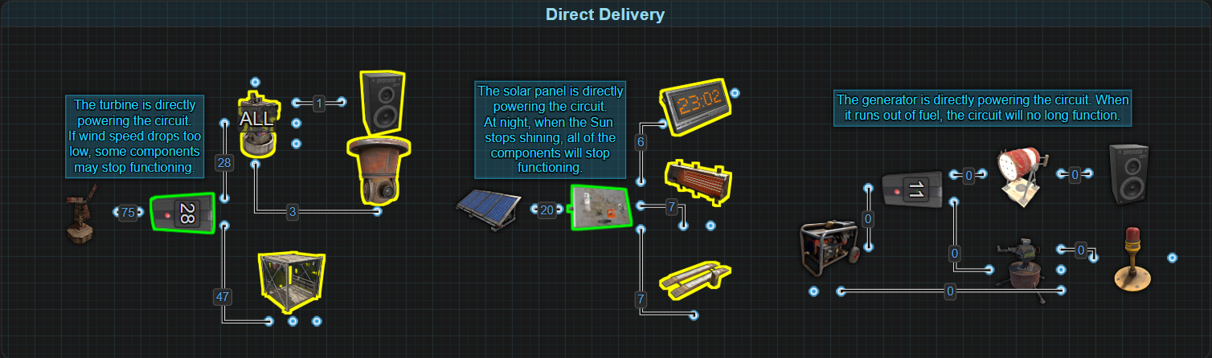

**Direct Delivery** refers to a circuit where the power source is connected directly to the components without the use of a battery. This approach provides power in real time and uses no backup system. If the power source is destroyed or stops producing electricity for any reason, the connected circuit will immediately go offline.

This method has been known to be used in the early stages of base development. It provides a quick and effective way to get essential systems online before players have a battery or additional components. Common examples include setting up auto turrets for defense or powering water pumps to start a berry farm.

While Direct Delivery provides a fast early-game advantage, it is not intended for long-term use. As a base grows and power demands increase, introducing batteries for storage and redundancy becomes critical for maintaining uptime, protecting vital systems and increasing efficiency.

Despite its simplicity, this method is rarely used in practice. Many players assume that a battery is required to complete a circuit and often overlook Direct Delivery as a viable option. Some players may attempt to brute force Direct Delivery by overproducing power with additional turbines to compensate for times of low power production, but this approach is highly inefficient and never recommended.

**🔍 Characteristics of Direct Delivery**

* Extremely easy to wire
* Uses minimal components
* Allows quick deployment of essential systems
* If the power source fails, the circuit will instantly shut off
* No redundancy or backup
* Not recommended for critical systems or long-term use
* Often misunderstood or overlooked as a valid early-game tactic

**📘 Additional Notes**

* This is not a battery backup system, but it is included here for comparison.
* For more resilient and scalable solutions, refer to the remaining sections in the Battery Backup chapter.

## Inline Backup

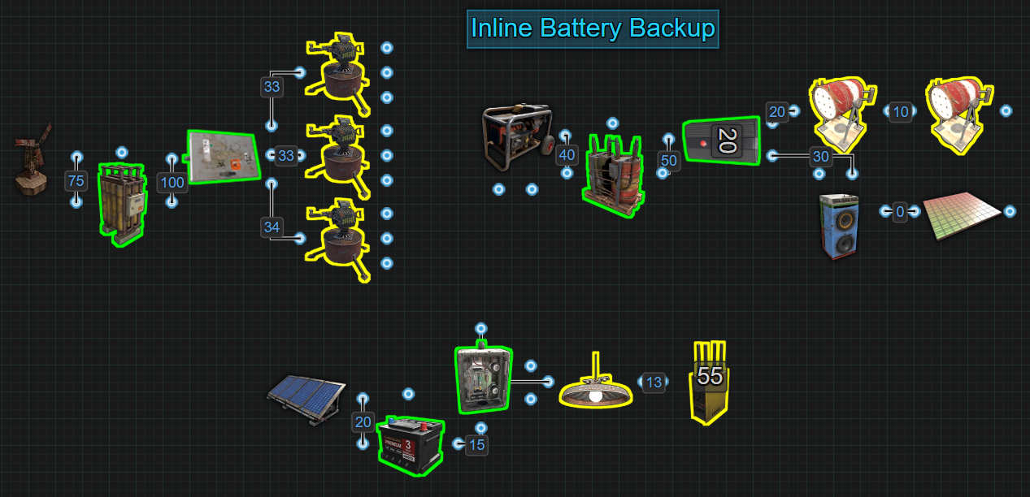

An **Inline Backup** is a power delivery method where electricity from a power source is routed through a battery before reaching any connected components. This is the most common and straightforward way to implement a battery backup in *Rust*. It offers simplicity, reliability, and fast setup, especially in early and mid-game environments.

Because power must pass through the battery at all times, this configuration is referred to as “inline.” Unlike bypass systems that activate only during failure, inline batteries are always providing continuous power availability.

Inline backups are most effective when fast deployment and minimal setup are prioritized. Their simplicity makes them ideal for quickly securing circuits with minimal components or wiring. However, due to battery efficiency loss, they become less power-efficient when scaled across multiple batteries or used in large, high-demand systems.

**✅ Benefits**

* Simple to wire and build with minimal components.
* Fast to deploy, especially during early game.
* Reliable for low-power circuits (<100rW) when managing their discharge.
* No power flicker due to the battery always being active.
* Ideal for easy decentralized circuit design when ignoring long term efficiency loss.

**❌ Limitations**

* Always subject to 80% efficiency loss when supplying power, even under normal operating conditions.
* IPower waste increases with each additional inline battery, making this method inefficient in large-scale systems unless properly managed and controlled.
* Requires understanding of Active Usage to prevent undercharging or overproducing power.
* Combining batteries in inline setups is inefficient unless used for high burst output, not constant load.
* Provides no built-in redundancy if the battery is destroyed, unless combined with additional logic (e.g., The Kore).

**⚙ How It Works**

**When a power source is directly connected to a battery:**

* 100% of the power is used to charge the battery.
* Batteries are 80% efficient, meaning more power must be supplied than is being consumed.
* Once a battery is fully charged, any input beyond the required maintenance level becomes unused power (waste).

**When the battery is connected to a circuit:**

* The battery makes power continuously available but only discharges when components draw power.
* If the power source stops producing electricity (due to wind speed, nightfall, or destruction), the battery continues powering the circuit until it is empty or destroyed.
* No switching logic is required, so there is no risk of power flicker, which refers to brief circuit shutdowns when power switches from one source to another.

**↺ Calculating Power Needs**

**To determine how much input power is required to sustain a battery without draining:**

Input Power = Active Usage ÷ 0.8

**For example, if a Large Battery shows 100 Active Usage, then:**

100 ÷ 0.8 = 125rW

125rW is the amount required to keep the battery in a neutral state where it neither drains nor charges. However, this is not sufficient to build usable capacity. If the battery has just been placed or is partially discharged, it will not fill unless it receives more than the neutral amount.

Providing only a small amount of excess power (e.g., 126rW) will result in extremely slow charging—too slow to be practical within a single wipe. Supplying more (e.g., 150rW) speeds up charging considerably, but also leads to more power being wasted once the battery is full unless the extra is redirected or removed.

* It is recommended to charge batteries to at least 3000rWm before connecting them to active circuits.
* Players using Wind Turbines or Solar Panels should expect downtime periods and ensure batteries are charged enough to survive through low production cycles and recharge after.

**This balance is essential:** Players must weigh charging speed against efficiency, especially in inline systems where the power demand is constant. Early overproduction is acceptable if it ensures batteries reach capacity quickly and can later be scaled back or redistributed.

**Fun Fact:** Providing only 1rW to a Large Battery results in an estimated 34 IRL days to fully charge.

**🧮 Estimating Charge Time**

To estimate how long it will take to fully charge an empty battery, use the following formula:

Charge Time (minutes) = Power Capacity ÷ (Input Power × 0.8)

* **Power Capacity:**
  + Small Battery: 400rWm
  + Medium Battery: 9,000rWm
  + Large Battery: 24,000rWm
* **Input Power:** The amount of power being supplied to the battery (in rW)
* **0.8:** The battery's efficiency (80%)

🧪 **Example:** Small Battery (Idle)

* **Input Power:** 25rW
* **Power Capacity:** 400rWm

Charge Time = Power Capacity ÷ (Input Power × 0.8)

= 400rWm ÷ (25rW × 0.8)

= 400rWm ÷ (20rWm)

Charge Time = 20 minutes

The Small Battery will fully charge in 20 minutes if it receives 25rW continuously and has no output load.

**🔄 Charging While In Use**

If the battery is powering a circuit while charging, subtract the power required to support the current load (Active Usage ÷ 0.8) from the input power. The remainder is the surplus, which determines how fast the battery will charge.

Surplus Power = Input Power - (Active Usage ÷ 0.8)  
Charge Time = Capacity ÷ (Surplus Power × 0.8)

* **Capacity:** Power Capacity - Current Capacity
* **Current Capacity:** The rWm value shown in a batteries UI
* **Power Capacity:**
  + Small Battery: 400rWm
  + Medium Battery: 9,000rWm
  + Large Battery: 24,000rWm
* **Input Power:** The amount of power being supplied to the battery (in rW)
* **0.8:** The battery's efficiency (80%)

🧪 **Example:** Large Battery (Active Load)

* **Input Power:** 130rW
* **Active Usage:** 100
* **Current Capacity:** 3200rWm

**Step 1:** Calculate how much power is available for charging.

Surplus Power = Input Power - (Active Usage ÷ 0.8)

= 130rW - (100 ÷ 0.8)

= 130rW - 125rW

Surplus Power = 5rW of power available for charging.

**Step 2:** Calculate the remaining charge time until full.

Charge Time = Capacity ÷ (Surplus Power × 0.8)

= (Power Capacity - Current Capacity) ÷ (Surplus Power × 0.8)

= (24000rWm - 3200rWm) ÷ (5rW × 0.8)

= (20,800rWm) ÷ (4rW)

Charge Time = 5200 minutes

= 5200 minutes ÷ 60 minutes

Charge Time = 86.6 hours

With only 5rW of surplus power, it would take 3 days, 14 hours and 40 minutes of real-time to fully charge the Large Battery with a current capacity of 3200rWm.

**📘 Recommended Reading**

* This area will be filled in once the recommended reading material has been updated to help prevent confusion.

**🔗 External References**

* Needs to be reviewed.

## The Kore

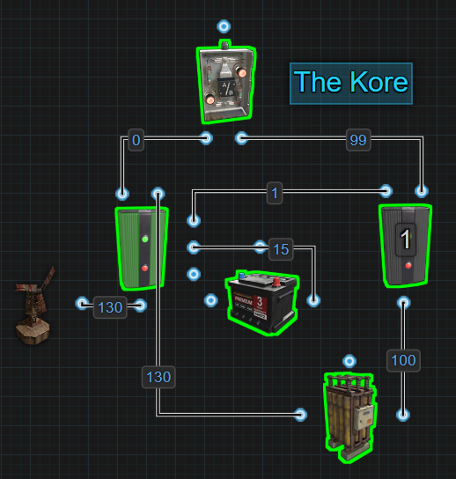

**About the Name**

The Kore is named after its creator, Korrektor, a highly respected member of the Rust community for his contributions to advanced circuit design. The name is a play on the word "core," reflecting its importance as a foundational upgrade to traditional inline backup systems. (I'd personally like to rename it to the KorrektCore so it can still be a play on his name, but also the words correct and core, so it would be pronounced as the correct core)

**The Kore** is an upgraded Inline Backup system that introduces battery health awareness. It retains all the speed and simplicity of a traditional inline design, while adding a crucial failover feature. If the battery is destroyed, the system automatically switches to the main power source, ensuring that the circuit remains powered.

Precisely because of its simplicity, players should upgrade their important or critical Inline Backups to a Kore as soon as they are able. Their setup is easy, components are minimal, and it significantly improves resilience.

**✅ Benefits**

* Simple to build with minimal components
* Fast and reliable for decentralized circuit setups
* No flicker during normal operation — only switches if the battery is destroyed
* Maintains circuit uptime even if the battery is removed
* More resilient than a standard Inline backup

**❌ Limitations**

* Still subject to 80% battery efficiency loss when active
* Power waste increases with each additional Kore unit used
* Requires understanding of Active Usage for proper power budgeting
* Combining batteries in inline setups is inefficient unless used for high burst output, not constant load
* Only 99 of 100rW from a Large Battery is available to the circuit, due to 1rW being used to maintain SET on the Memory Cell

**⚙ How It Works**

**The Kore follows the core structure of a traditional Inline Backup:** the battery powers the circuit full-time, while the main power source charges the battery. The key upgrade is its ability to detect when the battery is destroyed and immediately switch over to the power source, without the need for manual interaction or external switching.

This is accomplished using a Memory Cell, a Small Battery, an Electrical Branch and an OR Switch, making it simple, efficient, and highly reliable. The Small Battery is used as a representation of Control Power, and is used to RESET the Memory Cell.

**🔁 Power Flow Logic**

1. **Power Source → Memory Cell**Power from the main source (e.g., Wind Turbine) enters the Memory Cell through its main input.
2. **Inverted Output → OR Switch → Circuit**The left output of the Memory Cell (Inverted Output) connects to an OR Switch that feeds into the circuit. This becomes the fallback power path if the battery is destroyed.
3. **Normal Output → Large Battery**The right output (Output) sends power directly into a Large Battery, keeping it charged.
4. **Battery Output → Electrical Branch → Memory Set + OR Switch**
   * Power from the battery is sent into an Electrical Branch.
   * 1rW is branched off to the SET input of the Memory Cell.
   * The rest of the power is sent to the OR Switch, powering the circuit.
   * This means only 99 of the 100rW from a Large Battery is available for use.
5. **Small Battery → RESET**
   * A Small Battery is connected to the RESET input of the Memory Cell.
   * Side ports do not contribute to Active Usage, so this battery never drains, and does not need to be recharged.

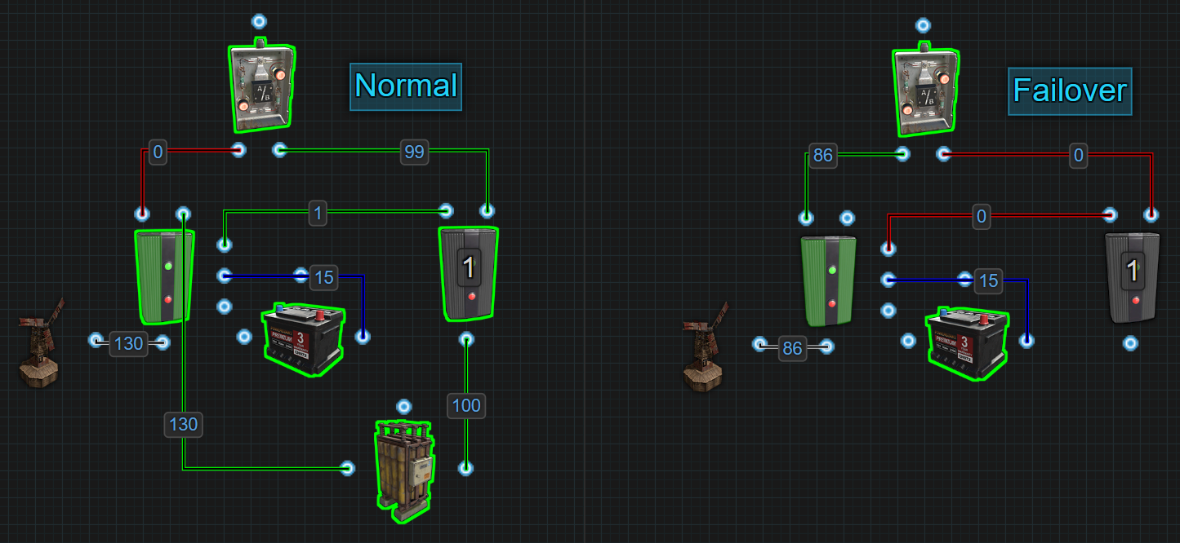

As long as the battery is functioning, SET receives power, and the Memory Cell continues to route power through its normal output. If the battery is destroyed, SET loses power while RESET continues to receive it. This causes the Memory Cell to flip, sending power through the Inverted Output and allowing the main power source to directly power the circuit.

This fallback ensures that some power — however limited — reaches the circuit instead of a complete loss.

**To determine how much input power is required to sustain a battery without draining:**

Input Power = Active Usage ÷ 0.8

**For example, if a Large Battery shows 99 Active Usage, then:**

99 ÷ 0.8 = 124rW

124rW is the amount required to keep the battery in a neutral state where it neither drains nor charges. However, this is not sufficient to build usable capacity. If the battery has just been placed or is partially discharged, it will not fill unless it receives more than the neutral amount.

Providing only a small amount of excess power (e.g., 125rW) will result in extremely slow charging—too slow to be practical within a single wipe. Supplying more (e.g., 150rW) speeds up charging considerably, but also leads to more power being wasted once the battery is full unless the extra is redirected or removed.

* It is recommended to charge batteries to at least 3000rWm before connecting them to active circuits.
* Players using Wind Turbines or Solar Panels should expect downtime periods and ensure batteries are charged enough to survive these low production cycles and recharge after.

**This balance is essential:** Players must weigh charging speed against efficiency, especially in inline systems where the power demand is constant. Early overproduction is acceptable if it ensures batteries reach capacity quickly and can later be scaled back or redistributed.

**Fun Fact:** Providing only 1rW to a Large Battery results in an estimated 34 IRL days to fully charge.

**🧮 Estimating Charge Time**

To estimate how long it will take to fully charge an empty battery, use the following formula:

Charge Time (minutes) = Power Capacity ÷ (Input Power × 0.8)

* **Power Capacity:**
  + Small Battery: 400rWm
  + Medium Battery: 9,000rWm
  + Large Battery: 24,000rWm
* **Input Power:** The amount of power being supplied to the battery (in rW)
* **0.8:** The battery's efficiency (80%)

**🔋 Example:** Medium Battery (Idle)

* **Input Power:** 80rW
* **Power Capacity:** 9000rWm

Charge Time = Power Capacity ÷ (Input Power × 0.8)

= 9000rWm ÷ (80rW × 0.8)

= 9000rWm ÷ (64rWm)

Charge Time = 141 minutes, or 2 hours and 21 minutes.

The Medium Battery will fully charge in 2 hours and 21 minutes if it receives 80rW continuously and has no output load.

**🔄 Charging While In Use**

If the battery is powering a circuit while charging, subtract the power required to support the current load (Active Usage ÷ 0.8) from the input power. The remainder is the surplus, which determines how fast the battery will charge.

Surplus Power = Input Power - (Active Usage ÷ 0.8)  
Charge Time = Capacity ÷ (Surplus Power × 0.8)

* **Capacity:** Power Capacity - Current Capacity
* **Current Capacity:** The rWm value shown in a batteries UI
* **Power Capacity:**
  + Small Battery: 400rWm
  + Medium Battery: 9,000rWm
  + Large Battery: 24,000rWm
* **Input Power:** The amount of power being supplied to the battery (in rW)
* **0.8:** The battery's efficiency (80%)

🧪 **Example:** Large Battery (Active Load)

* **Input Power:** 130rW
* **Active Usage:** 99
* **Current Capacity:** 500rWm

**Step 1:** Calculate how much power is available for charging.

Surplus Power = Input Power - (Active Usage ÷ 0.8)

= 130rW - (99 ÷ 0.8)

= 130rW - 124rW

Surplus Power = 6rW of power available for charging.

**Step 2:** Calculate the remaining charge time until full.

Charge Time = Capacity ÷ (Surplus Power × 0.8)

= (Power Capacity - Current Capacity) ÷ (Surplus Power × 0.8)

= (24000rWm - 500rWm) ÷ (6rW × 0.8)

= (23,500rWm) ÷ (5rW)

Charge Time = 4700 minutes

= 4700 minutes ÷ 60 minutes

Charge Time = 78.3 hours

With only 6rW of surplus power, it would take 3 days, 6 hours, 20 minutes of real-time to fully charge the Large Battery with an Active Usage of 99 and a current capacity of 500rWm.

**📘 Recommended Reading**

**🔗 External References**

## OR/Blocker

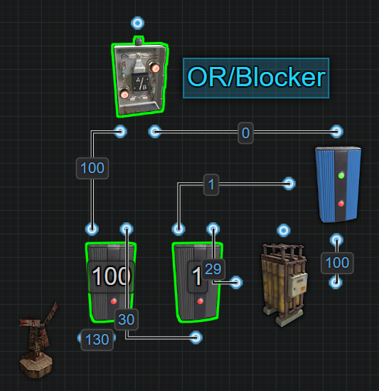

The **OR/Blocker** Battery Backup is one of the earliest and most well-known battery backups in Rust. Often mistakenly called "Infinite Power Loop," this circuit dates back to Rust’s 2019 electrical system, where batteries could either charge or discharge, but not both. In that era, batteries lacked Active Usage tracking and always pushed out maximum power. The so-called "Infinite Power Loop" was a real (and different) exploit, but this circuit simply offered the first bypass battery backup — not unlimited power.

Today, the OR/Blocker method may be obsolete, but it can still function as a basic bypass battery backup, where the main power source feeds the circuit, and excess power charges the battery. When the main power source fails or drops too low, the system automatically switches to battery power to keep everything running. While considered outdated due to newer mechanics, the OR/Blocker still has value. If modified, in specific situations where large-scale circuits need 2 or more layers of redundancy.

**✅ Benefits**

* Easy to build using minimal components
* Suitable for centralizing power and battery backup for larger circuits.
* Was designed to support circuits 200rW and above using root-combined batteries
* Automatic switching without any player interaction

**❌ Limitations**

* Outdated logic that ignores modern battery mechanics allowing for simultaneous charging and discharging and the OR Switches ability to block the inactive input.
* Without modernization, it causes power flicker when switching from main source to battery
* Wastes power during battery discharge because main power continues flowing through the first Branch Out, but is no longer used.
* Not optimized for circuits under 100rW. Those are better served by an Inline Backup or The Kore.

**⚙ How It Works**

The OR/Blocker Battery Backup is the traditional bypass design where the circuit is normally powered by the main power source. Excess power is used to charge a battery, which only activates when the main source drops below a usable threshold. A Blocker is used to prevent battery discharge during normal operation, while an OR Switch provides a seamless transition between main power and battery power during outages.

While this circuit will get the job done, its structure does not take advantage of Rust’s modern electrical mechanics. Things like batteries simultaneously charging and discharging results in significant power waste during periods of low production.

The detailed logic and wiring order for this setup are outlined below.

**🔁 Power Flow Logic**

1. **Main Power Source → Electrical Branch 1**Splits power into two directions:
   * Branch Out → OR Switch → Circuit
   * Remaining power → Electrical Branch 2
2. **Electrical Branch 2**
   * Branch Out: Sends 1rW to the Blocker to keep the battery output blocked
   * Remaining Power: Sent to the battery to charge it
3. **Battery → Blocker → OR Switch**
   * Battery is prevented from discharging while the Blocker is powered
   * When Blocker loses power, battery output flows to the OR Switch and powers the circuit

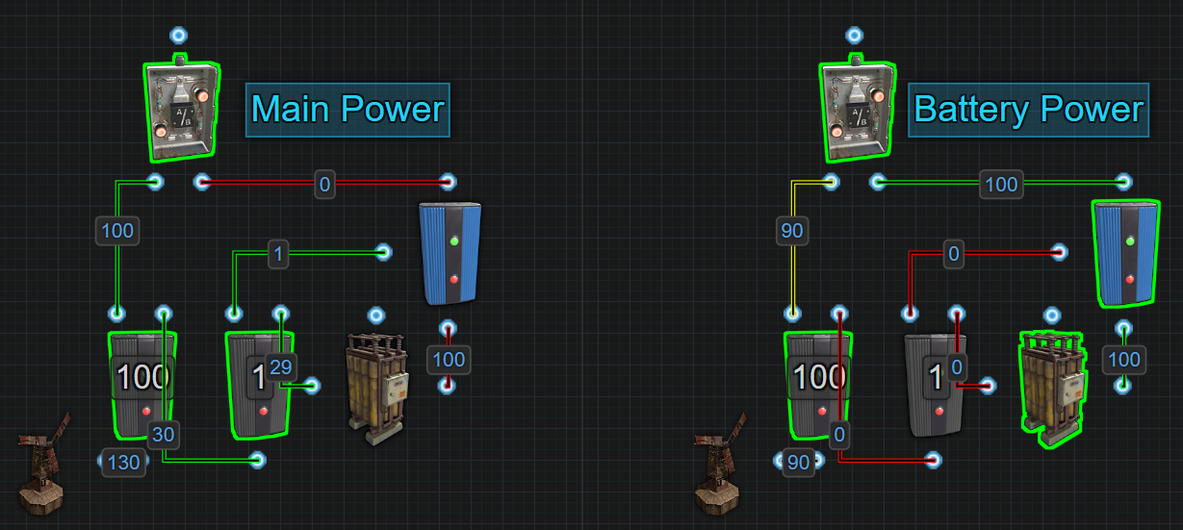

The nature of this system reserves power for the main circuit with the first Electrical Branch. That power during low production periods of time is just sitting there getting wasted. The flicker can be mitigated by modifying the system but at best, that will make this setup better suited as a secondary battery backup, which is covered in its own section.

**🔧 Design Considerations**

* **Designed for high-demand circuits**, typically 200rW+, in base-wide power configurations.
* Works best when paired with multiple root-combined Large Batteries, allowing for 200rW or more to be delivered.
* The Splitter is the best way to get as close to even charging across all batteries.

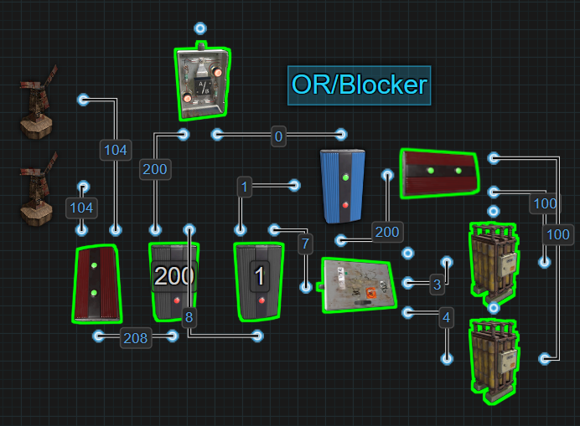

* **Active Usage is not relevant** in this setup because the batteries need to sustain a load greater than 100rW and they do not supply power until the main source fails. When they activate, they will run at maximum output (100rW per battery), meaning drain is predictable and straightforward.
* **It is not recommended for circuits under 100rW.** There are simpler and more efficient options like the Inline or Kore which are preferred.
* **This circuit only serves as a stepping stone** toward more advanced bypass backups like the Nih Core, which are capable of recovering the wasted power and preventing flicker while offering sustained, dynamic backup behavior.

**📘 Recommended Reading**

**🔗 External References**

## 

## Nih Core

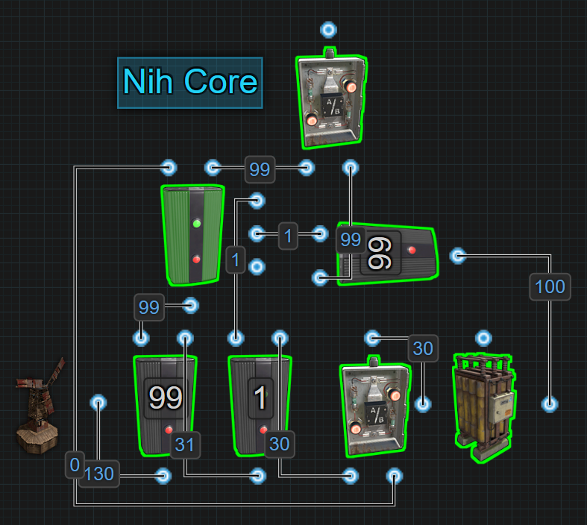

**About the Name**The Nih Core was named by the Rust community in honor of its creator, Nih. Although Nih himself did not choose the name, it has been widely adopted as a sign of respect for his contributions to advanced Rust electricity design.

The Nih Core is the modern version of, and replacement for, the OR/Blocker. It allows circuits to be powered directly with Root Power from the main power source while using the excess to charge the backup battery. When the main power source enters periods of low production or is destroyed, the battery automatically takes over. Once the main power returns to sufficient output, the system switches back.

What makes the Nih Core superior to older methods is its ability to take full advantage of a battery’s simultaneous charge and discharge capabilities. When the battery is powering the circuit, any insufficient power from the main source is redirected to the battery. This reduces battery drain and extends the runtime of backup power.

**✅ Benefits**

* Efficient modern bypass system using current Rust electrical mechanics
* Significantly reduces wasted power during battery discharge
* Automatically switches between power sources with no flicker
* Excellent for central power systems supporting over 100rW
* Designed to be compatible with multiple batteries using Root Combiners
* Will not attempt to switch to batteries if they are unable to support the required load

**❌ Limitations**

* Requires multiple components and a solid understanding of Power Flow
* The added complexity can be difficult to troubleshoot without a solid understanding of the logic
* If the battery depletes or is destroyed while active, main power must return to a sufficient level before power will be restored
* Not always suitable for small circuits under 100rW (Inline or Kore can often be better)
* Max Depth must be managed carefully when scaling with many batteries or power sources

**⚙ How It Works**

The Nih Core is a modern bypass-style battery backup system designed to solve the inefficiencies of older designs like the OR/Blocker and mitigate the over production of power often experienced by Inline backup. Its defining feature is the ability to redirect the flow of power to take advantage of a battery's ability to charge and discharge at the same time, while still maintaining full control over when the battery is actually used.

The system powers a circuit using electricity from a main power source — typically a Wind Turbine or Solar Panel — and uses any excess power to charge one or more batteries. The battery is kept on standby, wired into an OR Switch, but does not supply power unless the main source fails or produces insufficient output. This setup allows the battery to remain fully charged and unused until needed.

Power flows through a series of Electrical Branches and into a Memory Cell, which decides which output — main or backup — should be used:

* Electrical Branch 1 is configured to match the circuit’s expected load (e.g., 99rW). If the main source can satisfy this Branch Out amount, the circuit is powered directly by the main source.
* If the main power source drops below the set value, power to the SET input on the Memory Cell is lost, causing it to flip outputs and activate battery backup through the OR Switch.

The battery itself is connected to its own Electrical Branch, which is also set to the same value as Electrical Branch 1 (e.g., 99rW). This is crucial:

* If the battery provided more than the expected load to the OR Switch, the OR Switch would prioritize the higher input (battery) even when main power is still producing enough, causing unnecessary battery drain.
* Matching the set values ensures the battery never overrides the main source unless it is truly needed.

During battery-powered operation, any partial power still coming in from the main source is automatically redirected to the battery for charging, helping slow down battery drain and extending backup time.

Because the battery is only activated during failover, and because the OR Switch prioritizes active inputs correctly, the system avoids unnecessary battery drain and completely eliminates the need for a Blocker like in the past. The entire transition is managed automatically and without flicker, as long as components are properly configured.

**🔁 Power Flow Logic**

Each Electrical Branch in this setup plays a critical role. The first branch is configured to match the expected circuit load (e.g., 99rW). When main power drops below this value, the system triggers the battery to take over. The Memory Cell's SET and RESET inputs are responsible for determining when this switch occurs, based on power availability.

1. **Main Power Source → Electrical Branch 1 (Set to 99)**
   * Branch Out → Memory Cell Input
   * Power Out → Electrical Branch 2
2. **Electrical Branch 2 (Set to 1)**
   * Branch Out → Memory Cell SET input (keeps main power prioritized during normal operation)
   * Power Out → OR Switch for charging the battery
3. **Memory Cell**
   * Output (Right) → OR Switch to power a circuit
   * Inverted Output (Left) → OR Switch to charge the Battery
4. **Battery → Electrical Branch 3 (Set to match circuit load, e.g., 99)**
   * Branch Out → OR Switch to Circuit
   * Power Out → Memory Cell RESET input (flips output when SET loses power)

Using the following picture, it is possible to see where power exists and where it doesn’t when the Nih Core is running off of Main Power vs Battery Power. The green wires show the path of the power that is being used and/or consumed. The red wires show where there is no power. Blue shows power that is present and standing by from the battery, but not generating any Active Usage.

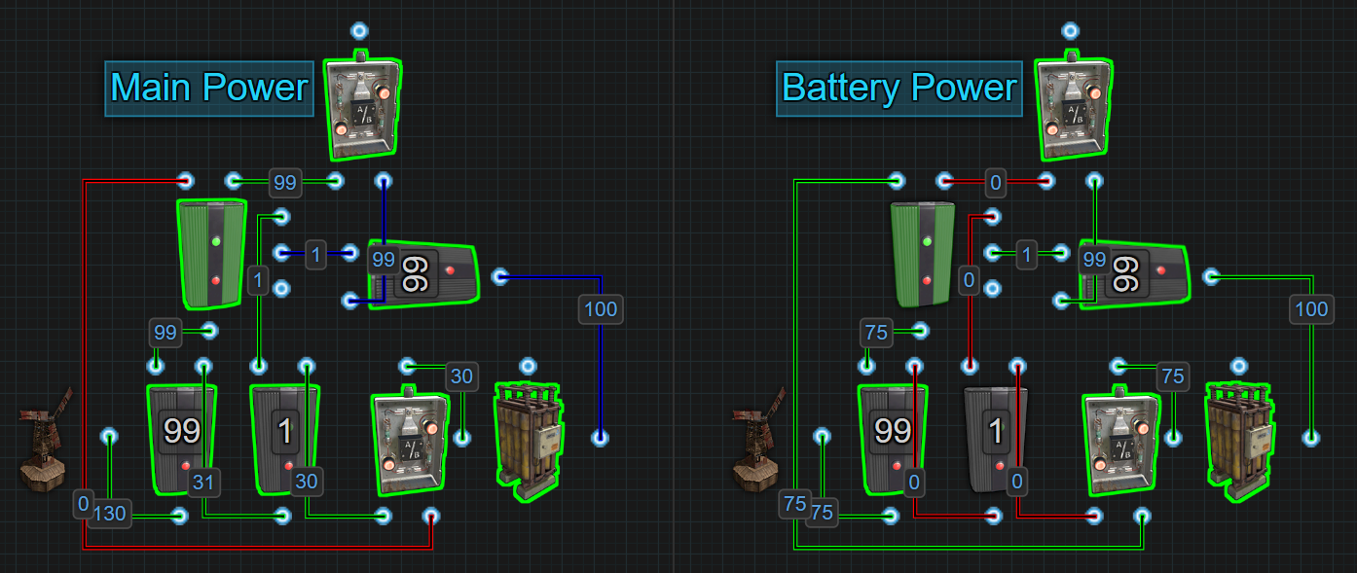

When power from the source is sufficient, the Memory Cell remains SET and uses the main power path to the circuit. The battery is charged passively in the background. When main power drops below the first Branch setting, SET loses power, and the Memory Cell flips — activating the battery via the OR Switch.

While the battery powers the circuit, any remaining power from the main source is redirected to charge the battery, helping reduce the battery’s drain rate.

It is important to note that If the battery is ever depleted or destroyed, the circuit will avoid trying to switch to the battery and remain on the main source, even if it doesn't have enough incoming power to meet the set demand.

**🔧 Design Considerations**

* **Power scaling favors the Nih Core**. In an Inline setup, each Large Battery requires 125rW to stay neutral when powering 100rW of Active Usage. Adding more batteries (for 200rW, 300rW, 400rW) massively increases the baseline power generation needed — 500rW for 400rW of load.
* **The Nih Core bypasses this scaling problem**. Circuits are powered directly by the main source most of the time, meaning batteries remain idle. Only a small amount of power is needed to charge the batteries during normal operation, rather than constantly feeding them.
* **Real-world example**:
  + A 400rW load using Inline backups would require over 500rW of power just to maintain battery charge.
  + The same 400rW load with a Nih Core can be sustained with as little as 421rW of production — 400rW for the circuit, 1rW for logic, and small surplus amounts (roughly 5rW per battery) for passive battery charging. At this rate, it will take a little more than 3 real life days to fully charge the batteries.

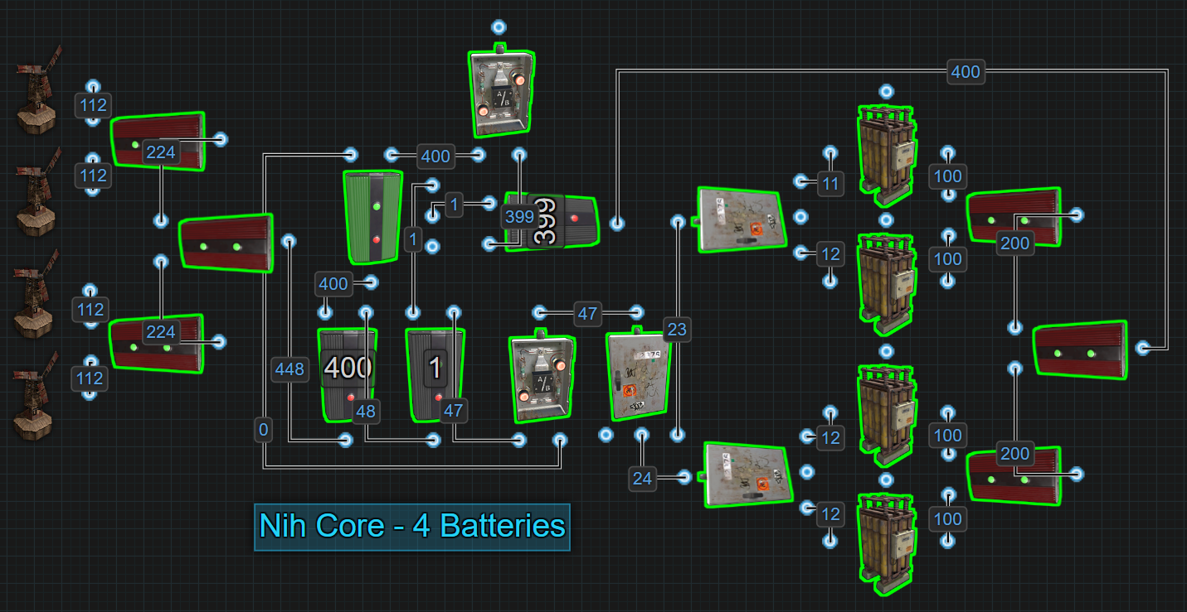

* **Efficiency increases the larger the circuit gets**, because batteries are not actively drained except during failover, and even then, any remaining power is redirected to slow the battery drain.
* **Flexibility during base growth**. Early on, players can temporarily lower Electrical Branch values (e.g., setting a 99rW Branch down to 50rW) to accelerate battery charging while the base's load is still small.
* **Battery sizes should be the same size** for consistent drain rates if using multiple batteries. If a player chooses to use different size batteries, they need to design their circuit by taking into account that when the smaller battery is empty, the circuit will have less power to function on. Using a Fixed Bus, ie Electrical Branches, to build in prioritization will be required to ensure the circuits with the highest priority get power first and the circuits with the lowest priority receive power last. When the smaller battery is depleted, only the circuits with the lowest priority will go offline.
* **Scaling requires attention to Max Depth**. Bases with many sources and batteries (e.g., 16 power sources and 16 batteries) can hit Rust’s Max Depth limitation — see **Short Circuit / Max Depth** for important planning details.

**⚡ Advanced Branch Configuration**

While setting Electrical Branch 1 and Electrical Branch 3 to matching values is standard, they do not have to be identical.

* The main power branch (Electrical Branch 1) can be set higher than the battery branch (Electrical Branch 3) to support additional non-critical circuits during normal operation. These extra circuits will automatically shut off during battery failover if the batteries cannot cover the full load.
* The battery branch (Electrical Branch 3) can be set lower if players want to conserve battery life and only power critical systems during failover.
* **Important**: The battery branch (Electrical Branch 3) must never be set higher than the main power branch (Electrical Branch 1), or the OR Switch will incorrectly prioritize the battery even when main power is available.

This flexibility allows players to prioritize what stays online based on available power without needing complex wiring changes.

**🔀Nih Core Variants**

Like most things with rustricity, there are always more than 1 way to accomplish anything. The Nih Core is no different. The version that has been discussed in detail above is the recommended version specifically because it has the built in safety of not swapping to the battery if it is depleted or destroyed. These next 2 versions are not uncommon to see players use and more accurately replicate the original Nih Core, including its flaw of swapping to the battery when it was depleted or destroyed. However, they do have the benefit of not costing 1rW from the battery.

**Variant 1 - The Classic Nih Core** updated for post 04/2024 rustricity mechanics.

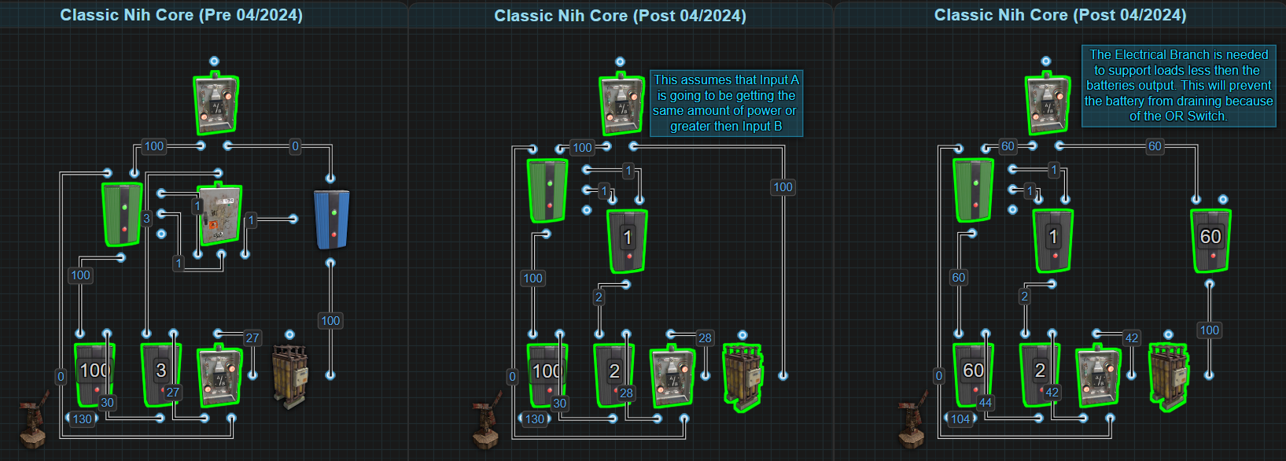

This variant of the Nih Core is the most similar to its original design that used a Splitter to control the logic, and a Blocker to stop the battery from draining. Today, the Splitter is replaced with an Electrical Branch to still control the logic, and either nothing replaces the Blocker or an Electrical Branch is used to limit power to the OR Switch if a player is working with power loads less than the batteries output. There is nothing wrong with using this version, as long as the player understands that when power production is running low, the core will flip to the battery, even if it is depleted or destroyed.

**Version 2 - The Modern Nih Core**, utilizing Control Power, a new mechanic post 04/2024.

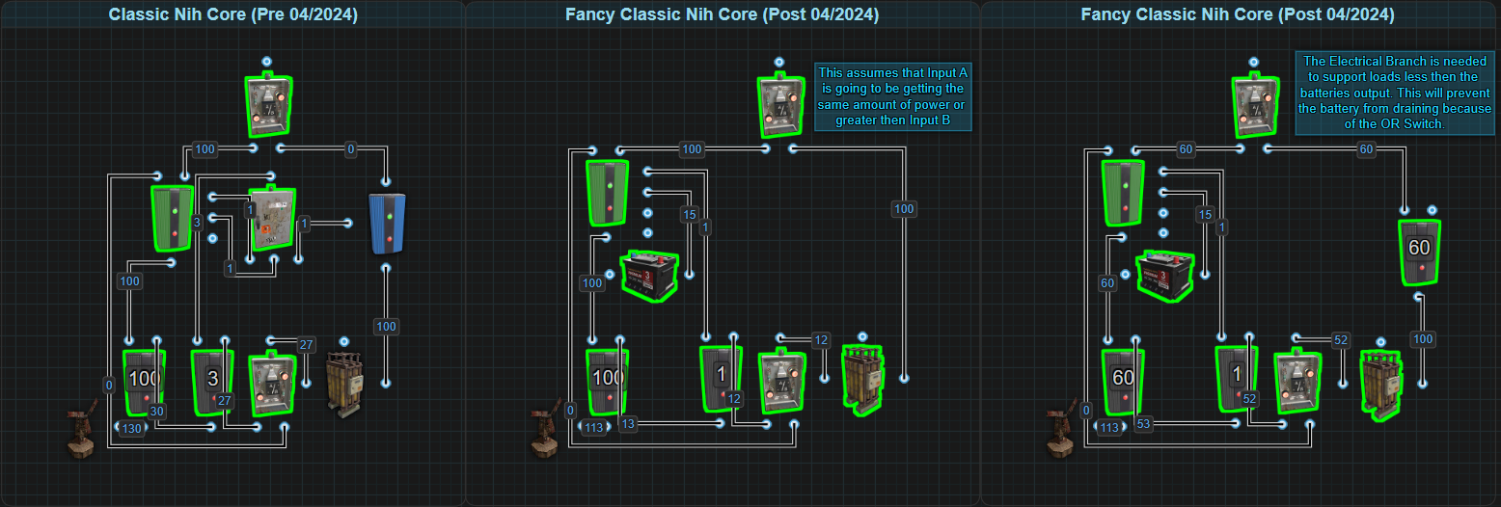

This variant acts just like the original design but now that AUX port, or side inputs, don't cause batteries any Active Usage, this in essence becomes Control Power that can be used to control the logic of systems. This allows more of the power produced to be used for the main backup battery and powering the attached circuits. The original design used a Splitter to control the logic, and a Blocker to stop the battery from draining. Today, the Splitter is replaced with a Small Battery and 1rW from an Electrical Branch to still control the logic, and either nothing replaces the Blocker or an Electrical Branch is used to limit power to the OR Switch if a player is working with power loads less than the batteries output. There is nothing wrong with using this version, as long as the player understands that when power production is running low, the core will flip to the battery, even if it is depleted or destroyed.

**📘 Recommended Reading**

**🔗 External References**

* [Nih Core Variants](https://www.rustrician.io/?circuit=0eb4ee6ed42bb240fd369006433e12c1)

## BCN Core

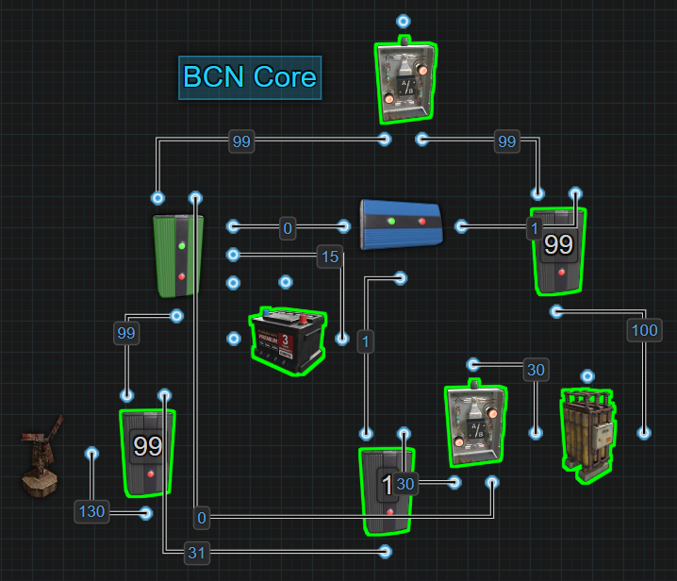

**About the Name**The BCN Core stands for Battery-Checked Nih Core. Created by SwiftCoyote, it enhances the original Nih Core by introducing battery health awareness just like The Kore.

The BCN Core is a direct upgrade to the Nih Core. It retains the same bypass and battery-charging mechanics, but introduces automatic fallback when backup batteries are destroyed or depleted while actively running on battery power.

In standard Nih Core designs, if batteries failed while active, the system would remain stuck waiting for main power to fully recover.

The BCN Core corrects this by forcing an immediate return to whatever main power is available, even if it is insufficient to meet the original demand.

This makes the BCN Core more resilient for bases relying on centralized battery backup systems that are likely to be raided.

**✅ Benefits**

* Efficient modern bypass system using current Rust electrical mechanics
* Significantly reduces wasted power during battery discharge
* Automatically switches between power sources with no flicker
* Excellent for central power systems supporting over 100rW
* Designed to be compatible with multiple batteries using Root Combiners
* Automatically recovers to main power if batteries are destroyed or drained
* Prevents systems from becoming stuck waiting for main power recovery
* No manual reset or intervention needed after battery failure

**❌ Limitations**

* Wiring is slightly more complex than a standard Nih Core, requiring additional components and precise setup
* Requires an understanding of Active Usage and Power Consumption to grasp the concept that allows the the Small Battery to be used without giving it a charge
* Players must understand Rust logic flow, including how Memory Cell priorities and OR Switch input behavior affect power routing
* Efficient scaling requires understanding Max Depth rules to avoid max depth errors when centralizing large numbers of power sources and root combined batteries

**⚙️ How It Works**

The BCN Core builds directly on the Nih Core's structure, maintaining the same bypass-first and passive battery-charging behavior during normal operation. Root Power supports the circuit directly most of the time, while excess or the remaining power charges the backup batteries.

If main power production falls below the reserved threshold, a blocker allows power from the battery to reach the Memory Cell SET input. This causes the Memory Cell to flip outputs, switching the circuit over to battery power through the OR Switch.

While running on battery power, any remaining main power — the amount that was insufficient to fully run the circuit — is automatically redirected to help charge the batteries. This extends backup runtime and improves overall system efficiency during low production periods.

If the batteries are later destroyed or fully depleted while active, the Memory Cell automatically flips back to using whatever main power is available. This fallback prevents circuits from remaining offline unnecessarily and ensures continuous operation whenever possible.

A Small Battery is used as a representation of Control Power, and is used to power the Memory Cell RESET input. The side inputs do not generate Active Usage, the Small Battery does not drain during any operation, making it ideal for this role without needing to receive power.

During normal conditions, the BCN Core retains all the efficiency advantages of the Nih Core:

* Main power supports the circuit directly most of the time.
* Batteries remain idle and charge passively.
* Battery drain only happens during actual failover.

**🔁 Power Flow Logic**

1. **Main Power Source → Electrical Branch 1 (Set to Circuit Load, e.g., 99)**
   * Branch Out → Memory Cell Input
   * Power Out → Electrical Branch 2
2. **Electrical Branch 2 (Set to 1)**
   * Branch Out → Block Passthrough on a Blocker
   * Power Out → OR Switch charging the battery
3. **Memory Cell**
   * Output (Right) → OR Switch to Battery
   * Inverted Output (Left) → OR Switch to power a Circuit
4. **Battery → Electrical Branch 3 (Set to match expected load, e.g., 99)**
   * Branch Out → OR Switch to Circuit
   * Power Out → Blocker Input
5. **Blocker Output**
   * Output → Memory Cell SET input
6. **Small Battery**
   * Connected → Memory Cell RESET input

Using the following picture, it is possible to see where power exists and where it doesn’t when the BCN Core is running off of Main Power vs Battery Power. The green wires show the path of the power that is being used and/or consumed. The red wires show where there is no power. Blue shows power that is present, being used and standing by from either battery, but not actually generating any Active Usage so batteries do not drain.

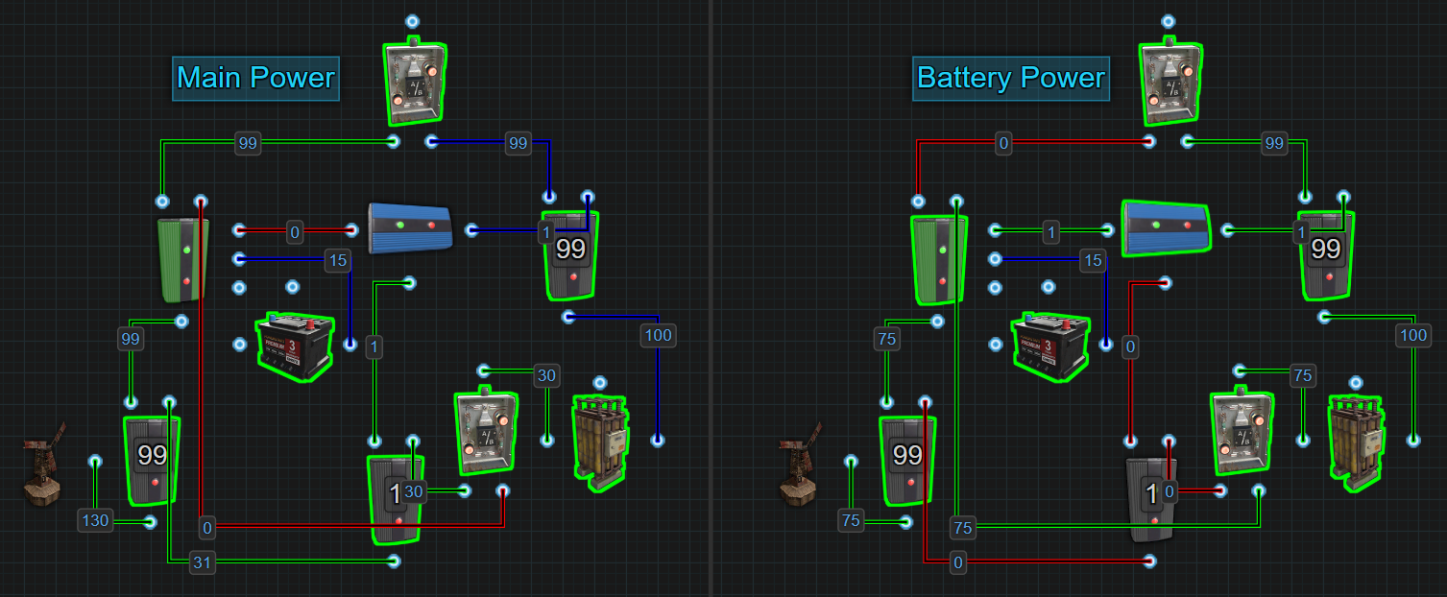

**When main power falls below the expected value:**

* SET gains power from the Large Battery.
* The Memory Cell flips, activating the battery through the OR Switch.

**If the battery later becomes empty or destroyed while active:**

* SET loses power.
* The Memory Cell automatically flips back to main power — even if main power is still below the original threshold — preventing complete circuit failure.

**🔧 Design Considerations**

* **Power scaling favors the BCN Core.** In an Inline setup, each Large Battery requires 125rW to stay neutral when powering 100rW of Active Usage. Adding more batteries (for 200rW, 300rW, 400rW) massively increases the baseline power generation needed — 500rW for 400rW of load.
* **The BCN Core bypasses this scaling problem.** Circuits are powered directly by root or main power most of the time, meaning batteries remain idle. Only a small amount of power is needed to charge the batteries during normal operation, rather than constantly feeding them.
* **Real-world example:**
  + A 400rW load using Inline backups would require over 500rW of power just to maintain battery charge.
  + The same 400rW load with a BCN Core can be sustained with as little as 421rW of production — 400rW for the circuit, 1rW for logic, and small surplus amounts (roughly 5rW per battery) for passive battery charging. At this rate, it will take a little more than 3 real life days to fully charge the batteries.

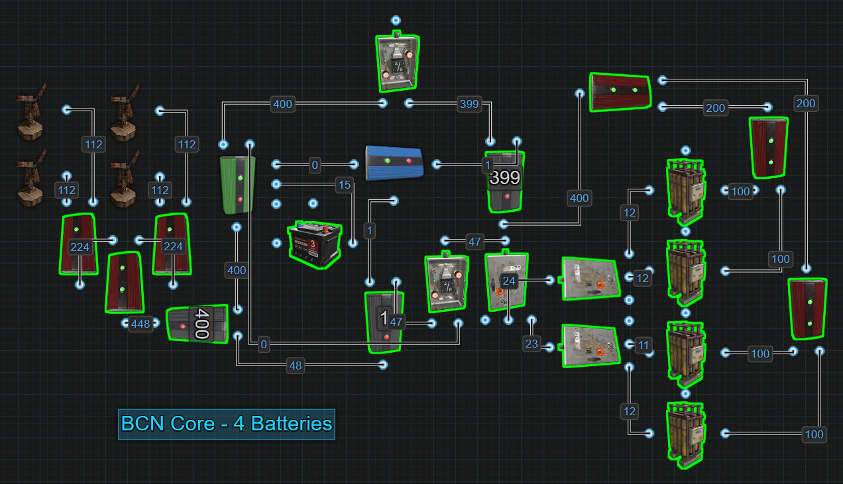

* **Efficiency increases the larger the circuit gets**, because batteries are not actively drained except during failover, and even then, any remaining power is redirected to slow the battery drain.
* **Flexibility during base growth.** Early on, players can temporarily lower Electrical Branch values (e.g., setting a 99rW Branch down to 50rW) to accelerate battery charging while the base's load is still small.
* **Battery sizes should be the same size** for consistent drain rates if using multiple batteries. If a player chooses to use different size batteries, they need to design their circuit by taking into account that when the smaller battery is empty, the circuit will have less power to function on. Using a Fixed Bus, ie Electrical Branches, to build in prioritization will be required to ensure the circuits with the highest priority get power first and the circuits with the lowest priority receive power last. When the smaller battery is depleted, only the circuits with the lowest priority will go offline.
* **Scaling requires attention to Max Depth.** Bases with many sources and batteries (e.g., 16 power sources and 16 batteries) can hit the Root Combiners Max Depth limitation — see Short Circuit / Max Depth for important planning details.

**⚡ Advanced Branch Configuration**

While setting Electrical Branch 1 and Electrical Branch 3 to matching values is standard, they do not have to be identical.

* The main power branch (Electrical Branch 1) can be set higher than the battery branch (Electrical Branch 3) to support additional non-critical circuits during normal operation. These extra circuits will automatically shut off during battery failover if the batteries cannot cover the full load.
* The battery branch (Electrical Branch 3) can be set lower if players want to conserve battery life and prioritize only critical systems during backup operation.
* **Important**: The battery branch (Electrical Branch 3) must never be set higher than the main power branch (Electrical Branch 1), or the OR Switch will incorrectly prioritize the battery even when main power is available.

This flexibility allows players to fine-tune which systems stay operational based on power availability without needing to rewire the core.

**📘 Recommended Reading**

**🔗 External References**

[BCN Core Variants](https://www.rustrician.io/?circuit=ae0cf0d33654af9a559464d6a4901658)

## Secondary Battery Backup

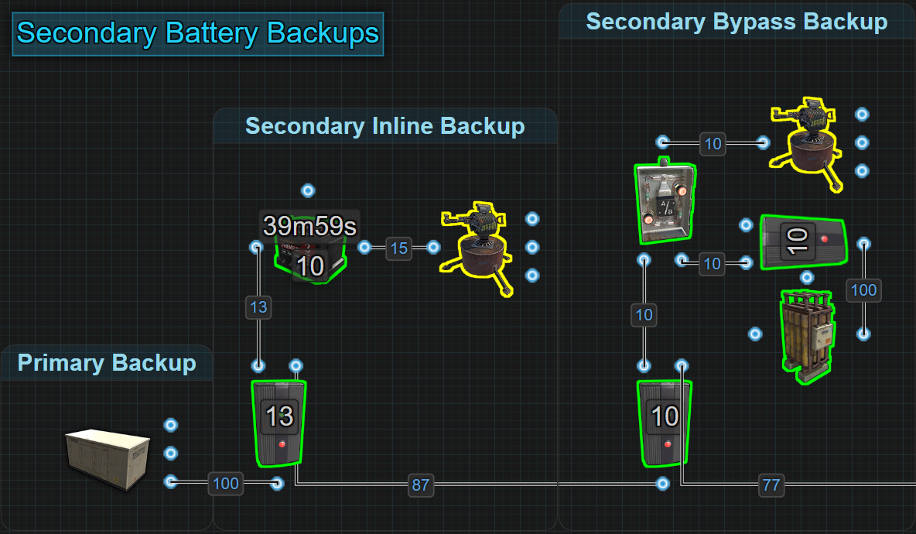

A Secondary Battery Backup provides an extra layer of protection for a base's most critical circuits after the primary backup system fails. It acts as a backup for the backup — rarely used, but essential when needed.

Although the chances of needing a Secondary Backup on a typical day are extremely low, the benefits can outweigh the costs. Installing them provides a way to use excess power after the primary batteries are full, while adding critical redundancy to base defenses.

There are two versions of Secondary Backups: Secondary Inline and Secondary Bypass. Both can be integrated into any part of a circuit, but they are ideally used to protect smaller, high-priority sections. The type of primary backup in use will influence which secondary method is best suited.

With an Inline Primary Backup, a Secondary Bypass is preferred. With a Bypass Primary Backup, either Secondary Inline or Secondary Bypass can be used, although Bypass remains the more efficient option.

**✅ Benefits**

* Simple to make with minimal components.
* Great for creating redundant backups while improving decentralization within a centralized circuit.
* Adds extra survivability to bases without major cost after setup.
* No flicker of power when switching onto the backup.
* Efficient use of otherwise wasted power after primary backups are charged.

**❌ Limitations**

* Secondary Inline systems introduce a 20% efficiency loss.
* Secondary batteries should be fully charged manually unless additional recharging systems are built.
* Adds more wiring complexity when integrating into existing circuits.
* Secondary Bypass backups require precise Electrical Branch configuration for proper failover.

**⚙️ How It Works**

A Secondary Battery Backup connects to critical circuits between the circuit itself and the main power supply, offering two different methods:

* **Secondary Inline Backup**

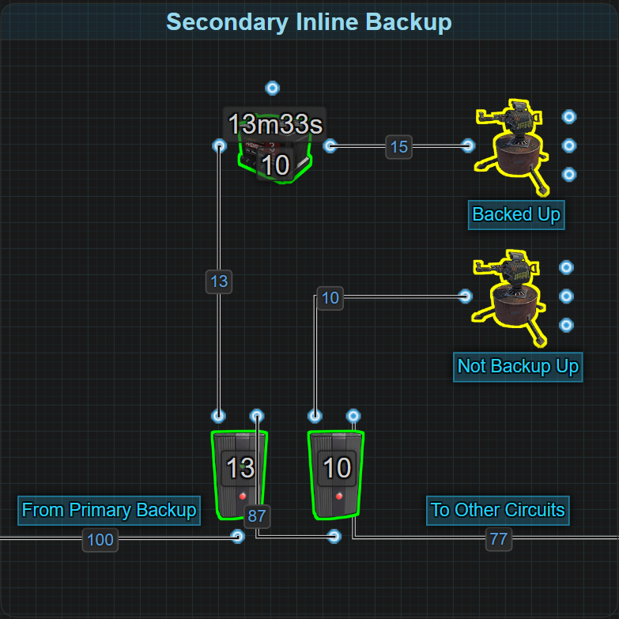

* + An inline battery is installed between the circuit's power source and the circuit itself (such as a group of Auto Turrets or Electrical Furnaces).
  + Power always routes through the battery, causing a 20% efficiency loss.
  + The Electrical Branch feeding the circuit must be set higher to compensate for the 20% power efficiency loss. (e.g., 13rW instead of 10rW for a single Auto Turret).
* **Secondary Bypass Backup**

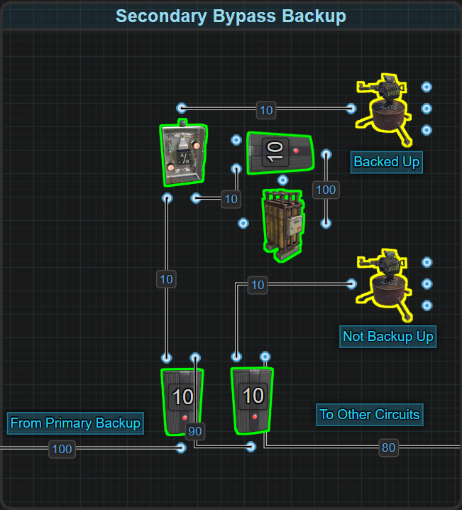

* + Power from the main backup flows into Input A on an OR Switch, then to the circuit.
  + A fully charged secondary battery is connected to Input B of the OR Switch, through its own Electrical Branch configured to equal the amount of power feeding Input A.
  + Power is prioritized from Input A (main backup) first. The battery sits idle and does not drain unless both the main backup and primary battery systems fail.
  + No ongoing power loss, no recharging system needed — the battery simply waits in reserve.

**Important Wiring Behavior:**

* For a Secondary Bypass Backup, set both Electrical Branches (Main and Battery) to provide the exact amount needed (e.g., both set to 10rW for an Auto Turret).
* Secondary batteries should be pre-charged before being installed to avoid extremely long charging times in case of emergency.

**🔌 Power Flow Logic**

* **Secondary Inline Backup:**
  + Power Source → Inline Secondary Battery → Circuit
  + Battery is always active. Primary power charges and routes through the battery.
* **Secondary Bypass Backup:**
  + Main Power Source → Electrical Branch → OR Switch Input A → Circuit
  + Secondary Battery → Electrical Branch → OR Switch Input B → Circuit
  + Main power takes priority. Battery remains idle unless main power and primary backup both fail.

**🔧 Design Considerations**

* **Choose the right type:**
  + Use Secondary Bypass Backup whenever possible to avoid continuous Root Power loss.
  + Avoid stacking Inline Primary + Inline Secondary backups due to excessive inefficiency.
  + Stacking Inline backups only compounds the 20% efficiency loss and if not properly regulated, it will place a heavy burden on the Primary Battery and risk fast depletion of the Primary Backup.
* **Pre-charge your batteries:**
  + Charging a Large Battery with 1rW takes over 800 hours (34 days).
  + Pre-charging with 400rW can fully charge a Large Battery in about 75 minutes.
* **Controlling Electrical Branch Values:**
  + For Secondary Bypass backups, match branch outputs carefully to avoid incorrect OR Switch prioritization.
  + Only set enough power to meet actual device needs — avoid unnecessary surplus.
* **Root Combining Secondary Batteries:**
  + When trying to combine multiple batteries, adding too many components between the Power Source and a Root Combiner can trigger the Max Depth wiring error. The depth at which a Secondary Backup will be used will exceed this limit. This should be avoided to prevent wiring failures.
* **Material Cost vs Survivability:**
  + While extra batteries and OR Switches increase material cost, they offer massive uptime gains after system-wide failures, especially when getting raided is almost certain.

**📘 Recommended Reading**

**🔗 External References**

# Batteries: Parallel vs Series

Understanding how batteries function in different configurations is critical for optimizing power systems. In real-life electrical systems, batteries can be wired in **series** or **parallel**, each offering different results in terms of power output and energy capacity. The same terminology can be applied to Rust, but with some differences due to the game’s simplified electrical mechanics.

## Real-World Analogy

In real-world electrical systems, batteries have two terminals:

* **Positive (+)**
* **Negative (-)**

These terminals are used to connect batteries in either **series** or **parallel**, depending on the desired outcome.

Battery performance is measured using:

* **V (Volts):** Indicates power output (pressure).
* **Ah (Amp hours):** Indicates energy capacity (storage).

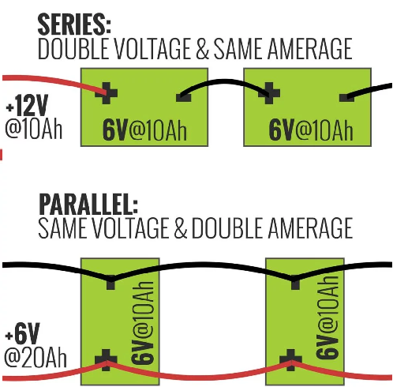

**🔗 Series Wiring (More Power, Same Runtime)**

* Batteries are connected by wiring the positive terminal (+) of one battery to the negative terminal (-) of the next.
* The remaining negative (-) and positive (+) terminals are used for the circuit’s input/output.
* This configuration adds voltage while keeping the capacity the same.
* **Example:** Two 6V 10Ah batteries in series = **12V, 10Ah**
* **Purpose:** Used when a system needs more power but does not require extended runtime.

**🔗 Parallel Wiring (Same Power, More Runtime)**

* Batteries are connected by joining all positive terminals together and all negative terminals together.
* This configuration keeps the voltage constant while adding capacity.
* **Example:** Two 6V 10Ah batteries in parallel = **6V, 20Ah**
* **Purpose:** Used to extend the runtime of a system without increasing power output.

## Translating to Rust

In Rust, battery behavior is streamlined compared to real-life electronics. There are no positive or negative terminals, and there’s no concept of voltage and polarity. However, the concepts of power and capacity still exist, just in different terms. Instead, everything revolves around two values:

* **Rust Watts (rW):** This represents the power output, similar to **voltage (V)** in real life. It’s the amount of energy delivered to components.
* **Rust Watt Minutes (rWm):** This represents energy storage capacity, similar to **Amp-hours (Ah)**. It shows the total energy a battery is holding.

Each battery in Rust has only two terminals:

* **Power In:** Used to charge the battery.
* **Power Out:** Used to supply power to a circuit.

There are no positive or negative terminals, and voltage does not exist, but the two core functions of batteries are still the same, powering circuits and storing energy. So while Rust doesn’t let you literally wire batteries in parallel or series, you can mimic those configurations in terms of outcome by connecting their outputs with 1 of 2 components:

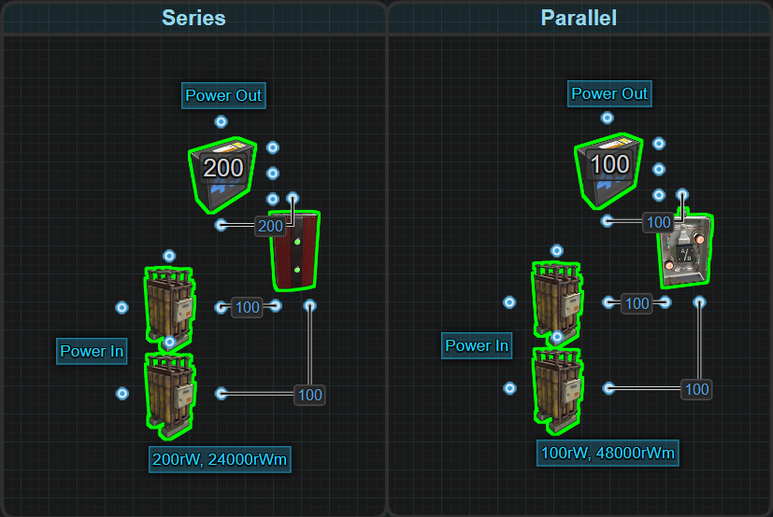

**🔗 Series Wiring in Rust (More Power, Same Capacity)**

* **Component Used:** Root Combiner
* **Effect:** Increases power output, maintains same capacity.
* **Example:** Two Large Batteries = **200rW output, 24000rWm capacity**

**🔗 Parallel Wiring in Rust (Same Power, More Capacity)**

* **Component Used:** OR Switch
* **Effect:** Keeps power output the same, doubles capacity.
* **Example:** Two Large Batteries = **100rW output, 48000rWm capacity**

**🔗 Hybrid (Series-Parallel) Wiring in Rust (More Power and More Capacity)**

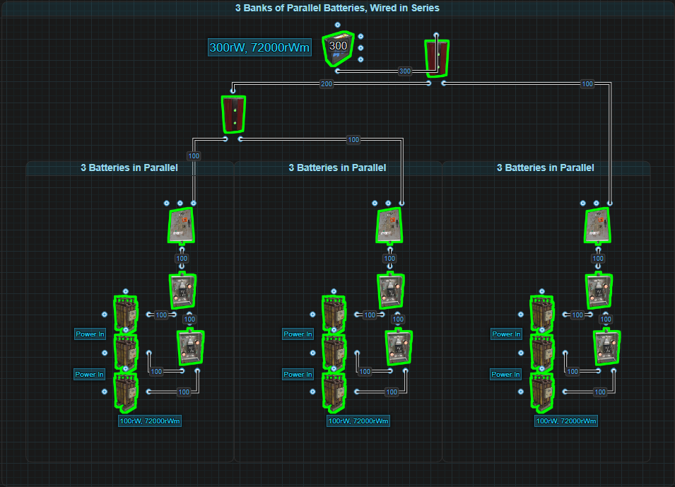

* **Component Used:** OR Switch to Root Combiner
* **Effect:** Keeps power output the same, doubles capacity.
* **Example:** 3 Battery Banks consisting of 3 Large Batteries wires in Parallel, wired together in Series
  + Three Large Batteries in Parallel = **Battery Bank 1 (100rW output, 72000rWm capacity)**
  + Three Large Batteries in Parallel = **Battery Bank 2 (100rW output, 72000rWm capacity)**
  + Three Large Batteries in Parallel = **Battery Bank 3 (100rW output, 72000rWm capacity)**
  + Battery Bank 1, Battery Bank 2 and Battery Bank 3 combined in Series = **300rW output, 72000rWm capacity**

So while you can’t physically “wire” batteries in series or parallel, the game still gives you the flexibility to design around the same trade-offs. Want more power all at once? Go series with a Root Combiner. Want to stretch your batteries to last longer? Design in parallel with the OR Switch.

Whether players have wired the batteries outputs into serial or parallel, they are joined in a way that leaves only a single output connection, just like any battery. The same must be achieved with the batteries inputs and to do that, you'll need a charging solution.

## Applying Series in Rust

To wire two Large Batteries in series in Rust, connect the outputs of both batteries to a Root Combiner. This will merge their outputs into a single line capable of providing 200rW, double the output of one battery, while maintaining the same 24000rWm capacity.

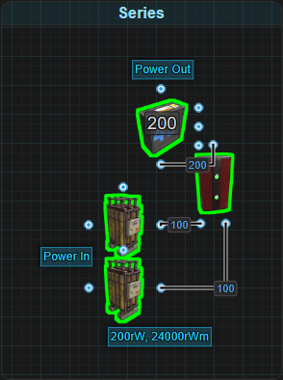

Need more than 200rW? Keep adding:

* More **Batteries**
* More **Root Combiners**

**Charging & Performance Considerations**

All batteries wired in series should be of the same size. This ensures that the batteries will supply the full amount of power, the entire time they are draining. That said, intentionally using mismatched sizes can be done, as long as players are aware that the smaller batteries will drain first.

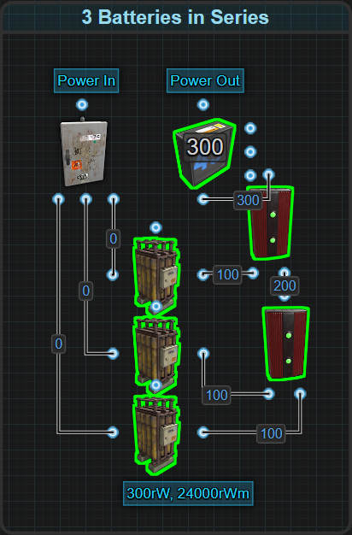

All batteries wired in series should be charged at the same rate to prevent imbalance. The Splitter will help keep power levels equal across all batteries. If one battery drains completely before the others, a portion of the circuit will lose power. For example, if there are 3 batteries in series and 1 of them empties, 33% of the circuit will go offline because one third of the power is gone.

If only 200rW is needed but there are 300rW worth of batteries, 1 of the batteries is redundant, meaning 1 battery can be destroyed and the main circuit will continue to function. This is a way to create redundancy but it's expensive and there are better and more efficient ways, such as Secondary Batteries.

**Series Wiring in Inline vs Bypass**

Batteries wired in series can be installed into both Inline and Bypass battery backups, but their performance differs significantly:

* **Inline Backups**:

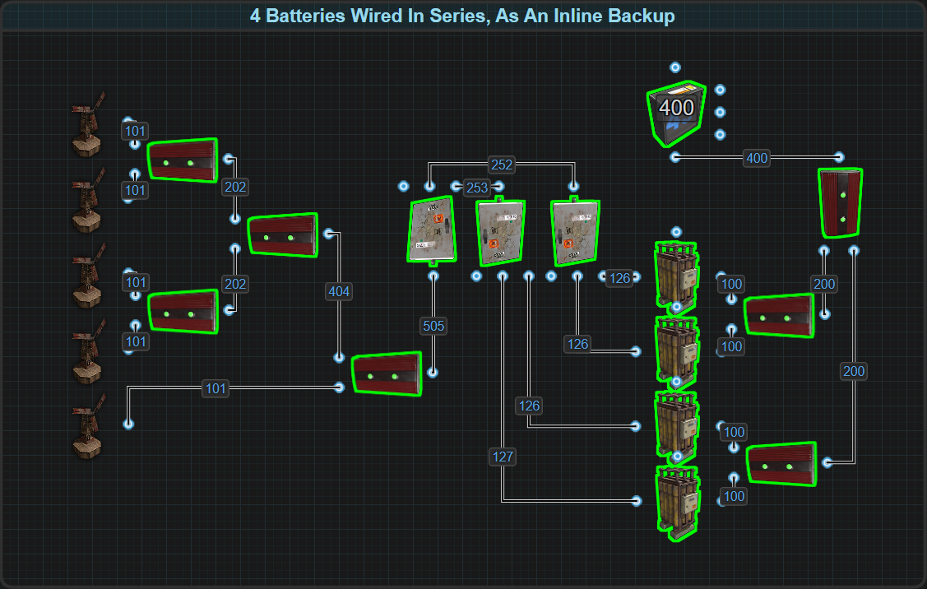

* + To install batteries in series into an Inline backup, players will need to connect their power source to the Splitters that evenly divide power to all the batteries.
  + Inline Battery Backups are great backup solutions as long as Active Usage on the battery is properly managed.
  + If one Large Battery is fully utilized (100 Active Usage), it requires at least 125rW input to remain charged.
  + Each battery wired in series will share the same Active Usage so two batteries in series now need 250+rW of Root Power just to stay neutral, and more to charge.
  + Four batteries wired in series used as an Inline Backup will need over 500rW of Root Power to maintain a positive charge.
  + An appropriate amount of Splitters are needed to evenly divide the incoming power to all the batteries.
  + This makes Inline setups highly inefficient when using series-wired batteries. The Active Usage tax removes the flexibility normally gained from inline control.
  + **Please don't do this.**
* **Bypass Backups**:

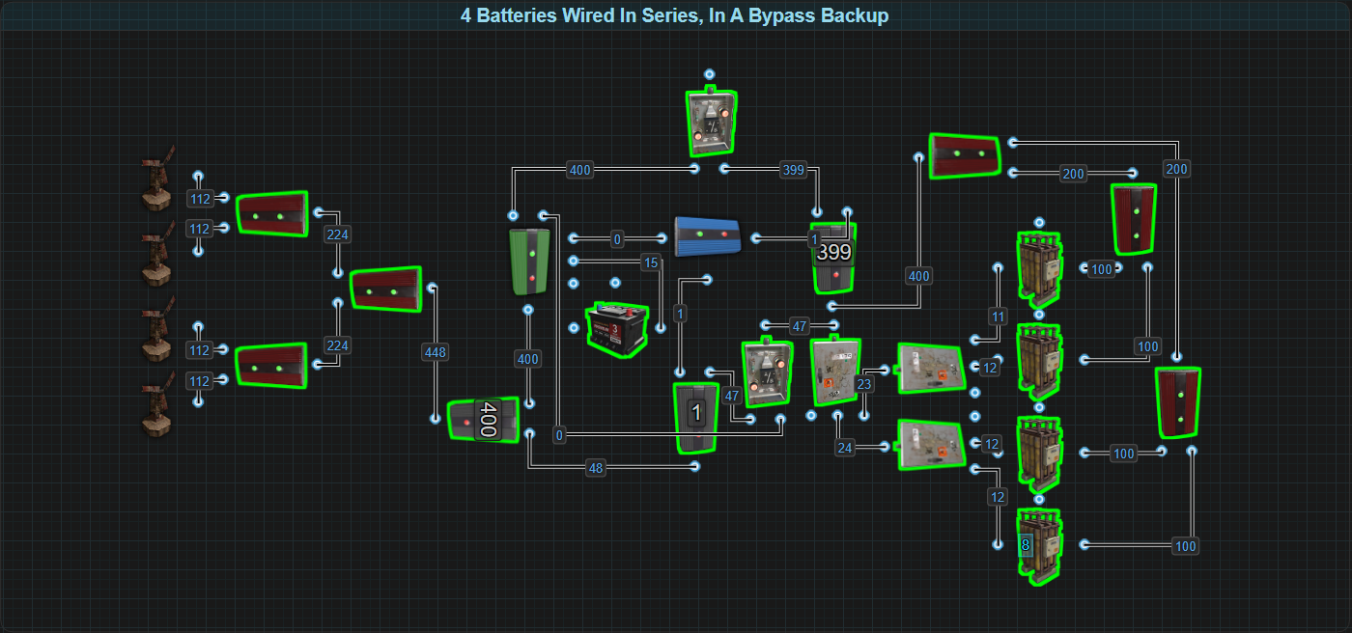

* + To install batteries in series into a BCN Core, players will need to connect the Splitters to the OR Switch that normally powers a single battery, and the Root Combiner from the batteries to the Electrical Branch that feeds power to the final OR Switch.
  + Since Bypass systems power circuits with Root Power directly, bypassing the batteries most of the time, Active Usage consideration is irrelevant.
  + The reason the batteries are wired in series to begin with is to provide more power then 1 battery is able to. Because of that, it is reasonable to assume that the Active Usage on the batteries will be maxed out and we accept the fact that they will only run for a minimum of 4 hours.
  + A setup like the BCN Core using four Large Batteries in series can supply 400rW for a minimum of 4 hours, assuming all Root Power has been removed.
  + The total Root Power requirement to keep this running is about 440rW, making it much more manageable than the Inline equivalent.
  + Adding additional large batteries increases available power in 100rW chunks while only increasing demand by roughly 110rW (100 for the new output, 10 to maintain charge).

**Efficiency Notes**

Bypassing Active Usage allows players to focus on efficient consumption of Root Power.

* If 200rW of battery power is available, circuit design should aim to use all 200rW, rather than leaving some power underutilized.

If a circuit only needs 120rW, it might be more efficient to cut the circuit in half. Powering it from 2 independent batteries instead might require less Root Power and extend the circuit's run time. Combining them to get 200rW is going to apply a max Active Usage and only last 4 hours.

* Never use batteries wired in series in an Inline Backup. Separate circuits into groups of power less then 100rW

**Be aware:** The Root Combiner has a maximum depth of 16 components from itself to the main power source. This theoretical maximum is covered in the Max Depth section under Power Distribution.

## Applying Parallel in Rust

To wire two Large Batteries in parallel in Rust, simply connect each battery’s output to an OR Switch. This will merge the battery's outputs into a simple line. The OR Switch prioritizes Input A over Input B or whichever has the higher power level and ensures only one battery is active at a time.

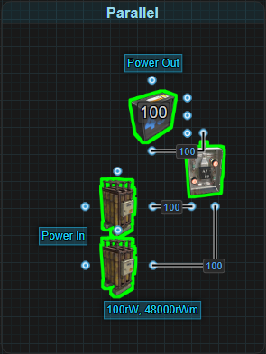

**How It Works:**

* While Battery 1 (Input A) has charge, it will fully power the circuit.
* Once Battery 1 depletes, the OR Switch automatically switches to Battery 2 (Input B) with no interruption to the circuit.
* This method effectively doubles total capacity allowing for twice the runtime, while maintaining the same output limit of 100rW.

**Adding more batteries is straightforward:** just chain more OR Switches.

* For 3 batteries:
  + Battery 1 and Battery 2 feed OR Switch 1.
  + The output of OR Switch 1 and Battery 3 feed OR Switch 2.
  + The final output goes to the circuit.
* For 4+ batteries: repeat the pattern.

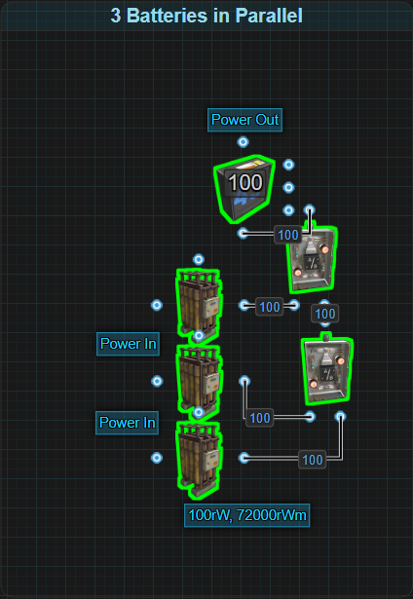

**Charging & Performance Considerations**

Parallel battery banks must be charged differently than series banks. In series, batteries should be charged simultaneously with a Splitter. In parallel, while a splitter can be used, it is highly inefficient. Instead, batteries should be charged sequentially, or one at a time.

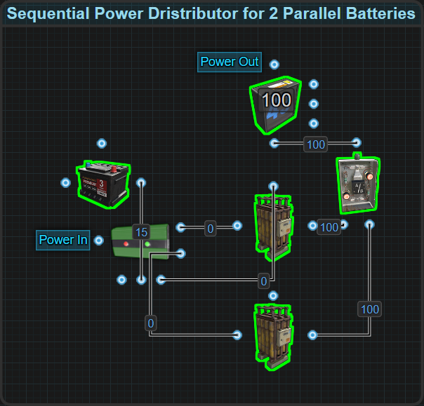

To charge batteries sequentially, a Sequential Power Distributor is used. This basic charging system uses Memory Cells and the battery’s Fully Charged output to rotate charging between batteries:

* The Memory Cell starts by sending power to Battery 1 from its Inverted Output.
* When Battery 1 is fully charged, its Fully Charged output goes to Set on the Memory Cell. This will flip the Memory Cells outputs to begin charging Battery 2.
* A Control Battery constantly provides power to Reset on the Memory Cell, ensuring the system defaults back to the first battery or any battery that starts to drain.
* The number of Memory Cells needed is always 1 less than the number of batteries.

4 Large Batteries in parallel = 3 Memory Cells → results in 96,000rWm capacity (16 hours runtime at 100rW).

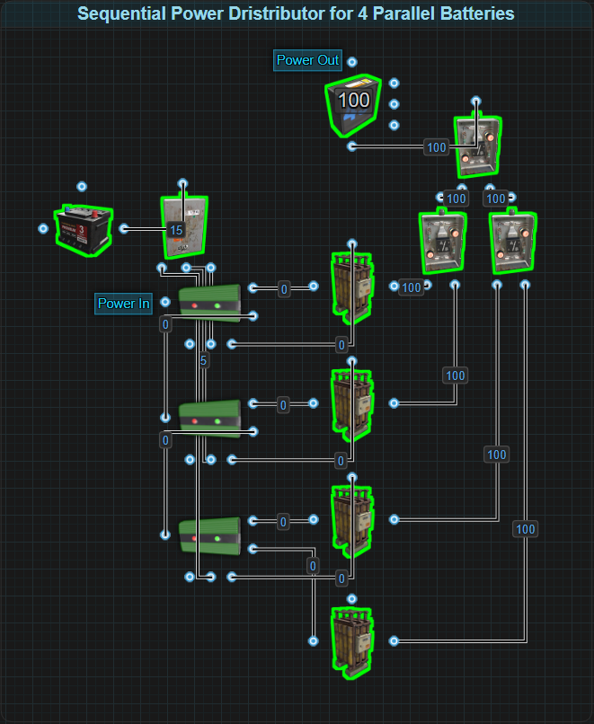

While this basic charging solution works, it assumes 2 things. The output power is 100rW, not less, and that no battery will be destroyed. If less than 100rW is needed or there is a concern that a battery might be destroyed, the charging solution needs some design changes.

**Advanced Charging**

If a circuit needs less than 100rW, or if there is a risk of a battery being destroyed (such as on a PvP server), the charging circuit requires some additional design features:

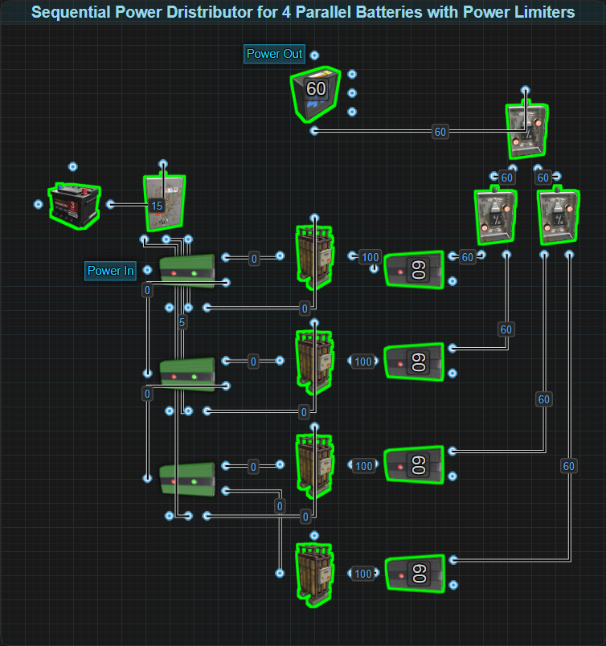

* If less than 100rW is needed, attach an Electrical Branch to the output of the battery and Branch Out the limited amount of power to the OR Switch. This ensures the output from the batteries will match the circuit’s demand.
* If there is a concern that a battery might get destroyed, a more intelligent design is needed.

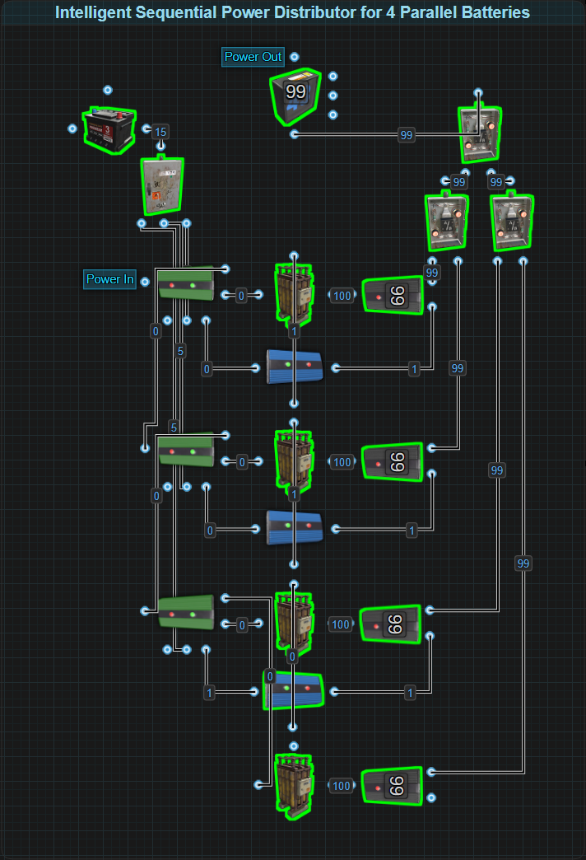

* Attach an Electrical Branch to the output of the battery and Branch Out all but 1rW to the OR Switch.
* Power Out will send power through a Blocker to Set on the Memory Cell. This will tell the system if the battery is present and needs to be charged.
* When the battery is full, its Fully Charged output will go to Block Passthrough on the Blocker allowing the Memory Cell to flip outputs and charge another battery, or pass power to another Memory Cell.
* Reset on the Memory Cells get constant power from a Control Battery to constantly try and push power to the next battery in line. This is only achieved if a battery is full or missing.
* The last battery in parallel will get its power from the Inverted Output from the last Memory Cell. It doesn't need a blocker but does need an Electrical Branch set to the same value as the rest.
* This kind of intelligent design does require 1rW from each battery.

**This setup allows for:**

* Safe automatic charging
* Dynamic prioritization
* Resilient operation even if a battery is destroyed

**Parallel in Inline vs Bypass Systems**

* **Inline Backups**

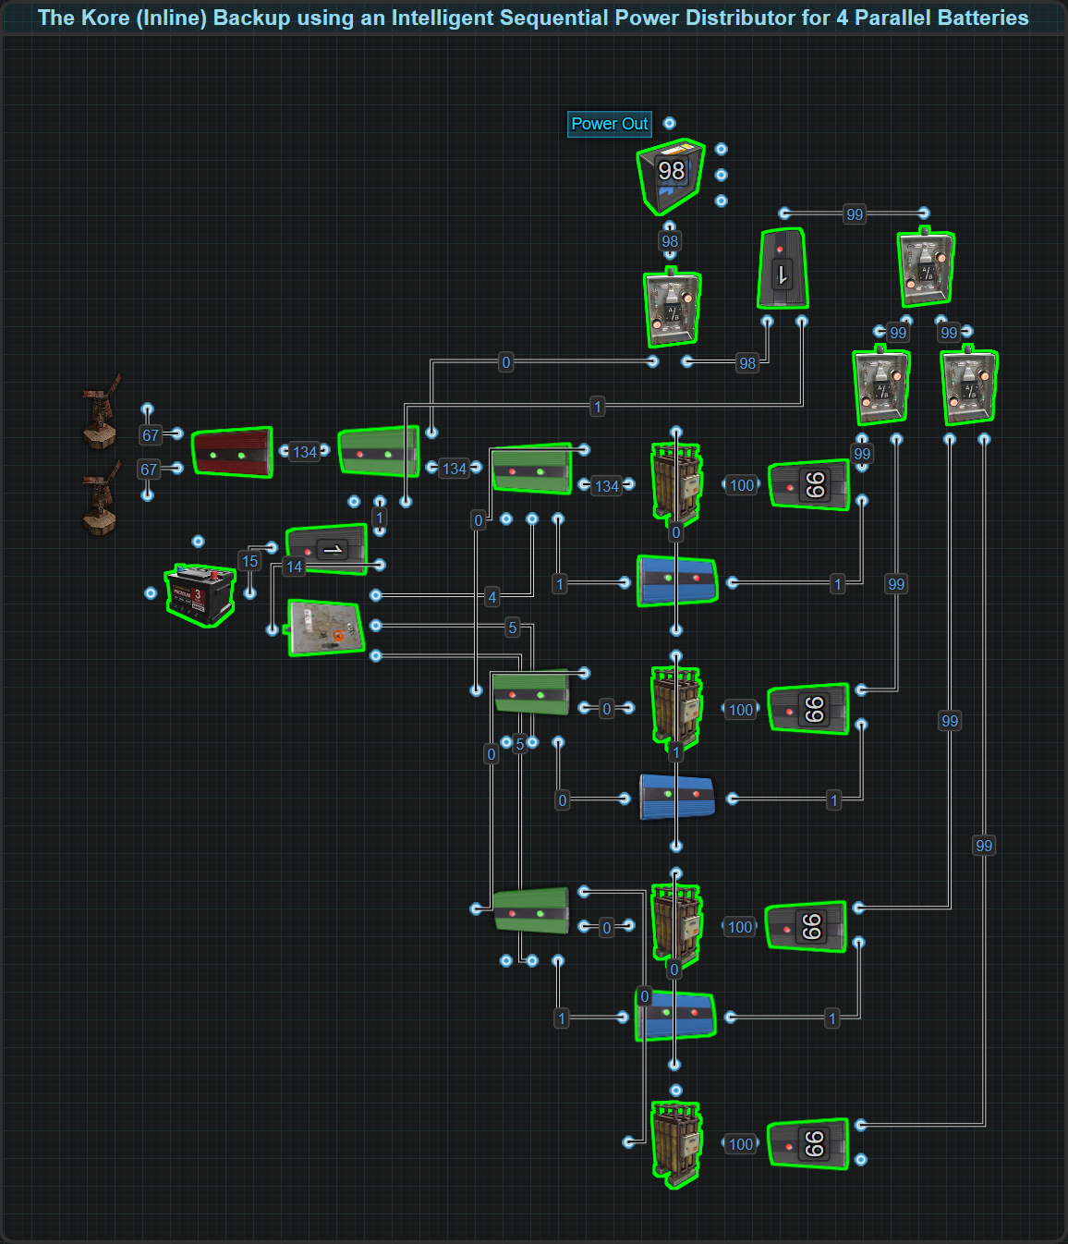

Parallel wiring is an excellent choice to extend the runtime of Inline backups:

* The first battery that gets charged will be the battery that will constantly be actively draining.
* The power given to this system will need to be high enough to overcome the batteries Active Usage just like any Inline Backup.
* Once the first battery is fully charged, the charging system will begin charging the next battery. However, because the first battery is still the one connected to supply the circuit, it will continue to discharge. This causes the system to alternate between topping off the first battery and briefly charging the second, resulting in the Memory Cell flipping back and forth.
* Once there is no Root Power supply, the batteries will drain one at a time, extending runtime.
* This allows for very efficient use of Root Power by charging as many batteries as a player wants.

**Bypass Backups**

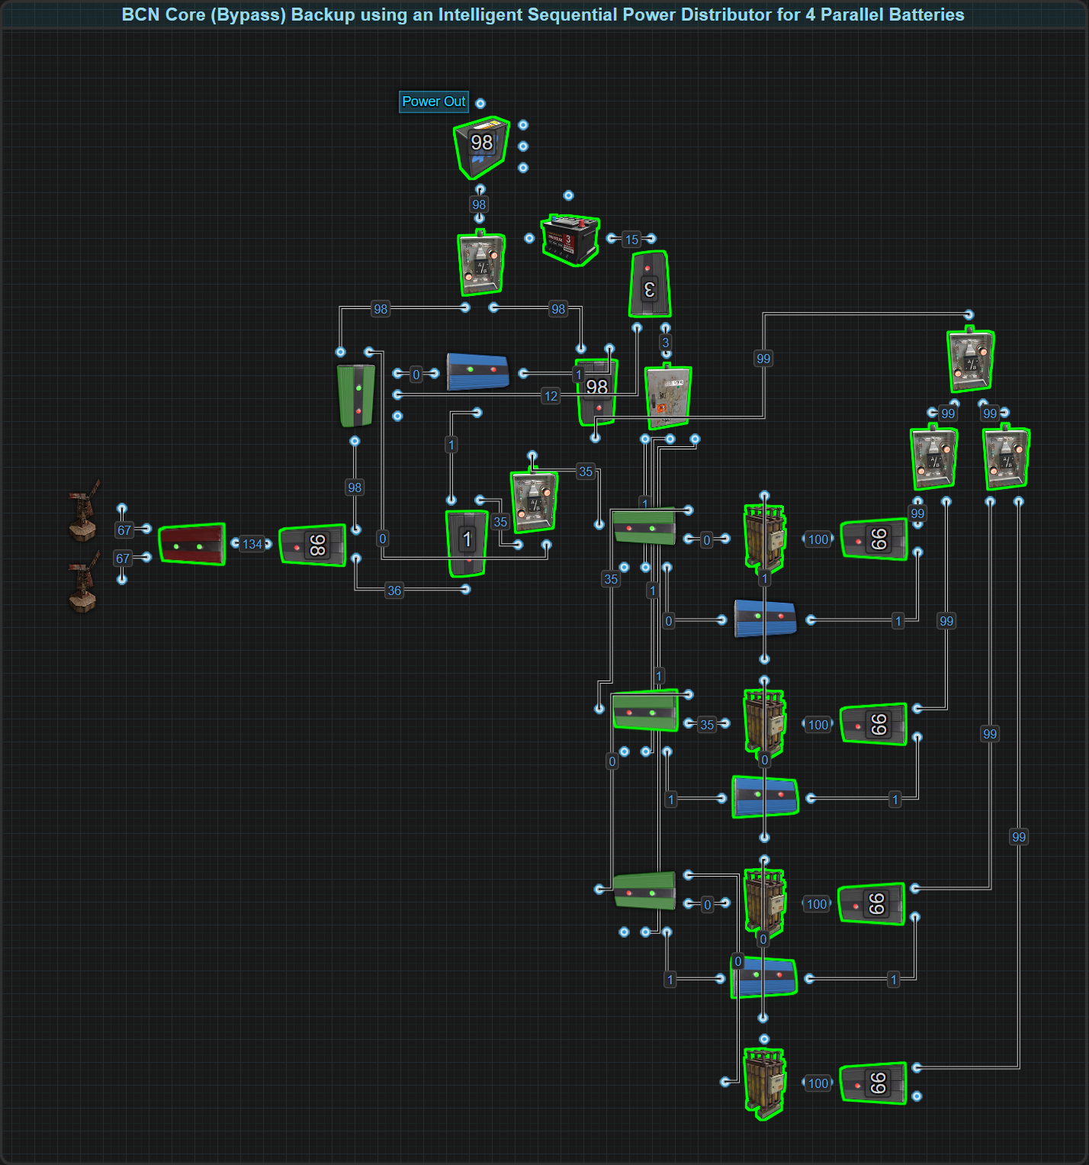

Parallel wiring also works in Bypass systems, but with limitations:

* Since Bypass systems power circuits with Root Power directly (bypassing the batteries most of the time), Active Usage consideration is irrelevant.
* A single parallel battery bank in a BCN Core is treated no differently than if there was only a single battery in terms of the amount of Root Power needed.
* In a BCN Core, 1rW is needed from the battery bank to let it know batteries are still present. The intelligent design of the distributor also needs 1rW from each battery. This means using Large Batteries, only a max of 98rW is usable.
* When Root Power is not enough to support the circuit, the battery bank will take over but is limited to a maximum output of only 100rW using Large Batteries.
* If Root Power fails, parallel batteries take over seamlessly, one at a time extending runtime.
* The more batteries in parallel, the longer the backup time will last for.
* Bypass Backups are typically used for circuits that need more than 100rW. If more power and a larger capacity is needed, a hybrid solution (series + parallel) is required.

**Efficiency Considerations**

Parallel setups excel in both Inline and Bypass backup. No matter how many batteries are wired together, the entire bank of batteries is treated no differently than a single battery.

* Only one battery’s Active Usage is in effect.
* Only one battery charges at a time.
* No additional Root Power is required to charge as many batteries as a player chooses.
* Uptime is greatly extended, ideal for critical circuits that must always stay online.

**Bottom Line:**The OR Switch is a highly effective way to parallel batteries, it's just the charging solutions that adds a layer of complexity. When uptime is more important than raw power, Parallel wins. For larger circuits needing more than 100rW, players should explore Series or Hybrid configurations.

## Applying Hybrid (Series-Parallel) in Rust

Hybrid battery wiring combines the power output advantages of Series with the extended capacity of Parallel. In Rust, this is done by first building parallel battery banks using OR Switches, and then wiring those banks in series using Root Combiners.

This allows players to create extremely powerful, high-capacity battery systems, ideal for large, high-demand circuits that require extended backup run times.



**How It Works:**

* **Build Parallel Battery Banks first:**
  + For example, 3 Large Batteries in Parallel = 100rW output, 72000rWm capacity.
  + One battery is active at a time; total capacity is multiplied.
* **Then wire these banks in Series using Root Combiners:**
  + For example, 3 Parallel Banks in Series = 300rW output, 72000rWm capacity.
  + The banks are treated as "super batteries" each capable of 100rW output.

**Charging & Performance Considerations**

Since Hybrid configurations are ultimately series-wired, efficiency considerations follow those of Series wiring. However, because each bank is built from Parallel batteries, charging the system requires two layers:

1️⃣ **Charging the Parallel Banks:**

* Each Parallel Bank needs its own Sequential Power Distributor (SPD).
* Inside each bank:
  + Only one battery is charged at a time.
  + The SPD ensures full cycling and correct battery selection.

2️⃣ **Charging All Banks (Series Layer):**

* The Parallel Banks (now treated like single batteries) are then charged evenly using a Splitter:
  + The Splitter evenly divides input power to each SPD (one per Parallel Bank).
  + This balances charging across the entire Hybrid stack.

**Efficiency Notes**

Hybrid configurations are ultimately **Series-based**. This means the same efficiency considerations that apply to Series wiring will apply here as well:

* When the Hybrid bank is called on to power the circuit, the first battery in each Parallel Bank carries 100% of its bank's Active Usage.
* The remaining batteries in each Parallel Bank remain idle until the first battery in that bank is depleted.
* This is functionally identical to Series behavior, but now multiplied by the number of batteries inside of each Parallel bank.

**Inline Backups (Poor Fit)**

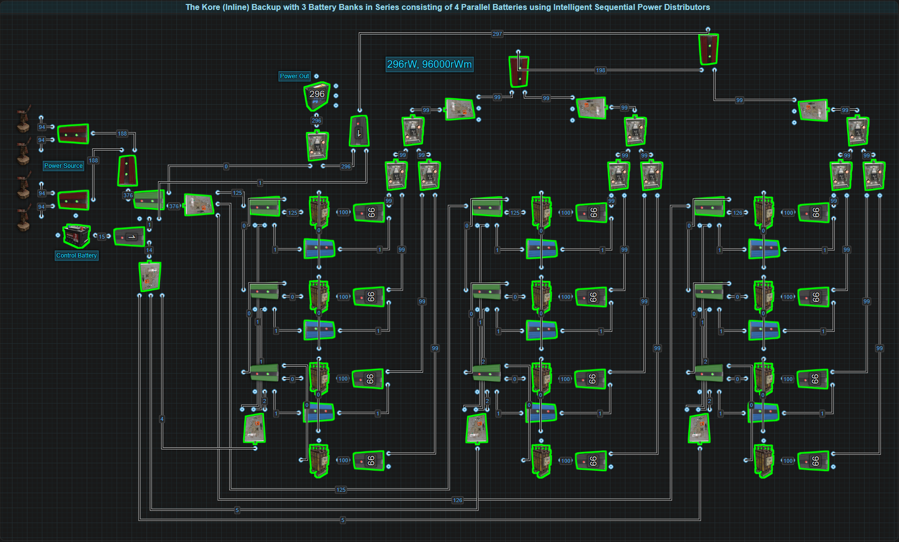

* In an Inline system, the first battery in all Parallel Banks must be kept fully charged because that first battery in each bank is always draining.
* This results in multiple batteries simultaneously draining at full Active Usage, forcing massive amounts of Root Power to be reserved to keep the system neutral or charging.
* **Example:**
  + A Hybrid bank outputting 300rW will have the 3 first batteries draining, each requiring roughly 125rW input → roughly 375+rW of Root Power just to maintain.
  + More if charging is desired.
* The result is extremely poor efficiency, far worse than running individual batteries or a bypass backup.
* **Conclusion:** Do not use Hybrid banks in Inline Backups.

**Bypass Backups (Ideal Fit)**

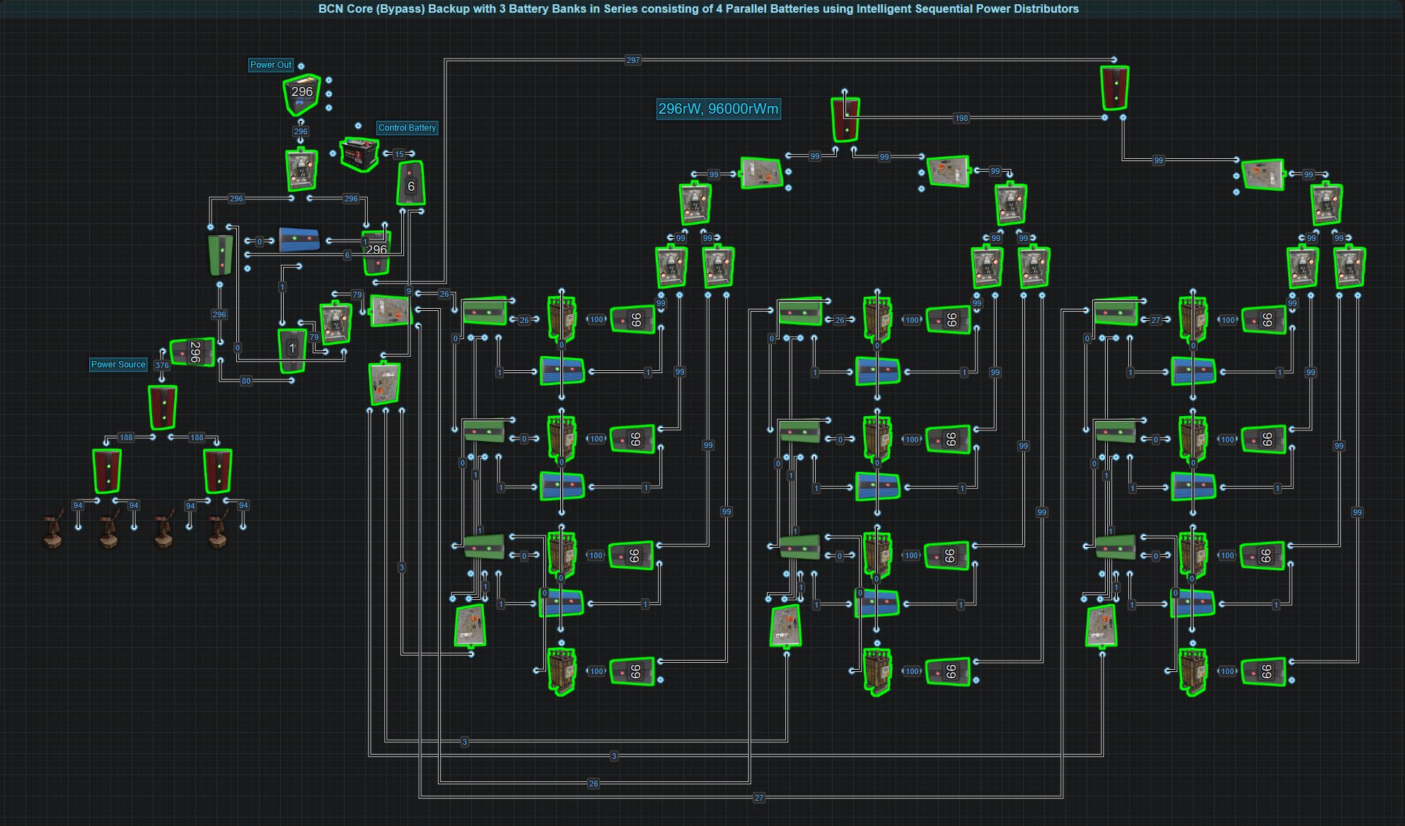

* In Bypass systems (such as a BCN Core), the batteries are only called on when Root Power fails or falls below a set level.
* While Root Power is active, the batteries remain charging and no Active Usage drain is applied.
* When needed, the Hybrid bank seamlessly supplies high output (200rW, 300rW, 400rW...) **f**or an extended runtime thanks to the large Parallel capacity.
* Think of each Parallel Bank as just an over-sized battery.  
  **Charging is straightforward:**
  + **Sequential Power Distributors** handle charging within each Parallel Bank.
  + **Splitters** ensure even charging of all banks.
* Root Power demand is predictable and much lower:
  + Approximately 110rW per 100rW of battery output (as with standard Series setups).

**Summary**

* **Inline Hybrid:** Wasteful, overproduces, complex, and not scalable.
* **Bypass Hybrid:** Efficient, scalable, and matches the design purpose of high-output, long-runtime backups.

**Design Tip:** Intelligent circuit design (reducing power demand where possible) is **more efficient** than simply stacking batteries. Many players overbuild Hybrid banks unnecessarily, more power is not always more better. Careful circuit planning will always outperform raw power and battery volume.

Power Distribution (Updating In Progress)

# Power Bus Theory

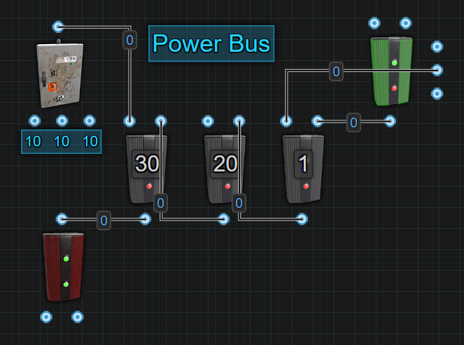

In any Rust base, electricity must travel from the power source (Wind Turbine, Solar Panel, Generator) to the components that need it (turrets, lights, doors, automation systems). Power Buses provide the structure and organization to manage this flow of power — controlling how much power goes where, in what priority, and under what conditions.

A Power Bus can be as simple as a single component or as complex as a multi-component distribution system. Its job is to direct power in a way that matches the needs of the circuits it supplies.

Think of a Power Bus like the breaker panel in a real home:

* It splits power into different circuits (kitchen, furnace, lights).
* It limits how much power each circuit can draw.
* It keeps everything organized, efficient, and safe.

In Rust, instead of breakers or fuses, we use Electrical Branches, Splitters, and Memory Cells to create and control Power Buses. Choosing when to use each bus is entirely situational and depends heavily on circuit type, backup strategy, and priorities. Here are key questions players should ask:

* How critical is the circuit or component?
* Does it need strict prioritization?
* Is resiliency needed?
* What is the primary power source?
* How will my backup behave?
* Is Active Usage a concern?
* Is the circuit always active or event-driven?
* Does the circuit or component operate in bursts or is it constant?
* Does the component generate Control Power or Free Power?
* What is the best way to simply reduce demand?
* Will this circuit be expanded later?
* Is material cost a concern?
* Is simplicity or resilience more important?
* What happens if part of the bus is destroyed?
* What combination of buses is needed to best serve a circuit's needs?

**At its core, a Power Bus helps manage:**

* **Capacity** — how much power is delivered.
* **Priority** — what gets power first during shortages.
* **Resilience** — how the system behaves if power drops or components fail.
* **Efficiency** — how much Root Power must be produced to meet needs.

## Fixed Bus (F-Bus)

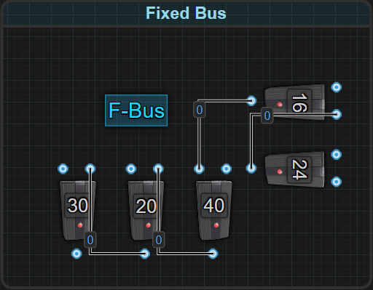

**What is an F-Bus?**

A Fixed Bus (F-Bus) is a Power Bus where specific, fixed amounts of power are reserved for each connected circuit or component. It guarantees that each destination always receives the same amount of power, regardless of whether or not that circuit is actively consuming power. It is the most stable and predictable form of power distribution, sometimes trading efficiency for guaranteed power delivery and strict prioritization.

In an F-Bus, each output is set to a specific value, providing an exact amount of power to each circuit or device. This power is reserved and always held, regardless of whether the downstream device is online, idle, damaged, or destroyed, the bus will still send the configured power.

Think of a Power Bus like the breaker panel in a real home:

* It splits up power into different circuits (kitchen, living room, furnace).
* It ensures no single circuit draws too much.
* It keeps things organized and safe.

It’s especially useful for both end devices (like turrets or lights) and for powering logic components (like splitting signal paths or sending reset triggers). Any time an Electrical Branch is used to explicitly control power levels to a specific location, an F-Bus is created. This simple mechanism becomes a powerful way to control power flow.

**How It Works**

**Core Structure**

An F-Bus can be a **single Electrical Branch** or a **chain of them**. Each branch reserves power through the Branch Out node, and passes along the rest via Power Out. This structure ensures consistent delivery of power, regardless of how many components are active or inactive.

**Example structure:**

Root Power → Electrical Branch (Branch Out: 11) → Turret 1

└ Power Out → Electrical Branch (Branch Out: 30) → Lights

└ Power Out → Electrical Branch (Branch Out: 1) → Logic

**Prioritization & Load Shedding**

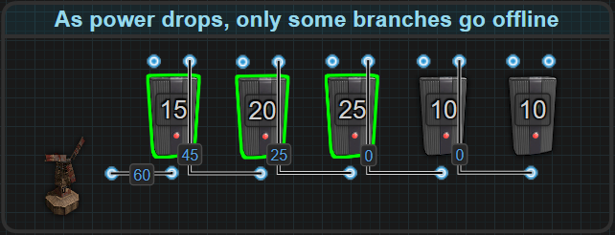

**Load shedding** in Rust is the ability to maintain the run times of important circuits during periods of low power. The F-Bus does this through **prioritization**. The first Electrical Branch to receive power has the highest priority. The last Electrical Branch has the lowest. When the input power starts to decrease, branches with the lowest priorities will lose power first. The highest-priority circuits at the beginning of the F-Bus will stay powered as long as enough power is available. Once a Branch Out exceeds incoming power, lower-priority Electrical Branches past it will brown out.

* Electrical Branches also prioritize their outputs.
  + Power flows from Power Out first followed by Branch Out.
  + This in turn means that after Branch Out sends power, the component that is connected to Power Out will be the next component to perform an action before the component connected to Branch Out.
* If power is suddenly and completely removed, the Electrical Branch with the lowest priority will lose power. This is further explained in **Power Flow.**

**Benefits**

* **Efficient power delivery** — circuits and components receive only their needed amount of power.
* **Prioritization** — branches towards the beginning maintain power longer during shortages.
* **Predictable behavior** — makes power degradation graceful, not sudden.
* **Great for critical defense systems** — support specific and predictable power delivery.
* **Supports scaling** — can be extended with additional branches or chained buses.

**Limitations**

* **Inefficient for idle or event-driven circuits** — power is reserved even when the circuit is unused.
* **Higher baseline power demand** — total power production must cover all reserved Branch Outs.
* **Material costs per output** — each Electrical Branch costs 75 Metal Fragments for 2 outputs.
* **Does not limit battery Active Usage** — reserved power does not limit the Active Usage that an Inline system can experience.
* **Material and wiring complexity** — large F-Bus chains can become harder to manage.

## Dynamic Bus (D-Bus)

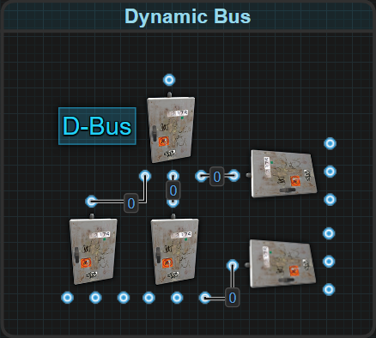

**What is a D-Bus?**

A Dynamic Bus (D-Bus) is a type of Power Bus where incoming power is automatically and evenly distributed across all connected outputs.

It is built using one or more Splitters and is ideal for circuits where each connected device or component needs the same amount of power and power shedding prioritization is either unnecessary or undesirable.

A D-Bus is dynamically responsive. As input power levels change, or as devices are added, removed, and destroyed, the Splitters automatically adjust how power is divided.

**In this way, a D-Bus is:**

* **Efficient** — no wasted reserved power.
* **Adaptive** — responds in real time to circuit state.
* **Simple** — fast to wire and expand.

**How It Works**

**Core Structure**

The D-Bus is typically built using **Splitters**, either as standalone units or in groups. Each output receives an equal portion of the available power, making this bus ideal when every connected component needs the **same amount of power**

* Unused or destroyed outputs do not consume power.
* If outputs are disconnected or destroyed, it redistributes remaining power across the still-connected outputs.
* Splitters can be chained or nested.
* While Splitters have no prioritization in terms of power shedding, they do have an internal processing order

**Load Shedding & Splitter Priority Behavior**

**Load shedding** in Rust is the ability to maintain the run times of important circuits during periods of low power. The D-Bus does not allow for easy management of load shedding. Once there is not enough input power, the connected outputs will cease to function, even if there is enough total power remaining to maintain 1 or 2 of the connected circuits or components.

Although a D-Bus is generally "equal," Splitters have built-in **output priority**:

* **Power Out 1** is powered first.
* **Power Out 2** is powered next.
* **Power Out 3** is powered last.
* This order is the same when the Splitter loses power.

This order of **Power Flow** also generally means that after all 3 outputs send power, the component that is connected to Power Out 1 will be the next component to perform an action, followed by the component connected to Power Out 2 then Power Out 3.

This priority is also applied when splitting odd amounts of power. Any remaining power that cannot be divided equally between the connected outputs is given to Output 1 first, followed by Output 2.

This is important for signal-based circuits or sequenced activation.  
It can be used to control the order of actions such as:

* Which Memory Cell is triggered first.
* Which door opens first.
* Which signal path activates last.

**Connecting Groups Of Splitters**

**A common D-Bus pattern is a pyramid or cascade:**

* One Splitter → Two Splitters → Six outputs.

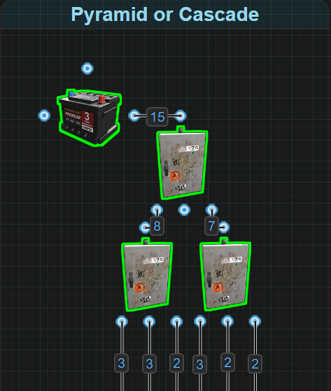

This is ideal when identical devices need to be powered, such as turrets, water pumps and batteries wired in series.

* All outputs should receive roughly equal power (within 1rW of each other when dealing with odd amounts of power).
* It makes the division of power easily predictable.
* **Beware:** this reduces available power per output quickly if power is limited.

**An uncommon D-Bus pattern is a chain:**

* Output 3 of Splitter A → Input of Splitter B → Output 3 of Splitter B → Input of Splitter C
* **Beware:** Each link in the chain further reduces the available power at the final outputs.

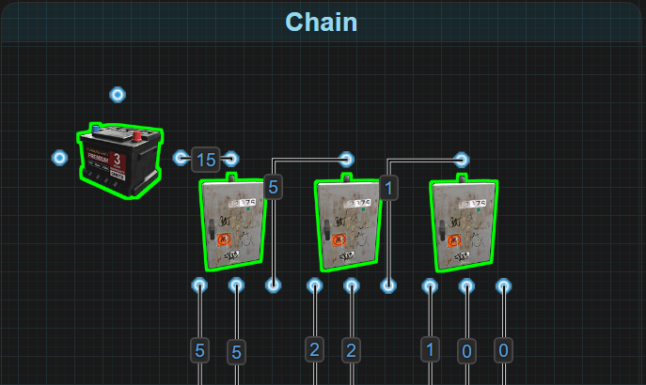

Each chained Splitter is splitting up to 1/3rd of original power, by up to 3 times. This significantly reduces available power the further down the chain Splitter is placed, and removes the ability for future expansion. This wiring is **not recommended** unless extremely low draw circuits are being powered or the player has a solid understanding of the dynamics of this method.

**Benefits**

* **Power efficient** when all circuits require the same wattage
* **Automatically redistributes** power when outputs are removed
* **Low material cost** (1 Splitter = 100 metal fragments, 3 outputs)
* **Great for identical devices** or logic circuits with equal signals
* **Simple to design** — no need to configure individual output amounts
* **Easy signal sequencing** using output order for logic circuits

**Limitations**

* **No prioritization** — all outputs treated equally
* **All circuits fail together** if input power drops below required threshold
* **Limited control** over which outputs stay active under strain
* **Cannot be used easily when different outputs need specific wattage**
* **Chaining splitters** reduces output power quickly and may limit scalability

## Configurable Bus (C-Bus)

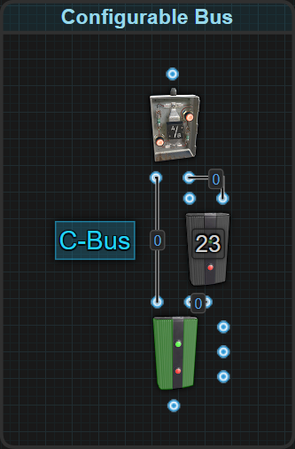

**What is a C-Bus?**

A C-Bus, short for Configurable Bus, is a logic-based power distributor that only activates when power is specifically needed. It operates as a conditional bypass circuit that intelligently diverts and applies power to a circuit only when triggered, thereby saving energy during idle periods.

It is not a physical component like the Splitter or Electrical Branch, but rather a logic design that combines multiple components—specifically the **Memory Cell**, **Electrical Branch**, and **OR Switch**. Without the logic system in place, the bus does not exist.

The C-Bus can be thought of as a dynamic F-Bus, with added intelligence. Instead of always reserving power like a traditional F-Bus, it reserves power only when activated, returning unused power back to the main line.

**How It Works**

**Core Structure**

Every C-Bus consists of three components:

1. **Memory Cell** — acts as the power path controller.
2. **Electrical Branch** — regulates the amount of power delivered when active.
3. **OR Switch** — merges bypass and active power paths.

At its core, every C-Bus has two paths:

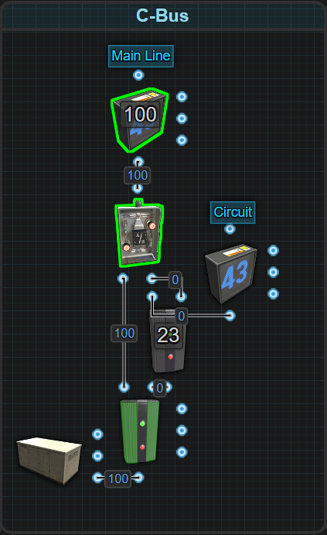

* **Main Line** - default power flow
* **Circuit Path** - activated power flow

**Main Line (Default State):**

* Power passes from the Inverted Output of the Memory Cell to the OR Switch and continues on.
* The destination circuit remains unpowered.

**Activation (Siphon State):**

* Memory Cell switches to its regular Output, which powers an Electrical Branch.
* The Branch Out is set to deliver a defined amount of power to the destination circuit.
* The remaining power flows through Power Out, merges via the OR Switch, and rejoins the main line.

**Deactivation:**

* When both Set and Reset are powered, priority will go to “Power Out”. When Set loses power, Reset will take priority.
* Power again flows through the Inverted Output and bypasses the circuit.

This creates an on-demand power siphon with no wasted reserved power during idle periods. What controls the activation is entirely situationally dependent.

**Operation Modes**

C-Buses can operate in 4 distinct modes, depending on how the Memory Cell is controlled:

**1 - Auto Set Auto Reset (Fully Automatic)**

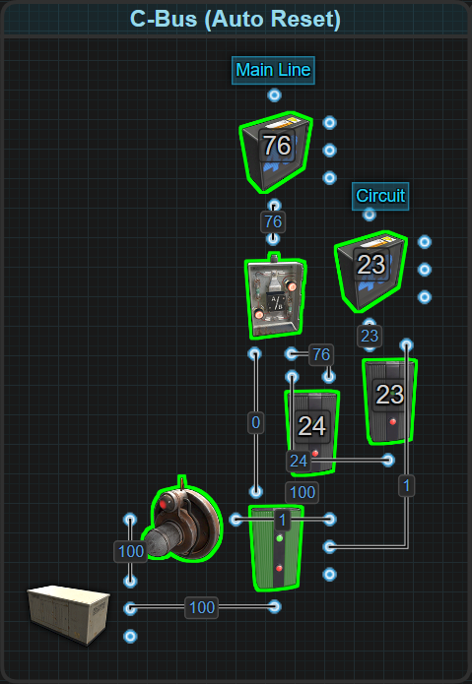

* The Memory Cell is controlled via **SET** and **RESET** inputs.
* When the trigger (ex: HBHF Sensor) provides power to SET, the Circuit Path activates.
* When the trigger stops sending power, RESET is activated — returning flow to Main Line.

**Behavior:** Circuit turns on when the trigger is present, turns off automatically when the trigger disappears.

This Auto Reset behavior can be achieved through another method. It doesn't need to use a second Electrical Branch as demonstrated.

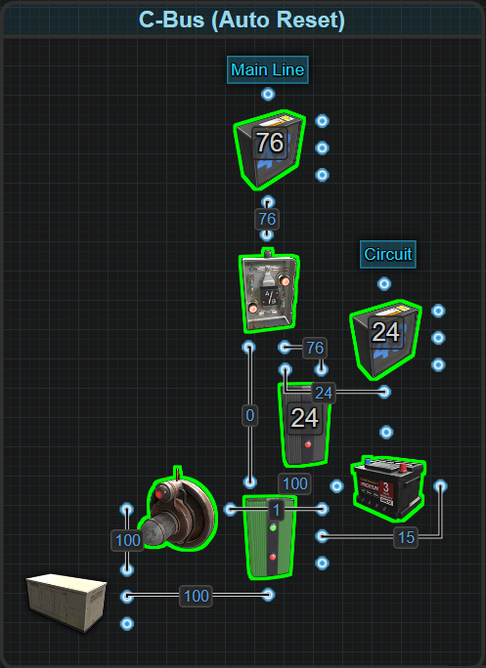

* The goal is simply to have power applied to Reset for the system to automatically reset after activation.
* If players are already taking advantage of Control Batteries, like the one used in The Kore or a BCN Core, then the second Electrical Branch is not needed

**2 - Manual Toggle (Player Controlled)**

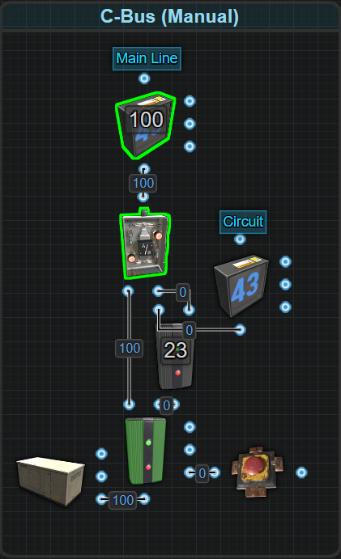

* The Memory Cell is controlled via **TOGGLE** input.
* Players manually activate/deactivate the Circuit Path with a button (or any momentary signal).
* Outputs remain in the last state until toggled again.

**Behavior:** Circuit stays ON or OFF until the player manually changes it.

**3 - Auto Set / Manual Reset (Hybrid Control)**

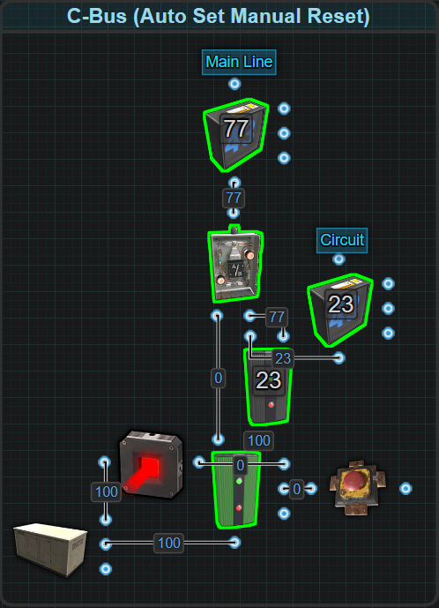

* The Memory Cell is SET automatically by a trigger (ex: Laser Detector).
* RESET is controlled manually by the player (ex: Button).
* Useful for circuits that must be acknowledged or intentionally reset after an automatic activation.

**Behavior:** Automatically turns on when triggered, but requires player intervention to turn off.

**4 - Inverted Set Auto Reset (Failure Controlled)**

In the previous methods, power was always bypassing the circuit until called upon. This is a more advanced variation where the Memory Cell is Set by default and only Resets when the circuit fails.

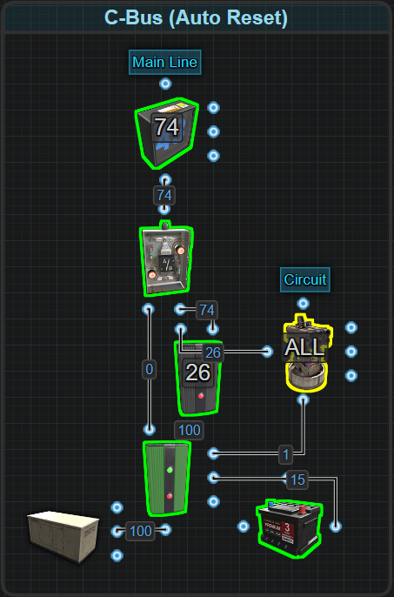

* Power flows through the circuit (ex. SAM Site) and Sets the Memory Cell
* Control Power is used to supply power to the Memory Cells Reset.
* If the circuit (ex. SAM Site) is destroyed, power it no longer applied to Set and Reset flips the power path.
* **Beware:** In its default state, the Memory Cell will not send power to the circuit (ex. SAM Site). That means Set will also not get power. Players will need to toggle the Memory Cell first, power the circuit and get power to Set before connecting Control Power to Reset.

**Behavior:** Automatically swaps the power path when there is a failure of the circuit.

**Benefits**

* **Power-efficient** — no energy waste when the target circuit is inactive.
* **Flexible** — supports manual, automatic, or hybrid logic triggers.
* **Perfect for situational circuits** (e.g., farms, traps, alarms).
* **Reduces standby power draw**, freeing power for higher-priority needs.
* **Can reintroduce unused power** back into the grid via OR Switch.

**Limitations**

* **Requires more components** than D- or F-Bus.
* **Complexity** increases with each logic variation.
* **Requires testing** to tune the proper power flow (e.g., +1rW for Memory Cell reset).
* **Requires understanding of Memory Cell behavior and logic principles**.

In all the examples Counters were used at each output. This is only to show how much power each output is passing through. Here is a Rustrician BP link to explore the C-Bus more - [Configure Siphon](https://www.rustrician.io/?circuit=68b52f071a9461e0b5e49c253374be36)

## Hybrid Bus (H-Bus)

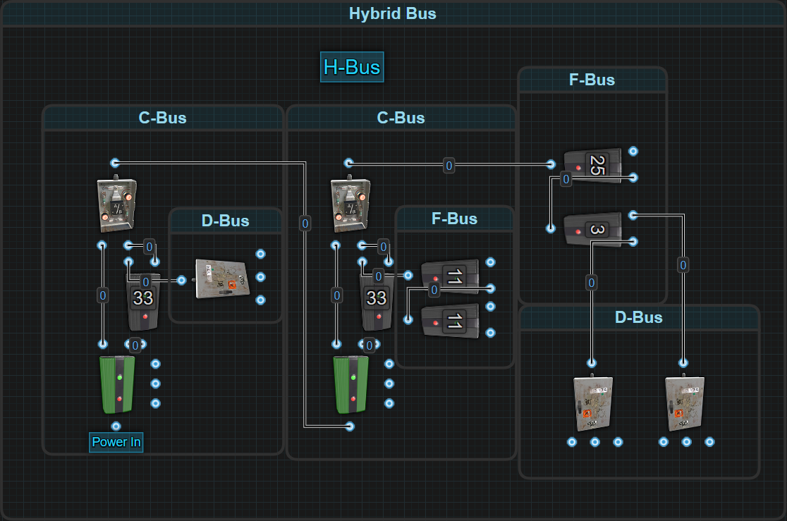

**What is a H-Bus?**

A Hybrid Bus, or H-Bus, is a composite power distribution system that combines multiple bus strategies, Fixed (F-Bus), Dynamic (D-Bus), and Configurable (C-Bus), within a single architecture. The H-Bus is not a standalone design, but rather a philosophy and approach to solving complex power routing needs using the most effective bus type for each circuit or subsystem.

Rather than sticking to a single distribution method, the H-Bus leverages the strengths of each individual bus style to balance efficiency, control, scalability, and reliability. This makes it the most flexible and capable bus system in Rust, though also the most complex to design and maintain.

**Note**: While the H-Bus may sound advanced, many players already use hybrid strategies without realizing it. Connecting F-Bus segments for turrets, D-Bus cascades for Electric Furnaces, and C-Bus siphons for conditional systems within the same base is an H-Bus in action.

**How It Works / Structure**

The H-Bus is built around segmented power layers, with each segment powered and regulated by the bus style that best fits its function:

* **F-Bus segments** provide precise and reserved power where reliability, predictability and prioritization are required.
* **D-Bus segments** handle mass distribution where devices have the same draw and power can be evenly split.
* **C-Bus segments** dynamically provide power to systems as required.

The cluster of these segments is the H-Bus. It is often powered from a common source and is either directly attached to one another or separated by any number of components, including switches, logic components, batteries and lights, to isolate or synchronize operation.

Each segment can be debugged and modified independently, but overall performance is optimized through central planning.

**H-Bus In Practice**

To help clarify the H-Bus design for new players, here are two real-world examples of circuits that follow the H-Bus structure:

**The BCN Core — Intelligent Battery Backup System**

The BCN Core (Battery-Checked Nih Core) is an H-Bus. It integrates all three major bus types—F-Bus, D-Bus, and C-Bus—into a resilient and efficient power control system. Let's consider a BCN Core that is setup for 4 Large Batteries.

* **F-Bus**: Supplies consistent and reserved power to the C-Bus and logic system.
* **D-Bus**: Charges multiple backup batteries using evenly distributed main power.
* **C-Bus**: Controls automatic battery failover and recovery.

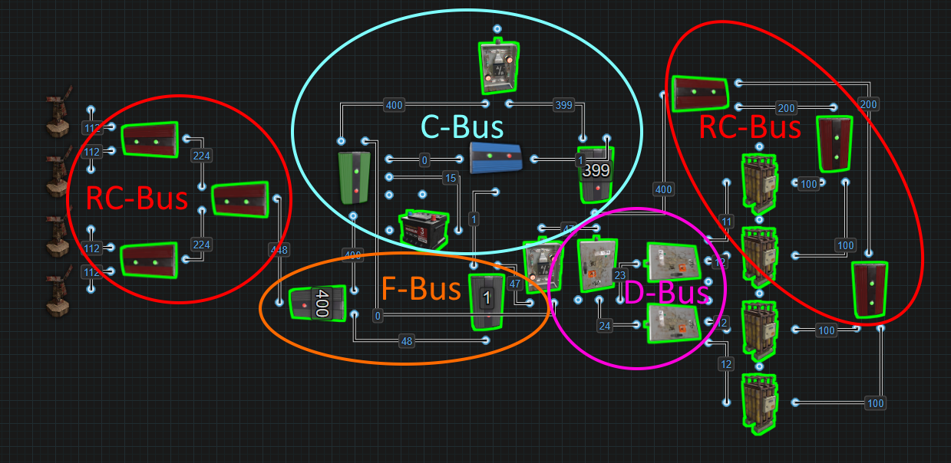

**How It Works**

From the Root Combiner-powered mainline, power first reaches Electrical Branch 1, the start of the F-Bus segment. This branch is set to match the circuit’s load requirement (e.g., 372rW) and sends:

* **Branch Out** → into the **Memory Cell**, powering its Input.
* **Power Out** → into **Electrical Branch 2**, which is set to 1rW.

The Memory Cell serves as the heart of the C-Bus logic:

* **Inverted Output** (Left) → powers OR Switch 1, delivering main power to a circuit during normal operation.
* **Output** (Right) → powers OR Switch 2 and is only used during battery failover.

Electrical Branch 2 continues the F-Bus logic path:

* **Branch Out (1rW)** → used to block passthrough on a **Blocker**, which helps govern when battery activation is allowed.
* **Power Out** → sent into **OR Switch 2**, which handles battery charging logic.

At this point, main power has been split, one half powering a circuit via the C-Bus, and the other preparing to charge the batteries. But before charging occurs, OR Switch 2 checks for alternate inputs:

* From **Electrical Branch 2** (main power)
* Or from the **Memory Cell Output** if battery fallback becomes necessary

From OR Switch 2, power enters a **D-Bus split pyramid**—a series of **Splitters** designed to evenly divide current to multiple batteries (e.g., 4 Large Batteries).

Each battery is connected to a **Root Combiner**, which outputs into **Electrical Branch 3**, part of the **C-Bus** segment. This branch is set to the same value (372 or lower) as Electrical Branch 1.

* **Branch Out** → enters OR Switch 1 to power the downstream circuit during failover.
* **Power Out (1rW)** → enters the Blocker’s Input, and if unblocked, continues through to the Set input on the Memory Cell.

Finally, a **Control Battery** powers the **Reset input** of the Memory Cell. Since side inputs don’t generate Active Usage, the Small Battery never drains, making it ideal for permanent reset logic.

**Behavior**

* During normal operation, main power flows through Electrical Branch 1 into the Memory Cell, which by default sends power from its Inverted Output to OR Switch 1 and into a circuit.
* Excess power flows through Electrical Branch 2, which blocks the Blocker and continues into OR Switch 2, which in turn charges the batteries evenly via a D-Bus made from Splitters.
* The battery output returns through Root Combiners into Electrical Branch 3. As long as Electrical Branch 2 is powered, the Blocker prevents battery power from reaching the Memory Cell.
* If main power drops, Electrical Branch 2 loses power, unblocking the Blocker. Battery power then hits the Memory Cell's Set input, flipping it.
  + Output now powers OR Switch 2 sending any remaining power to the batteries to slow their discharging.
* If the batteries are destroyed or drained, power to Set disappears. Since Reset remains powered by the Control Battery, the Memory Cell flips again, restoring whatever main power is available back to the circuit.

This behavior allows the BCN Core to switch seamlessly between main and battery power, recover automatically from battery loss, and prioritize main power when available—all without manual reset.

The BCN Core qualifies as an H-Bus because it:

* Uses **F-Bus** to power its control logic
* Charges multiple batteries via **D-Bus**
* Switches dynamically using **C-Bus** logic

Its modularity, fault tolerance, and precise power routing are a textbook example of Hybrid Bus architecture in action.

**CCTV vs Furnace Selector — Shared Power System**

This H-Bus circuit demonstrates how to share a single power source between two competing systems, CCTV Cameras and Electric Furnaces, using prioritized distribution, conditional toggling, and residual passthrough logic. It combines 3 F-Bus segments, 1 D-Bus, and a C-Bus controller to manage selective power routing without rewiring.

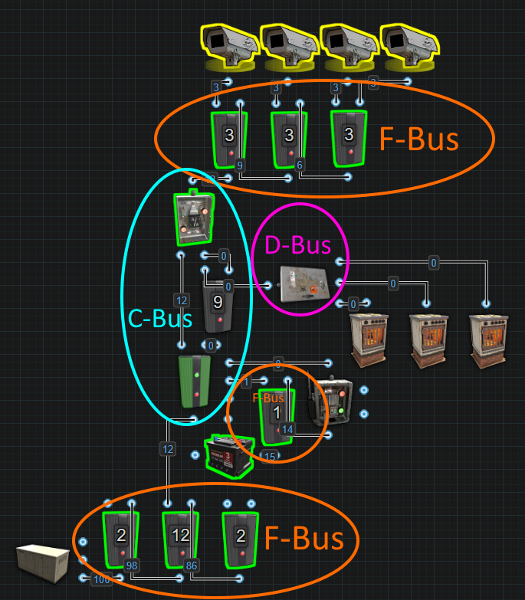

**How It Works**

* Power enters the system from an Electrical Branch set to 12rW. This branch could be part of a large F-Bus segment but is where this H-Bus gets its power from.
  + Branch Out (12rW) → powers the Memory Cell Input (C-Bus start).
* Inverted Output of the Memory Cell routes power to the OR Switch for it to exit the C-Bus. The power is then passed to an F-Bus chain made from 3 Electrical Branches, each reserving 3rW for four CCTV Cameras:
  + First 3 branches feed 3 Cameras (3rW each).
  + The remaining 3rW continues downstream to power a fourth camera directly.
* Output of the Memory Cell leads to an Electrical Branch, set to 9rW (part of the C-Bus segment).
  + Branch Out (9rW) → enters a Splitter (D-Bus) that feeds 3 Electric Furnaces (3rW each).
  + Power Out - Sends the remaining 3rW to the OR Switch which sends it to the F-Bus.
  + Due to the prioritization built into an F-Bus, 1 CCTV Camera will still remain active.
* A Control Battery powers an Electrical Branch set to 1rW (F-Bus logic):
  + Branch Out (1rW) → goes to Reset on the Memory Cell (default state: cameras powered).
  + Power Out → goes to a Smart Switch, which when toggled, powers the Set input of the Memory Cell.

**Behavior**

* When the Smart Switch is off, the Memory Cell defaults to its Inverted Output, keeping the CCTV Cameras powered.
* When the Smart Switch is turned on, it powers the Set input, flipping the Memory Cell to Output.
  + Now the Electric Furnaces receive power.
  + 3 of 4 CCTV Cameras turn off.
* Turning the Smart Switch off again flips the memory cell back, reverting power to the cameras.

This design shares one power source across two systems, enabling a clean and efficient toggle. All systems are logically gated, isolated, and powered via a segmented bus layout.

The CCTV vs Furnace Selector qualifies as an H-Bus because it:

* Uses multiple F-Bus segments for logic control and prioritized power routing
* Uses a D-Bus to split power evenly to Electric Furnaces
* Uses a C-Bus to toggle between different systems

This setup is a simple yet powerful demonstration of Hybrid Bus flexibility—allowing players to build circuits that reallocate power dynamically based on manual input while preserving priority logic.

This example helps players understand that H-Bus systems don’t always require battery failover or advanced triggers—**even simple switches and branches can form Hybrid Bus logic**.—allowing players to build circuits that reallocate power based on demand without rewiring.

**Benefits**

* **Maximum flexibility** – combine multiple bus types to suit each circuit's needs
* **Efficient power use** – minimizes waste by assigning the right distribution method per device group
* **Supports complex bases** – ideal for large or layered systems with varying power demands
* **Modular by design** – easy to expand, segment, or upgrade over time
* **Built-in prioritization and logic** – enables smart control, fallback behavior, and automation
* **High resiliency** – segments can continue functioning independently even if others fail

**Limitations**

* **High learning curve** – requires solid understanding of F-Bus, D-Bus, and C-Bus behaviors
* **More complex wiring** – difficult to troubleshoot without labeling or documentation
* **Increased component usage** – typically uses more branches, switches, and logic parts
* **Takes longer to plan and build** – not ideal for quick setups or temporary bases

## Root Combiner Bus (RC-Bus)

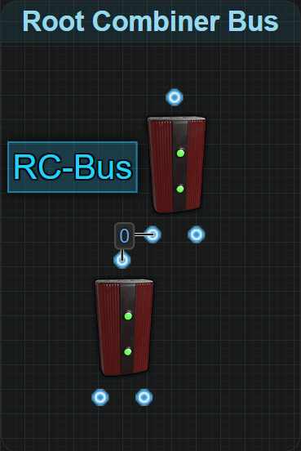

**What is an RC-Bus?**

An RC-Bus, or Root Combiner Bus, is a specialized wiring structure used to merge electricity from multiple sources into a single unified power line. It acts as a power aggregator, collecting electricity upstream before it is stored, regulated, or distributed.

Unlike output-focused bus types like the F-Bus or D-Bus, the RC-Bus does not route electricity to components. Instead, it gathers electricity from solar panels, wind turbines, generators, batteries, and other valid sources, and delivers it downstream through one clean, centralized line.

**How It Works**

**Core Structure**

An RC-Bus is built entirely from Root Combiners. Each Root Combiner merges power from two sources, like Solar Panels, Wind Turbines, or Generators, into a single output.

* Each Root Combiner has two inputs and one output.
* To combine more than two sources, multiple Root Combiners are chained in tiers or pyramid formations.
* The final output becomes the main power line, typically sent to a battery bank or core system.

The RC-Bus performs no distribution, only collection. It is designed solely for upstream power merging.

⚠️ **Two important factors must be considered when designing RC-Bus layouts:**

* **Max Depth Limit**: Each component in the power path contributes to signal depth. If any path from a power source to the final Root Combiner exceeds 16 components, it will trigger a Max Depth error. This includes sources, batteries, logic components, and combiners. For detailed examples, see the Max Depth & Short Circuit Errors section.
* **Battery Behavior**: When combining batteries through Root Combiners, each battery registers the full Active Usage of the circuit. This can cause excessive battery drain if not properly planned for. For a more detailed breakdown, see Root Combiner Behavior in Power Theory and Efficiency section.

**Combiner Layouts**

When building an RC-Bus, players must choose how to structure their Root Combiners. There are two main methods, and while both technically work, only one is recommended for long-term stability.

**Daisy Chain (Not Recommended)**

Most new players instinctively use this method due to its simplicity but it comes with hidden risks.

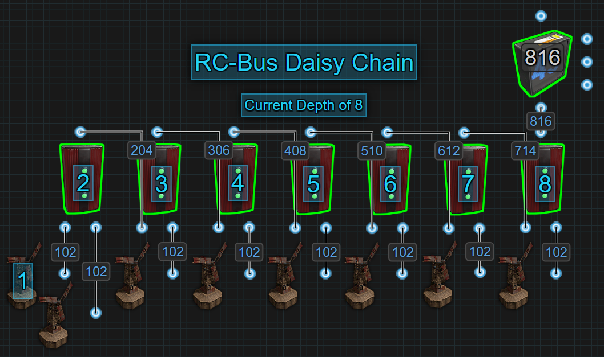

* **How it works**:
  + Connect Combiner 1 to two power sources.
  + Take the output of Combiner 1 and connect it to one input of Combiner 2.
  + Add a third power source to Combiner 2’s remaining input.
  + Continue this process in a linear chain: each new Combiner merges the previous output with one new source.
* **What’s the problem?**
  + Each Combiner in the chain adds one unit of depth between the final output and the earliest source.
  + The Root Combiner system in Rust has a Max Depth limit of 16 components.
  + Daisy Chains quickly reach this limit, especially when mixing in batteries or other logic components.
* **Result**:
  + A few extra devices or a battery backup can push your circuit over the limit, resulting in Max Depth or Short Circuit errors.
  + This layout becomes unstable and hard to expand or troubleshoot as your base grows.

**Pyramid (Recommended)**

A structured, layered layout that minimizes depth and supports larger builds.

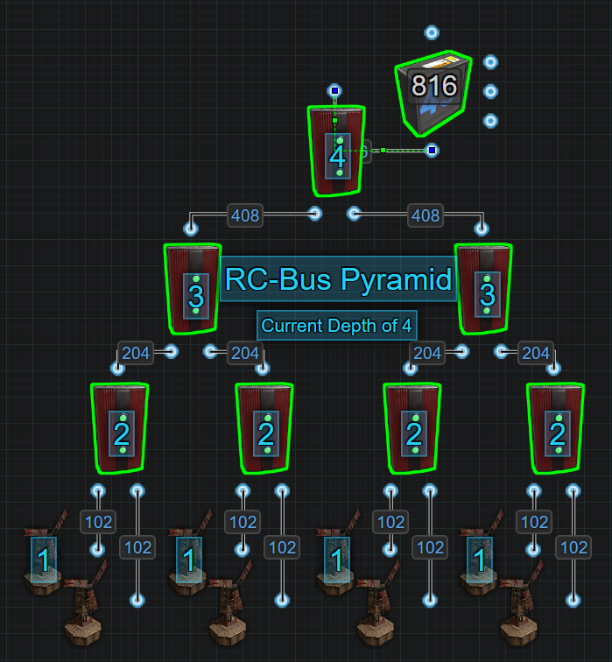

* **How it works**:
  + Combine power sources in pairs, filling one Root Combiner at a time.
  + Once all sources are paired, combine their outputs into new Root Combiners.
  + Repeat the pairing process layer by layer, until all power is unified at the top of the pyramid.
* **Why it’s better**:
  + Only each layer adds to circuit depth, not each individual Combiner.
  + A pyramid that combines 8 sources only reaches 4 depth, compared to 8 depth for a daisy chain.
  + Much more scalable, reliable, and organized for large RC-Bus trees.
* **Design Tip**:
  + If one source remains unpaired at any layer, add another Combiner to merge it with the leftover from a previous layer.

**Benefits**

* **Efficient scaling** – supports any number of power sources
* **Clean consolidation** – reduces wire clutter by merging lines early into a single output
* **Compatible with all source types** – solar, wind, generators and batteries
* **Maximizes output control** – ideal for feeding into downstream bus systems like the BCN Core

**Limitations**

* **No load sharing for batteries** – batteries combined in series will each register the full Active Usage of the circuit
* **Subject to Max Depth** – chaining too many components or wiring inefficiently can break the circuit
* **One-way design** – does not allow for looping power through itself that has already passed through it once before
* **Requires planning** – depth, layout style, wire length and placement must be considered to avoid errors

Sequential Bus (S-Bus)?

# Short Circuit / Max Depth

The **Short Circuit / Max Depth error** is a single in-game warning message that appears when certain rules are violated in the **electrical**, **water**, or **industrial** systems. It is displayed in **red text** when looking at an IO connection, but despite appearing as one message, this error actually represents **two separate problems**: a **Short Circuit**, or a **Max Depth violation**.

When players encounter this error, it will appear as red text when looking at an input or output connection of a component. However, the game does not show the error or tell you which of the two problems occurred, **it’s up to the player to determine whether they’ve created a Short Circuit or exceeded the Max Depth**.

This section of the handbook explains:

* What a **Short Circuit** is, why it happens, and how to resolve it
* What a **Max Depth** violation is, how it's triggered, and how to avoid it
* How these rules apply independently to the **electrical** system

### Short Circuit

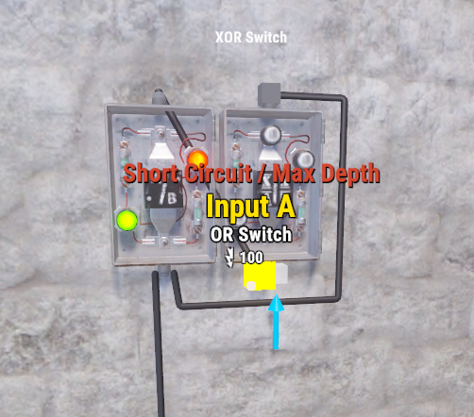

A **Short Circuit** occurs within the electrical system when power is wired into a loop and ends up feeding back into itself. This creates a recursive condition where power has no true destination, and instead endlessly cycles through the same path. Rust detects this and cuts the connection off.

**In short:** loops are invalid unless specifically structured to avoid this condition.

**Why Would Players Do This?**

In today’s Rust, **there is no valid reason yet to intentionally create a power loop**. However, this was not always the case. In the past, batteries behaved differently:

* They were either charging or discharging, not both.
* When discharging, they always output full power (e.g., 100rW for a Large Battery).
* This meant that the amount of power players saw on an IO connection was actually draining from a battery.

Players discovered ways to reuse unused battery output by **feeding it back into the battery** — a trick known as the “Infinite Power Loop.” This was the real Infinite Power Loop, not the OR/Blocker from the past and worked until **Active Usage** was introduced.

**What Changed?**

Batteries now calculate **Active Usage**, meaning:

* A battery only discharges the amount of power a circuit actually needs.
* The number seen at an IO connection is showing Available Power that can be used and is not contributing to Active Usage.
* If the battery has no Active Usage, it does not drain and there is no wasted power to “loop-back”.

Additionally:

* Batteries add their own Active Usage when charging. This value is 4x their max output. For a Large Battery, this is 400.
* Creating a loop now causes the battery to count the amount of power in the loop back as Active Usage, resulting in a 20% efficiency reduction with zero benefit.

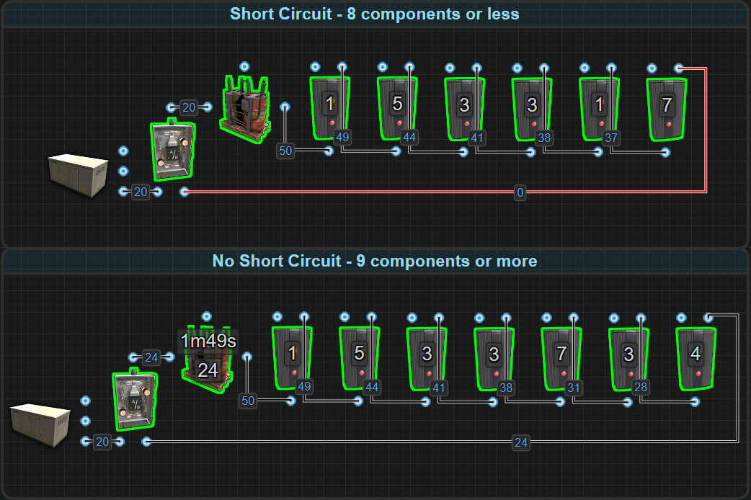

⚠️ **Feeding power back into a battery is not only useless, it actively harms your power efficiency.**

**How to avoid a Short Circuit**

Rust automatically detects when a power path forms a loop. If the total number of components involved in the loop is **8 or fewer**, the game issues a **Short Circuit error**.

However, you **can bypass this** detection by increasing the loop size to **9 or more components**. While this removes the error, the loop still offers **no practical benefit**.

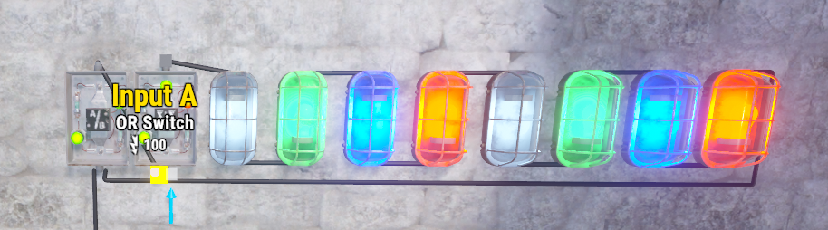

### Max Depth

A **Max Depth violation** happens when the number of components from and **including a Power Source to a Root Combiner** exceeds a hardcoded limit of 16. This is one of the most common causes of confusion when players build advanced centralized power networks.

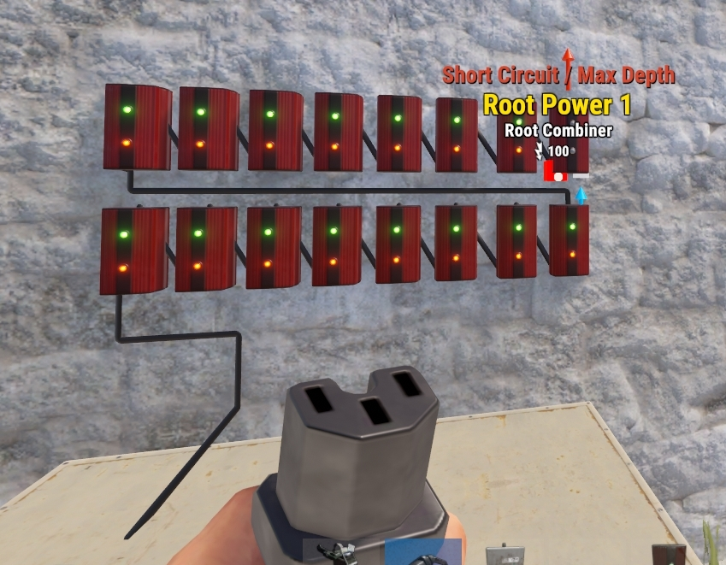

Despite showing the same **Short Circuit / Max Depth** error message, this is an entirely different issue than a Short Circuit.

**Understanding Max Depth**

When electricity travels from a **Power Source to a Root Combiner**, it may pass through many electrical components along the way, including branches, splitters, switches, lights, batteries, etc.

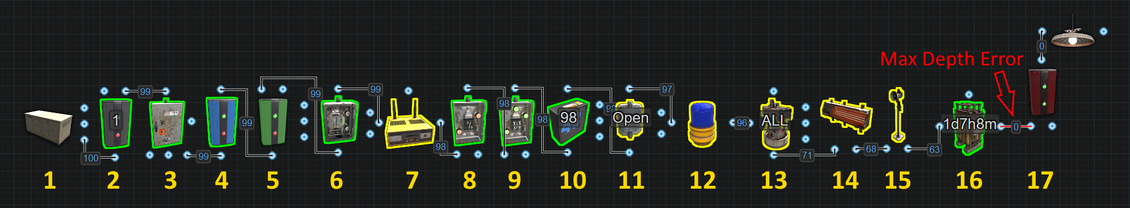

If the total number of components in that power path **exceeds 16**, the Root Combiner will stop functioning and display the Short Circuit / Max Depth error on one of its inputs.

* Power paths are not allowed to exceed 16 components between a Power Source and a Root Combiner. If this happens, the Root Combiner will reject the input entirely.

⚠️ **This rule applies to every unique path.** This includes circuits that use multiple power sources and multiple Root Combiners, such as in RC-Bus, or circuits that create many possible routes for power, like C-Bus layouts. Rust checks each one individually, and only one needs to exceed the limit to break the system.

**Quick Tip: How to Count Components**

When checking Max Depth, every **electrical component** the power passes through counts as 1. You don’t need to memorize examples. Just ask yourself:

“Is the path this power is taking going into and through this object?”

* If yes — it counts.

**Preventing Max Depth Errors**

There is no way to bypass the Max Depth limit, it is hardcoded. However, following best RC-Bus design practices, players can delay or eliminate the risk of hitting it:



* Use a **Pyramid** structure when combining power: pair sources into Root Combiners layer by layer.
* **Avoid** routing power through **non-essential components** before reaching the Root Combiner.
* Place Root Combiners closer to your power sources rather than centralizing too early.
* Take full advantage of **wire length** to prevent using another component to extend a wire.

🧠 Learn more about RC-Buses and Pyramid stacking in the Power Bus Theory section.

**Troubleshooting Max Depth Violations**

If you're seeing a **Short Circuit / Max Depth** error and suspect it's due to Max Depth, here's how to narrow it down:

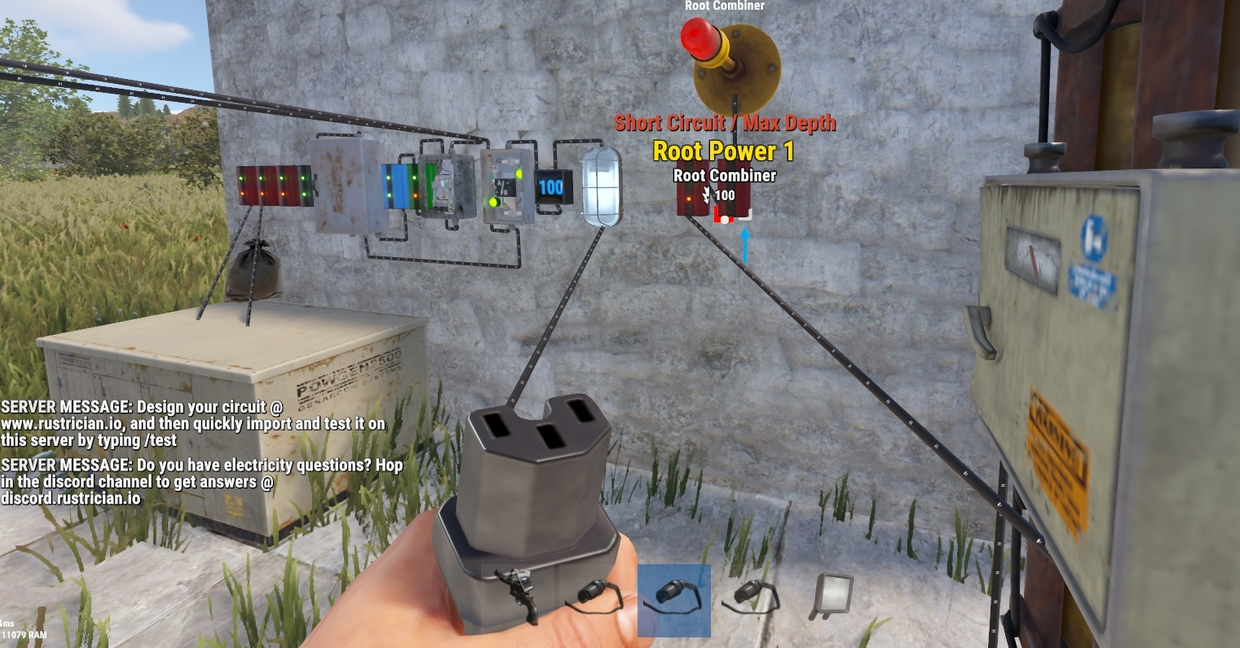

* Begin by identifying **which Root Combiner input is showing the error**.
* From that input, trace the **entire wire path back to the power source**.
* Count every component that power flows through, batteries, splitters, branches, etc. Include the power source.
* If **any single path** exceeds **16 components**, that path is invalid and will trigger the error.
* Repeat this process for **each power source** connected to the combiner. The error occurs if **even one** of them breaks the limit.

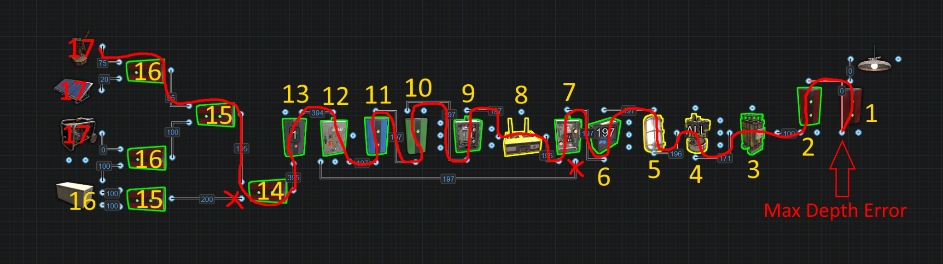

✅ It’s always the **longest path** that matters, not the average, and not the shortest.

This becomes especially tricky in:

* Circuits where **power is split and re-merged** (like a C-Bus)
* Setups that combine **power from distant locations** using multiple RC-Buses
* Battery backups with **shared outputs** routed through combiners

a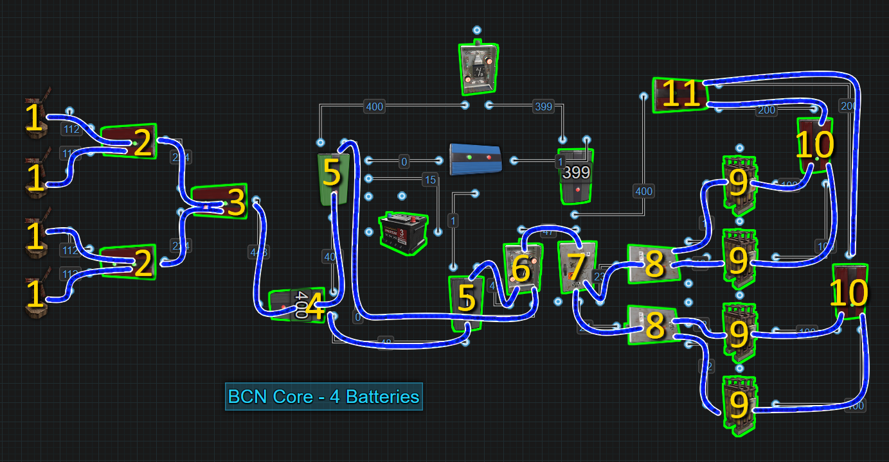

These designs introduce multiple valid paths, making it harder to troubleshoot a Max Depth violation. Players must manually check each path to ensure compliance, or plan ahead, to avoid accidentally hitting the 16-component limit.

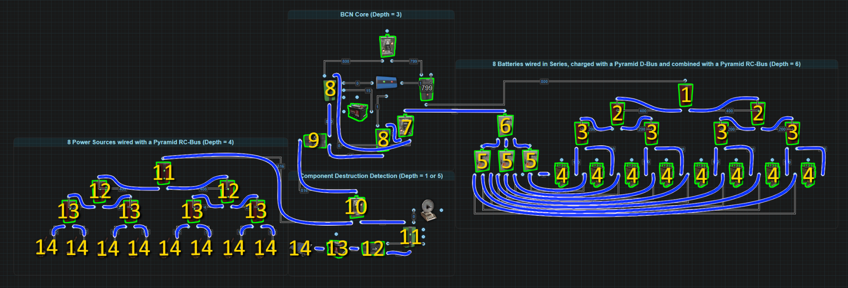

# *Circuit Delay and Power Flow (Slightly out of date)

The reason there is Circuit Delay or Power Flow is because we are dealing with lines of code. Specifically we are dealing with lines of code for electricity in Rust, aka rustricity. Rustricity is a single threaded system. This means that everything happens 1 line of code at a time for the entire server. It doesn’t matter how many circuits are running on a server at 1 time. The server will process everything rustricity, every activation, deactivation, action, reaction, transfer, etcetera, 1 at a time. Now this doesn't need to be said but just to make sure we are all on the same page, the server you login to to play on is running or hosted on a computer. That computer is also referred to as a server. The faster the hardware of this server is and the more dedicated this hardware is to running the game server, the better rustricity will perform.

The best rustricity will perform on any server is when it is solely hosting a vanilla game. The more programs running on the server or the more plugins installed for the game, the slower the rustricity will function therefore increasing Circuit Delay.

## **Circuit Delay**

Circuit Delay at its most basic, is the amount of time it takes power to pass from one component to another. The amount of time we are talking about is incredibly small but a lot of small increases will eventually become a large amount of time. One way to test how fast rustricity is on any server is by stringing a bunch of lights together, the more the better, and watch how long it takes for all of them to turn on and off. For this reason, it is impossible to say the specific amount of time it takes for components to react but some do react slower or faster than others.

All components that only have a power input and a passthrough power output, will react at or around the same speed. These would be components like lights. From the moment the light receives power to the moment it sends power out, we will call this 1 unit of time. If power passes through 2 lights, from the moment the first light receives power to the moment the second light sends power out, we can call this 2 units of time. The time it takes to pass through 3 lights, we call 3 units of time.

Components with multiple outputs have their own delay, 1 for each output. For example, the Splitter, it has 3 outputs. Power is sent out 1 output at a time. The amount of time from the moment the Splitter receives power to the time the last output sends power out is equal to 1 unit of time. The Electrical Branch sends power through Power Out first then Branch Out and this is equal to 2 units of time. On the Memory Cell, it needs 3 units of time to flip outputs.

Batteries also have their own delay. When a battery has an Active Usage of 0, it enters an ‘Off’ state. When the time comes for the battery to power something, it must enter an ‘On’ state which has a delay equal to 2 units of time. Keeping the battery in the ‘On’ state with a Root Combiner or an Industrial Light eliminates the delay so you have power right away.

Once a series of connected components exceeds X number, the entire series of components acts as if it is 1 component. For example 1000 lights in series. When turned on, they will all turn on at the same time.

## Power Flow

**Power Flow** is the path electricity takes through a circuit and the order of the path, aka the order of operation. We need to remember that Rustricity is nothing more than lines of code that are processed 1 after another. Not only does this create a Circuit Delay, as explained above, it also only allows 1 component at a time to perform an action. This creates the order of operation.

Using the picture below to help illustrate, when we flip on the Switch, light 1 will power on followed by light 2 then light 3 and finally light 4. When we flip the Switch off, light 1 will power off followed by light 2 then light 3 and finally light 4. Power flow gets a little more complicated when we introduce components with multiple outputs. 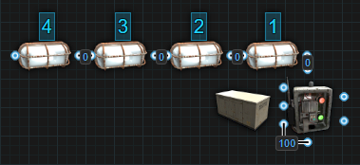

Starting with the Electrical Branch that has 2 outputs, power is first sent through Power Out then power gets sent through Branch Out. When power is removed, it will first be removed from Power Out then Branch Out.

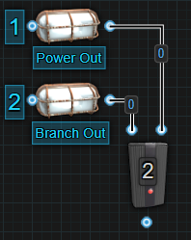

The Splitter is similar but it has 3 outputs. Power first goes through Power Out 1 followed by Power Out 2 then Power Out 3. When power is removed, it will be removed first from Power Out 1 followed by Power Out 2 then Power Out 3.

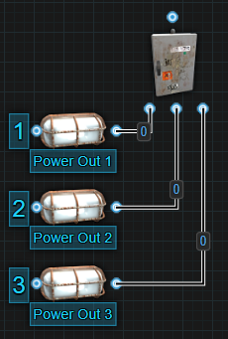

The Memory Cell is another component that has 2 outputs. Even though it only sends power through 1 output at a time, Output will always react before Inverted Output. This means that when we apply power to ‘Set’, power will be sent out the Output first before we lose power from the Inverted Output. When we apply power to ‘Reset’, we will first lose power from Output before power is sent out the Inverted Output.

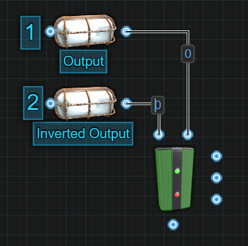

Looking at these components at the individual level should be fairly easy to understand. When we combine components with multiple outputs, we will start to create a semi-predictable path. Using the below image, we know that the Electrical Branch will send power through Power Out first before sending power through Branch Out. It will do this before either Splitter attached to them will react. This gives us the following order of operation, 1 through 8.

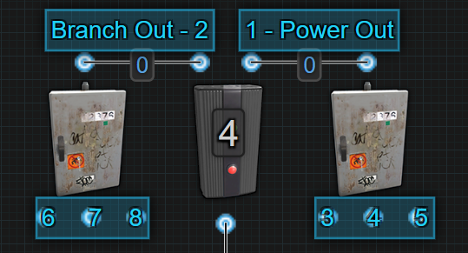

The Memory Cell acts similarly to the Electrical Branch. 1 output will react before the other, the only difference is 1 output is losing power while the other is gaining power. Let's say we are going to flip power from the Inverted Output to the Output. 1- Output will send out power first. 2- Inverted Output will lose power next. 3, 4 and 5 will send out power one at a time in order, followed by 6, 7 and 8 losing power one at a time, in order. The order of operation is the exact same when flipping power back over to Inverted Output from Output.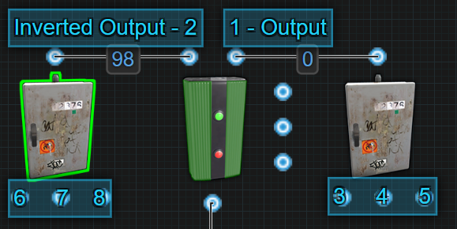

So far we have been talking about components sending power or losing power. There is another side to Power Flow and that is the order in which a component receives power. Some components require power first before getting toggled while with others, it doesn't matter what input gets power first, they will react once powered on.

Let's start with components that will react no matter what input gets power first.

**Memory Cell** - It doesn't matter if the side inputs or the main input gets power first. Once the main input receives power, it will put itself into the correct configuration based on what side inputs are receiving power.

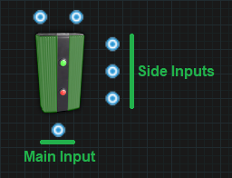

**Counter** - Sending power to the side inputs, it will count up or down and clear with no power provided to the main input. Only once power is provided to the main input will the screen turn on to display the number. If the number shown is the same as the target number, power will be sent through.

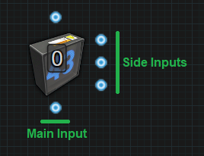

**RAND Switch** - Sending power to the side inputs will Set and Reset the RAND Switch with no power provided to the main input. Only once power is provided to the main input will power pass through or not depending on the state of the switch. The side inputs only react when they are provided with power. Having constant power on them when the main power is removed or received will not affect the switch and it will remain in the same state.

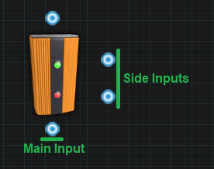

**Blocker** - Sending power to the side input before sending power to the main input will block power from passing through. However, if you send power to the main input first and the very next operation, send power to the side input, it should still block power from passing through. If the delay between sending power to the main input then to the side input is long enough, power will get sent through before it gets blocked.

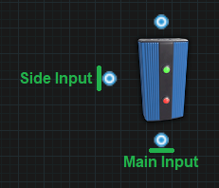

The following components require power to their main input first before sending power to their secondary inputs.

**Electric Furnace(no more inputs)** - If you want to use the secondary inputs to turn the furnace on or off, you must send power to the main input first. If you send power to the secondary input first, when the main input receives power, the furnace will remain in whatever state it was in before the main input lost power.

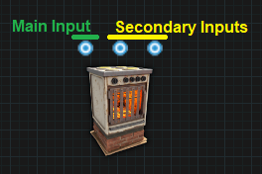

**Conveyor** - If you want to use the secondary inputs to turn the conveyor on or off, you must send power to the main input first. If you send power to the secondary input first, when the main input receives power, the conveyor will remain in whatever state it was in before the main input lost power.

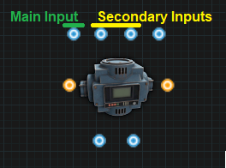

**Timer** - If you want to use the secondary input to toggle the timer on, you must first send power to the main input. If you send power to the secondary input first, when the main input receives power, the timer will not toggle on.

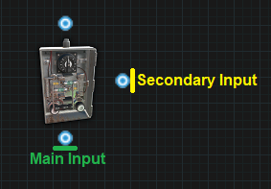

**Boom Box** - If you want to use the secondary input to toggle the boom box on to play music, you must first send power to the main input. If you send power to the secondary input first, when the main input receives power, the boom box will not toggle on and not play music.

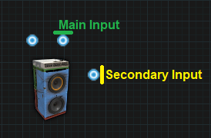

**Elevator** - If you want to use the secondary inputs to call the elevator to a floor, you must first send power to the main input. If you send power to the secondary inputs first, when the main input receives power, the elevator will not be called to a floor.

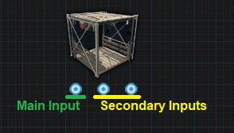

We have covered how power flow is affected by components with multiple outputs. We have covered components that are affected by the order they receive power flow. The last piece of the puzzle is something I don't have enough information to properly explain atm. It appears that the game can prioritize some components over another. I hope to one day be able to explain this in detail but to help illustrate how a complex circuit behaves, I have broken down the Nih Core to show the order of operation.

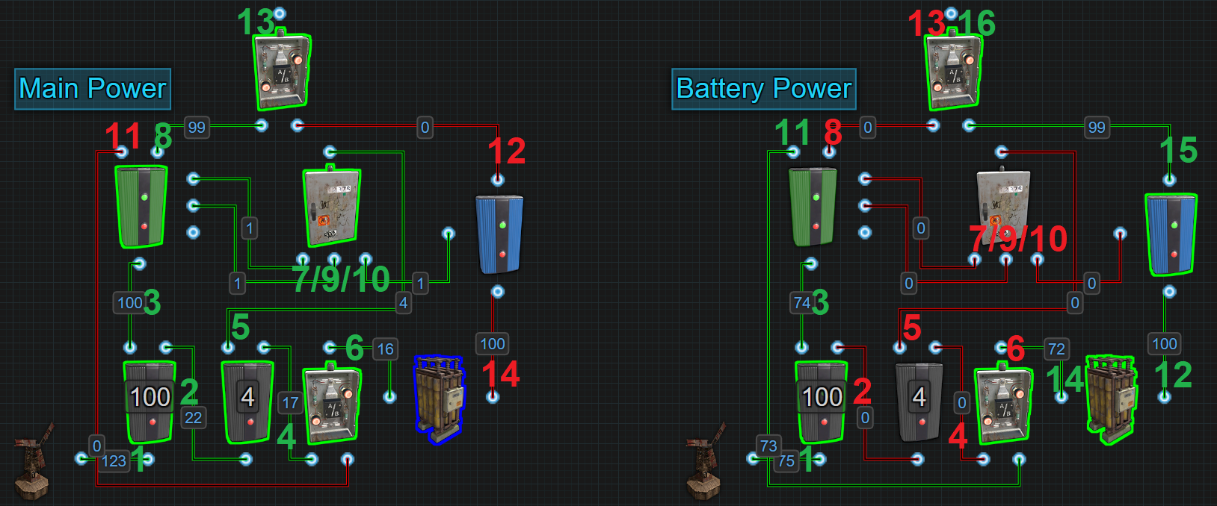

The left side shows the order of operation when switching from battery backup to windmill power.

Main Power:

1. The amount of power coming into the Nih Core rises above 106.
2. Power is sent out Power Out to the next Electrical Branch.
3. Power coming out of Branch Out to the Memory Cell rises to its set amount.
4. Power is sent out Power Out to the OR Switch.
5. Power is sent out Branch Out to the Splitter.
6. Power is sent out to the Large Battery.
7. Power is sent out to Set on the Memory Cell.
8. Power is sent out the Memory Cells Output.
9. Power is sent out to Reset on the Memory Cell.
10. Power is sent out to Block Passthrough on the Blocker.
11. Power stops coming out of Inverted Output on the Memory Cell.
12. Power stops coming out of Power Out on the Blocker.
13. Power from the Memory Cells Output is now the power passing through the OR Switch.
14. The battery enters its Off state.

The right side is the order of operation when switching from windmill power on to battery backup.

Battery Power:

1. The amount of power coming into the Nih Core drops below 106 triggering the flip but must drop below 101 for it to look like the example pictured.
2. Power stops coming out of Branch Out to the next Electrical Branch.
3. Power coming out of Branch Out to the Memory Cell drops below its set amount.
4. Power stops coming out of Power Out to the OR Switch.
5. Power stops coming out of Branch Out to the Splitter.
6. Power stops coming out of the OR Switch to the Large Battery.
7. Power stops going to Set on the Memory Cell.
8. Power stops coming out of the Memory Cells Output.
9. Power stops going to Reset on the Memory Cell.
10. Power stops going to Block Passthrough on the Blocker.
11. Power is sent out the Memory Cells Inverted Output.
12. The battery enters its On state and sends power out to the Blocker.
13. Power stops coming out of the OR Switch.
14. Power is sent out the OR Switch to the Large Battery.
15. Power is sent out the Blocker to the OR Switch.
16. Power is sent out the OR Switch.

That wraps up this section. I hope I have explained things in a way that makes sense. Please comment if you have any suggestions or questions.

Logic 101 (Needs Work)

This section should dive into logic gates and how to use them.

We need to discuss and show things like encoders and decoders. Shift Registers and Memory. Half-Adders, Adders, and the rest of subtraction, multiplication and division. Discussions on Flip-Flops. The logic behind probabilities.

Industrial Concepts

The industrial system lets players utilize electricity to replace several menial tasks. It is now possible to replace the manual labor of maintaining Tool Cupboards, sorting boxes, smelting ore or even crafting items with a few components and some rustricity. The details of the different industrial components can be found in the Industrial section under Component Details. It is recommended to be familiar with the different components before reviewing the different systems.

# Automated Tool Cupboard Extension

One of many menial tasks of daily base operations is topping up the Tool Cupboard to prevent the base decaying. If the base is small enough, the TC might be able to hold several days or more of upkeep, but as bases grow in size, it can quickly get out of control. With only a few components and a couple rust watts, players can reduce or even remove the need to spend any time focusing on the Tool Cupboard keeping it topped off. Like most things with Rustricity, there is more than 1 way to accomplish this task, all with different levels of complexity and functionality.

## Basic

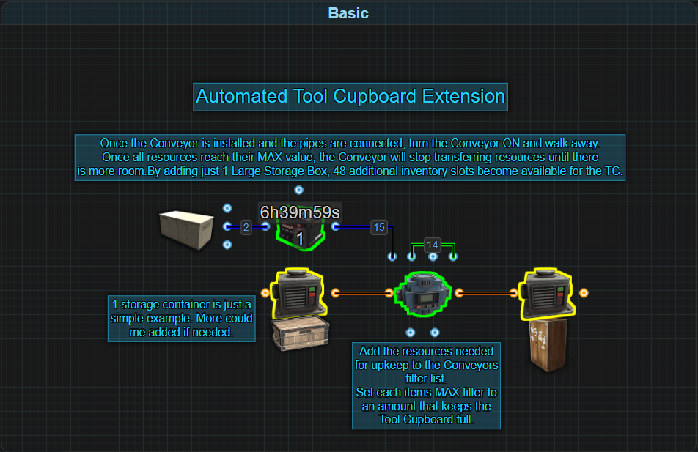

Starting with this basic example, we are using the Conveyor to pull resources from 1 storage container to put into the Tool Cupboard, effectively tripling the number of inventory slots available to the Tool Cupboard. A player will still need to put resources into the box, but not as often as compared to without it.

Adding a Small Battery to the system will help to increase the amount of time the TC will continue to get filled should something happen to the main power supply and backup system. The drain on the battery is only 1rW so the lowest amount of power it needs to be given is 2rW.

Utilizing the MAX filter setting, the Conveyor will try to keep that amount of each resource in the Tool Cupboard at all times. Sending power from its Passthrough output to its Turn ON input will ensure it always turns on after a server restart. The Conveyor should never be turned off. Note that the MAX values do not need to fill the TC all the way. Values can be set to a lower amount if the player desires.

**Example:** The upkeep cost of a base is 3978 Stone and 100 Wood. The MAX filter for Stone could be set to 23,000 and for Wood it can be 1000. This will provide over 5 days of upkeep in the TC alone. As upkeep is consumed, the Conveyor will move resources in. If the box has 46,000 Stone, that is enough resources to last roughly 17 days. Add 2000 Wood to the box and the player would only need to worry about the Stone, eventually.

With the added benefit of only needing 4 components and 2rW of power to maintain, this is a very simple setup to help reduce the amount of time restocking the Tool Cupboard. 2rW is not a lot of power, but this example is not necessarily the most efficient way to use it. The Conveyor only needs to turn on when resources need to be transferred. Adding a couple more components and a few more wires, players can easily increase the functionality of those 2rW in highly beneficial ways.

## Basic+

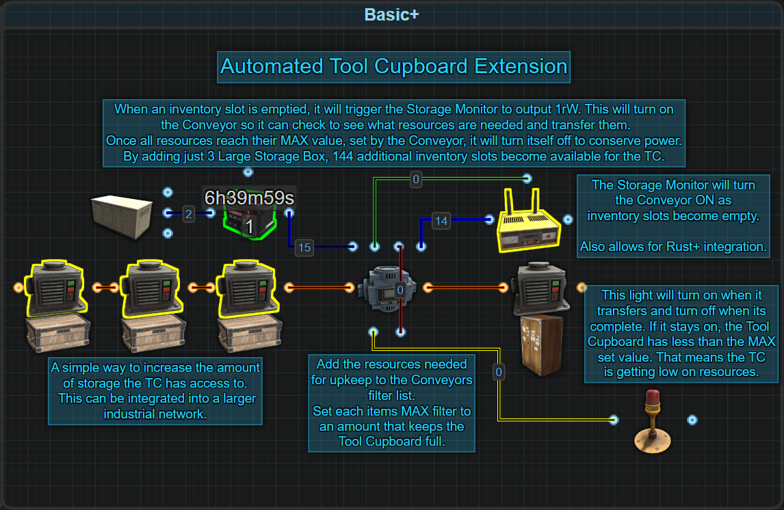

With this example, the Conveyor is used to pull resources from 3 storage containers to put into the Tool Cupboard, effectively multiplying the number of inventory slots available to the Tool Cupboard by 6 times. A player will still need to put resources into the boxes, but not as often as compared to with only 1 container.

The addition of the Storage Monitor allows the Conveyor to be turned off when the Tool Cupboard is full. The power that the Conveyor was always consuming from the prior example, is now used by the Storage Monitor. The drain on the battery is still only 1. The Storage Monitor will pulse 1 power to the Conveyors Turn ON input when an inventory slot in the Tool Cupboard is emptied.

The Conveyor will use the MAX filter setting to check to see what, if any, resources are needed to be transferred. If some do, Filter Pass will output power tuning on the light (or any 1rW component). Once the TC is full again, the Conveyor will output power from Filter Fail turning off both the light and itself. If the light doesn't turn off, the storage boxes are out of resources. Note that the MAX values do not need to fill the TC all the way. Values can be set to a lower amount if the player desires.

**Example:** The upkeep cost of a base is 3978 Stone and 100 Wood. The MAX filter for Stone could be set to 23,000 and for Wood it can be 1000. This will provide over 5 days of upkeep in the TC alone. As upkeep is consumed, the Stone will be used faster than the Wood. Each time an inventory slot frees up, the Conveyor is turned on by the monitor and resources are transferred. When the TC is full again, the Conveyor will turn off. If each of the boxes has 47,000 Stone and 1000 Wood, that is enough resources to last a wipe.

By adding the light (or any 1rW component like an Industrial Light or Audio Alarm), it gives players an easy visual or audible way to know when the Tool Cupboard is getting stocked or low on resources. Even better is the addition of the Storage Monitor giving players the ability to pair their Tool Cupboard with Rust+. No longer will they need to visit the TC to check on the amount of remaining resources. These were some simple modifications allowing more functionality at no additional cost to the amount of power used. Things don't have to stop here if players are willing to step up the complexity of the circuit.

## Intermediate

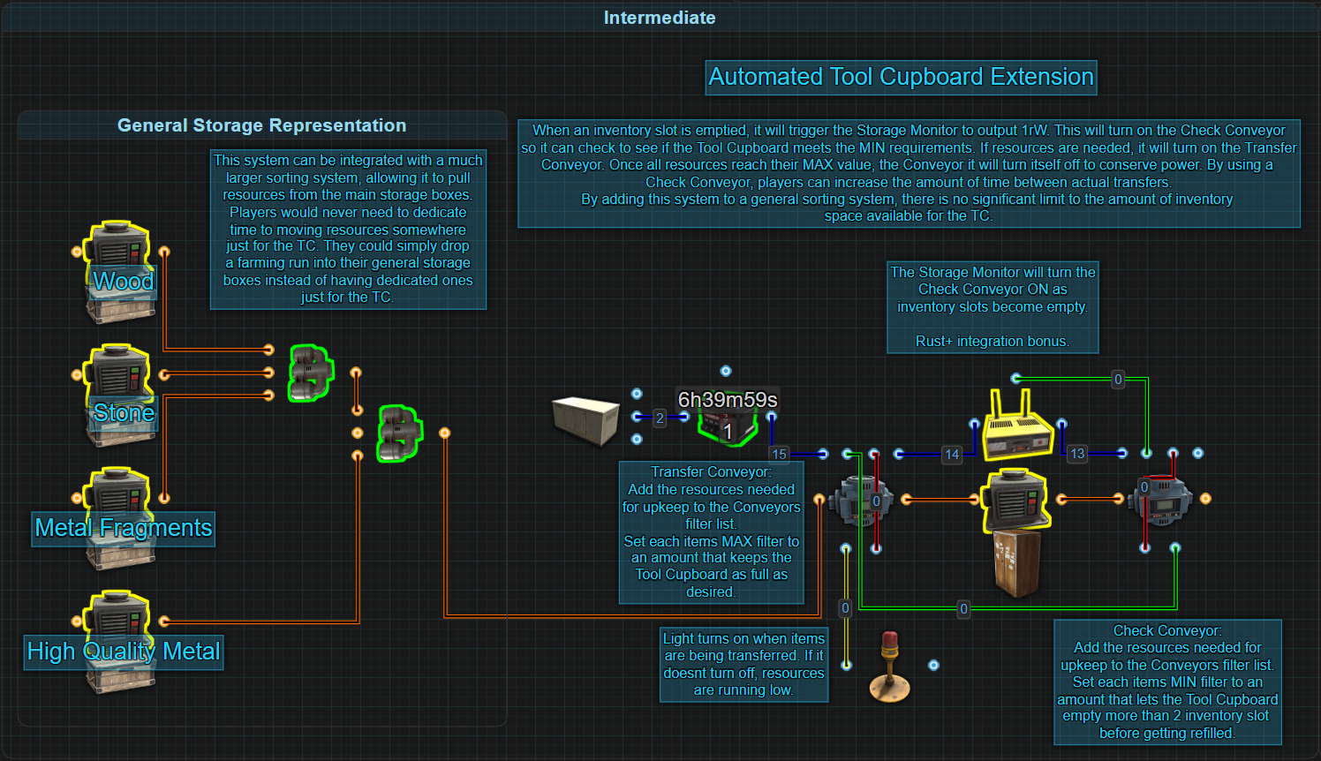

A step up in complexity, this example is going to pull resources from a general representation of a storage system rather than having dedicated boxes just for the Tool Cupboard. This can further reduce the time spent on keeping the TC stocked.

Continuing with the trend of using a Storage Monitor, it will pulse 1rW every time an inventory slot is emptied. That pulse is used to turn on a Check Conveyor to control the timing of resource transfers.

A Check Conveyor uses the filtered items MIN value to check the Tool Cupboard and see if there are more or less of this set value. If there is more than the MIN amount, the Check Conveyor will turn itself off. When there is less, it will turn on the Transfer Conveyor. Using a Check Conveyor in this way allows players to set how few resources the TC can get down to before restocking it.

When the Transfer Conveyor is moving items, it will turn on the light (or any 1rW component). It will transfer resources until it reaches each item's MAX filter value. Once these values are reached, the Transfer Conveyor will turn itself off. During the transferring of resources, the Check Conveyors MIN values will be surpassed allowing it to also turn itself off. Note that the MAX values do not need to fill the TC all the way. Values can be set to a lower amount if the player desires, it just needs to be higher than the Check Conveyors MIN values.

**Example:** The upkeep cost of a base is 24,000 Stone. The MIN filter for Stone in the Check Conveyor could be set to 6000, and the MAX filter for Stone in the Transfer Conveyor could be set to 12,000. This will provide no more than half a day's upkeep but no less than 6 hours. Each time an inventory slot is emptied, the Check Conveyor will turn on look to see if more or less than 6000 Stone is present. If there are 6000 or more, the Check Conveyor turns itself off. If less, it will turn on the Transfer Conveyor. The Transfer Container will move Stone from the general storage until 12,000 Stone is present before turning off.

By adding the light (or any 1rW component like an Industrial Light or Audio Alarm), it gives players an easy visual or audible way to know when the Tool Cupboard is getting stocked or low on resources. The convenience of the Storage Monitor gives players the ability to pair their Tool Cupboard with Rust+ so no longer will they need to visit the TC to check on the amount of remaining resources.

These were some more simple modifications allowing even more functionality at no additional cost to the amount of power used over any other example shown. If players still want to delay the transfer, and don't want to use a Check Conveyor, a Counter could be used instead.

## Intermediate+

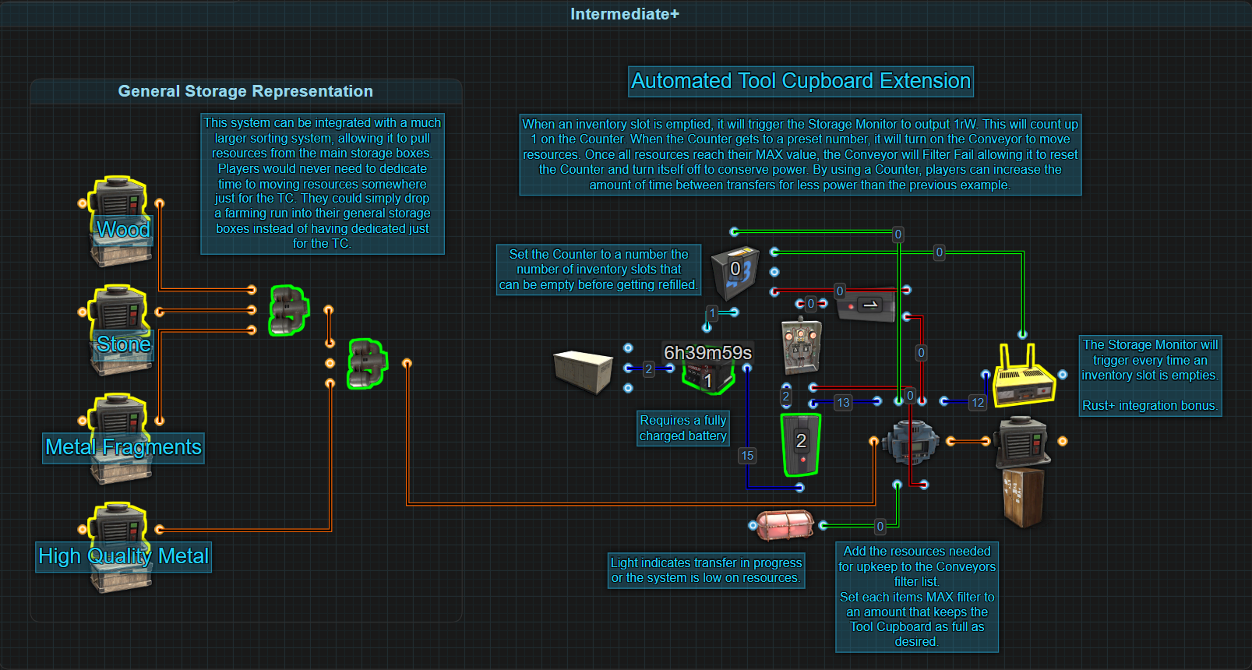

This example accomplishes the same task as the previous one, but with a few extra components. It is still going to pull resources from a general representation of a storage system rather than having dedicated boxes just for the Tool Cupboard. This will further reduce the time spent on stocking the TC.

Again, continuing with the trend of using a Storage Monitor, it will pulse 1rW every time an inventory slot is emptied. That pulse is used to count up once on a Counter and it is the Counter that controls the timing of resource transfers.

The Counter gets set to the number of inventory slots that will need to be emptied. Each slot that is emptied, a pulse from the Storage Monitor counts up by 1 on the Counter. When the Counters set value is reached, it will output power to turn on the Conveyor. The Counter does not consume power, so using the batteries Fully Charged output for this operation is actually free. While the Conveyor is running, the battery will drain a bit. The battery needs to be fully charged before the Counter gets back to the set value number.

When the Conveyor is turned on, it's going to transfer resources until it reaches their filters MAX value. When it starts to transfer, it can turn on a light or other 1rW components, to indicate that it is transferring or that the system is low on resources. Once the MAX values are reached, the Conveyor will both reset the Counter and turn itself off to conserve power.

**Example:** The upkeep cost of a base is 24,000 Stone. The MAX filter for Stone in the Conveyor could be set to 24,000 providing up to a day's upkeep. If the Counter was set to 12, the Tool Cupboard will consume 12 stacks or half a day’s upkeep, before turning on the Conveyor to refill the TC.

By adding the light (or any 1rW component like an Industrial Light or Audio Alarm), it gives players an easy visual or audible way to know when the Tool Cupboard is getting stocked or low on resources. The convenience of the Storage Monitor gives players the ability to pair their Tool Cupboard with Rust+ so no longer will they need to visit the TC to check on the amount of remaining resources.

This was another way to allow the same functionality at no additional cost to the amount of power used over any other example shown. If players want to take what has been shown here so far to the next level, combining everything is the only logical way forward.

## Advanced

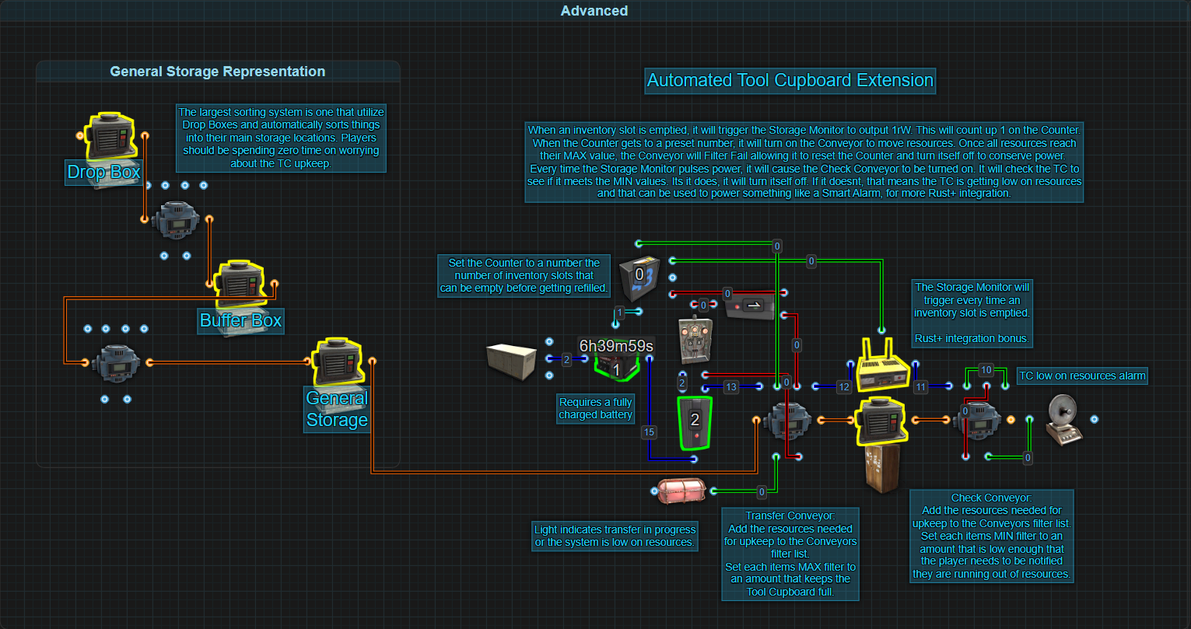

This example is a combination of what is shown is both the Basic and Intermediate examples, for no additional power cost. It is not unreasonable to expect that players would be using a fully automated sorting system complete with Drop Boxes. Players should be spending any time moving loot around for Tool Cupboard upkeep. Go farm, dump it in the Drop Box and the system should take care of the rest.

The Storage Monitor will pulse 1rW of power every time an inventory slot is emptied. Every pulse is used to count up on a Counter that is in control of when resources will be transferred.

The Counter gets set to the number of inventory slots that will need to be emptied. Each slot that is emptied, a pulse from the Storage Monitor counts up by 1 on the Counter. When the Counters set value is reached, it will output power to turn on the Transfer Conveyor. The Counter does not consume power, so using the batteries Fully Charged output for this operation is actually free. While the Transfer Conveyor is running, the battery will drain a bit. The battery needs to be fully charged before the Counter gets back to the set value number.

When the Transfer Conveyor is turned on, it's going to transfer resources until it reaches their filters MAX value. When it starts to transfer, it can turn on a light or other 1rW components, to indicate that it is transferring or that the system is low on resources. Once the MAX values are reached, the Transfer Conveyor will both reset the Counter and turn itself off to conserve power.

A Check Conveyor uses the filtered items MIN value to check the Tool Cupboard and see if there are more or less of this set value. If there is more than the MIN amount, the Check Conveyor will turn itself off. When there is less, it will turn on the Smart Alarm, or any 1rW components. Using a Check Conveyor in this way gives the player a backup way to know when resources have reached a critically low level.

**Example:** The upkeep cost of a base is 24,000 Stone. The MAX filter for Stone in the Transfer Conveyor could be set to 24,000 providing up to a day's upkeep. The MIN filter for Stone in the Check Conveyor could be set to 6000. If the Counter was set to 12, the Tool Cupboard will consume 12 stacks or half a day’s upkeep, before turning on the Transfer Conveyor to refill the Tool Cupboard back to 24,000 Stone. While it transfers resources, the light will turn on. Each time an inventory slot is emptied, the Check Conveyor will turn on to see if there is more or less than 6000 Stone. It should never get this low with the Counter in place, but maybe resources are just not available. The light not turning off should be the first indication something is wrong. If there are less than 6000 Stone, the Check Conveyor will turn on the Smart Alarm to notify the player in a more direct way.

These systems are not limited to what has been shown. These are just some of the most efficient ways to accomplish automating the Tool Cupboards upkeep, freeing a player from the mundane task. If players want to take upkeep to the next level, they can experiment with the decay and healing rates of both interior and exterior walls.

## Advanced+

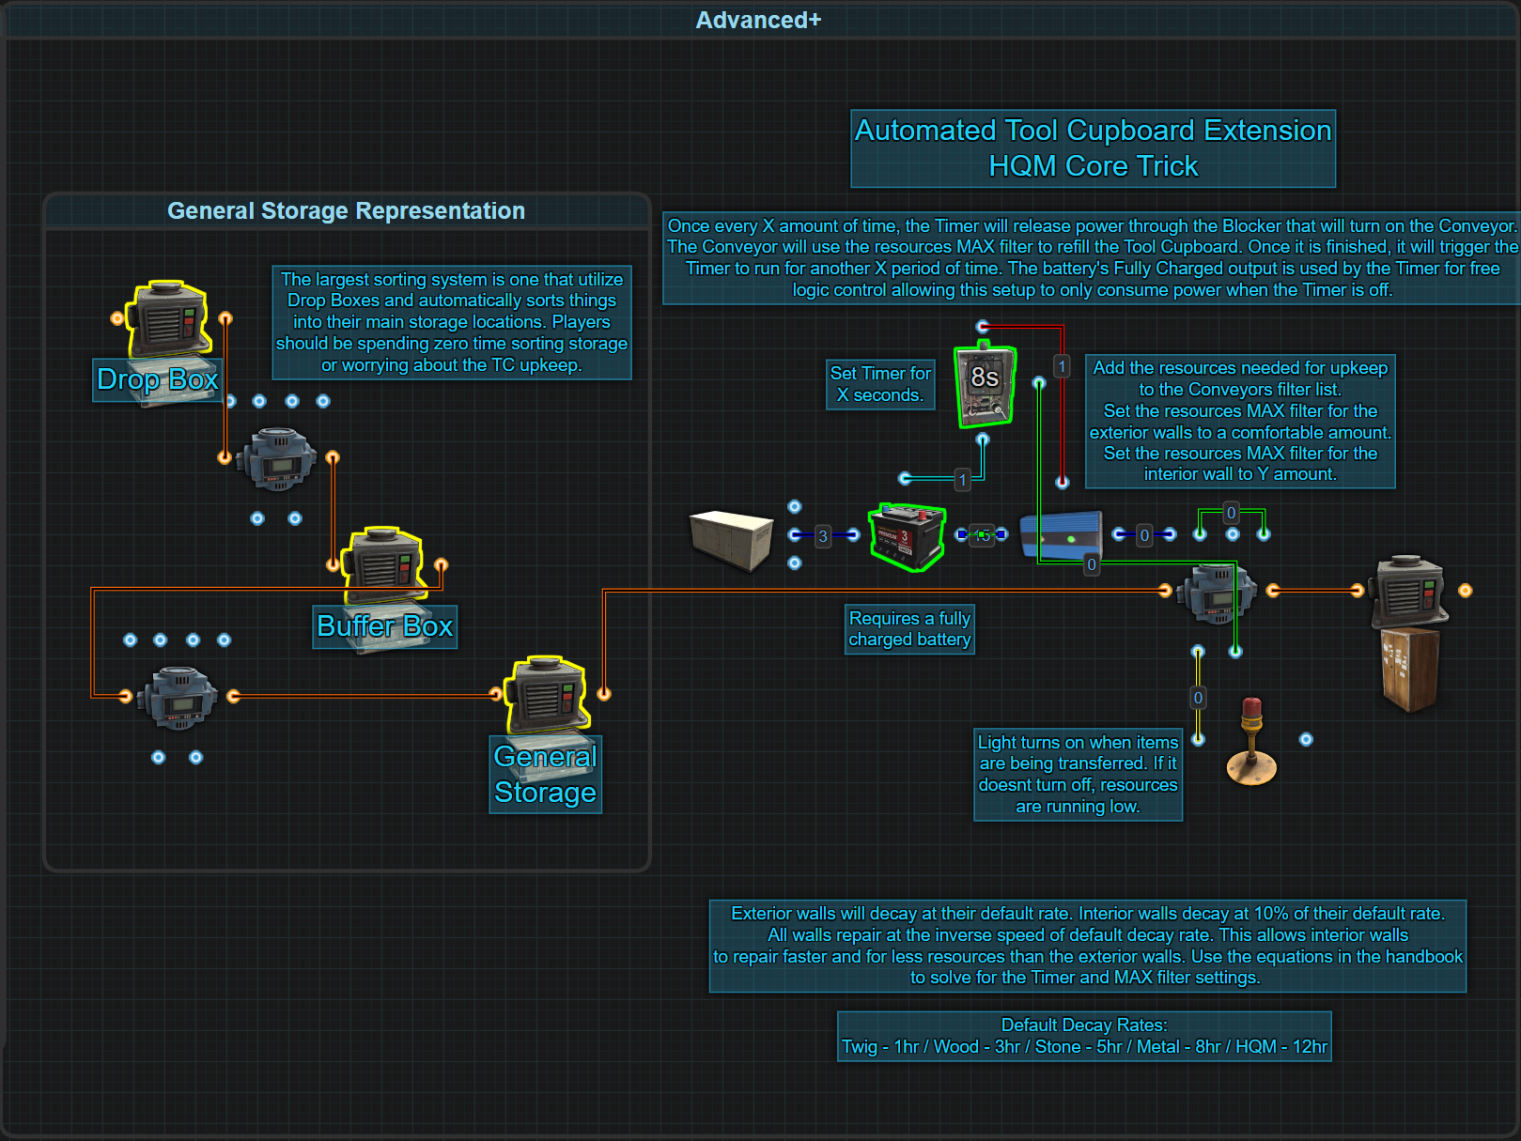

This final circuit in the Tool Cupboard Extension series goes beyond simply automating upkeep delivery. It introduces a strategic method for reducing the total amount of resources consumed by taking advantage of Rust's decay and repair mechanics.

Unlike exterior building blocks, interior blocks decay at only 10% the normal rate — but when upkeep is consumed, they are repaired just as fast as exterior walls to fully restore their health. When properly configured, this allows players to delay upkeep just long enough for damage to occur and then allow the Tool Cupboard to repair it at full efficiency. The result is a potential 90% reduction in upkeep cost for core structures built with Armored building blocks.

The purpose of this system is twofold:

1. Automate the replenishment of Tool Cupboard resources at fixed intervals
2. Calculate the optimal amount of resources to be transferred — and how often — based on acceptable building block health loss.

By using mathematical formulas based on decay cycles and repair behavior, players can precisely tune their setup. This system benefits solo players and large teams alike by minimizing farming, maximizing efficiency, and ensuring a base remains protected with minimal overhead.

**🧠 How It Works**

This circuit uses a fully charged Small Battery as a power source to drive a Conveyor at regular intervals. Unlike traditional battery-backed circuits, the logic here leverages the batteries Fully Charged output for a Timer and the Conveyor’s Filter Fail output to automate shutdown and schedule the next transfer.

**The system operates as follows:**

1. The Small Battery’s Fully Charged output powers a Timer.
2. The Timer powers the Block Through input of a Blocker.
   * When the Timer is ON, the Blocker is blocked.
   * When the Timer is OFF, the Blocker passes power through.
3. The Small Battery’s Power Output is connected to the Blocker’s input.
4. The Blocker’s output powers a Conveyor.
5. The Conveyor’s Passthrough is connected to its Turn On input, ensuring it self-triggers.
6. Once the Conveyor finishes transferring resources, it activates its Filter Fail output.
7. Filter Fail powers the Timer ON, restarting the Timer and blocking the circuit again.

This automation ensures that the Conveyor only runs at specific intervals and shuts off properly including after a server restart.

**⚠️ Important:** The Small Battery must remain fully charged. To ensure this, provide it with a constant 2rW of power after it is completely charged.

**🔄 Power Flow Logic**

**Power Source:**

* Small Battery
  + Fully Charged → Timer input
  + Power Output → Blocker input

**Main Circuit Flow:**

* Timer → Block Through (Blocker)
* Blocker Output → Conveyor Input
* Conveyor Passthrough → Conveyor Turn On
* Conveyor Filter Fail → Timer Toggle

**Cycle Behavior:**

1. Timer OFF = Blocker allows power → Conveyor turns on → Transfer begins
2. Conveyor completes transfer → Filter Fail triggers Timer ON → Blocker activates → Conveyor loses power
3. Timer counts down again, cycle repeats

**🔄 Decay/Repair and Upkeep Mechanics**

**🕐 Upkeep Timing**

* After construction or upgrade, each building block starts its own 10-minute timer. At the end of that timer, the building block requires upkeep.
  + If supplied, there is no change to the building block.
  + If not supplied, the building block takes damage.
  + If supplied and the building block is damaged, it will be repaired.
* The TC checks every 10 seconds to see what building blocks have expired timers. At this time, any expired timers will either consume upkeep or inflict decay.

**📉 Default Decay/Repair Rates per Tier**

| **Tier** | **Max HP** | **Total Time** | **# Intervals** | **HP lost / 10 min** |
| --- | --- | --- | --- | --- |
| Twig | 10 | 1h | 6 | 1.67 |
| Wood | 250 | 3h | 18 | 13.88 |
| Stone | 500 | 5h | 30 | 16.67 |
| Metal | 1000 | 8h | 48 | 20.83 |
| Armored | 2000 | 12h | 72 | 27.78 |

* Interior building blocks decay at 10% of the normal rate, but they are repaired just as quickly as exterior blocks.
* This creates a huge opportunity to reduce upkeep cost by delaying repair for as long as health loss is acceptable — and then recovering full durability quickly and cheaply.

**📌 Tax Scaling**

Tool Cupboard upkeep is based not only on the materials used to build but also on the number of building blocks connected to a structure. Rust applies an upkeep tax percentage that increases as more blocks are added.

This tax is calculated using four brackets, each applying a different rate:

| **Bracket** | **Block Range** | **Tax Rate** |
| --- | --- | --- |
| 0 | 1–15 blocks | 10% |
| 1 | 16–65 blocks | 15% |
| 2 | 66–190 blocks | 20% |
| 3 | 191+ blocks | 33.3% |

The final tax is an average across all blocks, not just a flat rate. Each building block contributes its own tax rate based on its bracket. The total upkeep is calculated by summing the taxed values of all blocks, then rounding up.

This cumulative system means that as base size increases, the average tax — and thus total upkeep — rises proportionally, encouraging compact and efficient designs.

**📀 Key Formulas**

These formulas allow players to calculate exactly how long to wait before sending resources to the Tool Cupboard, and how many to send based on desired damage tolerance, upkeep cost, and repair rate.

**1. ⏱️ Timer Delay (in minutes)**

Determines how long to set the Timer to. This is how long the system should wait before transferring upkeep resources to the Tool Cupboard.

TimerSeconds = ((HP_loss ÷ DecayRate) × 10) × 60

**Legend:**

* **TimerSeconds:** The amount of time to set the Timer to
* **HP_loss:** How much damage a player is willing to let blocks decay (eg. 200hp)
* **DecayRate:** HP lost per 10 minutes (based on building tier for interior building blocks)
  + **Armored:** 2.78
  + **Metal:** 2.08
  + **Stone:** 1.67
  + **Wood:** 1.388
  + **Twig:** 0.167
* **× 10:** Converts intervals into real-world minutes
* **× 60:** Converts Minutes to Seconds for the Timer

**2. 🎚️ Conveyor Max Filter (Resource Quantity)**

Calculates how many resources to send to repair the defined damage.

MaxFilter = CEIL( (HP_loss ÷ RepairRate) × (Upkeep ÷ 144) )

**Legend:**

* **MaxFilter:** The amount to set the resources MAX filter setting to in the Conveyors filter list.
* **HP_loss:** Same value as above, how much damage a player is willing to let blocks decay( eg. 200hp)
* **RepairRate:** HP repaired per 10 minutes (based on building tier for exterior building blocks)
  + **Armored:** 27.78
  + **Metal:** 20.83
  + **Stone:** 16.67
  + **Wood:** 13.88
  + **Twig:** 1.67
* **Upkeep:** The 24-hour upkeep value displayed in the Tool Cupboard
* **÷ 144:** Number of 10-minute intervals in 24 hours
* **CEIL:** After completing the equation, round up to the next closest full number (eg. 1.2 = 2, 7.01 = 8)

**Supporting Formulas**

These additional formulas help with broader upkeep planning and fine-tuning:

**3. 🔄 Calculate The Upkeep Cost Every 10 Minutes**

Upkeep10Min = Upkeep ÷ 144

**Legend:**

* **Upkeep10Min:** Resources consumed per 10-minute interval
* **Upkeep:** Daily upkeep cost shown in the Tool Cupboard
* **÷ 144:** Number of 10-minute intervals in 24 hours

**4. ⏳ Calculate The Amount Of Resources Consumed Over A Player Specified Time Period**

UpkeepTotal = (Upkeep ÷ 144) × (Minutes ÷ 10)

**Legend:**

* **UpkeepTotal:** Total resources consumed over custom time
* **Upkeep:** Daily upkeep cost shown in the Tool Cupboard
* **÷ 144:** Number of 10-minute intervals in 24 hours
* **Minutes:** Number of real-time minutes chosen by the player
* **÷ 10:** Converts minutes into intervals

**5. ⌛ Calculate How Many Minutes A Given Amount Of Resources Will Last?**

UpkeepMinutes = (Resources ÷ (Upkeep ÷ 144)) × 10jin

**Legend:**

* **UpkeepMinutes:** How many real-world minutes the resources will last
* **Resources:** The player chosen number of resources placed into the Tool Cupboard
* **Upkeep:** Daily upkeep cost shown in the Tool Cupboard
* **÷ 144:** Number of 10-minute intervals in 24 hours
* **× 10:** Converts upkeep intervals into real-world minutes

**6. 🔁 Calculate How Many Intervals A Given Amount Of Resources Will Last?**

Intervals = (Resources × 144) ÷ Upkeep

**Legend:**

* **Intervals:** Number of 10-minute cycles
* **Resources:** The player chosen number of resources placed into the Tool Cupboard
* **Upkeep:** Daily upkeep cost shown in the Tool Cupboard
* **× 144:** Number of 10-minute intervals in 24 hours

**7. 🧱 Calculate The Amount Of Decay Over A Players Given Number Of Minutes (Interior Walls Only)**

HP_loss = InteriorDecay × (Minutes ÷ 10)

**Legend:**

* **HP_loss:** Total health lost before a repair cycle begins
* **InteriorDecay:** HP lost per 10 minutes (based on interior walls — 10% of normal rate)
  + **Armored:** 2.78
  + **Metal:** 2.08
  + **Stone:** 1.67
  + **Wood:** 1.388
  + **Twig:** 0.167
* **Minutes:** Number of real-time minutes the player allows the walls to decay
* **÷ 10:** Converts minutes into 10-minute intervals

**8. 📏 Calculate The Number Of Intervals Required To Allow A Specific Amount Of Decay, or HP Loss (Interior Walls Only)**

Intervals = HP_loss ÷ InteriorDecay

**Legend:**

* **Intervals:** Number of 10-minute cycles
* **HP_loss:** How much damage a player is willing to let blocks decay (eg. 200)
* **InteriorDecay:** HP lost per 10 minutes (based on interior walls — 10% of normal rate)
  + **Armored:** 2.78
  + **Metal:** 2.08
  + **Stone:** 1.67
  + **Wood:** 1.388
  + **Twig:** 0.167

**🧰 Example Calculation — Optimizing Armored Core Upkeep**

A player has a base with a 2x2 core and honeycomb. The exterior is Stone, the interior is Armored with Metal floors. The Tool Cupboard shows a daily upkeep of 1843 Stone, 172 Metal, and 61 HQM. For this example, we will calculate only for HQM. The player is willing to allow 200 HP loss before repair begins.

**Step 1: Calculate the Timer Delay**

TimerSeconds = ((HP_Loss ÷ InteriorDecayRate) × 10) × 60

= ((200 ÷ 2.78) × 10) × 60

= (71.94 × 10) × 60

= 719.42 × 60 = 43,165 seconds (~12 hours)

**Step 2: Calculate Conveyor HQM Max Filter**

MaxFilter = CEIL((HP_Loss × UpkeepPerDay) ÷ (RepairRate × 144))

= CEIL((200 × 61) ÷ (27.78 × 144))

= CEIL(12,200 ÷ 3999.84)

= CEIL(3.05)

= 4

**✅ Final Setup:**

* **Timer Delay:** 43,165 seconds (~12 hours)
* **HQM Max Filter:** 4
* **Metal Max Filter:** 2000 (for multiple days of upkeep)
* **Stone Max Filter:** 20000 (for multiple days of upkeep)

This setup allows the player to reduce upkeep by letting the armored core decay intentionally, then repairing with only 4 HQM every 12 hours rather than spending 53 over the same time period.

**⚙️ Design and Efficiency Considerations**

* Players may optionally connect a Siren Light to the Filter Pass output of the Conveyor.
  + This provides a visual indicator that a transfer is occurring.
  + If the light remains on, it means the Conveyor is stuck trying to complete the transfer — likely due to insufficient resources to satisfy all filters.
  + This early warning can prevent silent TC failures.
* When using a Siren Light, the small battery must be given a constant 3rW:
  + This ensures that its Fully Charged output stays active at all times, keeping the light circuit functional and preventing unintended battery drain.
* This setup offers an intuitive and effective status alert for long-term bases with minimal monitoring needs.
* The feature is especially useful for low-frequency transfer systems (e.g., every 12+ hours) where failures might otherwise go unnoticed for a full decay cycle.

**📘 Recommended Reading**

**🔗 External References**

* [Automated Tool Cupboard Extensions](https://www.rustrician.io/?circuit=1e1ee758894ce7c070c80455dc024fff)

## 

# Auto-Smelting

## Automatic Electric Furnace

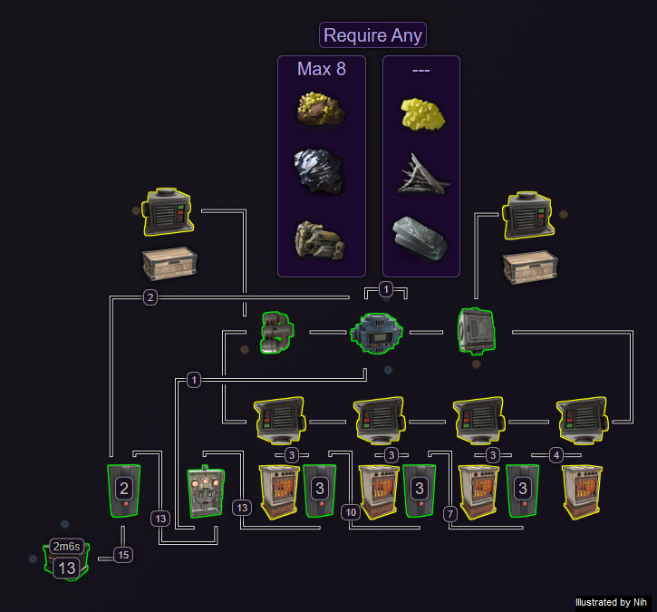

Farming

# Plant Farming

# 

# 

# 

# 

# 

# 

# 

# 

# 

# Horse Farming

# 

# 

# 

# 

# 

# 

Turret Systems

# Misc Turret Info (Holding Area)

# Backup Turrets

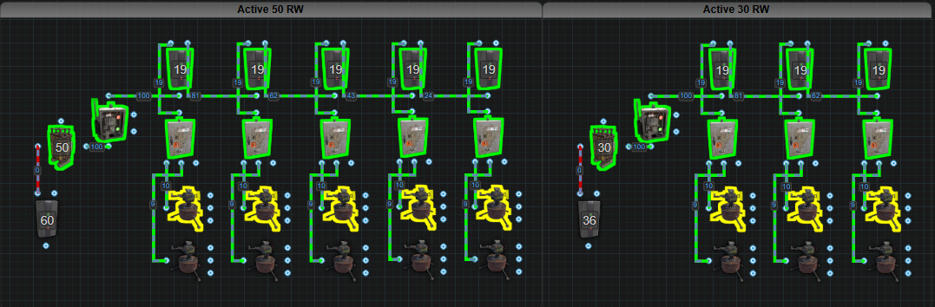

# Flip-Flip Turrets

# 

# 

Historical Archive

# [The original handbook (RIP 2019)](https://www.rustrician.io/rust_electrical_handbook_(rev_j).pdf)

This is the link to the original handbook. Created by GlossyEyedGnome on Reddit in late 2018. It became obsolete in 2019 and there was no immediate replacement.

# [Handbook 2.0 (RIP 2024)](https://www.rustrician.io/wiki/index.html#the-rust-electrical-handbook)

This is the link to the 2nd version of the handbook. It was created by SwiftCoyote in early 2023 but became obsolete in 2024.

# Nih Capacitor

This has been patched out on November 4th 2023 but remains here for the historical record. 🙁

The Nih Capacitor was first established by Nih, with assistance from SwiftCoyote, on September 11, 2022. A Capacitor is a set of components that accumulate power, much like rechargeable batteries. However, the method for assessing the amount of stored power differs.

  
For batteries, the stored power is represented as ‘Capacity,’ measured in Rust Watt Minutes (rWm).

Contrarily, in a Capacitor, we gauge the power storage by examining an Input/Output (IO) connection and observing a figure that is typically associated with ‘power,’ or the amount of power available for use. But within the Capacitor, this figure DOES NOT indicate the amount of power that can be utilized. Rather, this figure is what we call ‘Wire Capacity,’ symbolized as ‘Np’. For instance, in the image below, the displayed 6,492,076 is NOT the amount of power available. Instead, it represents 6,492,076Np of Wire Capacity.

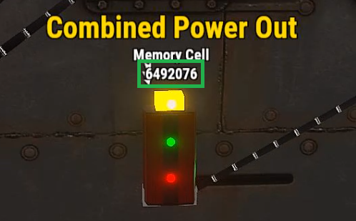

Before going into the construction and operation of a Capacitor, it’s essential to understand the math conversions between Rust Watt Minutes (rWm) and Wire Capacity (Np). Both represent capacity, but they use different units of measurement depending on the energy storage container, be it a battery or a capacitor.

**The Maths**

rWm: rust watt minute

rW: rust watts (commonly referred to as “power”)

Np: Wire Capacity

∅: 7.5 (Trust Me Bro)

S: Seconds

τ: 60 (The number of seconds in a minute, and minutes in an hour)

M: Minutes

P: Max power output for 1 second

O: The amount of power you want to output

H: Hours

To convert rWm into Wire Capacity(Np), use the following equation:

(rWm × τ = P) × ∅ = Np

To convert Wire Capacity(Np) into rWm, use the following equation:

(Np ÷ ∅ = P) ÷ τ = rWm

To figure out how much time a given capacity will run for outputting a specific amount of power, use the following equations:

Seconds: (rWm ÷ O = M) × τ = S

Minutes: rWm ÷ O = M

Hours: (rWm ÷ O = M) ÷ τ = H

**Examples**

Using Capacity from the battery in the first picture, it is possible to figure out the number that would be seen if looking at an IO connection in a Capacitor to view Wire Capacity(Np).

(rWm × τ = P) × ∅ = Np

(271 × 60 = 16,260) × 7.5 = 121,950Np

Therefore a capacity of 271rWm when viewed on an IO connection is equal to 121,950Np. We can also see that if the Large Battery did not have an output limit of 100, it would be able to output 16,260rW of power for 1 second.

Using the IO connection to view Wire Capacity(Np) from the second picture, it is possible to figure out how much rWm of Capacity we would have if this was viewed on a battery.

(Np ÷ ∅ = P) ÷ τ = rWm

(6,492,076 ÷ 7.5 = 865,610.1333) ÷ 60 = 14,426rWm

Therefore a Wire Capacity of 6,492,076Np when viewed on a battery represented as Capacity, it is equal to 14,426rWm. Without a limited output, the Capacitor is capable of delivering 865,610rW of power for 1 second.

Using both of these examples, it's possible to calculate the length of time both the Battery and Capacitor would power a circuit for, given a set output. For our example, let's say the circuit needs 100 power.

Battery

(rWm ÷ O = M) × τ = S

(271÷ 100 = 2.71 Minutes) × 60 = 162 Seconds

Capacitor (you will need to convert from Np to rWm first)

(rWm ÷ O = M) × τ = S

(14,426 ÷ 100 = 144.26 Minutes) × 60 = 8,655 Seconds

OR

(rWm ÷ O = M) ÷ τ = H

(14,426 ÷ 100 = 144.26 Minutes) ÷ 60 = 2.40 Hours

Prior to constructing a capacitor, it’s crucial to understand its limitations and potential issues. This will clarify misconceptions such as the notion of ‘infinite power’ and help identify the appropriate contexts for its use.

1. It doesn’t survive server restarts. Everytime the server restarts, all of the stored power will vanish, poof gone.
2. When automating energy extraction, it is possible that a flicker will be created or worse, all the power vanishes, poof gone.
3. It consumes power even when nothing is connected to it, unlike a battery that doesn’t lose power if nothing is connected to it.
4. It is not portable.

Now, some of the advantages and benefits of the Capacitor

1. The ability to release large amounts of power for short periods of time.

AND

1. Can be used in conjunction with existing battery backup systems to stabilize incoming power.

# Side Inputs

The side ports have been changed to toggles as of November 2 2023. What remains below is for the historical record.

They are not bugged or broken, you just don’t know how to use them yet.

It is not uncommon for people to think of ‘Switch On’ and ‘Switch Off’ as a toggle like on the side of a Timer. They are not toggles, they are inputs with an added function. Just like the ‘Power In’ on the bottom, the side inputs also pass power through to the top. The function part only functions when power is received, removed or the amount of power is updated.

When ANY input on the Switch receives an ‘update’, the Switch will bind to that input for its source of power that passes through to the top. It will remain bound to that input until another input ‘updates’ which will force the switch to bind to the new input. An update is either losing power or receiving power, 0-1 or 1-0 or power levels change up or down.

The exception to this is when one input is receiving an amount of power and another input receives the same amount of power, the Switch will not recognize the new source and remain bound to the original input.

The following pictures will help illustrate how it works.

Starting off, we are using 3 Switches to provide 3 different amounts of power each input. Green wire is for Switch On. Red wire is for Switch Off. Black wire is for Electric Input on the bottom. Yellow lines mark the path power is taking. Red lines mark where power stops. In this first picture, we are sending power to the bottom input and the Switch sends it out the top, with the expected power loss.

Next, we leave power going into the bottom and then apply power to Switch Off. As we can see, the Switch will flip off.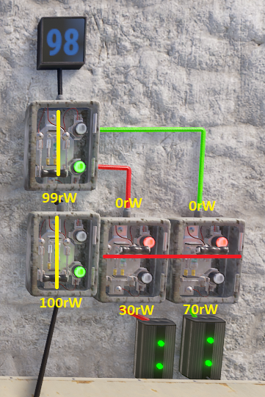

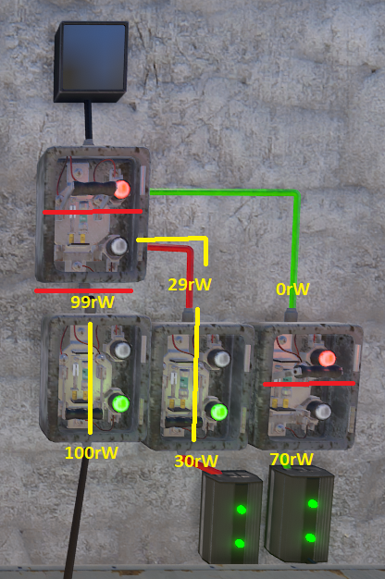

If we manually flip the Switch back on, we can now see a new amount of power displaying on the counter.

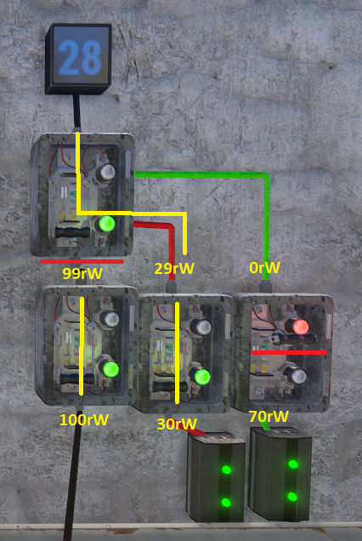

This is because the Switch is now bound to the Switch Off input for the power that passes through to the top. The power going into the bottom input is completely ignored. For the next picture, we flip the Switch back off and then apply power to Switch On.

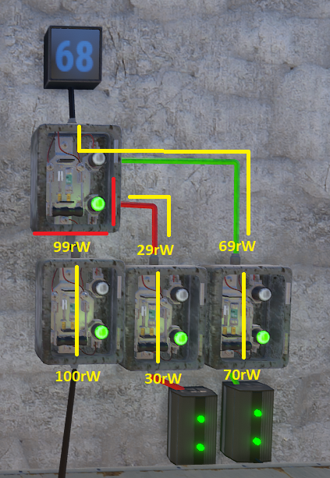

The Switch will now flip on and once again pass through a new amount of power to the counter. The power going to the bottom input or Switch Off input is now ignored and the Switch is bound to Switch On. In the next picture, we remove power from Switch On while keeping power applied to Switch Off and the bottom.

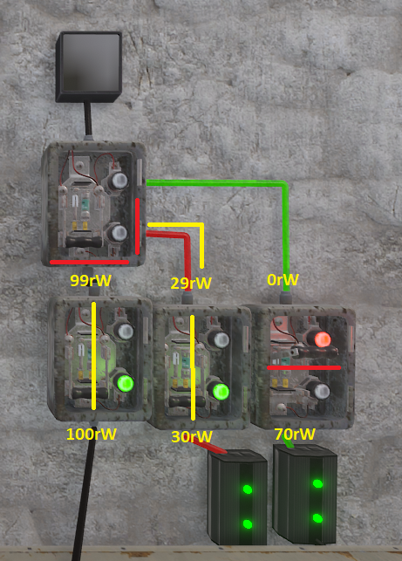

We can see here now that power was removed from Switch On, the Switch has no power. The green light turns off and the Switch is still in the on position. Even though the other 2 inputs have power, the Switch is bound to Switch On for its source of power, which was removed. If we restore power to Switch On, the Switch will start passing power though again like the previous picture. With power restored, for the next picture we will remove power from Switch Off.

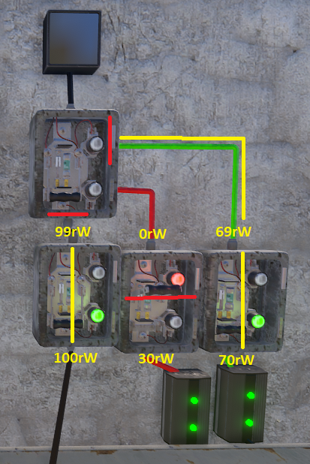

We restored power to Switch On before removing power from Switch Off. The green light turns off when power is removed and the Switch binds to the Switch Off. This is because that input received an update from ‘having power’ to ‘not having power’, from 1 to 0. For the next picture, we restore power to Switch Off.

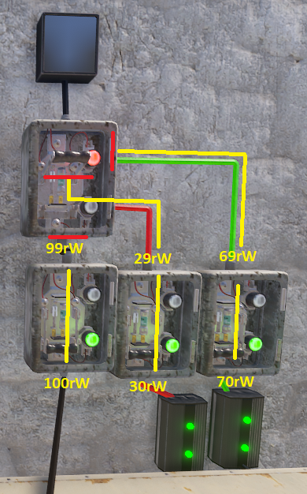

Restoring power to the Switch Off input, the red light turns on and the Switch flips to the off position. When we manually flip it on we can see the new amount of power passing through.

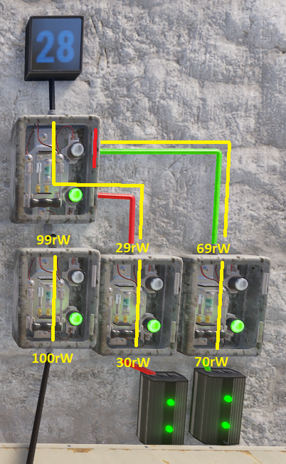

Seeing that we only have 28 power showing on the counter, it is clear power is coming through the Switch Off input. When we remove power from the bottom input, the Switch loses power.

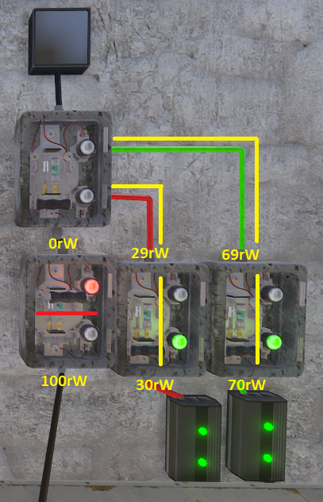

It loses power because the bottom input was updated, from 1 to 0, so the Switch is bound to it. Now bound to the bottom input and not receiving power, the green light turns off and no power passes through. Restoring power to the bottom input, the green light turns back on and the new power amount is displayed on the counter.

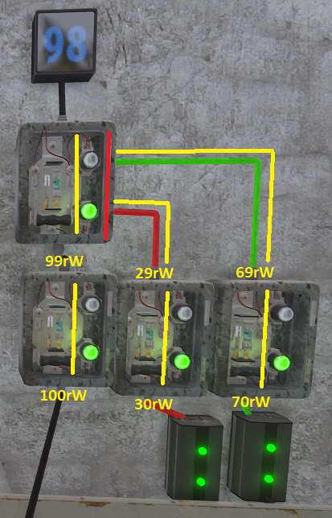

Seeing the power level on the counter confirming power is coming into the bottom, we will now adjust the Electrical Branch to send more power to Switch On.

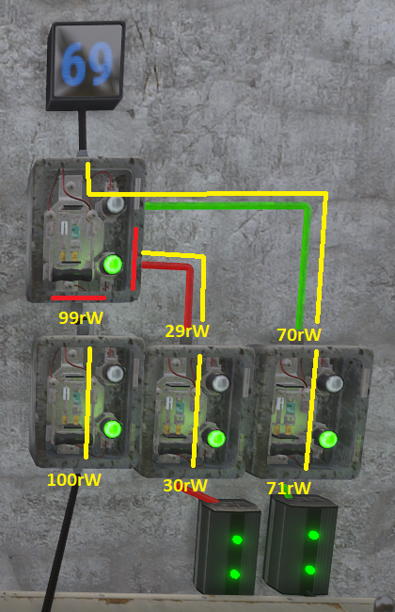

After increasing the amount of power, we can see an instant change on the counter to reflect that the Switch changed the input it was bound to from the bottom input to Switch On.

In conclusion, whichever is the last input to receive an update is the input the Switch will bind to for its source of power. Adding power, removing power or a change in power levels will update the Switches input. When moving power from one input to another, it is important

## 

Useful Circuits (Most will likely be out of date. Review Needed)

[Auto Lights](https://www.rustrician.io/?circuit=dc6bf5e524299bf241b218e2565876d0)

[Auto Smelter](https://www.rustrician.io/?circuit=23c3fe0a5ba8c9bedb35af9a709a1344)

[Auto Refinery](https://www.rustrician.io/?circuit=0664f79c2fe179678eff13b3ce74a3fd)

[Blocker Chain](https://www.rustrician.io/?circuit=773b599014deb161fc173f295727be77)

[Close All Doors with a Red Button](https://www.rustrician.io/?circuit=0101564d3656de1f3bedb87ab2625788)

[Configure Siphon](https://www.rustrician.io/?circuit=3845504916b931067b5e89a7c6efce23)

[Dance Dance Revolution](https://www.rustrician.io/?circuit=e3b55e828700c9c44198bf34d4ccd284)

[Delay Timer](https://www.rustrician.io/?circuit=fa8ba5c2e3974185c6f01273eab653f1)

[Destruction Detection - 2025](https://www.rustrician.io/?circuit=b95bd288fa0d6af839f8bd531b2bded8)

[Component Destruction Detection](https://www.rustrician.io/?circuit=dbb794dc52d82a91250591510ca2d3f9)

[Industrial Merchant](https://www.rustrician.io/?circuit=e5aa034300bbbb59558b033a2af6059e)

[Logic Gates](https://www.rustrician.io/?circuit=64810508602bc0cd1baa954d1a1da539)

[Memory Cell Explained](https://www.rustrician.io/?circuit=b64e3a0f6f9d6d456ead9821abf9d7d7)

[Morning Light Delay](https://www.rustrician.io/?circuit=c2d4d06371b08c0e63bb8ccf9e975049)

[Nih Core](https://www.rustrician.io/?circuit=d131cf1233742ebd0acb8ebaaf3b9d1a)

[Nih Core - 4 Large Batteries](https://www.rustrician.io/?circuit=60fc05f187614f131aa5565be42a6687)

[Nih Core - Decentrali```zed](https://www.rustrician.io/?circuit=1d0b869c046f6d05ee75ab0f841fc150)

[Nih Core - Solutions To Flicker](https://www.rustrician.io/?circuit=66021c4866d7093b77e9268bf8f9cb00)

[Parallel vs Series](https://www.rustrician.io/?circuit=0191b550a1c45104ce7129c15ba13d4f)

[PepsiCore](https://www.rustrician.io/?circuit=5b31017e9e3316c7246deb869d56c08b)

[Probability Master Class](https://www.rustrician.io/?circuit=ca9bdcbc87f0a13ca3a3ce0c8fe4146d)

[Every Box is a Drop Box](https://www.rustrician.io/?circuit=8958914d237cd6fce723a5ca2fc4cd8d)

**Pulse Control (Configure)**

Basic set - [https://wgfww.rustrician.io/?circuit=c0487dd792adbd543e8d234a3979bc38](https://www.rustrician.io/?circuit=c0487dd792adbd543e8d234a3979bc38)